Weather Forecasting

Using Machine Learning And Deep Learning

Jitender Pratap Singh, Komal Kumar

Department of Information Technology, Bharati Vidyapeeth’s College of Engineering, New Delhi, India

Abstract – Weather forecasting has been playing an important factor due to its applications in the various sectors such as in agriculture, utility company and in day to day life. Weather prediction is a real-time challenging issue witnessed by the world in the last decade. The prediction is becoming more complex due to the ever-changing weather conditions. Weather forecasting details predicting is how the present state of the atmosphere will change. For effective analysis of the weather, it is necessary to understand various influencing factors that cause the weather changes. Weather forecasting is the process of recording the parameters of weather like wind direction, wind speed, humidity, rainfall, temperature etc. Since machine learning techniques are more robust to perturbations, in this project we applied linear regression to predict the weather such as temperature, rainfall, wind speed etc. analyzed it. We used three different datasets for the same. Coming to result that we got from each approaches was quite amazing. In the linear regression approach, we got mean absolute error about 96.32 mm and 2.69 celsius when performing rainfall and temperature prediction respectively whereas in the deep learning approach.

Keywords— Weather forecast, Machine Learning, data preprocessing

# **1. Introduction**

Weather conditions changes rapidly, weather forecast is a vital process, weather forecasting is a process of collecting data on atmospheric conditions, which records the temperature, humidity, rainfall, wind speed and its direction etc. high-speed computers, wired and wireless sensors, meteorological satellites and weather radars are the tools used to collect the weather data for weather forecasting. Weather is so popular that there is now a television channel completely devoted to weather issues.

Weather can have a substantial impact on the economy, especially agriculture but other areas as well. The 2005 hurricanes Katrina and Rita caused an extensive shutdown of oil and gas rigs in the Gulf of Mexico resulting in a significant spike in energy prices while the 2006 freeze in California caused hundreds of millions of dollars in losses to citrus growers and widespread unemployment.

There are many applications that this system is used such as Air Traffic, Agriculture, Marine, Forestry, Navy, and Military etc.  The weather forecasting methods used in the ancient time usually implied pattern recognition i.e., they usually rely on observing patterns of events. For example, it is found that the following day has brought fair weather; if the preceding day sunset is particularly red. However, all of the predictions prove not to be reliable. Here in this system, we used parameters like average temperature, cloud cover to predict the rainfall. Two machine and deep learning algorithms were implemented: linear regression and artificial neural networks. A corpus of historical weather data for Denmark and India was obtained and used to train these algorithms.

The Linear Regression method is modified in order to obtain the most optimum error percentage by iterating and adding some percentage of the error to the input values. This method provides an estimate of rainfall using different atmospheric parameters like average temperature and cloud cover to predict the rainfall. The linear regression is applied to the set of data and the coefficients are used to predict the rainfall based on the corresponding values of the parameters. The main advantage of this model is that this model estimates the rainfall based on the previous correlation between the different atmospheric parameters.

Thus, an estimated value of what the rainfall could be at a given time period and place can be found easily.

There are four types of forecasting-

1. Climatology method - The climatology method offers a simple technique for generating a weather forecast. They predict the weather for a specific day and location based on the weather conditions for that same day for several years in the past.
2. Analog method - The analog method is a difficult method to use when predicting the weather because it requires finding a day in the past with weather similar to the current forecast, which is difficult to do. For example, suppose the current forecast indicates a warm day with a cold front imminent in the region of the forecast.
3. Persistence and trends method- The persistence and trends method requires little to no skill to predict the weather because it relies on past trends. In an ideal world, the atmosphere changes slowly, which equates to a forecast tomorrow that stays the same as today, with a hat tip to the climate's norm for the specific time of year.
4. Numerical weather prediction- Numerical weather prediction relies on computers to predict the weather. Massive supercomputers, complete with software forecasting models, help meteorologists make weather predictions based on multiple conditions in the atmosphere such as temperatures, wind speed, high- and low-pressure, rainfall and other conditions.

The paper is organized as following. 1. Introduction, 2. Related Work, 3. Dataset, 4. Methodology, 5. Results, 6.Conclusion and future prospective and 7. References.

**2. Related Work**

Machine learning in weather forecasting is a recent trend in the literature. There are several works which discuss this topic. Holmstrom et al. proposed a technique to forecast the maximum and minimum temperature of the next seven days, given the data of past two days . They utilized a linear regression model, as well as a variation of a functional linear regression model. They showed that both the models were outperformed by professional weather forecasting services for the prediction of up to seven days. However, their model performs better in forecasting later days or longer time scales. A hybrid model that used neural networks to model the physics behind weather forecasting was proposed by Krasnopolsky and Rabinivitz . Support vector machines was utilized for weather prediction as a classification problem by Radhika et al. A data mining based predictive model to identify the fluctuating patterns of weather conditions was proposed in . The patterns from historical data is used to approximate the upcoming weather conditions. The proposed data model uses Hidden Markov Model for prediction and k-means clustering for extracting weather condition observations. Grover et al. studied weather prediction via a hybrid approach, which combines discriminatively trained predictive models with deep neural networks that models the joint statistics of a set of weather-related variables. Montori et al. used the concept of crowdsensing, where participating users share their smart phone data to environmental phenomenons. They introduced an architecture named SenSquare, which handles data from IoT sources and crowdsensing platforms, and display the data unifiedly to subscribers. This data is used in smart city environment monitoring. However, none of these works use the idea of combining data from neighboring places.

**3.Dataset**

We started to collect out the dataset and we look out to various websites and found a dataset on Open Government Data ([**data.gov.in/**](https://data.gov.in/)) which consist of various attributes. Dataset used in the project is month and year-wise.

Figure no.1 :

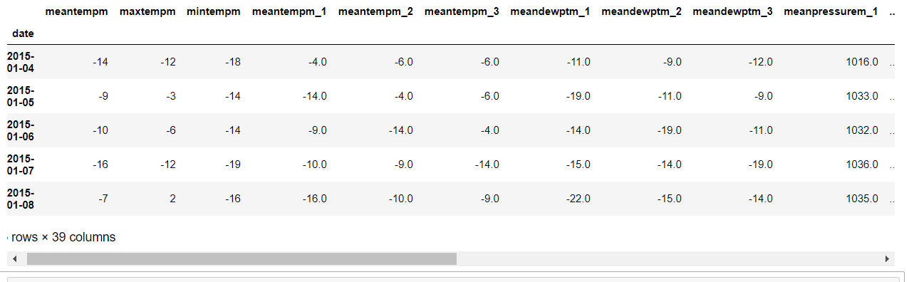

(a)

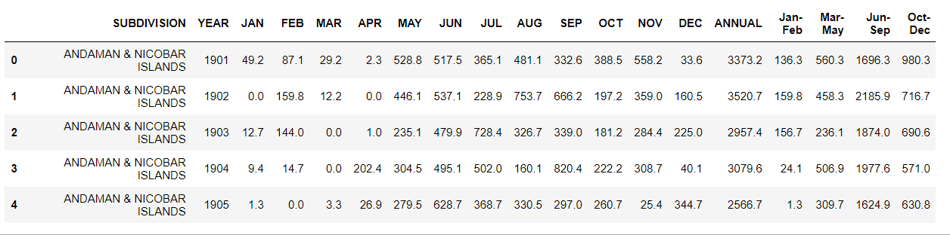

(b)

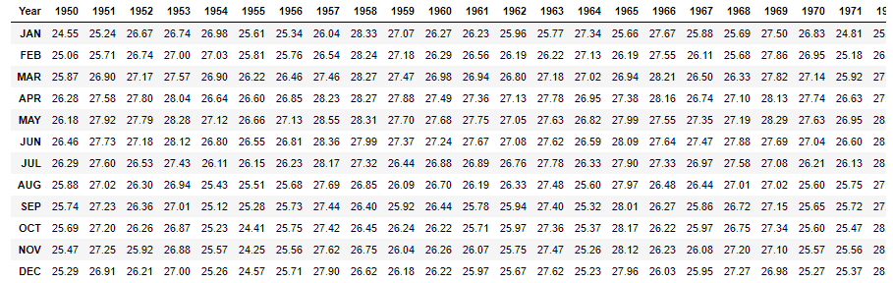

(c)

Figure No.1 (a) the dataset of temperature, (b) the dataset of Rainfall, (c) the dataset of Wind speed

In the dataset, there are three features basically temp, rainfall and wind speed.

**4. Methodology**

For the weather forecasting, we try to solve the problem using two methods and those were-

* Machine Learning
* Deep Learning

We divide the problem using two methods and we have done so because of the following reasons-

* Tackle the problem with different approaches
* Will know what are the strengths and weaknesses of each method.
* Will know what are the difficulties one could face while approaching the problem with these two methods.
* Will know what is the efficiency of each process.

Coming to the first approach that is Machine Learning, here we have solved the problem of weather forecasting with linear regression. In this approach, weather forecasting like rainfall prediction and temperature prediction is done separately. Also, the linear model which was trained for temperature predictions and rainfall predictions were trained using ordinary least square and regularization respectively.

Now coming to the second approach that is Deep learning, here we have solved the problem of weather forecasting in a single stroke. Mean, only in one solution, we have done the forecasting of the temperature, wind speed, and pressure. We have trained our model on LSTM (advanced version of the RNN).

Figure no.2 :

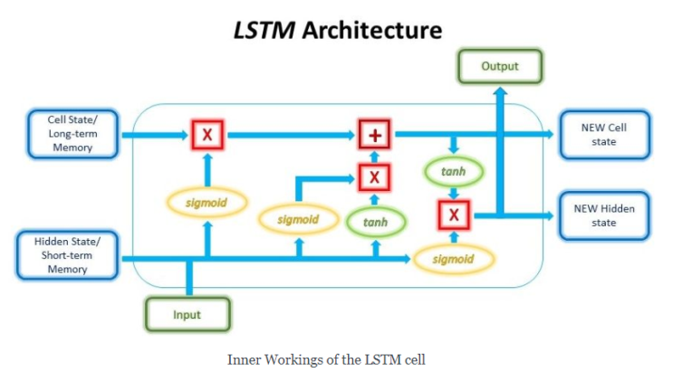

Figure no.2 Showing the architecture of Long Shot Team Memory

**5. Results**

Figure no.3 :

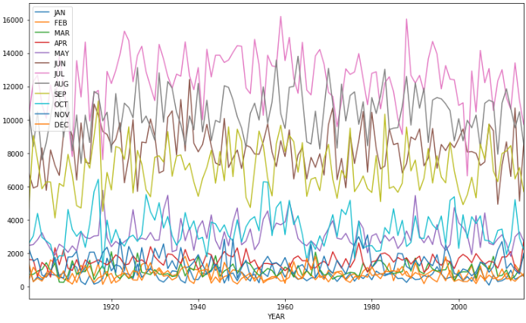

(a)

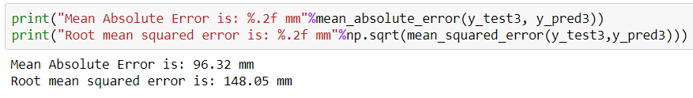

(b)

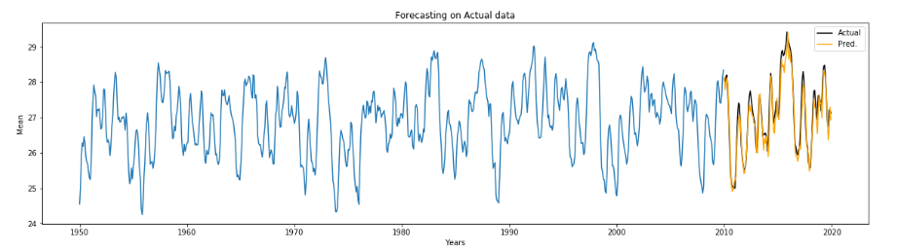

(c)

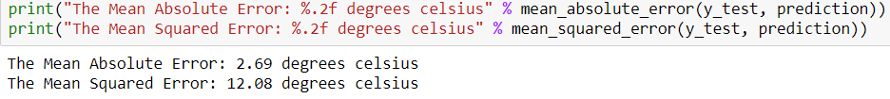

(d)

Figure no.3(a) the Prediction using Linear Regression on Rainfall dataset, (b) the result of Mean Absolute Error && Mean Squared Error Using Linear Regression on Rainfall Dataset, (c) the Prediction using LSTM on wind dataset, (d) the result of Mean Absolute Error && Mean Squared Error Using Linear Regression on Temperature Dataset

**6. Conclusion and future prospective**

In this project, linear regression and deep learning are used to predict the weather forecasting. We divided the whole weather forecasting project into two parts. Compared to the machine learning approach, deep learning approach which was the deep learning approach gives the better result.

Weather forecasts are increasingly accurate and useful, and their benefits extend widely across the economy. While much has been accomplished in improving weather forecasts, there remains much room for improvement.

For future improvements, following step we thought to took-

* Replacing model with a latest/different model
* Using other robust datasets
* Predicting result on more attributes
* Training model on higher-end GPU

Also, while performing weather forecasting, there was a lot of complexities involved. There are a lot of variables/attributes to consider for forecasting weather and if all or most of them are used, then we need a lot of computation power to get weather information. And, Real time weather forecasting is very difficult to forecast correctly.

**7. References**

1. Parmar, Aakash&Mistree, Kinjal&Sompura, Mithila. (2017). Machine Learning Techniques for Rainfall Prediction: A Review.
2. Mateo, Fernando & Carrasco, Juan José &Sellami, Abderrahim&Millán-Giraldo, Mónica&Domínguez, Manuel & Olivas, Emilio. (2013). Machine learning methods to forecast temperature in buildings. Expert Systems with Applications. 40. 1061–1068. 10.1016/j.eswa.2012.08.030.
3. Pooja Malik, Prof. Saranjeet Singh, Binni Arora. An Effective Weather Forecasting Using Neural Network
4. Abhishek, Kumar & Singh, M. & Ghosh, Saswata&Anand, Abhishek. (2012). Weather Forecasting Model using Artificial Neural Network. Procedia Technology. 4. 311–318. 10.1016/j.protcy.2012.05.047.
5. Long Short-Term Memory Recurrent Neural Network Architectures for Large Scale Acoustic Modeling. Has¸im Sak, Andrew Senior, Franc¸oise Beaufays
6. Chatfield, C. (1994): The Analysis of Time Series-An Introduction. Chapman and Hall.
7. Sivakumar, B. (2001): Rainfall dynamics in different temporal scale: A Chaotic percepective. Hydrology and Earth System Science, Vol.5, pp. 645-651.
8. Guhathakurta, P. (2006). Long range of monsoon rainfall prediction of 2005 for the districts and sub-division in kerala with artificial neural network. Current science, Vol. 90, pp. 773-779.
9. Saima, H., Jaafar, J., Belhaouari, S. and Jillani, T.A. (2011): ARIMA based Interval Type-2 Fuzzy Model for Forecasting. International Journal of Computer Applications, Vol. 28, No. 3, pp. 17-21.
10. M.Tektas, “Weather Forecasting Using ANFIS and ARIMA (2010): A Case study of Istanbul,” Enviornment Research , Engineering and Management , vol. 1(51), pp.5-10.

1. Mahmudur Rahman, A.H.M. Saiful Islam , Sahah Yaser Maqnoon Nadvi , Rashedur M Rahman (2013) : Comparative Study of ANFIS and ARIMA Model for weather forecasting in Dhaka” IEEE.
2. Sarah N. kohail, Alaa M. EI-Halees(2011): “Implementation of Data Minning Technique for Metrological Data Analysis”,IJICT Journal Volume 1 No.3, july
3. S.A. Shamsnia, N. Shahidi, A. Liaghat, A.Sarraf and S.F. Vahdat. 2011. Modeling Of Weather Parameters Using Stochastic Methods. Internat. Conference on Environment and Industrial Innovation, IPCBEE, Singapore, 282-285.
4. R Development Core Team (2008). R: A language and environment for analytic computing. R Foundation for Statistical Computing, Vienna, Austria. ISBN 3-900051-07-0, URL http://www.Rproject. org. [15] Montgomery, D.C., and Lynwood A.J. (1996): Forecasting and Time Series Analysis, Mc. Graw-Hill.
5. Abramson, Bruce, et al. ”Hailfinder: A Bayesian system for forecasting severe weather.”International Journal of Forecasting12.1 (1996): 57-71.
6. Cof?no, Antonio S., et al. ”Bayesian networks for probabilistic weather prediction.”15th Eureopean Conference on Artificial Intelligence (ECAI). 2002.
7. Krasnopolsky, Vladimir M., and Michael S. FoxRabinovitz. ”Complex hybrid models combining deterministic and machine learning components for numerical climate modeling and weather prediction.”Neural Networks19.2 (2006): 122-134.
8. Lai, Loi Lei, et al. ”Intelligent weather forecast.”Machine Learning and Cybernetics, 2004. Proceedings of 2004 International Conference on. Vol. 7. IEEE, 2004.

.

1. Radhika, Y., and M. Shashi. ”Atmospheric temperature prediction using support vector machines.”International Journal of Computer Theory and Engineering1.1 (2009): 55.
2. ”Stanford, CA” in Weather Underground, The Weather Company, 2016. [Online]. Available: https://www.wunderground.com/us/ca/paloalto/zmw:94305.1.99999. Accessed: Nov 20, 2016.
3. Stern, H. (2008), The accuracy of weather forecasts for Melbourne, Australia. Met. Apps, 15: 65?71. doi:10.1002/met.67