**Practical Final Exam**

Name: Israel Bernal Martinez

WEB2040

Time Duration: 4 hours

Due Date: 12/2/2015

This test refers to the HR database in the following site: [http://www.w3resource.com/mysql-exercises/join-exercises/#PracticeOnline](http://www.w3resource.com/mysql-exercises/join-exercises/)

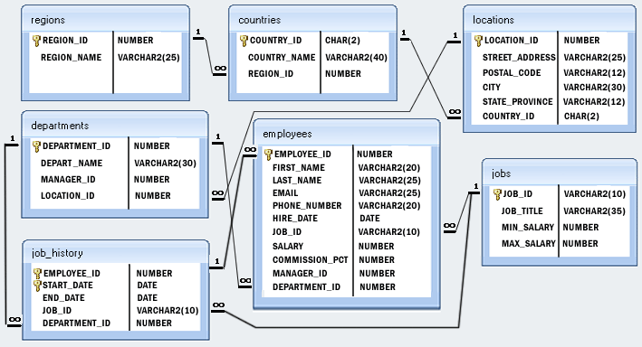

Please complete each question by issuing the query and then pasting a screenshot of the query AND the output under each question.

1. Create a query which outputs a table containing the department id, department name, and manager name (first and last name) of all departments in the company (simple join, 40pts).

SELECT d.DEPARTMENT_ID, d.DEPARTMENT_NAME, CONCAT_WS(" ",e.FIRST_NAME,e.LAST_NAME ) AS FULL_NAME FROM departments d JOIN employees AS e ON e.MANAGER_ID = d.MANAGER_ID

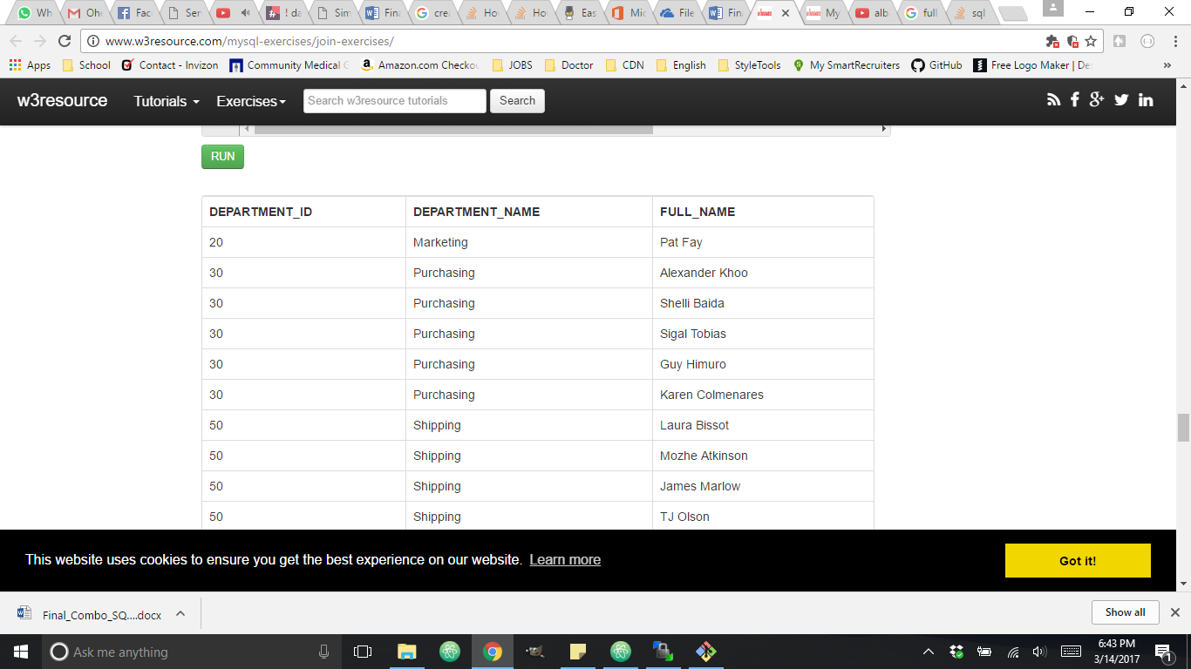

1. Write a query that shows the name of each employee (first name and last name), the city, state and country name of the location where they work (Double Join, 30pts).

SELECT CONCAT_WS(" ",e.FIRST_NAME,e.LAST_NAME ) AS FULL_NAME , l.CITY, l.STATE_PROVINCE, c.COUNTRY_NAME FROM employees e JOIN departments d ON e.DEPARTMENT_ID = d.DEPARTMENT_ID

JOIN locations l ON l.LOCATION_ID = d.LOCATION_ID

JOIN countries c ON l.COUNTRY_ID = c.COUNTRY_ID

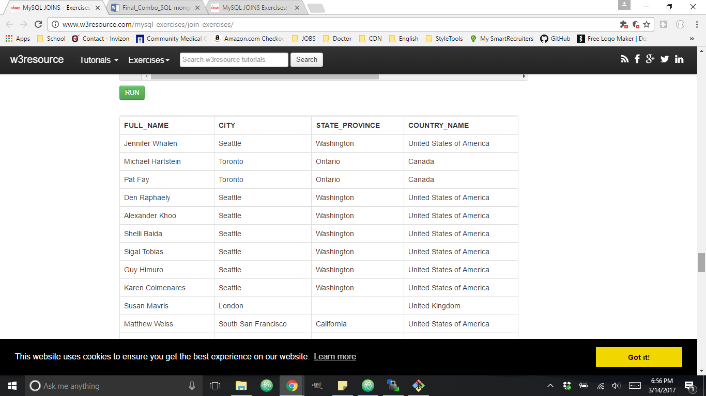

1. Write a query which shows the first name, last name, and region where each employee is based. (Quadruple join, 20pts)

SELECT e.FIRST_NAME,e.LAST_NAME , r.REGION_NAME FROM employees e

JOIN departments d ON e.DEPARTMENT_ID = d.DEPARTMENT_ID

JOIN locations l ON l.LOCATION_ID = d.LOCATION_ID

JOIN countries c ON l.COUNTRY_ID = c.COUNTRY_ID

JOIN regions r ON r.REGION_ID = c.REGION_ID

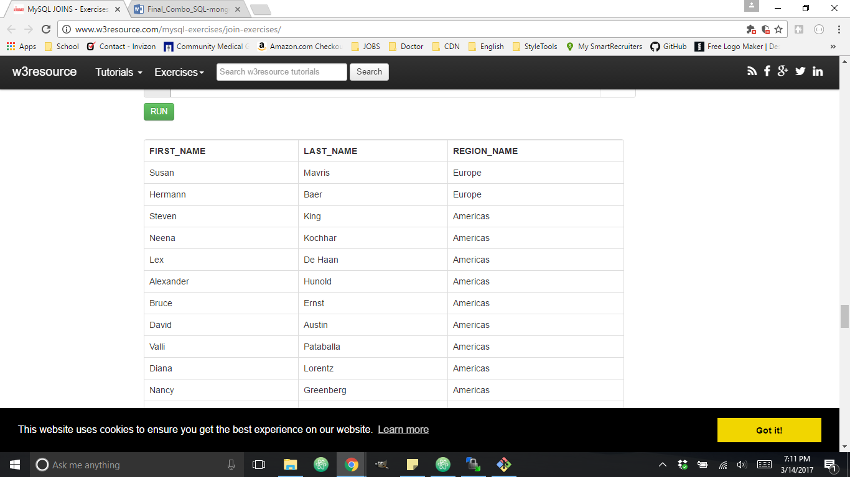

1. You are writing a service for application in NodeJS. The purpose of the service is to provide a leaderboard for an online game. Use mongoDB to create a server which can display all score entries and to which you can post a new score entry.

A score entry is defined by two attributes: The name of the player and the score they obtained. (MongoDB, 50pts)

Upload your solution to github under the name **highscore-backend**.

Answer:

https://github.com/imbernal/highscore-backend

1. Consider the solution to the previous question. Add the following enhancements:
   1. The service returns the scores in the proper order from highest to lowest (Mongoose sorting query, 20pts)
   2. The service has an additional endpoint which can take a request parameter to limit the number of results provided. For instance, if the endpoint’s name is “/leaderboard” and you send a GET request to this endpoint, you should get all the scores (as per the previous question). This question asks that if a request is sent to “/leaderboard/20” then only the top 20 results come back to the requester.

Answer:

https://github.com/imbernal/highscore-backend