MY DIARY ENTRY FOR WEEK ONE

Tuesday: 03/05/2022
Tuesday is one of the busiest days of the week for me. My day started around 8: 00 am after doing my routine morning exercise and the morning devotion, I checked my email inbox and other social media inbox to reply to the most important messages. I took my breakfast around 11:00 am a cup of milo tea, fried egg, and bread. I then started reading articles related to my dissertation and getting more ideas about my research topic. On started preparing for an interview with [researcher] which started around 2:00 pm and ended around 4:00 on campus. On my way home to my flat, I went to the grocery shop to get pizza, fries and Pepsi as shown below which means no cooking on Tuesday. I dumped the pizza paper in the paper and cardboard bin and the Pepsi can in the plastic as shown below.
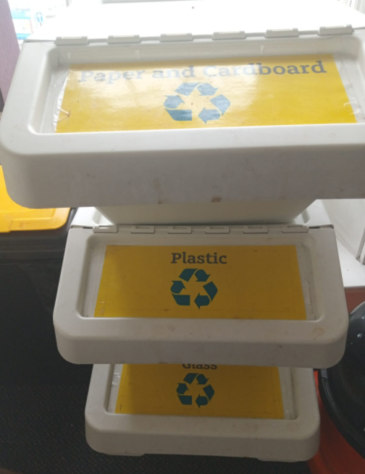
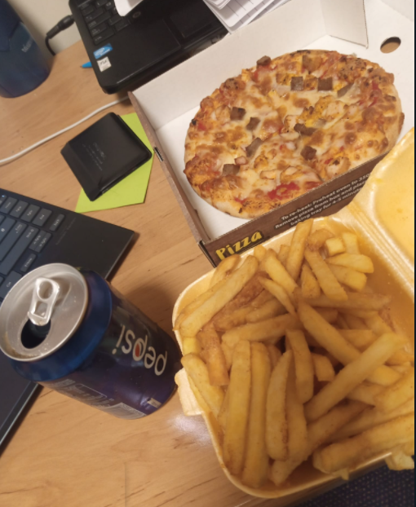

Wednesday: 4/05/2022
I went to shopping on Wednesday around 10 am, I started my shopping at a Nigerian local grocery shop whereby a bought fish, tomatoes, semolina, and beans. I then proceeded to Lidle supermarket to get a bag of rice, eggs, drinks, and vegetables. The first thing I normally do during my shopping is to check the expiring date of the items. The vegetables, fish, and drinks went to the fridge. My shopping lasted for three hours this is because I later went to Primark to get a pair of shoes and trousers for myself. I cooked rice and reheated my cabbage stew and these became my lunch and supper for the day.

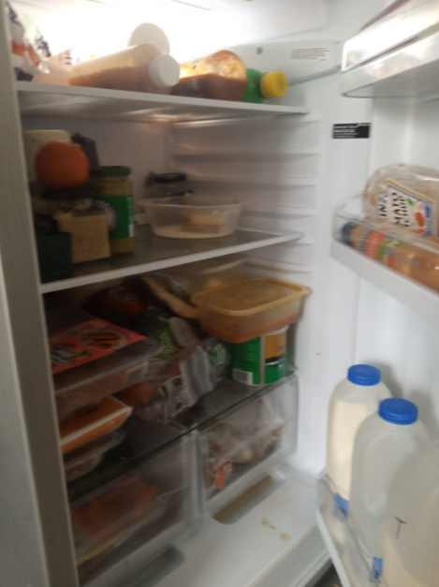
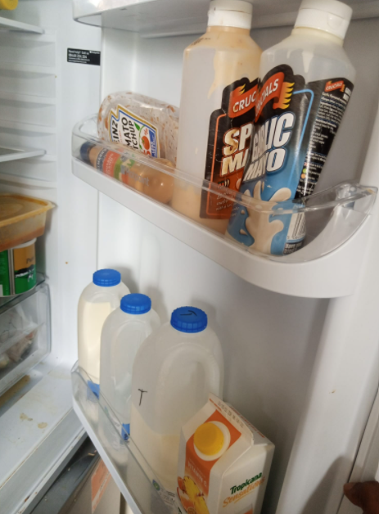

Friday: 06/05/2022
On Friday I had a meeting with my dissertation supervisor, so I took my breakfast around the 10 am semolina, milk, and bread. The leftovers of the breakfast went to the general bin and the milk can went to the plastic bin. I cooked yam and eggs stew as lunch and the rest of the stew was stored in the fridge. Half of the yam got spoilt and it was dropped to the refuse bin.

