MY DIARY ENTRY FOR WEEK TWO

Monday: 09/05/2022
I had my breakfast around 11 am, a cup of tea and fried egg and bread. I gather the ingredients I bought last week for the preparation of the stew, and I started preparing cabbage stew. The preparation process took about 1 hour, and 30 minutes and the preparation of the stew and rice happened concurrently. The leftover of the food preparation went to the respective bins and started lunch around 3:30 pm. After lunch, the rest of the stew was packaged and stored in the fridge.
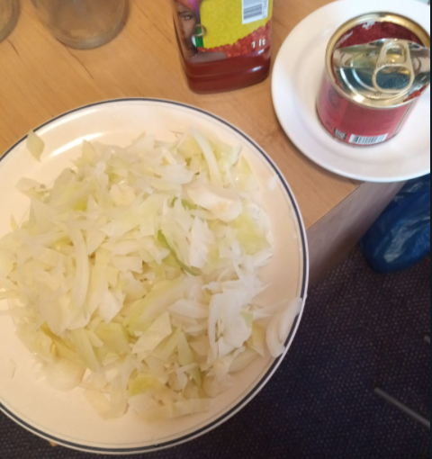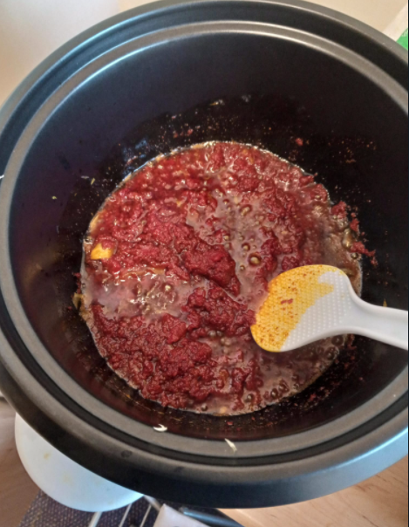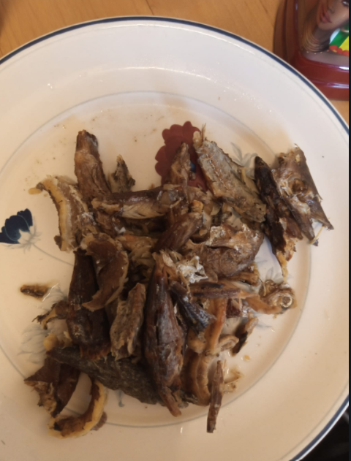

Wednesday: 11/05/2022
I spent my Wednesday morning at the university library which implies I skipped breakfast on Wednesday. I had my lunch around 2:00 pm, I cooked plantain and reheated the cabbage stew. I later ate banana and grape before I went to bed.
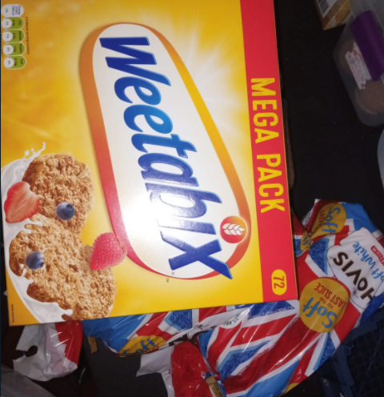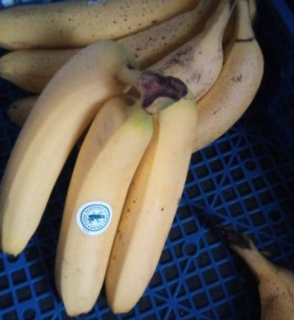
Friday: 11/05/2022
On Friday morning I took in Weetabix with milk and toasted bread as my breakfast. The leftovers of the breakfast went to the general bin and the milk can go to the plastic bin. Later in the evening, I prepared salad with orange juice as dinner.
