2022-

Diary – Week 1

Monday 25th April 2022
18:45 Home from work. No ideas for dinner, so trip to Tesco Express to browse the reduced section (limited options available means easier decision making – important when hungry and tired).
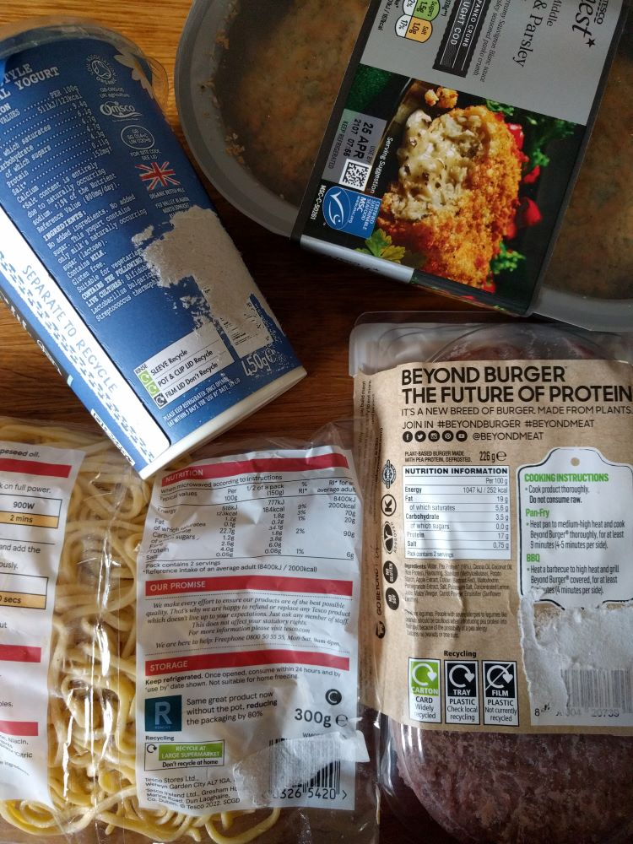
Bought:

- Organic yoghurt usually keeps well so will use for breakfast despite use by date. Clearly marked information for separating and recycling the packaging after use.
- Suitable for freezing, so will keep for another time. No packaging information at all, but based on similar items, the tray can be put in the recycling bin once rinsed, and a good portion of the paper label is likely to detach easily to go in the recycling too.
- Not suitable for freezing so will use for dinner. Packaging has recently changed to reduce the amount of plastic used, with clear instructions for recycling.
- Not suitable for freezing so will use for dinner. Clear recycling information.
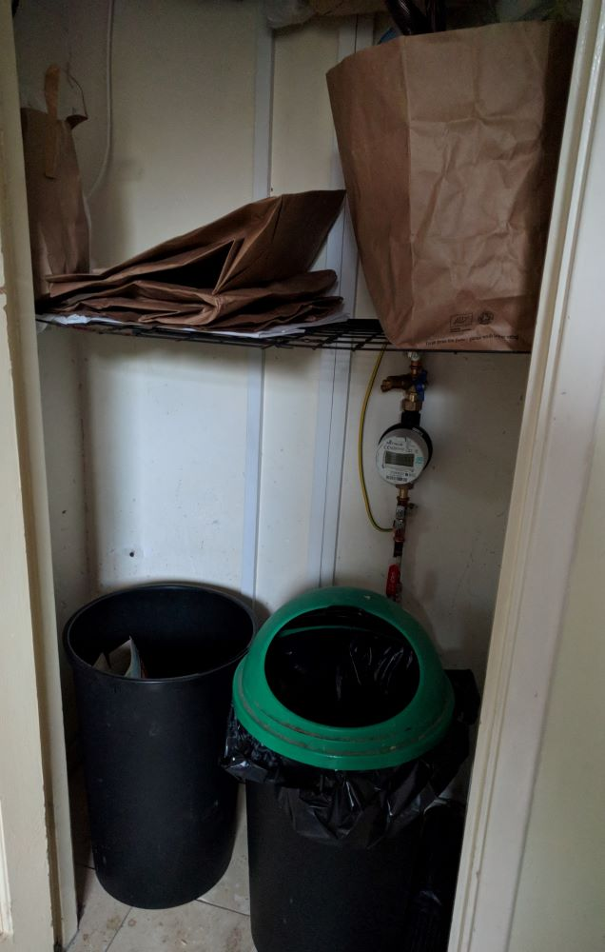
In my bin cupboard (right) I have a rubbish bin with a black bag for non-recyclable waste (B), a lidless bin for mixed recycling (C) and a large paper bag (A) that I use to collect flexible plastic to take to the nearest large supermarket.
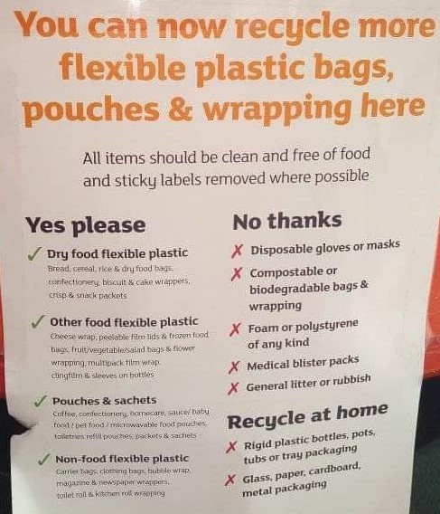
The carrier bag collection point at the supermarket has a label saying, “You can now recycle more flexible plastic bags, pouches & wrapping here. All items should be clean and free of food and sticky labels where possible”, followed by examples of the types of packaging collected (shown below).

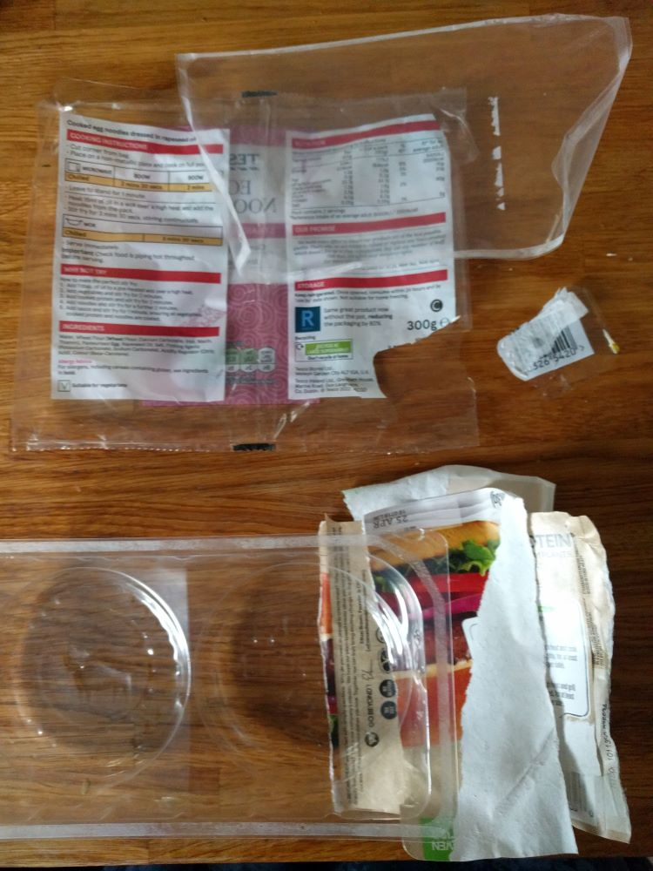
Packaging disposal:
The packaging for item 3 says that it should be recycled at a large supermarket, and the supermarket has stated that the packaging should be clean and free of sticky labels. I was able to wipe the inside of the packaging easily with a cloth and removed most of the reduced sticker label. Rather than spend lots of time trying to get the rest of the sticker off, I decided to just cut the ‘contaminated’ part away to put in the rubbish bin.
I liked that the packaging for item 4 separated easily into the three separate materials. Although the recycling information says that the film is not currently recycled, one of the items collected at the supermarket is peelable film lids. The plastic film and tray both needed cleaning before disposal but were easy to wash up in warm soapy water. The tray even had a “please recycle” reminder on it, which was nice to see.

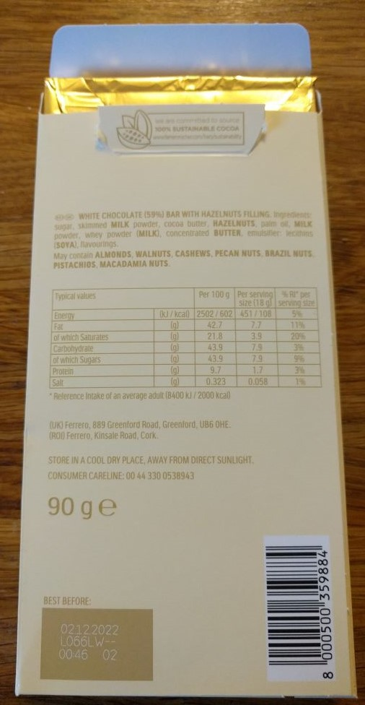
Tuesday 26th April 2022
18:45ish Home from work with no ideas for dinner again, so another trip to Tesco Express to browse the reduced section. Picked up a few other items as well, including a bar of chocolate to try (shown right).
There was no packaging information at all on the chocolate bar, but the outer wrapper was card, so I hoped that the inside would be foil, though there was no way to know until I had opened it at home, and I have been disappointed before that the inner wrapper has been some sort of mixed material destined for the rubbish bin only. As chocolate is an item that I buy as a treat I am much more discerning about the packaging. I used to be particularly fond of Cadbury’s chocolate, but stopped buying it a few years ago, due to the hard to recycle packaging. Since then, I look out for chocolate bars that are wrapped in foil and paper instead, so the only time I buy Cadbury’s now is at Easter, though I’m limited to the Creme Egg variety of Easter egg, as most of the other treat options (that come with the foil wrapped egg) are still wrapped in some sort of plastic-foil material. I have found that Nestlé are a better choice for packaging, with more paper-based options, and was definitely swayed to buy their Easter Smartie treats this year because they were in a paper bag. If one company has proved it is possible, then my custom will go to them until other companies catch up.

Two of the other items that I bought were in similar packaging, a plastic tray with a plastic film lid. The difference in recycling instructions (shown below) is a bit confusing though. However, the packaging on the right has not been updated since 2020, so I will assume (perhaps wrongly) that the more recent instructions (© Tesco 2022) apply to both.
One of the things I dislike about plastic is the different varieties, that some are easier to recycle than others, and that it’s not easy as a consumer to distinguish between them. That is why I prefer packaging that is clearly labelled.

Friday 29th April 2022
[x] delivery day. Food delivered is cardboard crates that are collected back and reused:
[photo deleted]
I get most of my fresh fruit and veg delivered by [x] for several reasons. Firstly, good quality, seasonal produce. Secondly, the company’s environmental ethos aligns with mine with regards to packaging and farming. Thirdly, the website is updated regularly to say where the produce is being grown or shipped from, so I know where the food I am buying comes from. This is something that is particularly important to me as a consumer. I may not have any say in decisions that affect global food production or energy use, but I would rather spend my money in a responsible way where I can.
Today’s delivery contains:
- A fruit bag – a selection of loose fruit in a sturdy paper bag. The label isn’t recyclable, so it has to go in the rubbish bin. The bag is recyclable, but it is sturdy enough to be reused first.
- A pack of kiwi fruit – added as a separate item so sealed in a smaller bag. Thin paper means less packaging, but single use only.
- Mushrooms – in a cardboard tub with paper sleeve. I usually use the tub to collect compostable waste for the compost bin in the garden, but could be recycled instead.
- Spring greens – added as a separate item so packaged in a compostable bag. Writing on the bag says, “This bag may look like conventional plastic, but when composted it will break down completely like a plant decomposing.” This item arrives packaging free when part of a veg box, which I prefer, but the contents of the veg boxes cannot be altered so I will only buy one when I like everything on offer that week (to avoid food waste).

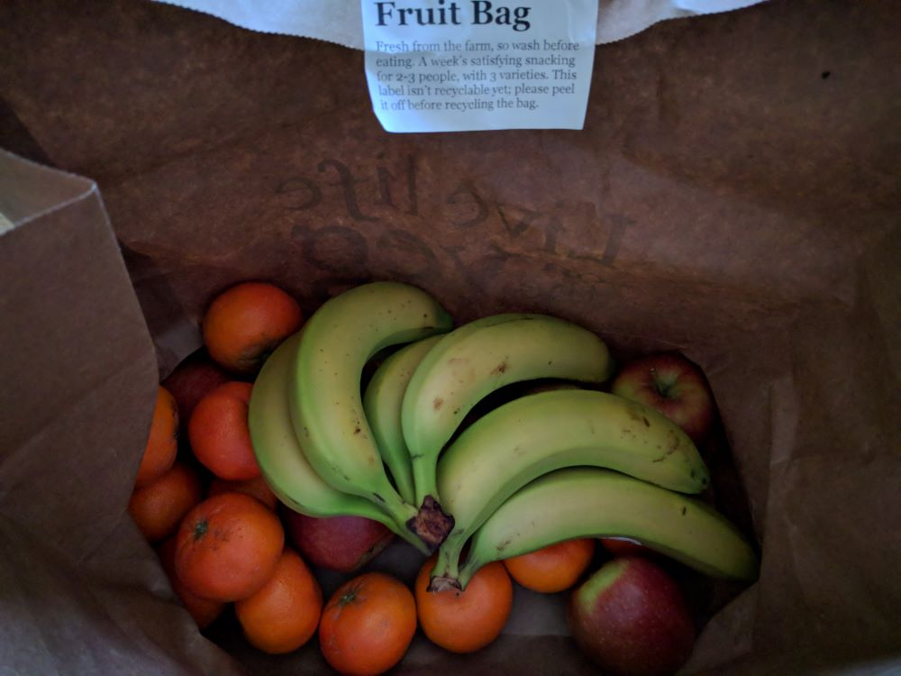

Saturday 30th April 2022
Unexpected refill shop find!! So exciting, particularly as they had the most extensive collection of goods I have seen, including several things that I haven’t seen before, such as crisps! Like chocolate, I rarely buy crisps due to the packaging that’s used, so I decided to treat myself to crisps, and also some fudge (again something that’s normally sold in plastic). They also had a good selection of dried fruit, so I stocked up on a couple of those too.
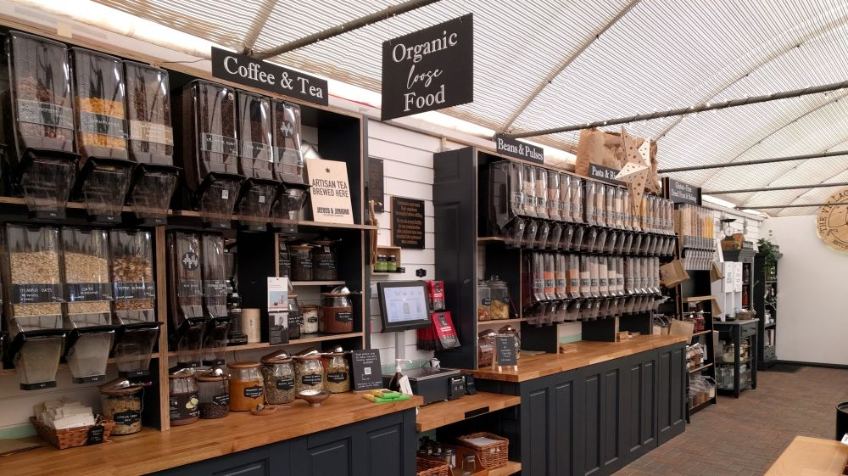
Luckily, I had some of my refill bags with me, though there were also paper bags available to use too, but I prefer to reuse what I have rather than pick up something new, even if it is just a paper bag.
Once I got home, I transferred the contents into glass jars.
