Diary – Week 2

Monday 2nd May 2022
Have plenty of food in so decided to make an all in one veg meat rice dish.
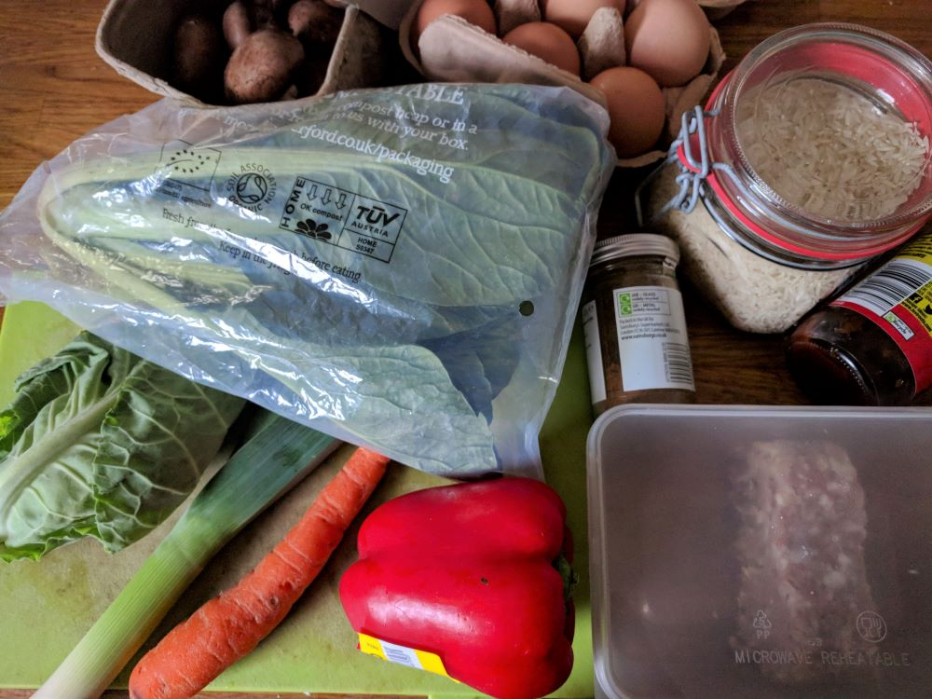
Dinner ingredients:
- Veg-box veg – no packaging, food scraps to go in the compost bin.
- Veg-box veg wrapped in compostable packaging – I don’t like to put too much of this packaging into the compost bin at one time (not sure how well it composts), so have started to get a pile of it in the kitchen. The packaging states that it can be left out with the delivery boxes for collection for those who are unable to compost it at home, so I may need to try that with the excess.
- Veg and eggs in cardboard packaging – once empty the packaging will either go in the recycling bin or be added to the compost bin.
- Loose veg from Tesco – I hate buying vegetables and fruit in single use plastic packaging when I know that alternatives are available. I like eating a variety of food colours (due to the range of nutrients that provides) so red peppers are something I do buy from the supermarket since they’re not often added to the veg box. I do tend to only buy single peppers when reduced though, and I think the reason for that is because the cheaper price persuades me to compromise on the unknown origin and farming methods used for growing the veg (it’s not organic and could be covered in pesticide residue for example). I guess that means that somewhere on my decision-making priority list, the cost of the food can be a deciding factor.
- Ingredients in refill containers – bought loose at refill stores. The spice pot has been refilled after first use rather than being recycled and the glass refill jar was also obtained second hand. (I’m a firm believer in reduce -> reuse -> recycle).
- Sauce – glass jar with cap can be recycled once empty, although may be suitable for reuse.
- Meat – previously frozen in a reused plastic takeaway container. I try to reuse the containers a few times before throwing them in the recycling. They do tend to break after a while.

Wednesday 4th May 2022
In the mood for pizza today, so quick trip to Tesco Express to get one. Picked up a couple of accompaniments to go with it, and added some salad veg from the fridge to complete the meal.
Bought:
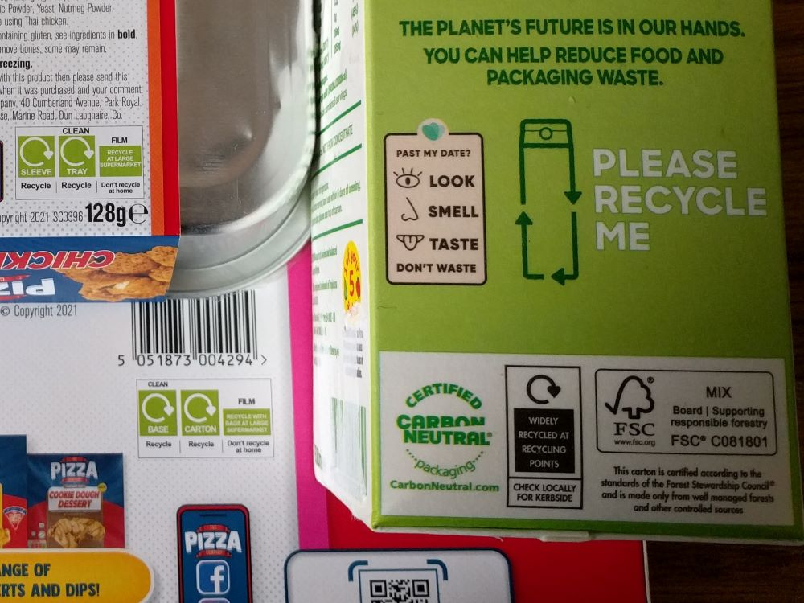
Clear recycling instructions for each part of the packaging. Both the tray and the base were easy to wipe clean after use and the film for the pizza had very little tomato on it, so that proved to be easy to wipe too, meaning that none of the packaging ended up in the rubbish bin, yay!
The juice carton was reduced as it had reached its best before date, but as it clearly states on the side of the carton, that doesn’t mean that it should go to waste. I bought a couple of cartons as I drink juice regularly. Once finished I refill the carton with a bit of water, place the lid back on and shake it to clean it out. I then pour the water away and leave the carton to drain for a while before putting the empty carton in the recycling bin. I tend to reattach the lid to the carton, although it’s quite common for packaging to not say anything about items such as lids and labels. I find that most unhelpful when the lid is plastic and the bottle or container is another material.

Thursday 5th May 2022
One of my most common dishes for dinner today – pasta with mackerel, green leaves and cheese.
Ingredients:
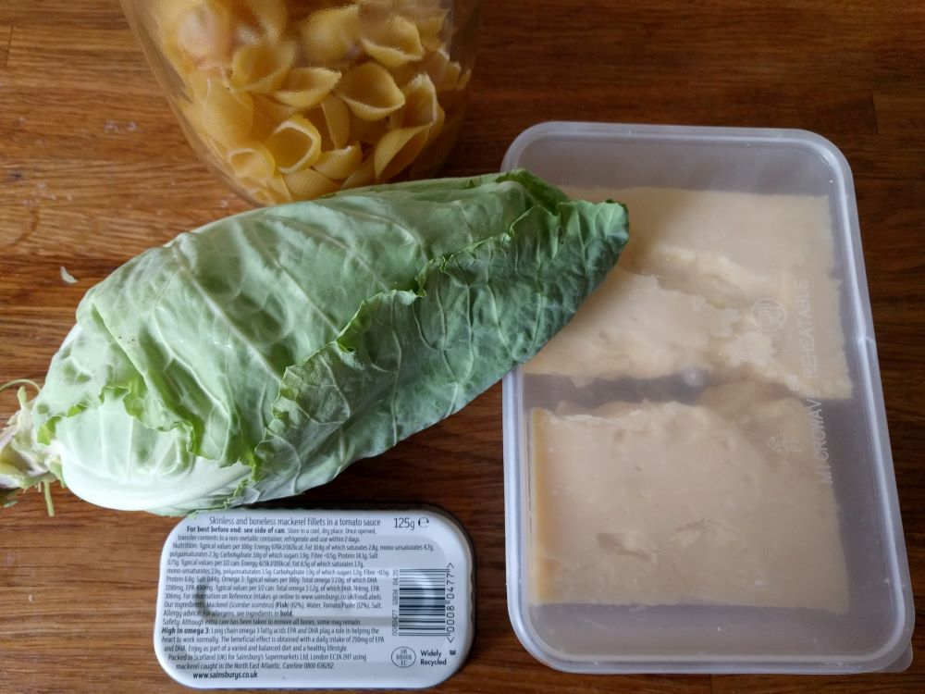
- Pasta in refill container – bought loose or in a large (3kg) plastic bag and decanted to jar for easier use.
- Packaging free veg.
- Fish in a metal tin – widely recycled, though requires warm, soapy water to clean, plus care due to the sharp edges of the tin once opened.
- Cheese – bought as a whole wheel, initially wrapped in a paper like wrap inside a cardboard box. The wrap was thrown in the rubbish bin as it was covered in residue from the cheese rind and the material used was unclear (possibly some mixed paper-plastic material). To preserve the cheese once opened, I transferred it to a used takeaway container.

Friday 6th May 2022
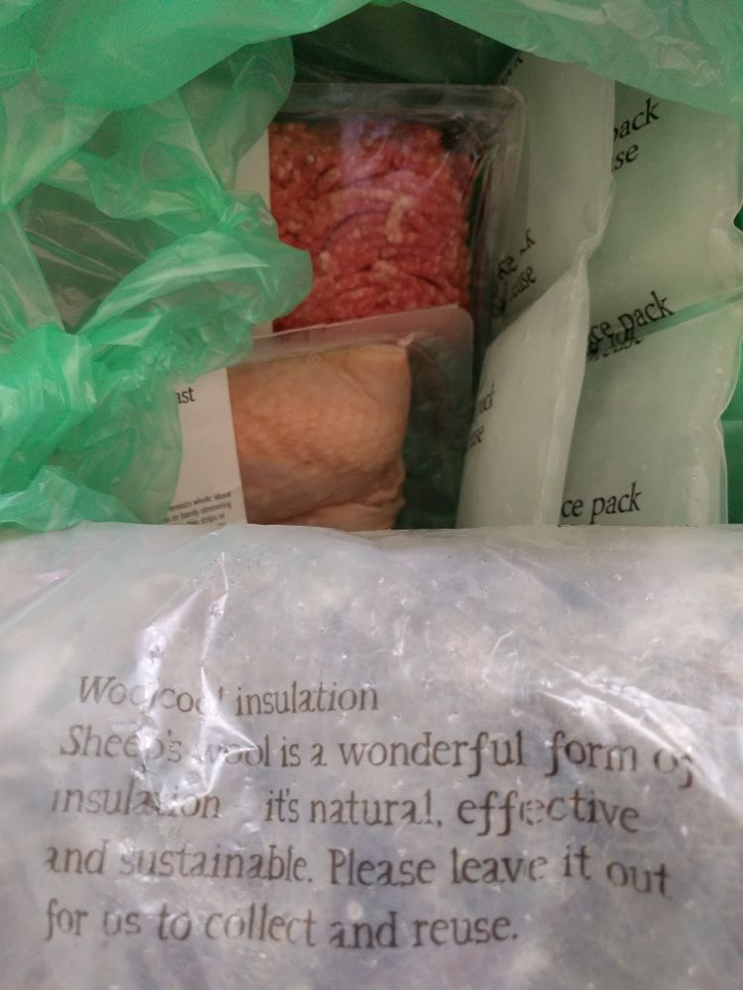
Got some meat delivered today, as well as another fruit bag (like last week).
The meat arrived in a well insulated box with reusable ice packs and wool insulation. The ice packs were still frozen upon opening the box, so I know that the contents has stayed cold. That also means it arrives at my house in better condition than it would if I bought it at a supermarket. All delivery packaging is collected for reuse on the next delivery date.
The meat is packaged in a rigid plastic tray with a plastic film lid. I tend to throw the film lid away, rather than trying to get the label off when the other side has been touching raw meat, but I will wash the plastic trays alongside any cooking utensils that I’ve used with the raw meat. The tray then gets added to the recycling once dry.

19:15 – Returning from an exercise class and feeling hungry, so stopped via Tesco for more food. Ending up getting quite a few items, some reduced, some on special and some as ingredients that would go well with other food at home.
Bought:
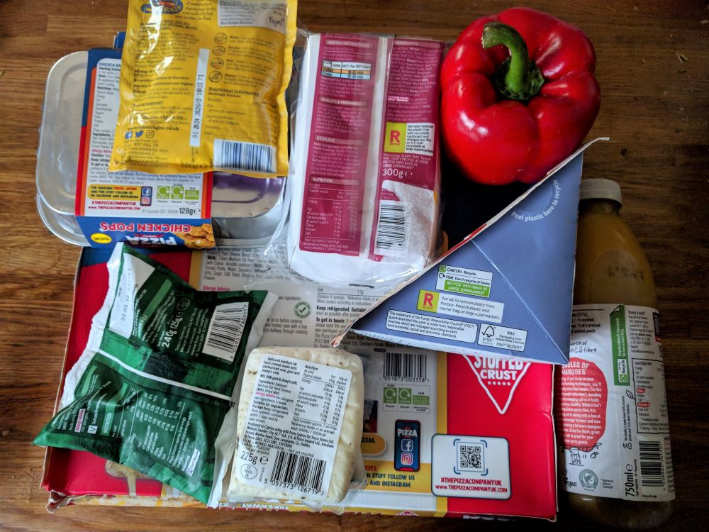
- Speciality cheeses – non recyclable, single use plastic packaging. Limited options available for cheese packaging, so I buy these items rarely.
- Stirfry sauce in an unspecified sachet – again something that I try not to buy too often as the packaging will get thrown in the rubbish bin, but sometimes it is nicer to use a sachet for flavouring rather than trying to make my own sauce. These sachets are also a convenient size when cooking for one, as the contents need to be used within a couple of days of opening, and the potion size is for two. Sometimes I will make a double sized portion of food (to use up the sachet in one go) and place the leftovers in an old takeaway container to have a couple of days later.
- Meat filled pastries – bought because they were reduced and can be frozen to use as easy oven food. Recyclable cardboard tray and film that can be recycled with bags at large supermarkets.
- Sandwich – bought as a snack. Whilst the packaging has been designed to be completely recyclable, by separating the film (to recycle with carrier bags) from the cardboard (to recycle at home), in practice the film only pulls away easily from certain parts of the carton. To completely separate the two materials is fiddly and time consuming and ultimately not worth the effort, so I remove what cardboard I can and dispose of the rest of the packaging in the rubbish bin.
- Packaging free veg (reduced).
- Breaded chicken pieces – fully recyclable packaging, as found earlier in the week, so bought again to create dinner.
- Pizza – fully recyclable packaging. Currently my favourite pizza (due to the taste and the packaging) and reduced, so bought a couple to store in the freezer. Sometimes the film used on pizza is awkward to clean, so whilst certain brands have stated for a while that the film can be recycled with carrier bags, I have often decided that it is easier to throw the film in the rubbish bin rather than trying to clean tomato sauce out of all the wrinkles.
- Smoothie – currently on special and also very tasty. One of those items that is quite pricey usually, but regularly gets reduced. I like this particular brand, partly because of the taste, but also because of their labelling. The bottle is made from 50% recycled plastic and the recycling instructions clearly state to remove the paper label and recycle the plastic bottle with the cap on.

