Diary – Week 3

Wednesday 11th May 2022
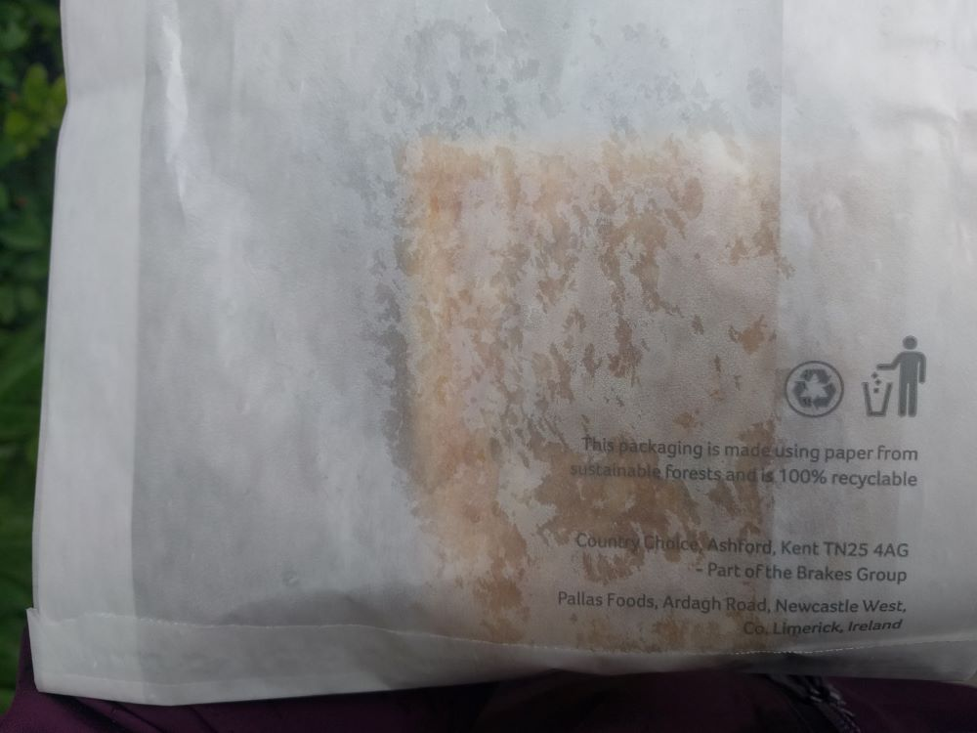
8.30 am - Not been a good start to the week food wise. Long days at work with an early start and late finish meant no time for breakfast before leaving home (grabbed some fruit for the train journey instead), and too tired to cook in the evening (so snacking on bread, nuts, and dried fruit). Understandably feeling hungry this morning though so decided to stop at a village shop that I walk past on my way to work. They have a nice selection of freshly baked savoury pastries that are kept warm in a little display oven next to the till. When you request one of these goods, they are removed from the display and put into a paper bag. If I bought breakfast there more regularly, I would try reusing the bags, rather than getting a new one each time.

Thursday 12th May 2022
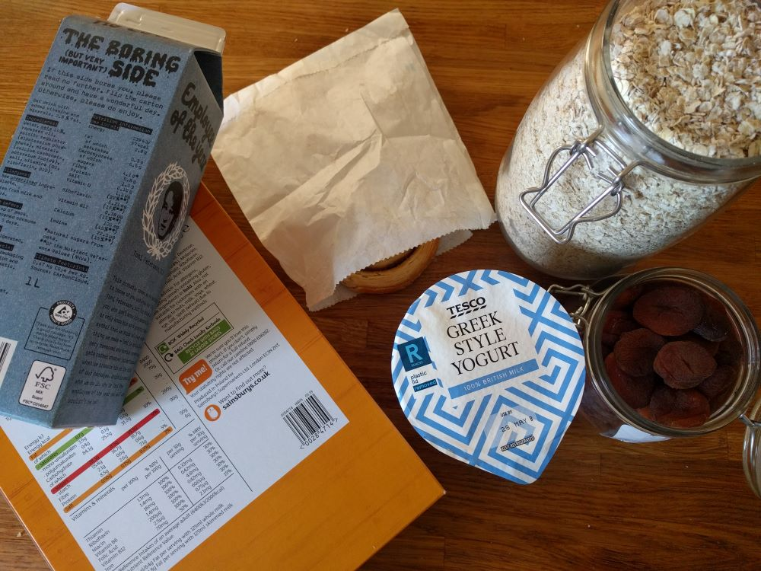
8 am – Have an extra hour before work, so plenty of time for a decent breakfast today (to make up for the lack of food earlier in the week):
- Sweet pastry bought the evening before. I enjoy eating these sorts of pastries and prefer the sort that has been freshly baked to the longer life, pre-packaged goods that lack the crispy flaky texture of the freshly baked versions. There are several stores around that have an in-store bakery; none of the closest ones though, so I do occasional make a special trip out to another store specifically to pick up freshly baked pastries. I usually have a paper bag with me to reuse, rather than taking a new one from the store.
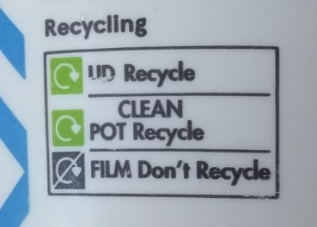
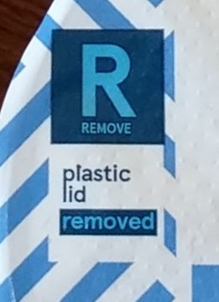
- One of my most common breakfasts next of oats, dried fruit, and yoghurt. A broken fridge at the Tesco Express store meant that only one style of yogurt was available when I popped in specifically for yoghurt earlier this week. I noticed a mismatch on the packaging though (shown right) – the film lid mentions that the plastic lid has been removed, but the notes on the side of the pot still include the lid. From a plastic use point of view, it is nice that the lid has been removed, but I like having the lid on to help reseal the pot once opened. I don’t know if the lid actually helps the yoghurt stay fresh for longer, but I found a previously used lid in the recycling bin that fits, so I have added that on. [EDIT: I noticed on a shopping trip later in the week, that the lids are being removed from more brands of yoghurt, so I will hang on to a couple of the plastic lids I already have and reuse them until they break.]
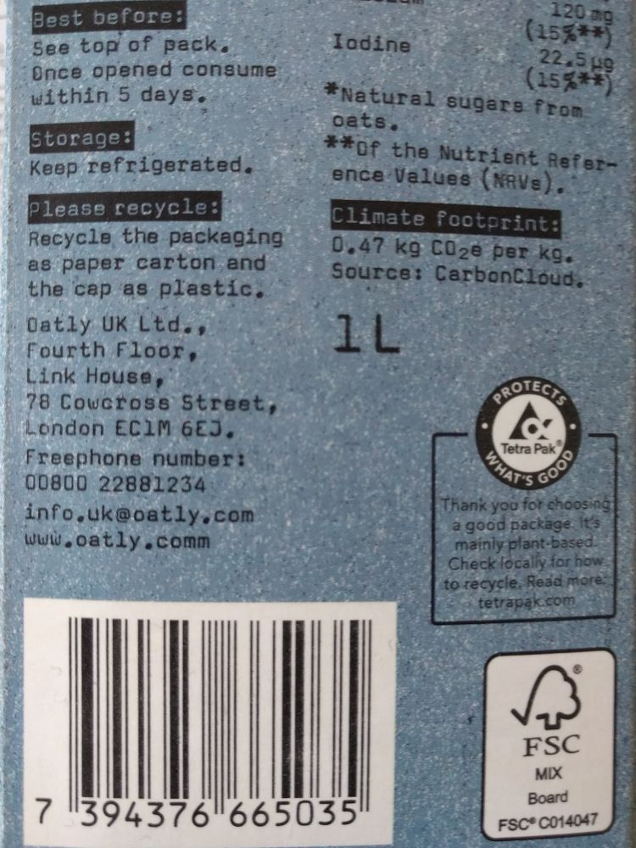
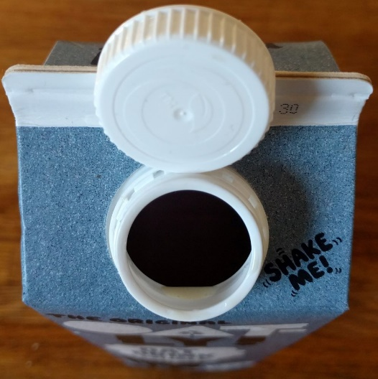
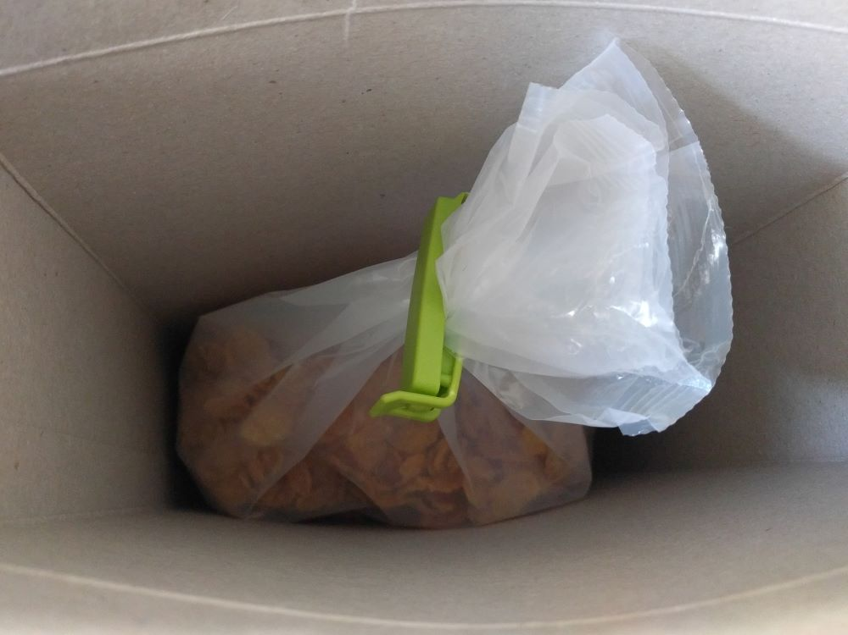
- Next, cereal with milk. Unless there is a special offer on, I tend to opt for supermarket own brand cereal, rather than the more expensive branded options. Whilst, I have seen cereal options at some refill shops, cereal does quicky loses its crunchy texture unless it is packaged properly (ie. kept sealed from the air), so I prefer to get a box of cereal and use a plastic clip to reseal the plastic bag once opened. I also prefer to buy large boxes, where possible, to reduce the amount of packaging that I buy. For milk, I normally opt for a specific oat milk (I have tried a few other milk variations, but this is one that tastes the best). The recycling instructions on the packaging say to recycle the cap as plastic, but the insert on the opening is also plastic, and not mentioned at all. Since I have never seen anything mention about removing the plastic insert from a Tetra Pak, I will reattach the plastic lid before recycling the packaging.

5.30pm – dinner for two today. In need of an easy option (feeling tired), so have raided the freezer: 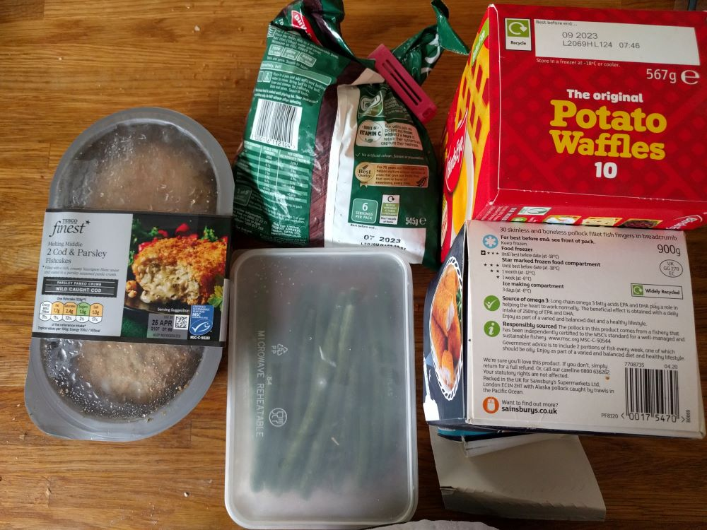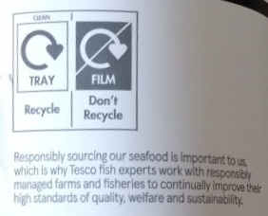
- Fish cakes bought a couple of weeks ago – turns out the recycling information is on the inside of the packaging, so can only be seen once the item has been opened for use. I try to only buy seafood that has been certified as sustainable and ideally caught using a method that doesn’t destroy other sea life. I often hear that eating fish regularly, particularly oily fish, is good for one’s health. However, I live far from the sea, so I can’t buy local, freshly caught fish, which means my fish intake is mainly through tinned portions (which store well) or processed into fishcakes.
- Green beans – frozen in a reused takeaway container to prolong their life.
- Peas – one of the few vegetables that I buy frozen in a plastic bag for ease of use. I make sure the packaging is marked as recyclable before purchase.
- Cardboard based packaging can be folded over as the contents gets used to allow room for other items in the freezer. It’s normally easy to wipe clean after use too, before recycling.

Friday 13th May 2022
Veg box delivery today, with most of the veg arriving packaging free, including a cucumber. I have several unpleasant memories of throwing away mushy cucumber in plastic packaging that I refuse to buy wrapped cucumber anymore. I’ve actually found that I rarely throw away cucumber now and I don’t think that’s necessarily because it keeps any better without plastic. I think it’s because I eat it quicker. I have found that veg stored in packaging is more easily overlooked when I check the contents of the fridge, so I don’t notice when it starts to discolour or needs eating. I am more likely to eat loose veg whilst it’s still fresh when I can see it clearly.

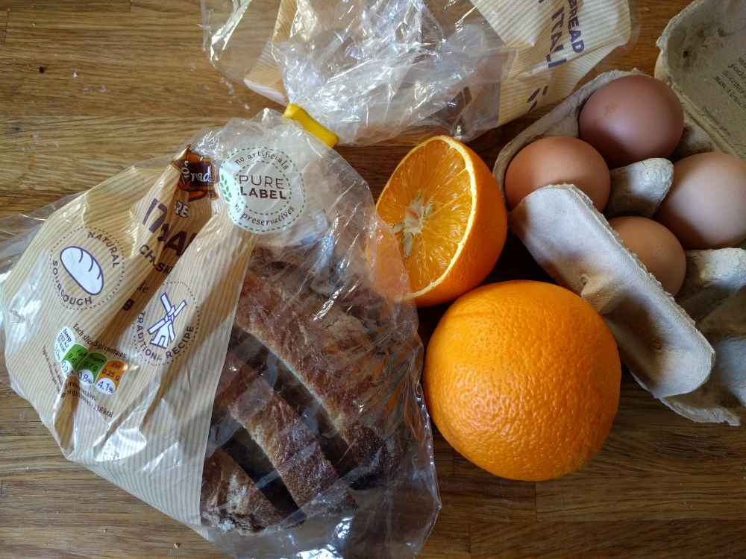
Saturday 14th May 2022
9 am - time for a more leisurely breakfast today: poached egg on toast and freshly squeezed orange juice. I drink juice regularly and prefer the taste of not-from-concentrate juice, even though I know that juice from concentrate is a better option transport wise, because of how heavy water is. I like that juice made at home is packaging free and have deliberately bought oranges loose to juice them. However, sometimes a large quantity of fruit is required to make a glass of juice (these particular oranges were some of the best I’ve had), so I am not sure whether the best option, from an environmental point of view, is to buy loose fruit for juicing (no packaging, but heavier to transport) or to buy juice packaged in a plastic bottle or paper-based carton, and which of the two packaging types is better (due to the sustainability of production, energy use during manufacture and ease of recycling). I have tried to find that information, without any luck, so until I have an answer, I will continue to do a mix of all three.
12 pm - Went out for a pub lunch with family and fancied dessert on the way home, so stopped by Tesco Express to see what was available. Opted for some vanilla ice-cream for several reasons: the packaging advertises clearly that there is 93% less plastic than their previous container, and whilst smaller quantities of ice cream have been sold in paper based packaging for a while (which is what I prefer to buy), this is the first time I’ve seen a portion in this size; the packaging also advertises that the vanilla is sustainably grown and rainforest alliance certified, meaning that the company are considering the impact of food production on local communities. The ice cream was also on offer, so seemed like a good choice price-wise too. Turned out to be a tasty option too, so am likely to buy it again, whilst the price remains low.
