Sunday 15th May 2022
5 pm - Feeling too exhausted to cook this evening so have ordered food for delivery. It’s been about a month since I last ordered food, so I will treat myself today. The food cost has noticeably gone up since last time (and has been increasing since the end of last year), so I may have cut back on the frequency.
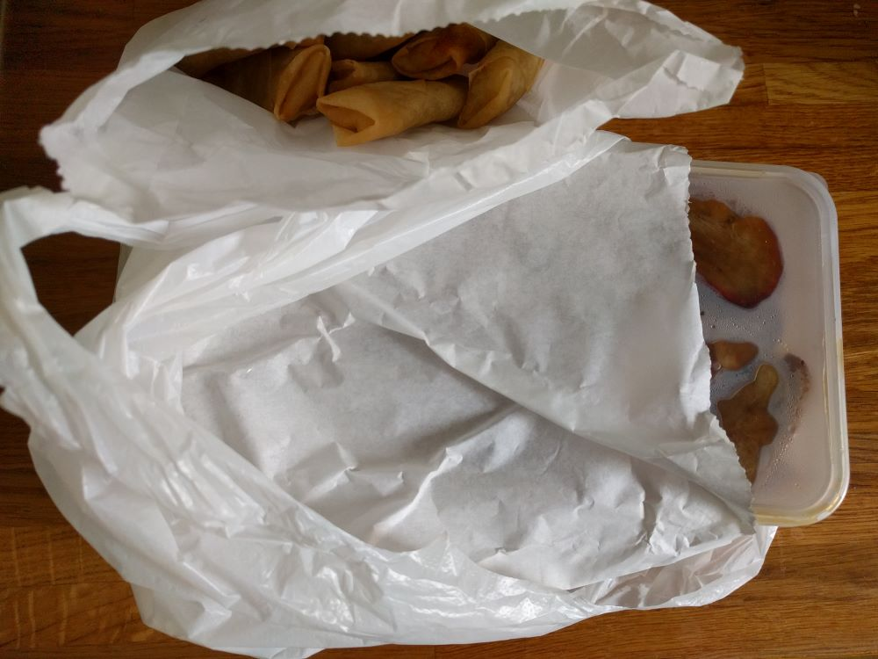
The main dish is an all-in-one dish in a single plastic tub, which has been placed in a paper bag. To make up the order to the minimum value for delivery I added some spring rolls as side, which arrive in another paper bag. The paper bags are a nice size to reuse for wrapping food (such as an apple to take to work) or for pastries (from an in-store bakery help-your-self section). The plastic bag that the food arrives in is a nice size to use as a liner for the food waste caddy, so all the packaging will get reused before it gets discarded.

Monday 16th May 2022
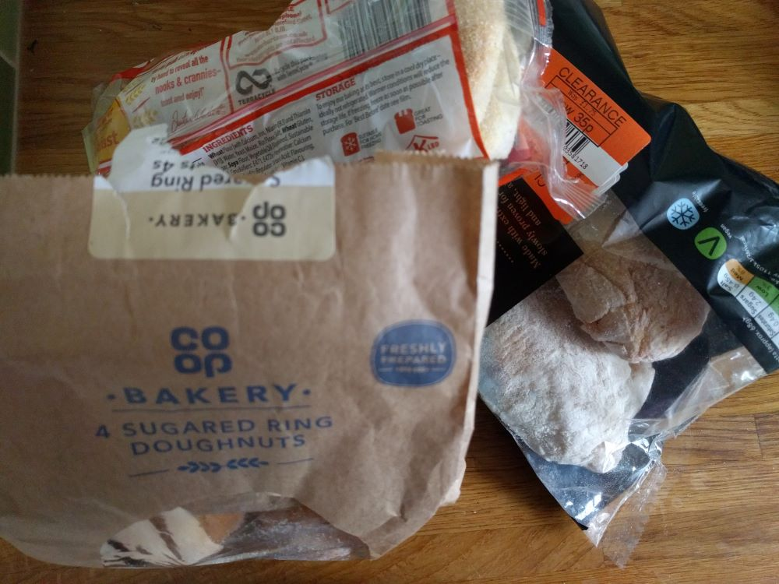
Had a lift into work this morning, so didn’t have my bicycle at the station on my return, meaning I had to walk home. Felt like a sugar boost so took a slight detour to the Co-op to see what they had available:
- Found some doughnuts in the reduced section – just the thing I was looking for (ended up eating two on the walk home). The packaging is paper with a thin plastic window and a large label holding it closed.
- Also bought some muffins and ciabatta rolls wrapped in plastic. They were both reduced to a fifth of their original price and can be frozen until I use them.

Tuesday 17th May 2022
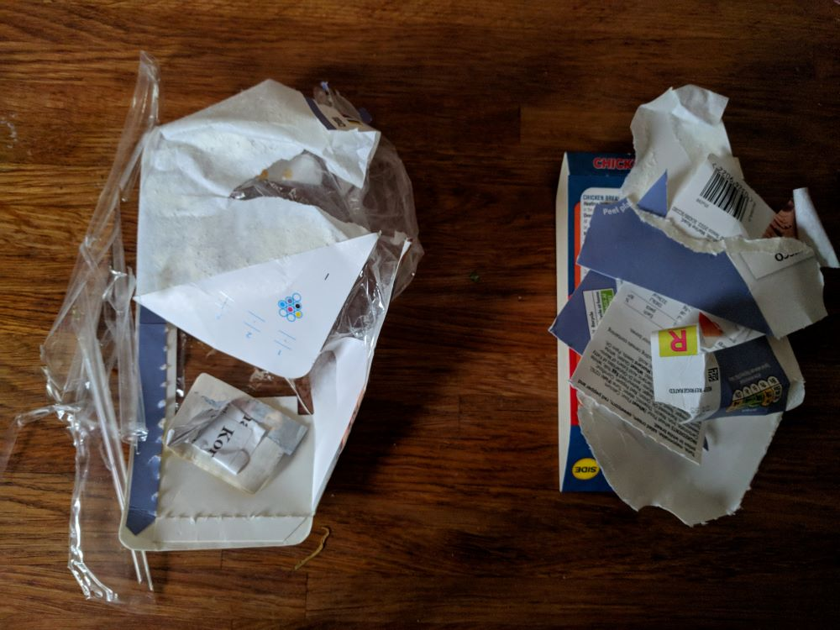
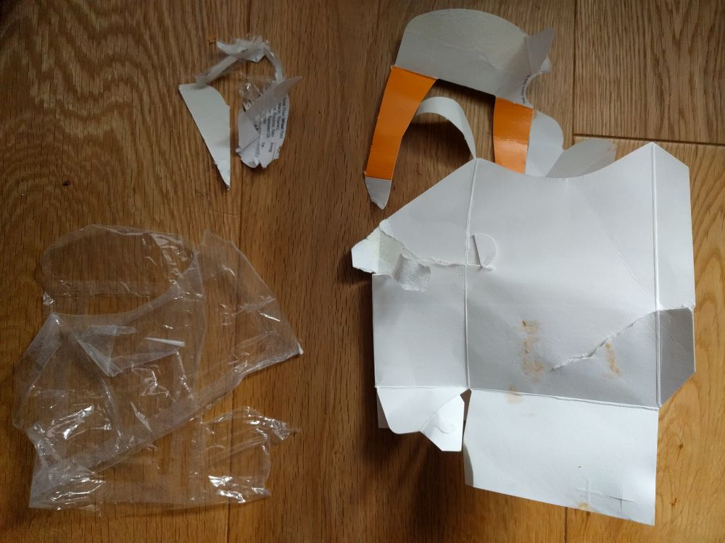
Picked up a wrap for a snack this evening from Tesco. The packaging has been designed to be separated to recycle the different materials. Whilst the materials do separate easily in places, the way that the packaging has been cut and stuck together means that it is fiddly to separate the materials completely. The packaging on the wraps does seem to separate better than the packaging on the sandwiches (that I tried a couple of weeks ago). I was able to separate most of the cardboard (for recycling at home), from the film (for recycling at a supermarket). The sandwich packaging proved harder to separate so I ended up with a larger pile of mixed materials for the rubbish bin
wrap sandwich

Wednesday 18th May 2022
I’ve had to throw out the last couple of pieces of bread from a loaf that I bought a week ago as they’ve started to go mouldy. I do try to freeze half of a loaf of bread shortly after purchase, to avoid that kind of waste, and have several old bread bags that I reuse for that purpose. I will then get a couple of slices out of the freezer at a time, either to toast or to defrost for sandwiches. When I get bread out of the freezer for defrosting, I reuse an additional bread bag. I do a similar thing with bagels, so I often have a few bags available whenever I need them.
I store the bags of the top shelf of my larder, so they are within easy reach when I want to use one. I also store paper bags and cardboard punnets in the bottom of the larder for reuse, rather than putting them straight in the recycling. The punnets are a nice depth for storing food. If I have opened a box of cereal bars, for example, I empty the contents into a punnet to save space, making it easier to select an item and keep track of how many are left. I will also reuse several of the punnets later in the year to collect strawberries and raspberries from the garden.
The second shelf in the larder has an assorted selection of glass containers that I use for storing dried goods. They are deliberately put at the most comfortable height, for ease of use. When they are empty, I move them to a different cupboard so that they are out of the way until I have restocked.
The third shelf contains mostly ingredients for baking, such as assorted flour and sugar. I like the availability of paper packaging for these ingredients, partly because it’s easy to recycle once empty, but also because the paper can be folded over, so the packets take up less space as the contents get used up (which is a good visual clue for seeing when I’m running out of something). I have a selection of collected rubber bands (that I keep in the cutlery drawer) that work well to keep the packaging closed.
Larder:
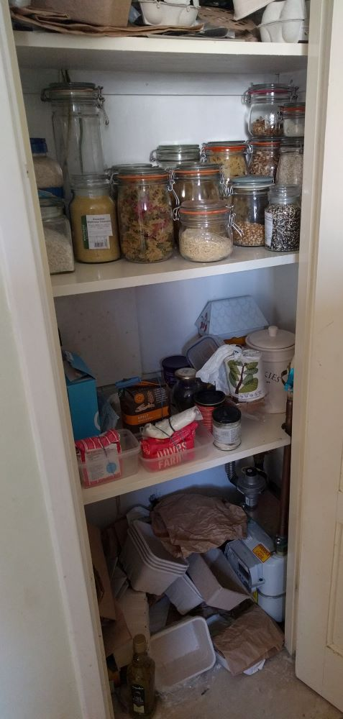

Thursday 19th May 2022
Heading into work early today and it’s been a very busy week so far with work, so I fancied another treat for breakfast. This time I visited the Spar at the station to see whether anything took my fancy. They normally have several items available for £1, so I went in with a specific budget in mind. When I saw the Hobnobs tiffin slices marked at £1, I couldn’t resist (despite being aware that they were individually wrapped). It’s been ages since I’ve had Hobnobs as I haven’t bought biscuits for a long time, but I would say that they are one of my favourites. I also really like tiffin, so I was sure that I would enjoy the taste.
Turned out to be ones of those impulse buys that I will not be repeating. Aside from the extra packaging that comes with multipack items, I hate seeing excess packaging, when air has been used to give a false sense of size. These bars ended up being tiny, eaten in two bites and barely satisfying. Plus, tiffin was one of the dessert options for lunch, and those pieces were easily twice the size of one of these wrapped portions, didn’t cost me anything and came packaging free on a plate.
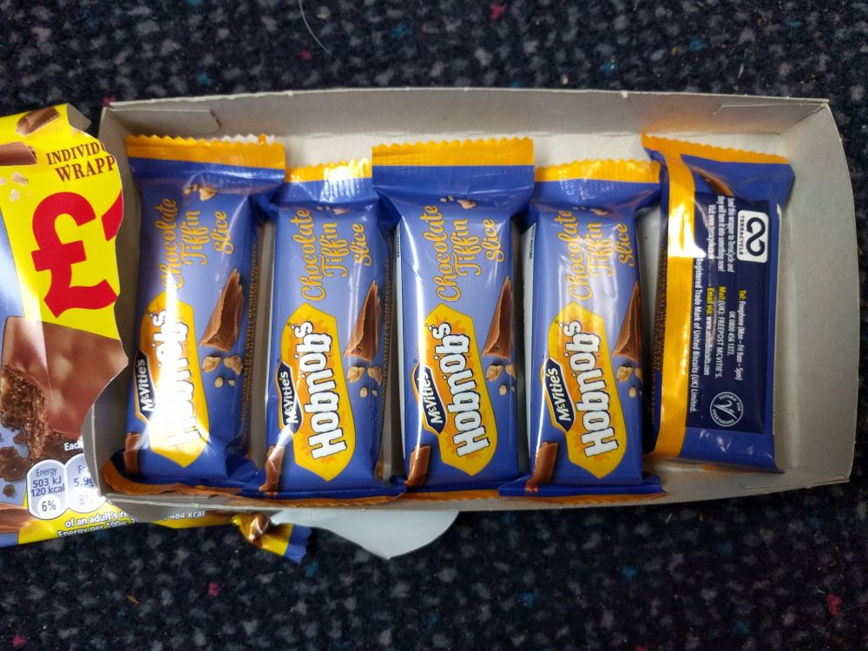

I have seen the TerraCycle logo around on packaging for a while, but when I did look into it a few years back it did not seem that easy to find out what to do with the packaging. I will probably put the wrappers with the supermarket recycling instead (biscuit wrappers are included on the list).

Friday 20th May 2022
Bin day – mixed recycling this week (collected every two weeks). The recycling bin is a full-size wheelie bin that is wider than the bin for the non-recyclables. The non-recyclable bins are deliberately smaller because (according to the bin lorries) up to 80% of household waste is recyclable. I haven’t put either bin out for several weeks (I prefer to put them out when full) and the recycling bin still has plenty of space in it, so I won’t be putting that out next to the curb today. Even if I don’t manage to reduce the amount of packaging I bring into the house as much as I like, the fact that I have to put the bins out so infrequently is a nice reminder that I am doing quite well.

