Date:

13th Oct 2021:
- Had a discussion with one of my flatmates today, who is originally from [x]. She mentioned that, where she is from, they have an additional recycling bin to what they do up here in [x], this bin is for food waste only and is collected by a separate collecting service to the other recycling. I mentioned this is unheard of from my point of view and we concluded it’s probably a practise more prevalent down south.
- Carried out a little food shop at Sainsburys to get some of the essentials I tend to go through quickly and buy more often. My friend also picked me up some Bao buns from M&S, these are limited addition and are always sold out when I go to M&S, so I ask her to get two packs! (Pictures below). I had one of these for tea with some pilau rice and veg. I realised the packaging of pilau rice is made of plastic, I just never tend to recycle these as they can be quite messy on the inside and so I put them straight in the general bin bag I have in my room.
- I ventured into the kitchen for once and saw that the main red bin that we were given for basically all our rubbish was full of mixed waste (i.e., food waste, plastic etc), even though the girls have made dedicated bags for the recycling at the other side of the kitchen.
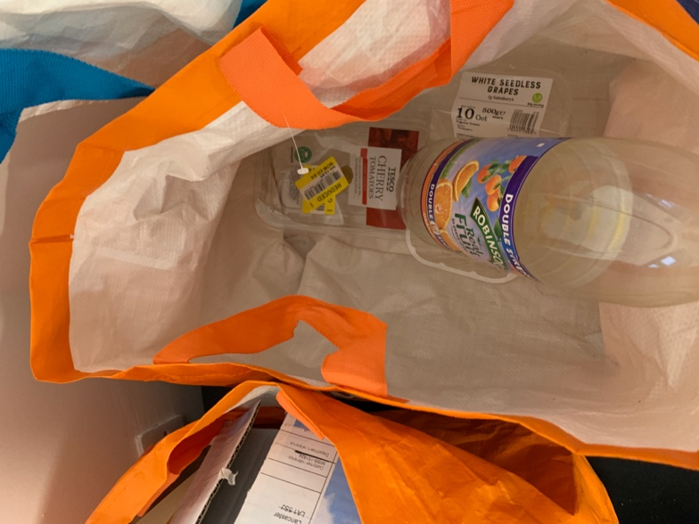
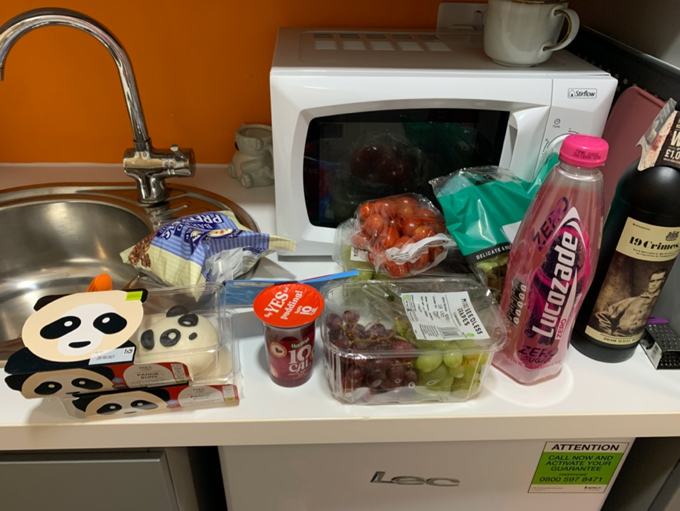
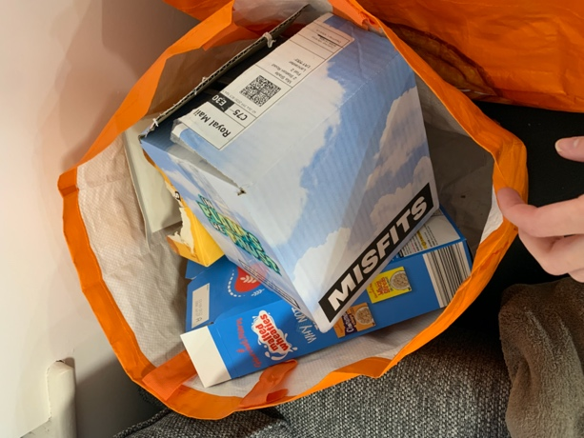
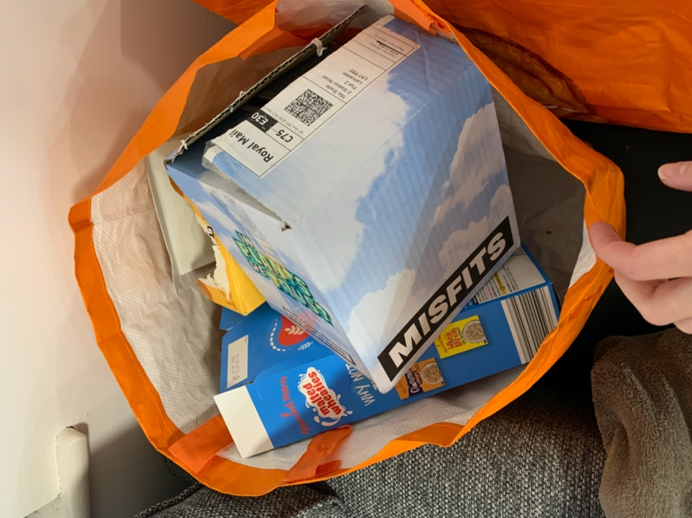

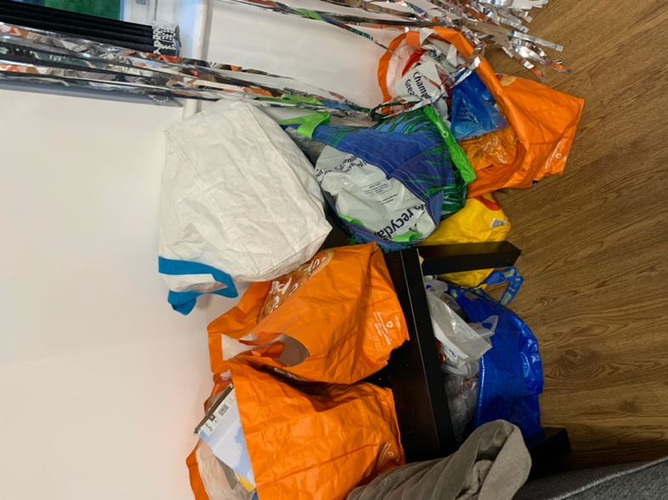

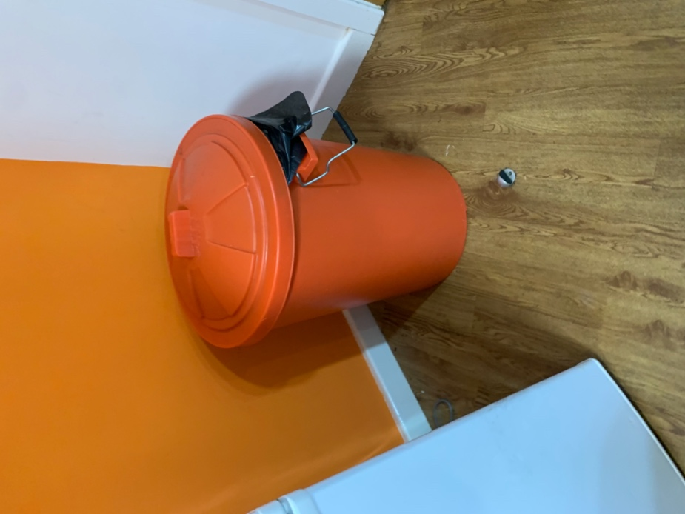
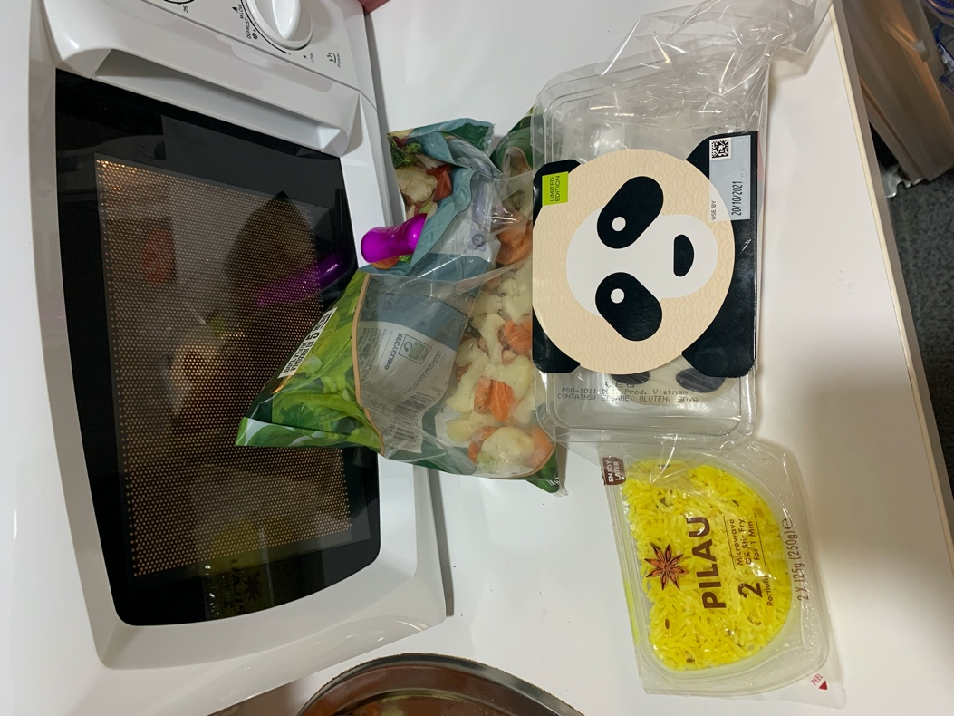
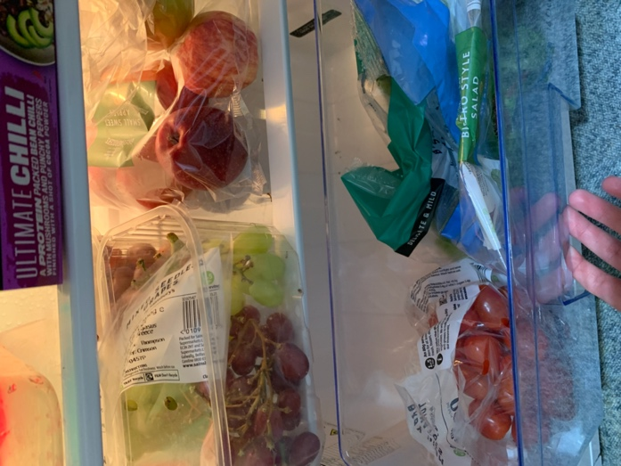
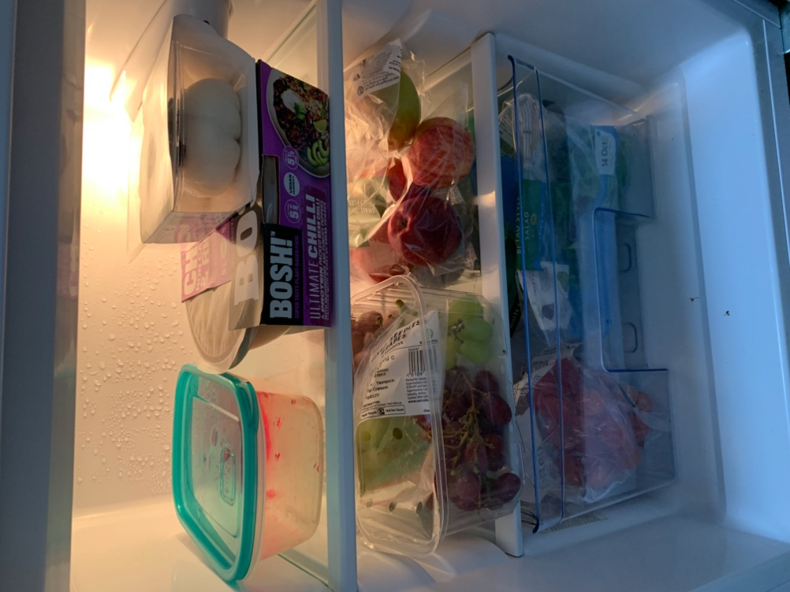
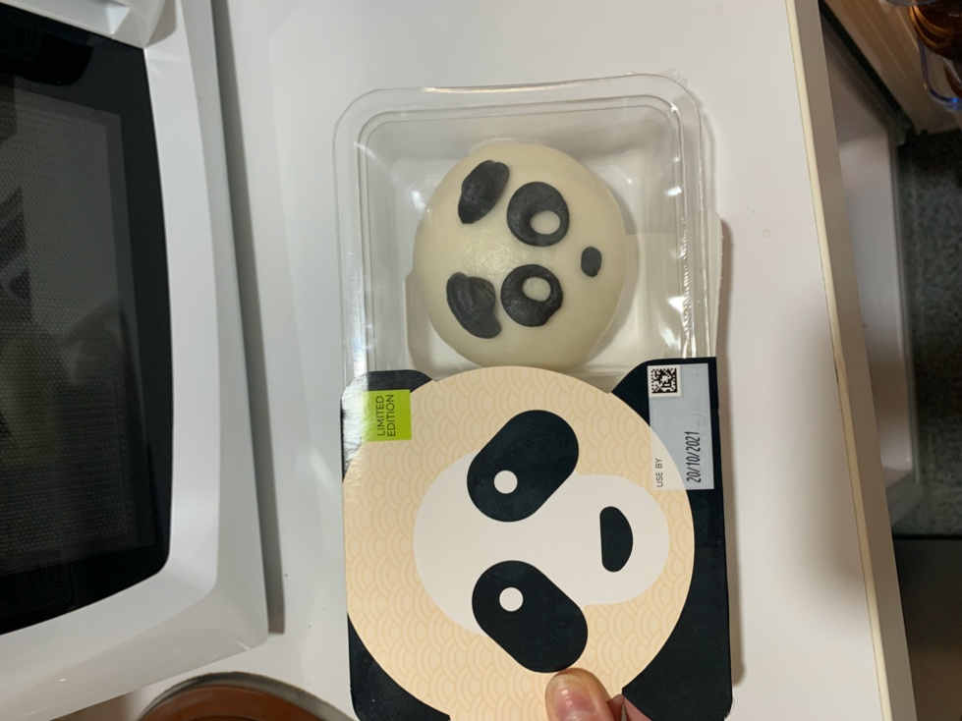

14th Oct 2021:
- Spent most of the day in the library
- There are dedicated little tables all around the library for cleaning, these include: Sanitiser spray, blue roll, and a bin with a black binbag inside.
- I noticed that a guy sat close to one of these stations just put all his lunch rubbish and plastic water bottle in one of these bins, probably purely because it was close.
- Yet a guy sat next to me, when leaving the library, walked what I would approx. say was 40 steps to go to a dedicated plastic bottles/cans bin just to bin one bottle he had.
- In preparation for the first sessions of med school running club tonight, I bought a microwave meal from Morrison’s earlier this week. Just because its quick and there is very little washing up to do after, I can just bin the container and get straight off to running once I’m finished. It’s also a new range of meals, as I am a vegetarian (who doesn’t eat cheese to make matters more difficult), there’s rarely a microwave meal that suits me, so I thought I’d give one a go. (Picture below).
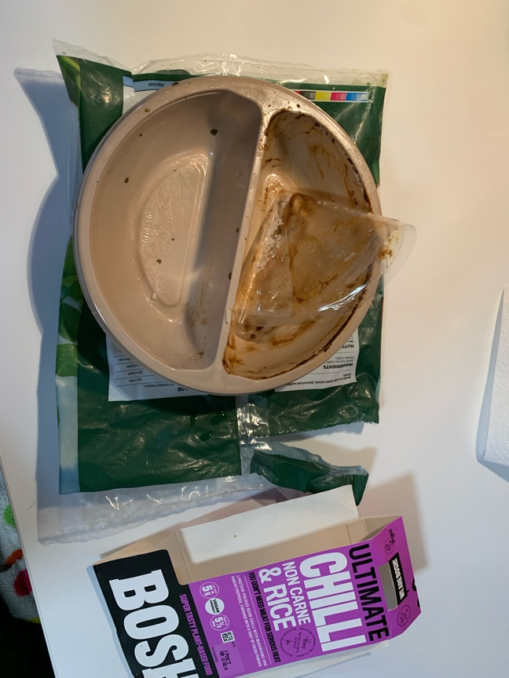
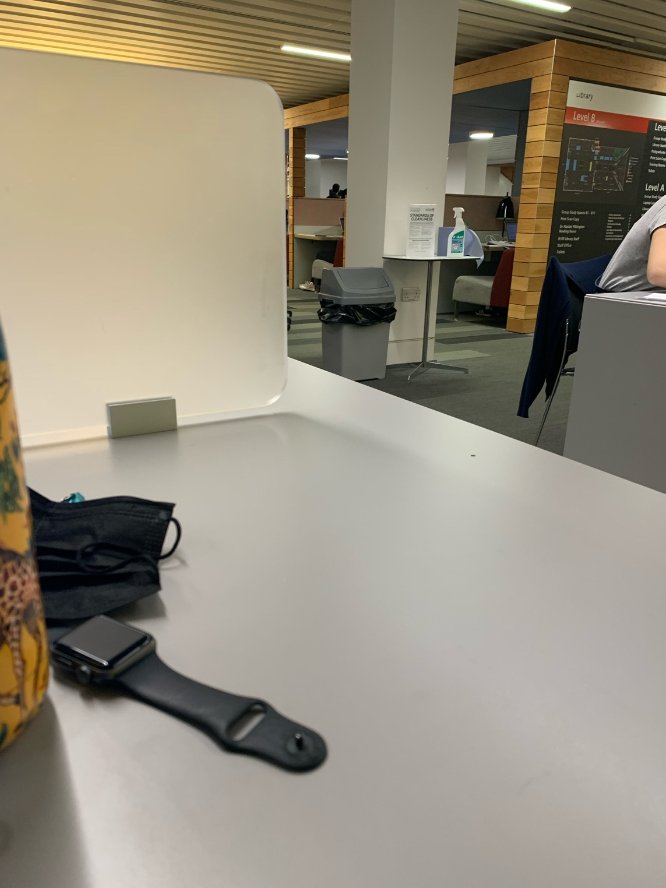
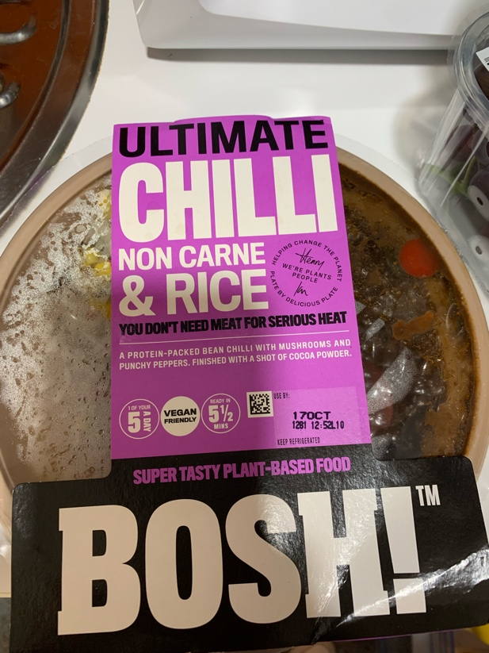
15th Oct 2021:
- Had [xxx] today so was busy at uni
- Bought a salad from [place] with ‘vegan duck’ (nicer than it sounds), this came in a cardboard takeout box and with wooden knifes and forks. Although this was cardboard because it was messy from the contents, I just binned this in general waste.
- I went home (to my aunties) after Uni and arrived probably around 6pm for tea. I had an open pack of the panda bao buns, as I only had one bun on Wednesday, so bought that with me for tea, to save throwing it away.
- The others in the household were having a sourdough pizza and some beans. I noticed that my mum poured the beans into the pan and rinsed out the now empty can before throwing it in the bin dedicated for plastic/cans/bottles. My auntie walked in at this point and quickly jumped at my mum saying, ‘oh no, did you wash that can out?’ which was a surprise.
- I also went to get some veg to have with my tea, so rummaged through the fridge and found 2 cauliflowers. I asked my auntie ‘which needs eating first?’ And she was actually unaware there were two cauliflowers in the fridge, as she can only recall the one she bought today. It ended up that one of the cauliflowers was over two weeks out of date and quite soft, so we ended up throwing the whole thing away, in the general waste.
- Aunties bin setup is shown below, one silver bin for general waste, one for bottles/cans and the bag for cardboard.
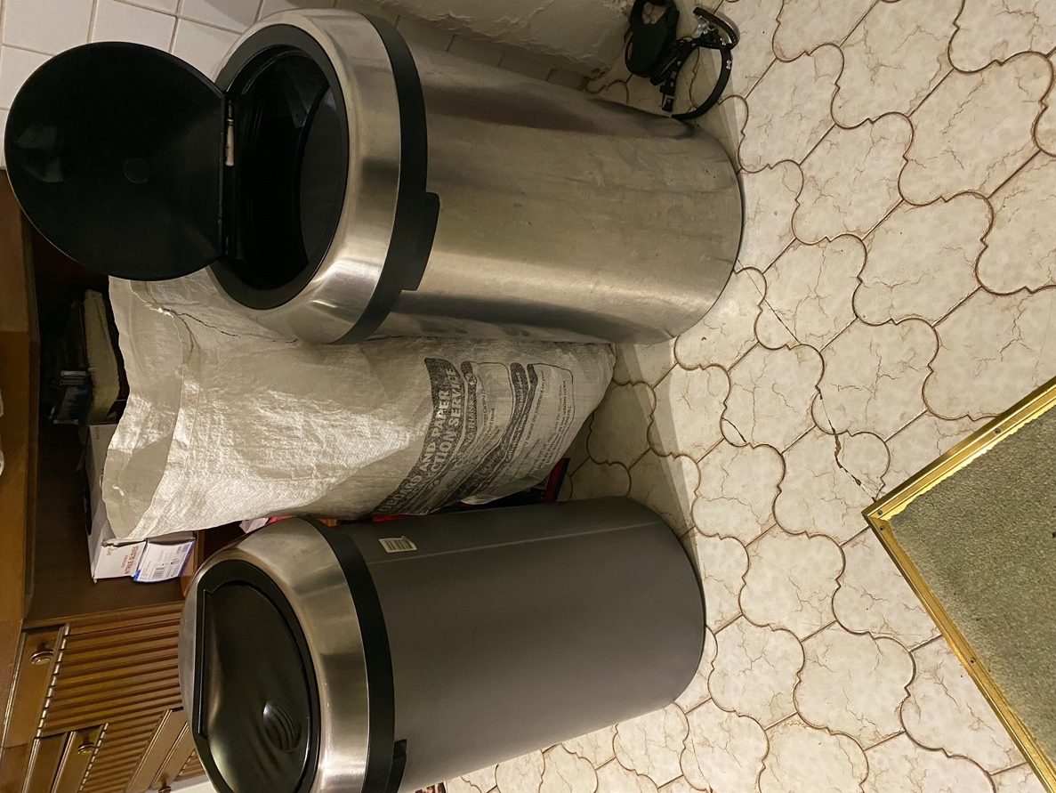

16th Oct
- Had porridge for breakfast this morning, I weight out my oats and measure the relevant amount of almond milk as indicated on the box into a plastic container. This container is an old ice cream tub, I find it useful due to its size as my porridge wont overflow (pic). We, as a family, often keep plastic tubs used to contain food we buy (including takeaway tubs). We use them for all sorts: storing leftover food in the fridge, taking prepared lunches in to work/uni and microwaving things.
- Had a lentil Dhal for tea with some veg and salad. The salad was going off slightly and was a little but soggy, so I decided to throw the rest away (pictured)
- Bought some snack, tend to have a packet of one of these or something similar each night (pictured)

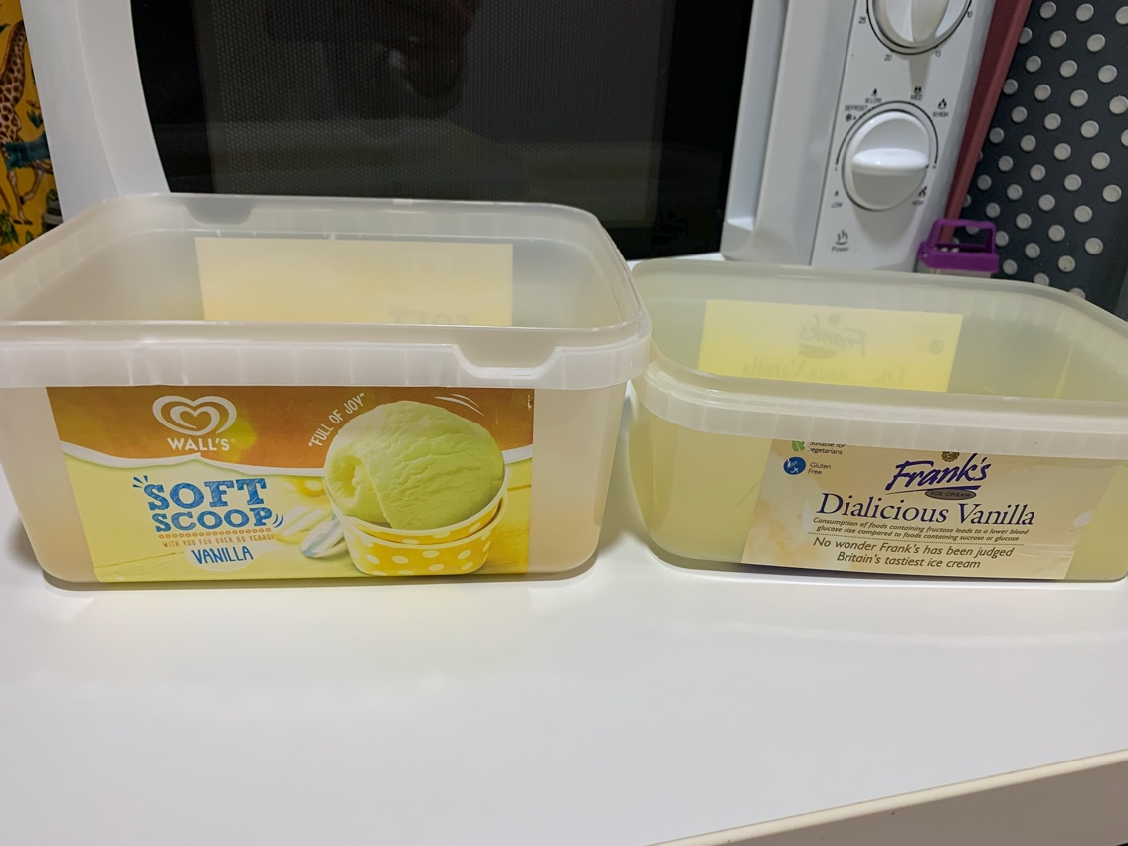
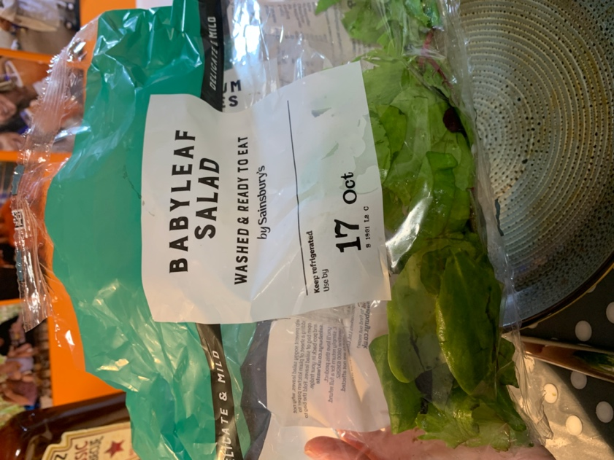
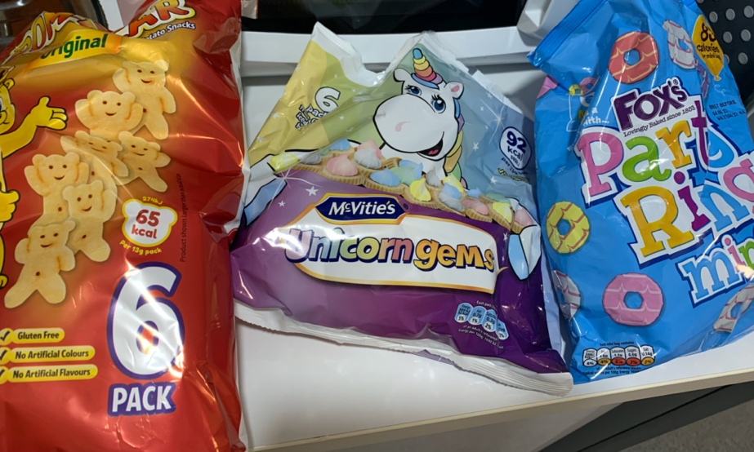

17th Oct:
- Nothing much new.

18th Oct:
- Start of my ‘clinical consolidation week’ so my timetable is a bit different to normal. Started the day off with some introductory lectures on various things we have coming up, then had a [xxx] session in the afternoon. I have included some pics of the models we used, just for interest, to show what they’re made of etc but this is only a glimpse, there are 100’s of models!
- One interesting thing did happen today on reflection. I was taking my rubbish out in the morning; one bag of general waste and one bag full of bottles/cans. The bin man ran over to me and said he’d take it out of my hands for me and sort it. I mentioned it was for different bins and he just said, ‘ah it’ll be fine’ and just took it to his truck and dumped them both together. Which was strange I thought, a little annoying too seeing as id gone to the effort to separate them as I usually do.

19th Oct:
- Had a [xxx] training session this morning at [xxx] in Morecombe. We performed [xxx]. Between each examination, each of us (16 in my room) changed our PPE (Mask, gloves and apron – all made of plastic), changing a total of 5 times each. Binning it into clinical waste bags (tiger bags). [xxx]

- Submitted 6pm.

