28th Oct:
- Was just on [xxx] today and so nothing much new. I did manage to get a picture of a clinical waste bin though.
  - I had just put my PPE in the bin so that’s what is visible on the top. Although underneath I can see someone has just put paper towels in which is wrong.
  - In defence though, the bin for paper towels was almost hidden under the hand-washing sink so its understandable for someone to just not see it.

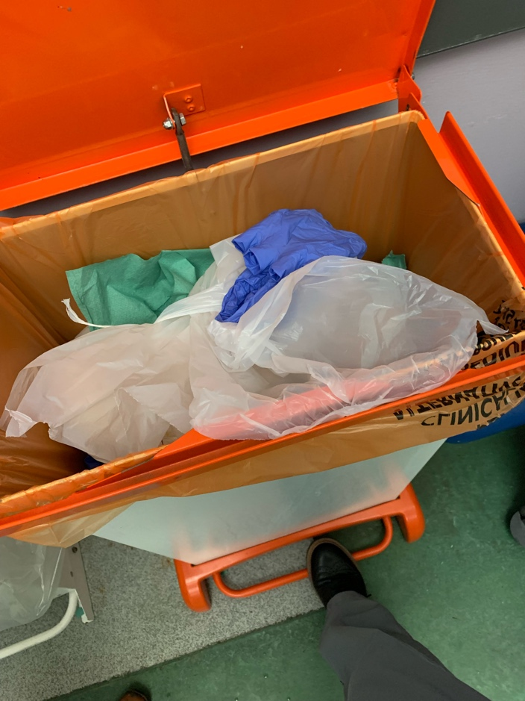

29th/30th:
- Truthfully, after hearing some bad news, I was just not in the mindset to consider what I was throwing away or what I was eating. Definitely just the case of putting everything in the bin regardless of what it was really.
- Noticed how my recycling habits and thoughts towards what food I was buying and why, just completely went out the window.

31st:
- My friend took me to the Trafford centre today and we got some dinner at wagamama’s. I noticed they were packaged order for takeaway and delivery services too.
- I was actually surprised at how little effort had gone into making the takeaway packing plastic free. Everything; bowels, lids, little sauce pots, cutlery etc was made entirely from plastic.
- It was more of a shock because the restaurant has just made their menu over 50% plant-based and I’ve always thought of them to more of a ‘conscious’ brands. I guess they’re not entirely related topics, veganism and recycling, but its all for the ‘greater good’ and for some reason I just see the two going hand-in-hand.
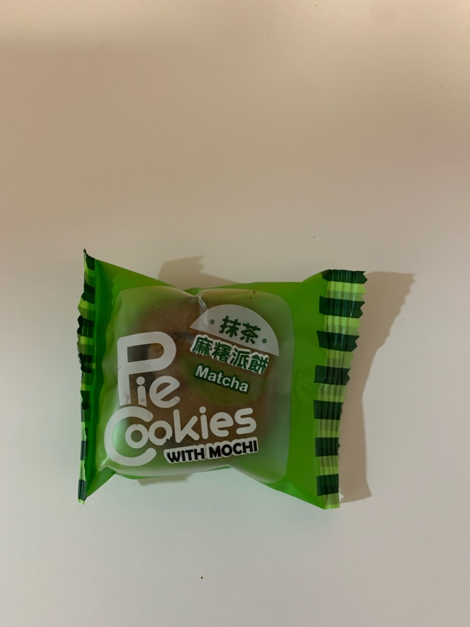
- My friend and I are really into Japanese food and culture, so were really excited to notice a new Japanese store in the Trafford. My friend loves mochi and green tea flavoured things, he noticed some cookies which he originally just pointed out to me but after noticing the cookies were all individually wrapped – he decided to buy them. He said ‘if they weren’t I’d end up just throwing most of them away’. The whole bag was pretty big so I understand where he was coming from, it’d be a lot for him to get through on his own. I do like and favour the idea of having little snacks like this individually wrapped, purely for freshness I guess but at the same time I am definitely aware and conscious of the amount of wrapping paper that comes with it.

1st November:
- After having wagamama’s yesterday I was craving something similar again and so decided to treat myself to go and pick something up from M&S. I decided on prawn dim sum which I know I really enjoy (pictured).
- As I had it alongside some pilau rice, I thought 6 of the dim sum pieces was a bit much, so I ended up just having 4 and throwing two away (into the main bin in the shared kitchen because I didn’t want to make my room smell).
- I kept my packet from the pilau rice and actually used this as a little soy sauce pot for whilst I was eating.
- I did consider buying these new sweet and sour bao buns which my friend sent me a picture of via instagram (knowing I love bao buns) but I decided against it as there is 4 in a pack. I knew I’d either ended up eating them for 4 days in a row or probably throwing 2 out, which would be a waste. Ironic considering I threw out 2 dim sum – I doesn’t feel like as big of a waste because they’re smaller than the bao buns – stupid logic I know!

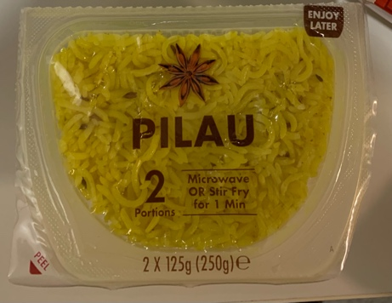
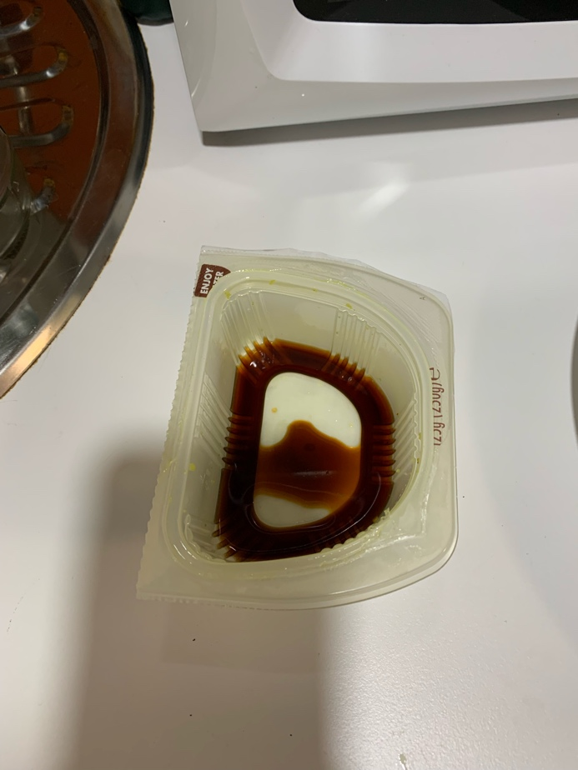
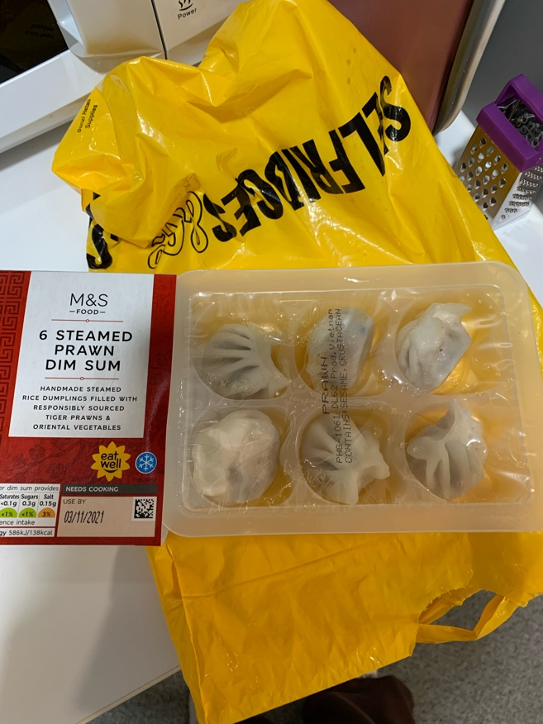

2nd November:
- I had a meeting with my group today for a project/presentation we have to give next week on [xxx]. Nothing much to tell other than a member of my group had just bought a meal deal; sandwich, crisps and canned drink. When we were walking out, she went to put her rubbish in the general waste, noticed there wasn’t a bin bag inside and then without hesitation just went and put it in the ‘cardboard and paper’ bin. It made me cringe and I found it bizarre how she just did that without a second thought.
- During the evening I was having a snack on some pretzels and, as the bag was coming towards end, I opened another. The empty bag was on the side and I just happened to notice it said ‘terrarecycling’ on the back. Which took me back a bit because I’ve eaten these particular pretzels for years and never even noticed it.
- I researched into terrarecycling later that night and was actually really intrigued by the idea. The thought of getting points and a reward scheme for recycling is very tempting but I just kind of disregarded the idea, knowing I’m already busy. As well, the actually process involved was a bit confusing to find, the website had many different sections and ‘programmes’ so I gave up quite quickly to be honest.

3rd November:
- Just another day in the library. I did go for a drive and then to the shop with my friend, as she needed a few things. I did find that I was so tempted just to buy things JUST because I was there, even though I know I have literally 2 of everything (if not more) back at my flat. Ive become a lot more conscious of this, more so on the fact I’m spending money when I don’t need to be. So I’m putting more of an effort into breaking the routine of going to the shop most days to get little things and working my through what I already have first.

SUBMITTED 4pm.

