PPiPL Diary

w/c 8th November 2021

This first week hasn’t been a typical week, as I’ve eaten out several times during the week and therefore haven’t prepared as much food as normal.
Breakfasts
Mostly eaten at home. Cereal with milk, coffee with milk.
Lunch
Monday – prepared at home. Sandwich, yoghurt (in a recyclable pot)
Tuesday – bought on campus. Subway tuna mayo sandwich.
Wed – prepared at home. Tikka paneer with salad on naan bread (naan bread and paneer were in plastic packaging)
Thursday – prepared at home. Sandwich, yoghurt (in a recyclable pot)
Friday – prepared at home and eaten on campus. Sandwich, yoghurt (in a recyclable pot)
Saturday – pasty from Filberts in Lancaster. No plastic
Sunday – homemade mackerel pate with a bagel. Mackerel was in vacuum-packed plastic packaging
Dinner
Monday – pasta with homemade vegetable sauce and goats cheese
Tuesday – Tikka paneer with salad on naan bread (naan bread and paneer were in plastic packaging)
Wednesday – homemade risotto. Mushrooms had plastic film over them, Chinese rice wine and seasonings were in plastic sachets (Gousto)
Thursday – ate dinner at a local restaurant
Friday – homemade pizza (tomatoes were in plastic packaging, as were the pizza base and goats cheese)
Saturday – ate dinner at a restaurant in Manchester
Sunday – cheese, coleslaw, bread, salad. All the ingredients had plastic packaging
Cat Food
Two cats, eating four sachets of Felix ‘as good as it looks’ per day.

Snacks
- Crisps (in plastic packaging)
- Chocolate (in plastic packaging)
- Grapes (in a plastic tray, with plastic film around it)
Drinks
1 large bottle of sparkling water, which goes into my fortnightly recycling bin. I have my milk delivered by a milkman, who uses traditional glass milk bottles. I take a metal water bottle and travel mug with me when I work on campus.
General
I have a Gousto subscription and most weeks I have a delivery arrive from them on a Sunday. Each box contains ingredients for 8 meals. Gousto appear to be a company that is mindful of sustainability and the need to reduce packaging, but many of the ingredients are in plastic bags, sachets or pots – salad and fresh herbs, dried herbs/spices, vinegars etc.
Photos
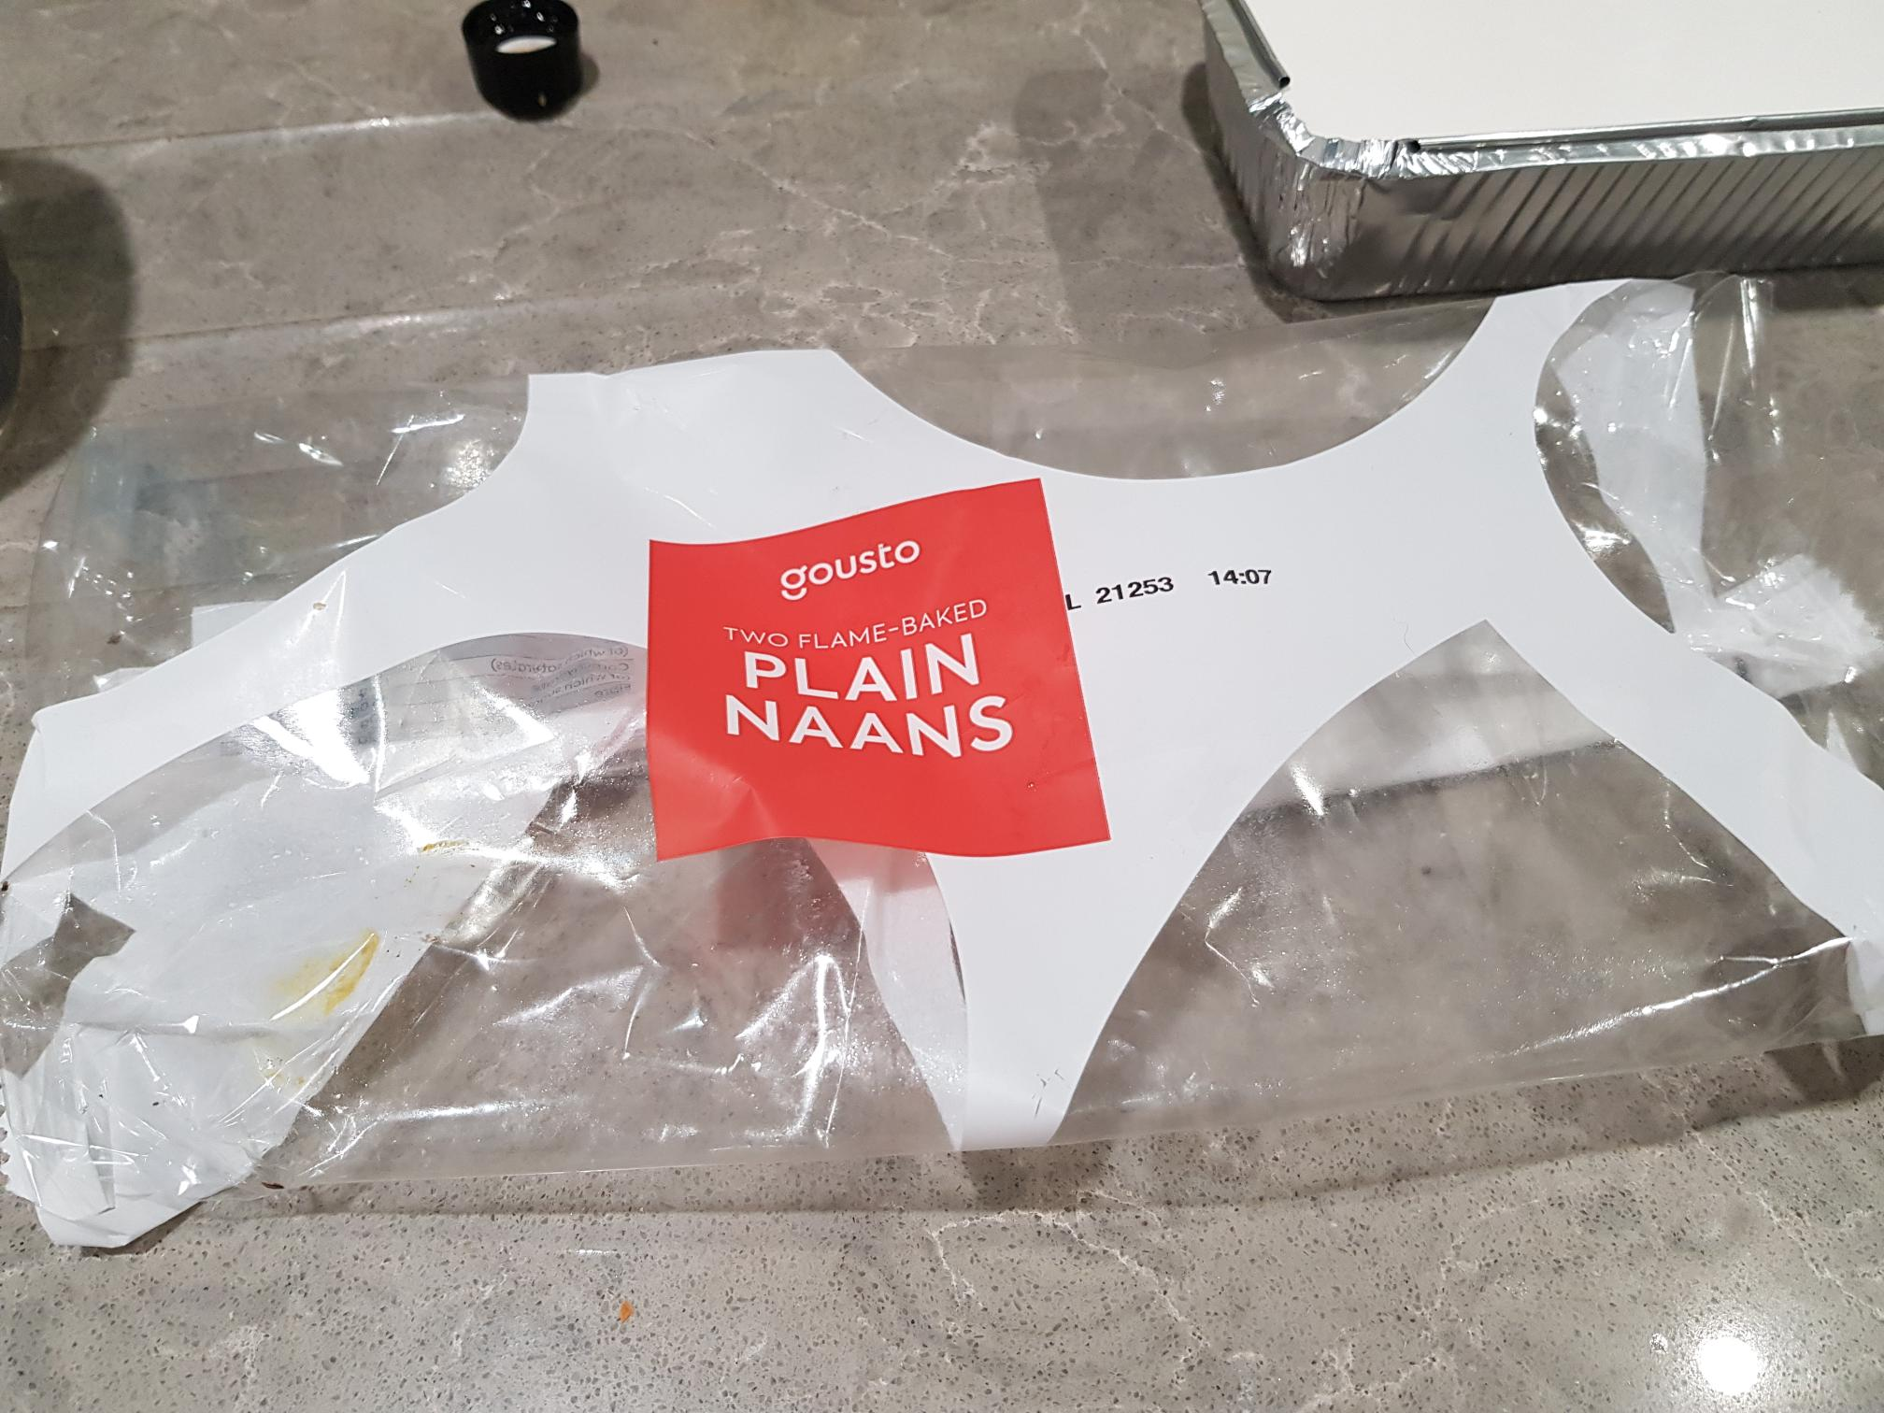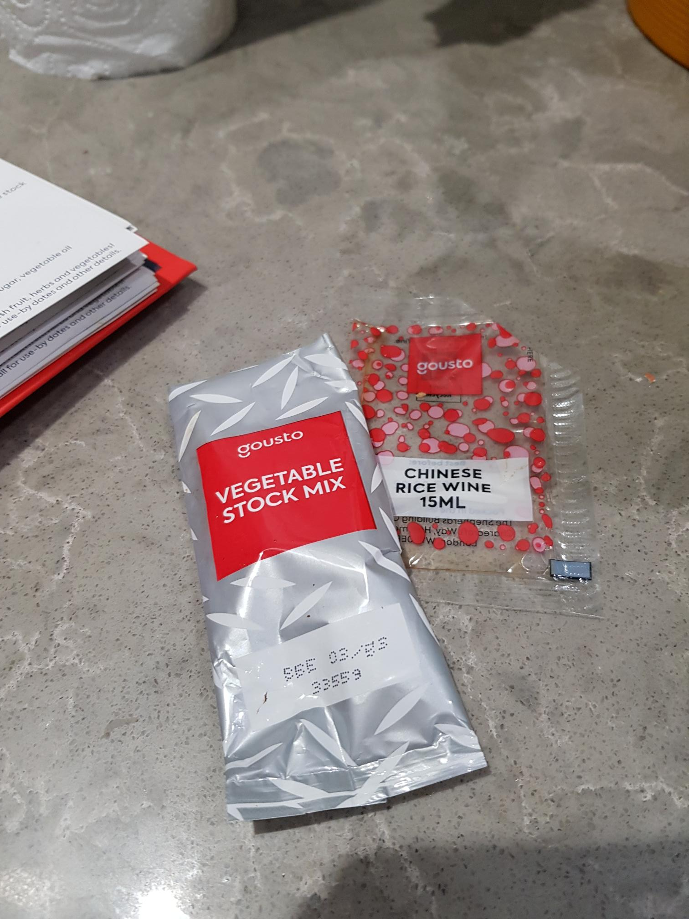
Plastic packaging from Gousto delivery, 7th November. Although much of the vegetables in each Gousto box are loose, there are a lot of small plastic pots and packets that contain spices/herbs/vinegars etc.

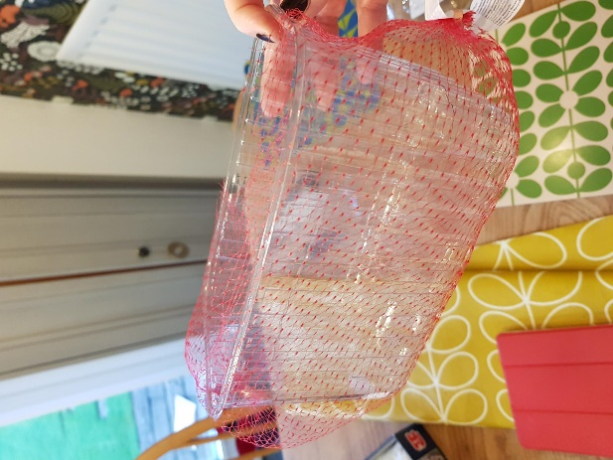
Plastic box and netting from plums ordered from Sainsbury’s. Box can go into my plastic and glass recycling bin but not the netting.

