ppIpl diary

w/c 15th November 2021

monday 15th November
[xxx], so not a typical day in terms of routine or food. Breakfast was a bagel with cream cheese, plus coffee (bagel was in plastic packaging, as was the cream cheese).
Lunch today was eaten in a pub in Lancaster (sea bass) and then dinner was light snack food (cheese, coleslaw, crackers, salad) and a slice of chocolate birthday cake. The cheese, coleslaw and crackers were all in plastic. The[x] had plastic wrapping on it and then inside a box.

tuesday 16th November
Bit more rushed today as I was [x] for an early meeting, so had to take my breakfast into work with me (I don’t tend to fancy food before 7.30am) and ate at my hot desk. Breakfast was cereal and milk, taken to work in a Tupperware box and small flask.
Lunch was with friends as another part of [x] and we stayed [x] for burger (spicy beanburger for me) and chips.
As that was a larger lunch than I normally have, I didn’t want much for dinner and just had a bagel with cream cheese [x].

Wednesday 17th november
A very rushed morning today as I was out of the house before 7.30am to go for a 3-mile walk – squeezing down some Weetabix and warm milk, as although I don’t tend to eat that early, I need to eat before I go walking. Then straight back home and into a 2-hour meeting, followed by a 1-hour meeting. Sainsbury’s arrived during the second meeting, with a delivery of food and household products (cat food, sparkling water, fresh veg, some wine, prawn cocktail, pizza base, biscuits). Lunch was a soft white roll (in plastic) with prawn mayonnaise and cucumber [x].
I’d placed the food order quickly and realised once it had arrived that it contained very little actual food, so struggled to think of something for dinner. In the end I decided on some pasta, with mushrooms, tomatoes and Rose Harissa pesto. (pesto was in a glass jar, mushrooms and tomatoes were in a film-covered cardboard box, pasta was in a plastic bag.
It didn’t particularly fill me and I had two slices of toast with butter and jam as a snack.

Thursday 18th november
Working at home today and no early meetings, so I made porridge for breakfast (porridge oats in a large plastic bag and milk, cooked in the microwave).
A cold, grey and damp day and I would have liked something warm to eat at lunch, but as the prawn cocktail needed finishing, I had the remainder of the tub of that, with cream cheese on two slices of white toast, plus a yoghurt and bag of mini cheddars. The yoghurt pot was washed afterwards and put into the main plastic/tin/glass recycling bin, the mini cheddars were in a small plastic bag, the prawn cocktail pot was washed and put into the recycling, but the plastic film on top was thrown away.
Dinner was a pizza made using a bought pizza base, with goats cheese, fresh tomato, mushrooms, rose harissa pesto. Served with a bit of mayonnaise on the side. Bit of a weekly treat, the pizzas. I’m a bit predictable with the toppings but I really like it.

friday 19th November
On [x] today, which meant taking cereal and milk with me, as I didn’t have or feel like eating before leaving the house. I got takeaway from [x] for lunch today – a very large box of loaded Mexican fries (fries with refried beans, guacamole, pica de gallo, sour cream, cheese sauce). It was so large and filling that I didn’t have dinner as such, opting for some toast with butter and jam.
As it’s Friday night, I also had some wine and crisps in the evening, whilst watching TV.

saturday 20th November
Quick early breakfast of Weetabix and hot milk, with cup of tea, before heading out for a 4 mile walk with a friend. After the walk, we had breakfast at a local café (two poached eggs on toast, pot of tea). It was good to see that the café had now returned to its pre-pandemic set up of large glass bottles of ketchup and sauce, rather than individual plastic sachets.
Bit of a lethargic day today, after the walk. I really struggle with the dark evenings – more so this year than previous years – and find it hard to motivate myself to do much once it’s gone dark.
No lunch today because of the large second breakfast. Dinner was made at home and was a pasta (dried pasta in a plastic bag) dish with lentils (Merchant Gormet, in a plastic pouch), fresh tomatoes and goats cheese (in plastic).

sunday 21st November
Gousto box arrived today. I used that as the subject of my first video diary entry, which I uploaded onto OneDrive). Felt a bit odd filming myself in the kitchen as I unpacked the box.
Breakfast today, was quite leisurely and was Greek yoghurt (from a large, recyclable pot) with fruit and granola. I made a large pasta bake for lunch, that would do two meals, lunch today and lunch tomorrow. Similar to yesterday’s pasta dish, it used up the remaining lentils, plus fresh tomatoes and I make a cheese sauce to go over it.
I should have made one of the Gousto dishes for dinner, but had no enthusiasm for cooking, so made do with cereal and then toast a bit later. Not like me to not be bothered making a proper meal, but at least I had a proper, substantial lunch.

photos

Plastic packaging for the coleslaw (purchased from Booths) and prawn cocktail (from Sainsbury’s)
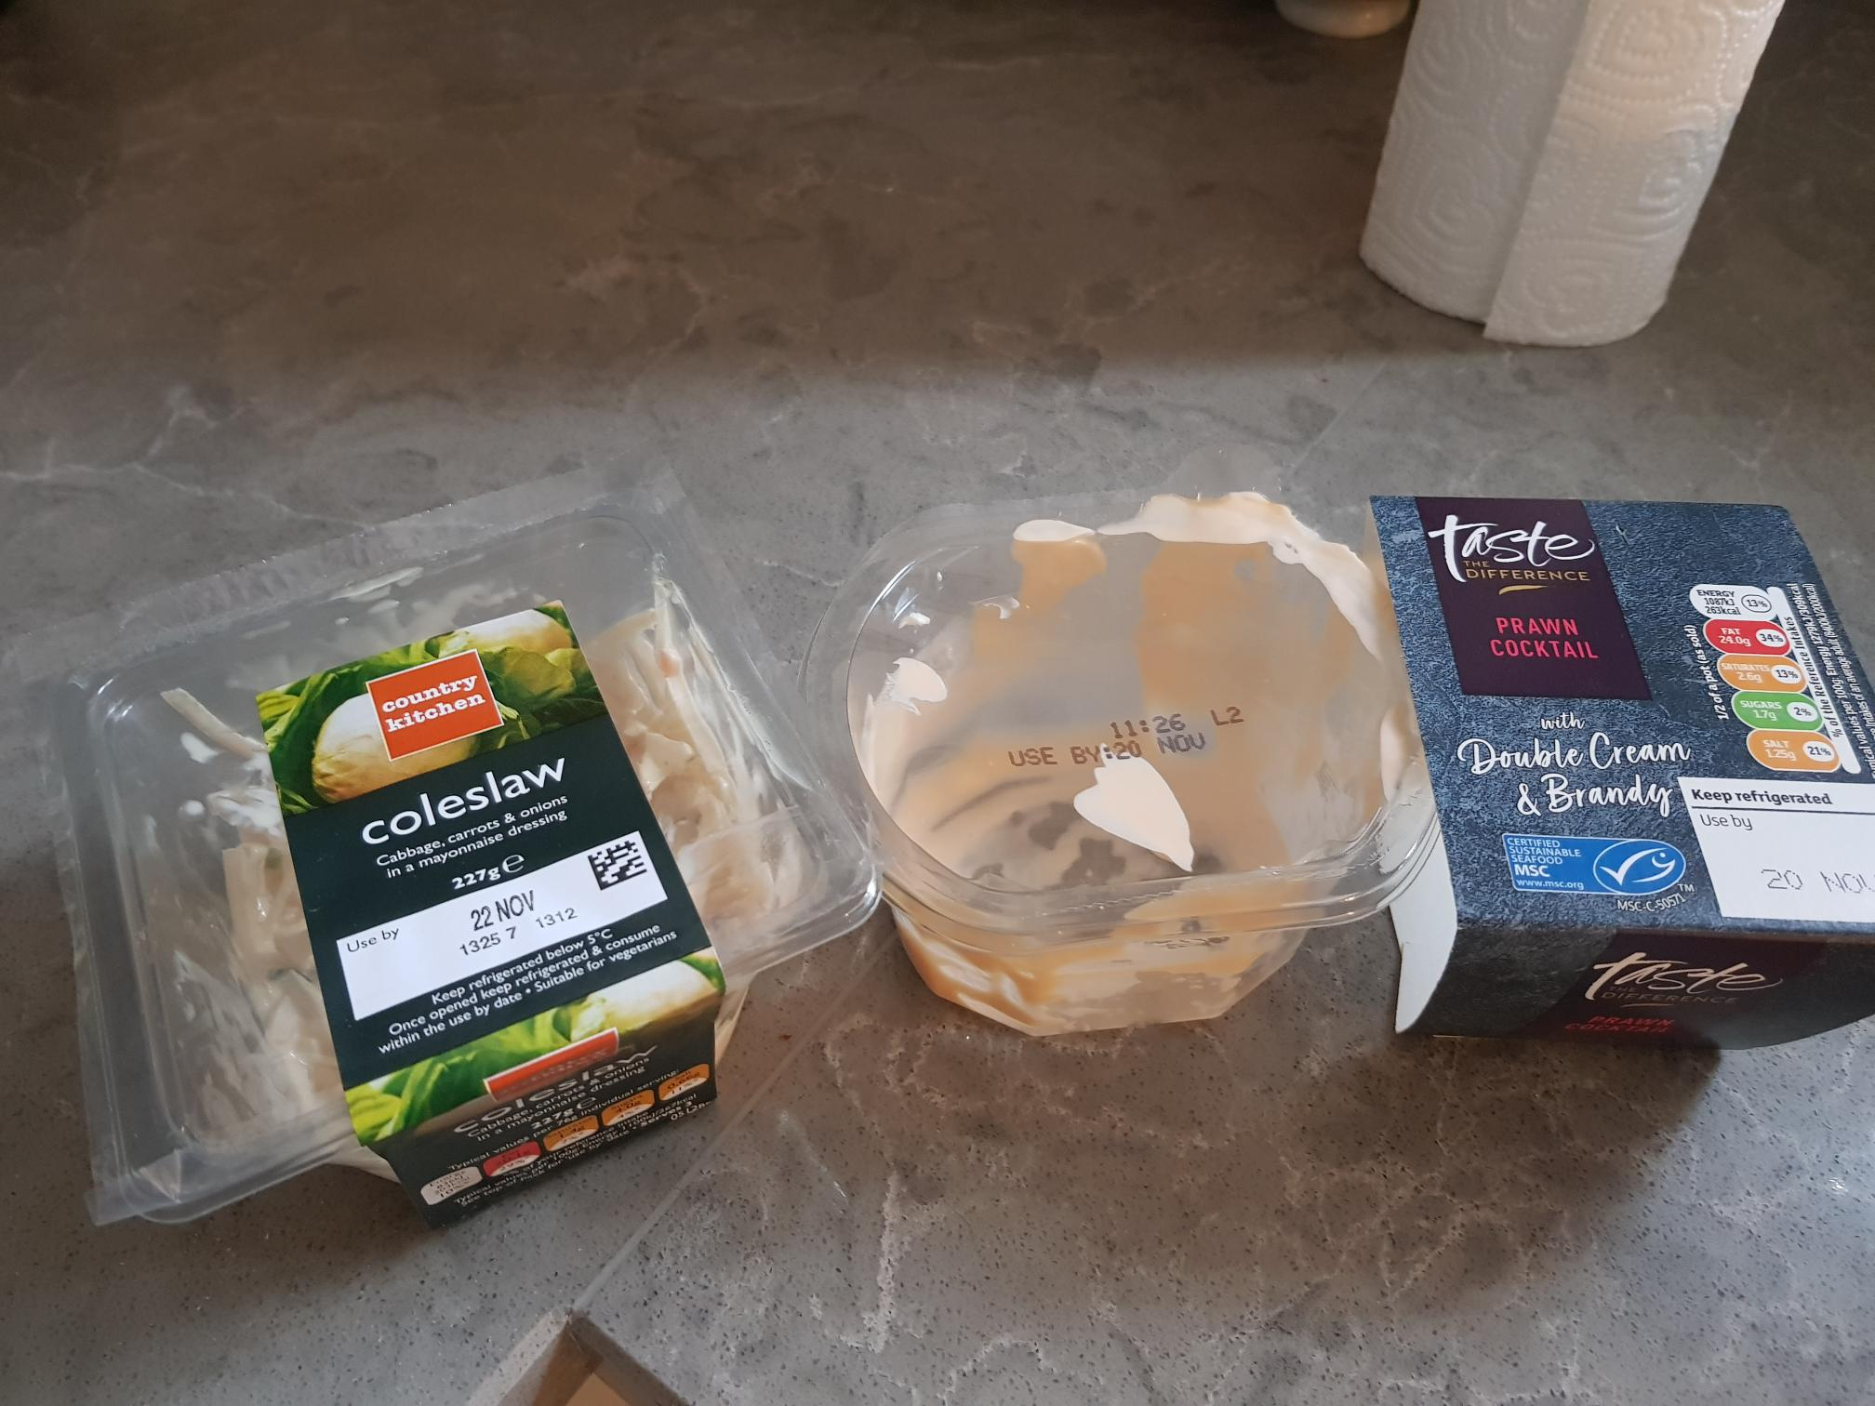

Packaging for the pizza base I used for Thursday’s dinner – the cardboard is recyclable, but not the plastic. At least there’s not a polystyrene base.
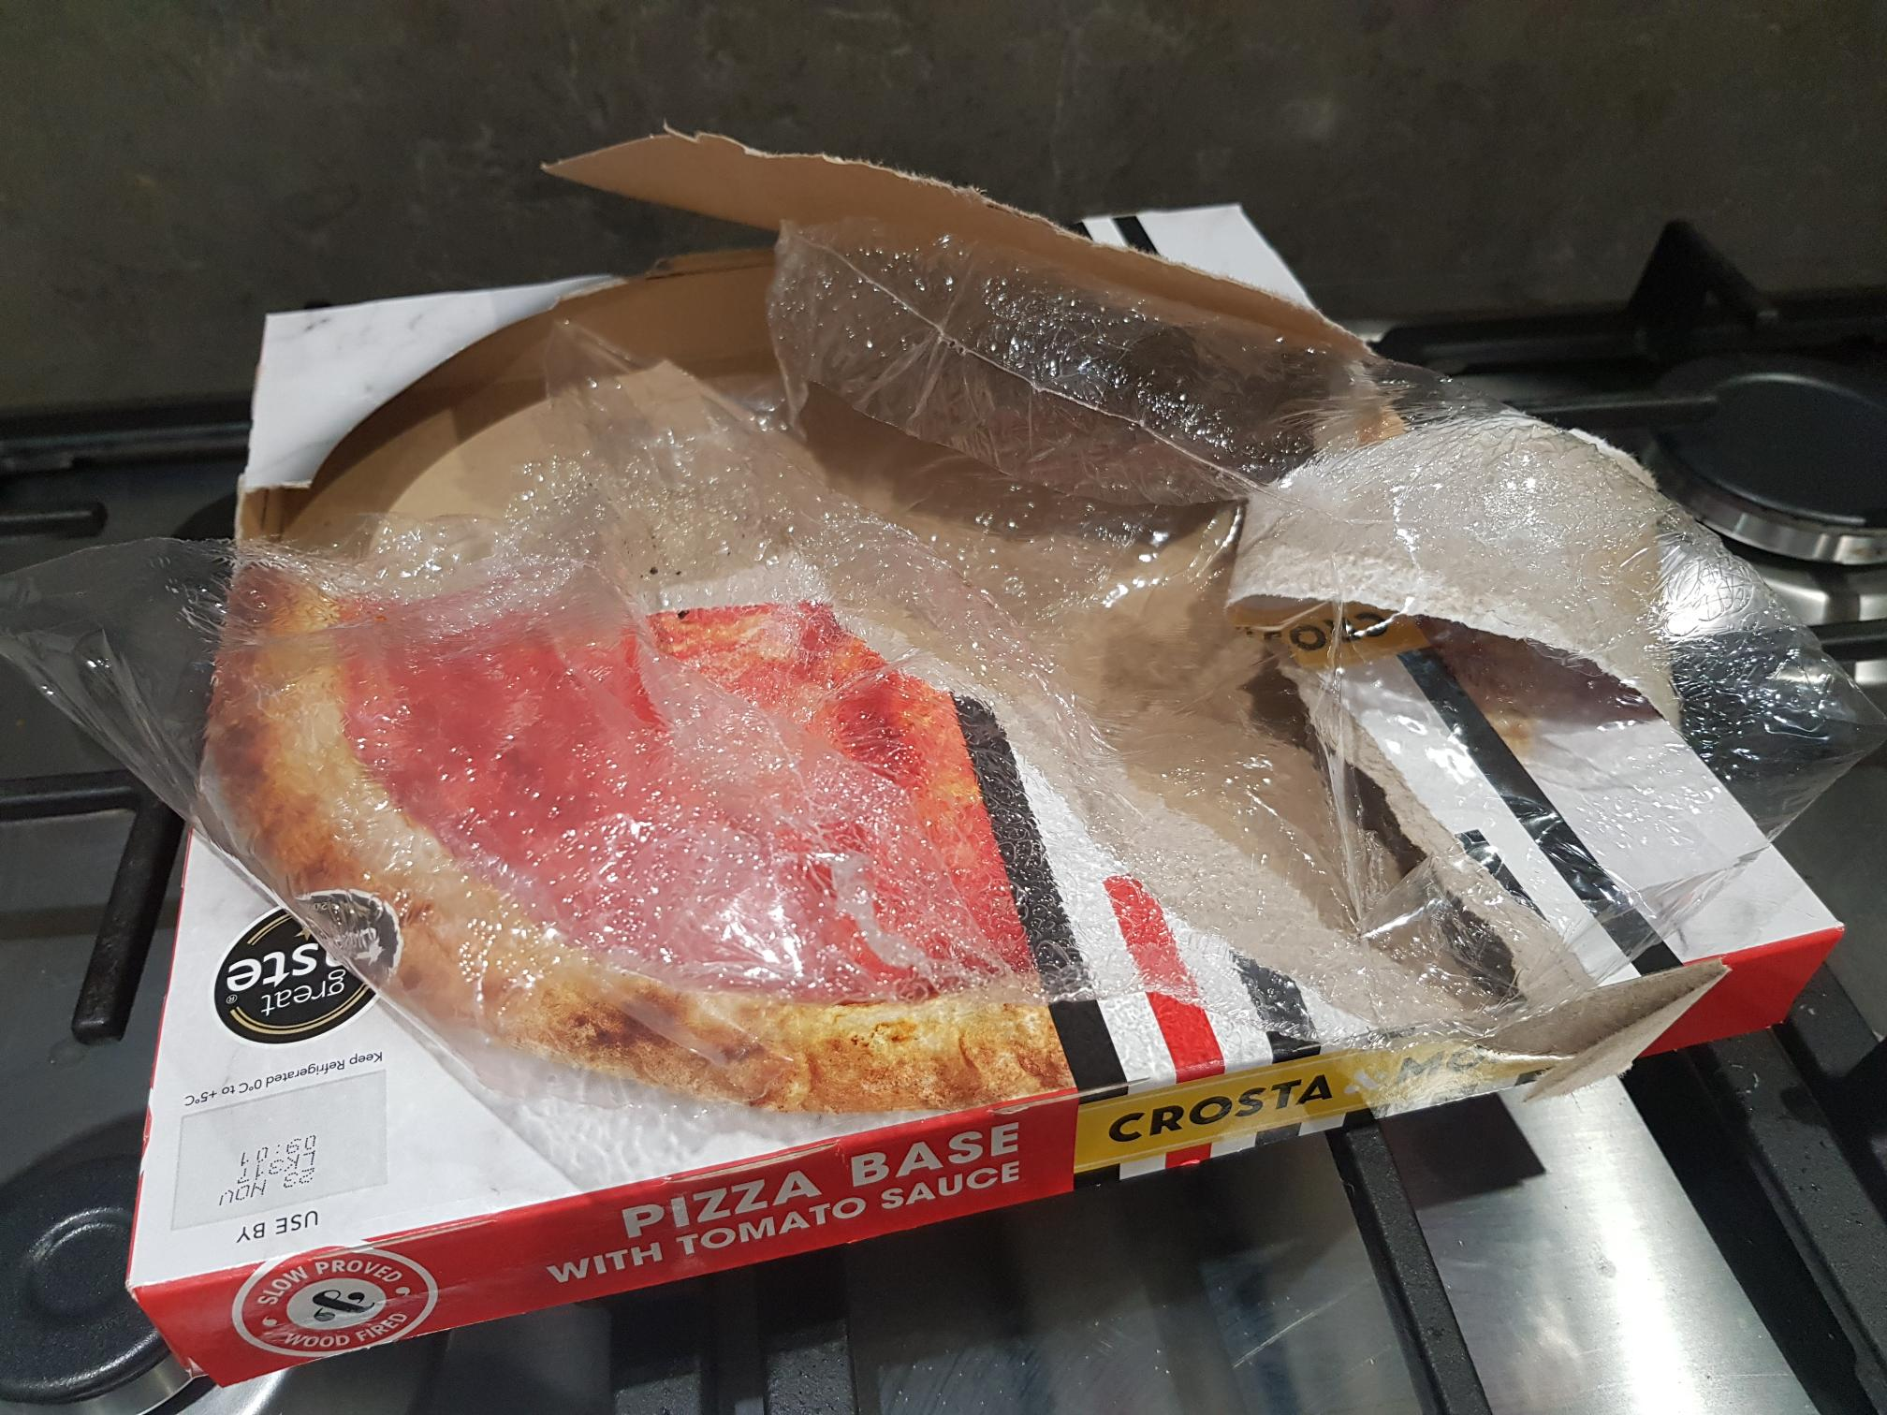

Inside of the fridge, taken after Sainsbury’s had been. I don’t know how I ended up with two jars of mango chutney open. You can also tell that Boursin was on offer from Sainsbury’s as there’s two packs of it in there. I eat a lot of cheese – in all forms. There’s also leftover pasta and a lot of yoghurts in there.
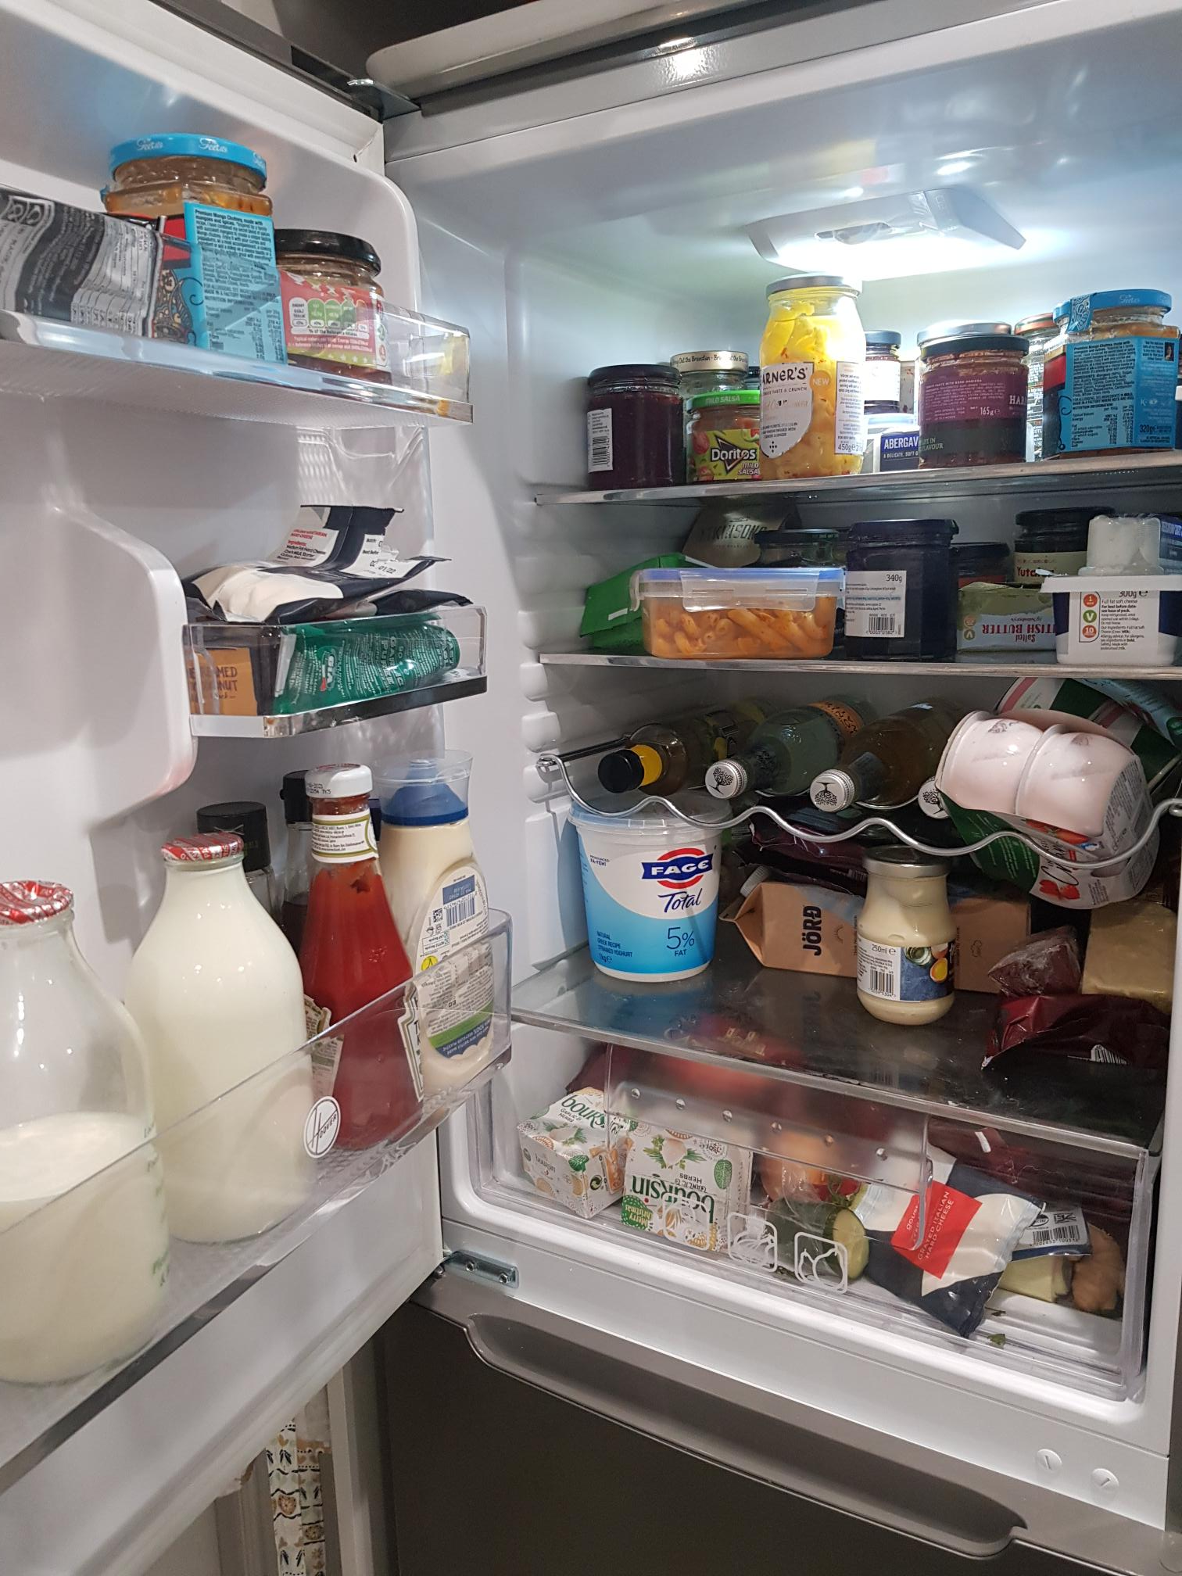

Not food, but I noticed that Finish have switched from the grey plastic tubs they used to use (and which I have repurposed for other uses around the house (storing chargers, cables, pegs, random bits and pieces)) to plastic bags. Info on the back of the packet states that they’re recyclable with carrier bags at larger supermarkets. This can be a struggle in [x] as the shops aren’t ‘large’ supermarkets – even Sainsbury’s is small.
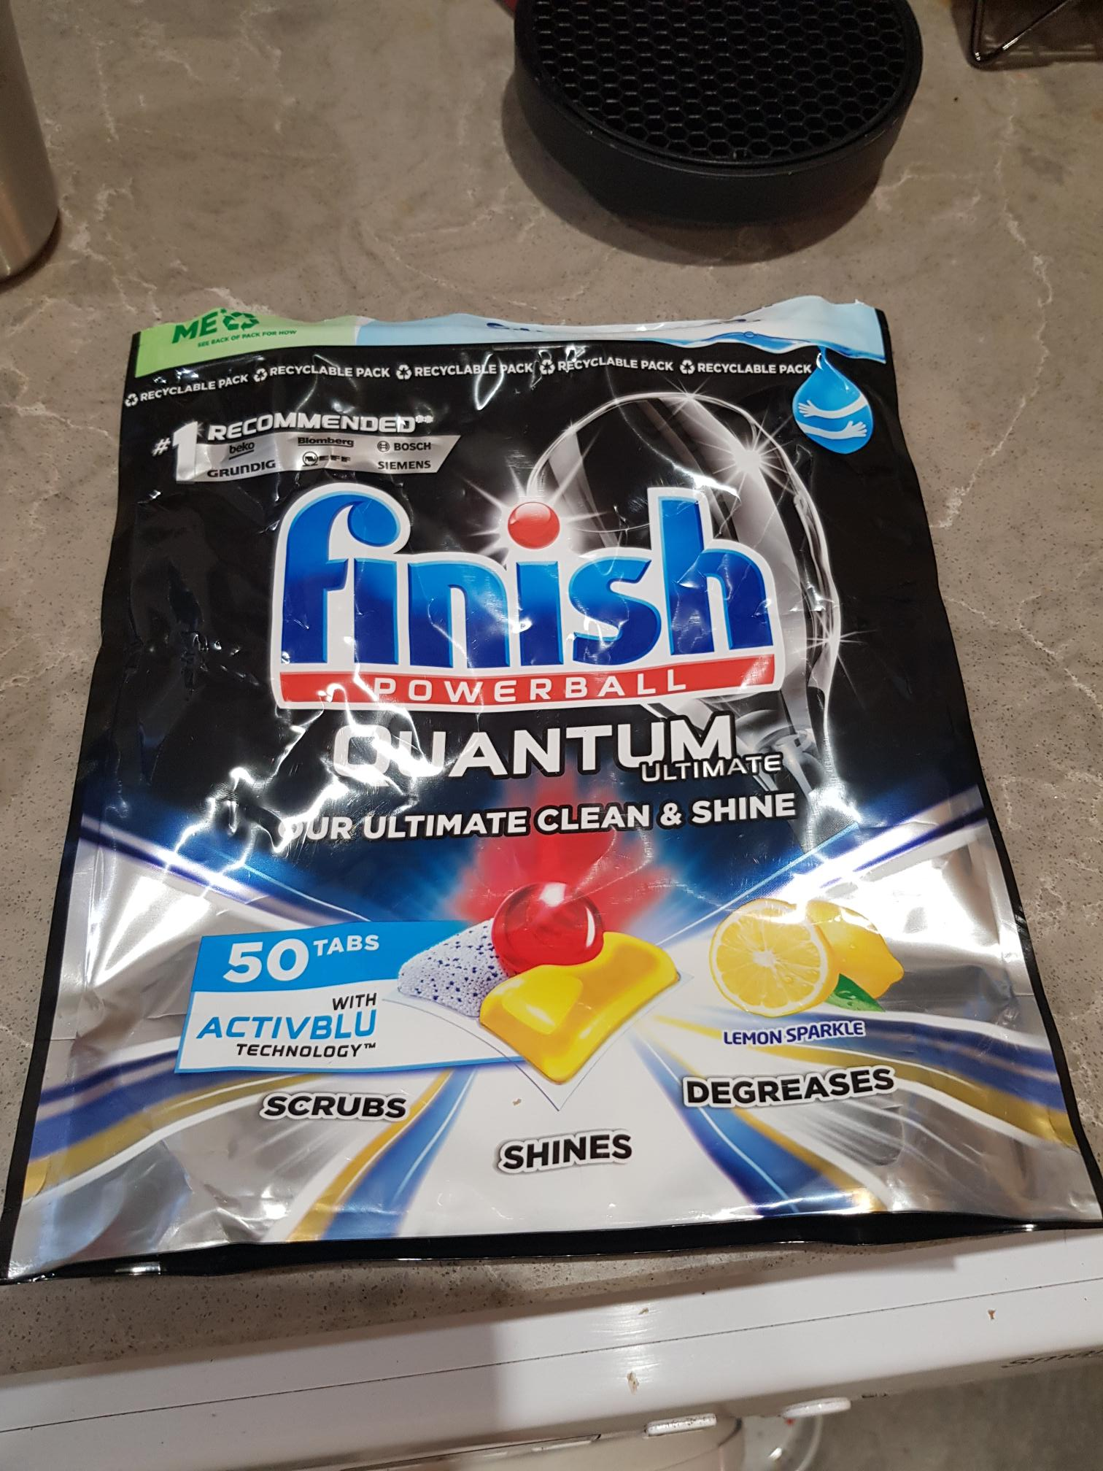

washing detergent bottle, yoghurt pot and prawn cocktail tub, all washed, dried and ready to go into the plastic/glass/metal recycling bin
[photo removed]

