ppipl diary

week commencing 22nd november 2021

monday 22nd November
Working at home today and was up early, so had time to eat breakfast whilst catching up on some of last night’s launch show of I’m A Celebrity. Breakfast was Greek yoghurt, fruit and granola with a mug of coffee.
Lunch was reheated pasta bake that I’d made for yesterday’s dinner.
Dinner was the first Gousto dish I’ve made in a couple of weeks. It was a wheatberry salad with roasted tomatoes, a honey & mustard dressing and toasted ciabatta with goats cheese and sundried tomato. It was delicious, and there’s enough for lunch tomorrow, but a lot of the ingredients were in plastic: goats cheese, ciabatta, sultanas, mustard, honey, almonds, salad leaves.

Tuesday 23rd november
I was [at work] today, which meant I took my breakfast with me, to eat at work. I’m till working through the large pot of Greek yoghurt, so had that with granola and fruit. Lunch was leftovers from yesterday’s dinner.
Dinner tonight should have been something healthy from this week’s Gousto box, but I really fancied something comforting and unhealthy, so had oven chips, that I topped with refried beans and a homemade cheese sauce. Not classy, or elegant, but really lovely. Only plastic packaging was the pouch that the refried beans came in.

wednesday 24th november
I was [at work] again today, so another breakfast of yoghurt (from the same seemingly bottomless Greek yoghurt tub), fruit and granola that was taken into work and eaten whilst checking emails.
I came back home at lunchtime and as I had to pop into [home town] on the way, I picked up a 6inch sub from Subway. Dinner was a Gousto meal of dal with crispy mushrooms, onions and a coriander chutney. The ingredients for the chutney (chili flakes, coriander, rice vinegar) were in small plastic sachets, but the other ingredients were in paper/tins that are easily recyclable.

Thursday 25th november
Working from home today, but was up early to meet a couple of friends to do a 4 mile walk. Really cold, frosty and incredibly beautiful morning and it was so good to be outside in the countryside before a day spent in front of the computer. Breakfast was a quick bowl of cereal.
A friend popped round for lunch today, which was unexpected and lovely. She brought a baguette, cream cheese and smoked salmon with her, plus mince pies for dessert. The packaging from the mince pies, was a plastic tray and that went into my plastic/tin/glass recycling bin. The wrapping from the salmon went into the bin as it was non-recyclable and my friend took the rest of the food back with her as there was baguette and cream cheese left.
Dinner was leftover dal from last night. I store leftovers like this in Tupperware boxes, therefore there was no additional plastic packaging used.

friday 26th November
I was [at work] today, which meant that I took my breakfast into work and ate it there. It was cereal and milk – both in reusable containers.
I made lunch before leaving home and took this into work to eat in the office. It was an egg mayonnaise sandwich on granary bread, with a yoghurt and small packet of mini cheddars. I couldn’t find a small enough Tupperware box, so unfortunately had to wrap the sandwich in cling film, before then putting into the Tupperware box, to stop it moving around in transit, and to help keep it fresh. The cling film and empty bag from the mini cheddars went into the general waste bin in the office kitchen, but the yoghurt pot was washed out, dried and taken home with me to go into the main plastic/tin/glass recycling bin that I have.
Dinner was a Gousto meal, of vegetarian mince chili with apple and red onion pickle, cheese and tortillas. The tortillas came in plastic, which went into my soft plastic bag, to be taken to a supermarket for recycling. The apple and onion didn’t have plastic packaging as they’d arrived loosed in the Gousto box. The cheese was in non-recyclable plastic and the vegetarian mince was in a clear plastic tray (very much like meat mince does) and that was washed and put in with my other recyclable plastics in the recycling bin. The mince packaging also had an outer sleeve of cardboard, which went into the paper/cardboard recycling bin at home.

Saturday 27th November
Breakfast was a cinnamon and raisin bagel with cream cheese and a coffee. The bagel is in a bag of 5 and the bag is still in use, so hasn’t been disposed of yet. The cream cheese tub is recyclable but again, that’s still in use and hasn’t been disposed of yet.
The coffee I have is Nespresso Vertuo pods, which are aluminium and I recycle them through Nespresso’s ‘pod back’ scheme, where they’re put into a bag and sent back to Nespresso for recycling.
Lunch was leftovers from last night’s dinner. Again, the leftover chilli and pickle had been stored in Tupperware, so no additional plastic waste was generated.
Some friends arrived after lunch and we ate dinner at a local Indian restaurant. Nothing came in plastic

sunday 28th November
My friends and I went out for breakfast this morning, to a local garden centre that has a café. We all had a full vegetarian breakfast and the only thing that came in plastic was the tomato sauce which was in a plastic sachet. We left the empty sachets on our plates at the end of the meal.
I bought some mince pies from the garden centre. These are in a plastic tray (which can be recycled) covered in plastic film (not sure if this can be recycled).
Because of the large, late breakfast, I didn’t have lunch. I only had a light dinner today, of vegan ‘pastrami’ sandwich with mayo, cream cheese and pickled gherkin. It’s the same tub of cream cheese that I opened yesterday and is still in use, the mayo is in a glass jar as are the gherkins. The vegan ‘pastrami’ is in a pack that’s got plastic film over the top and a card base. I also had a yoghurt (again, the pot was washed out and went into the main plastic/tin/glass recycling bin at home).

photos

I have four bins provided by [xxx]. Three are kept outside and one is kept in the garage. The green one is for garden waste, black is for general waste and blue is for paper and cardboard. Black is collected fortnightly and the others are only collected monthly.
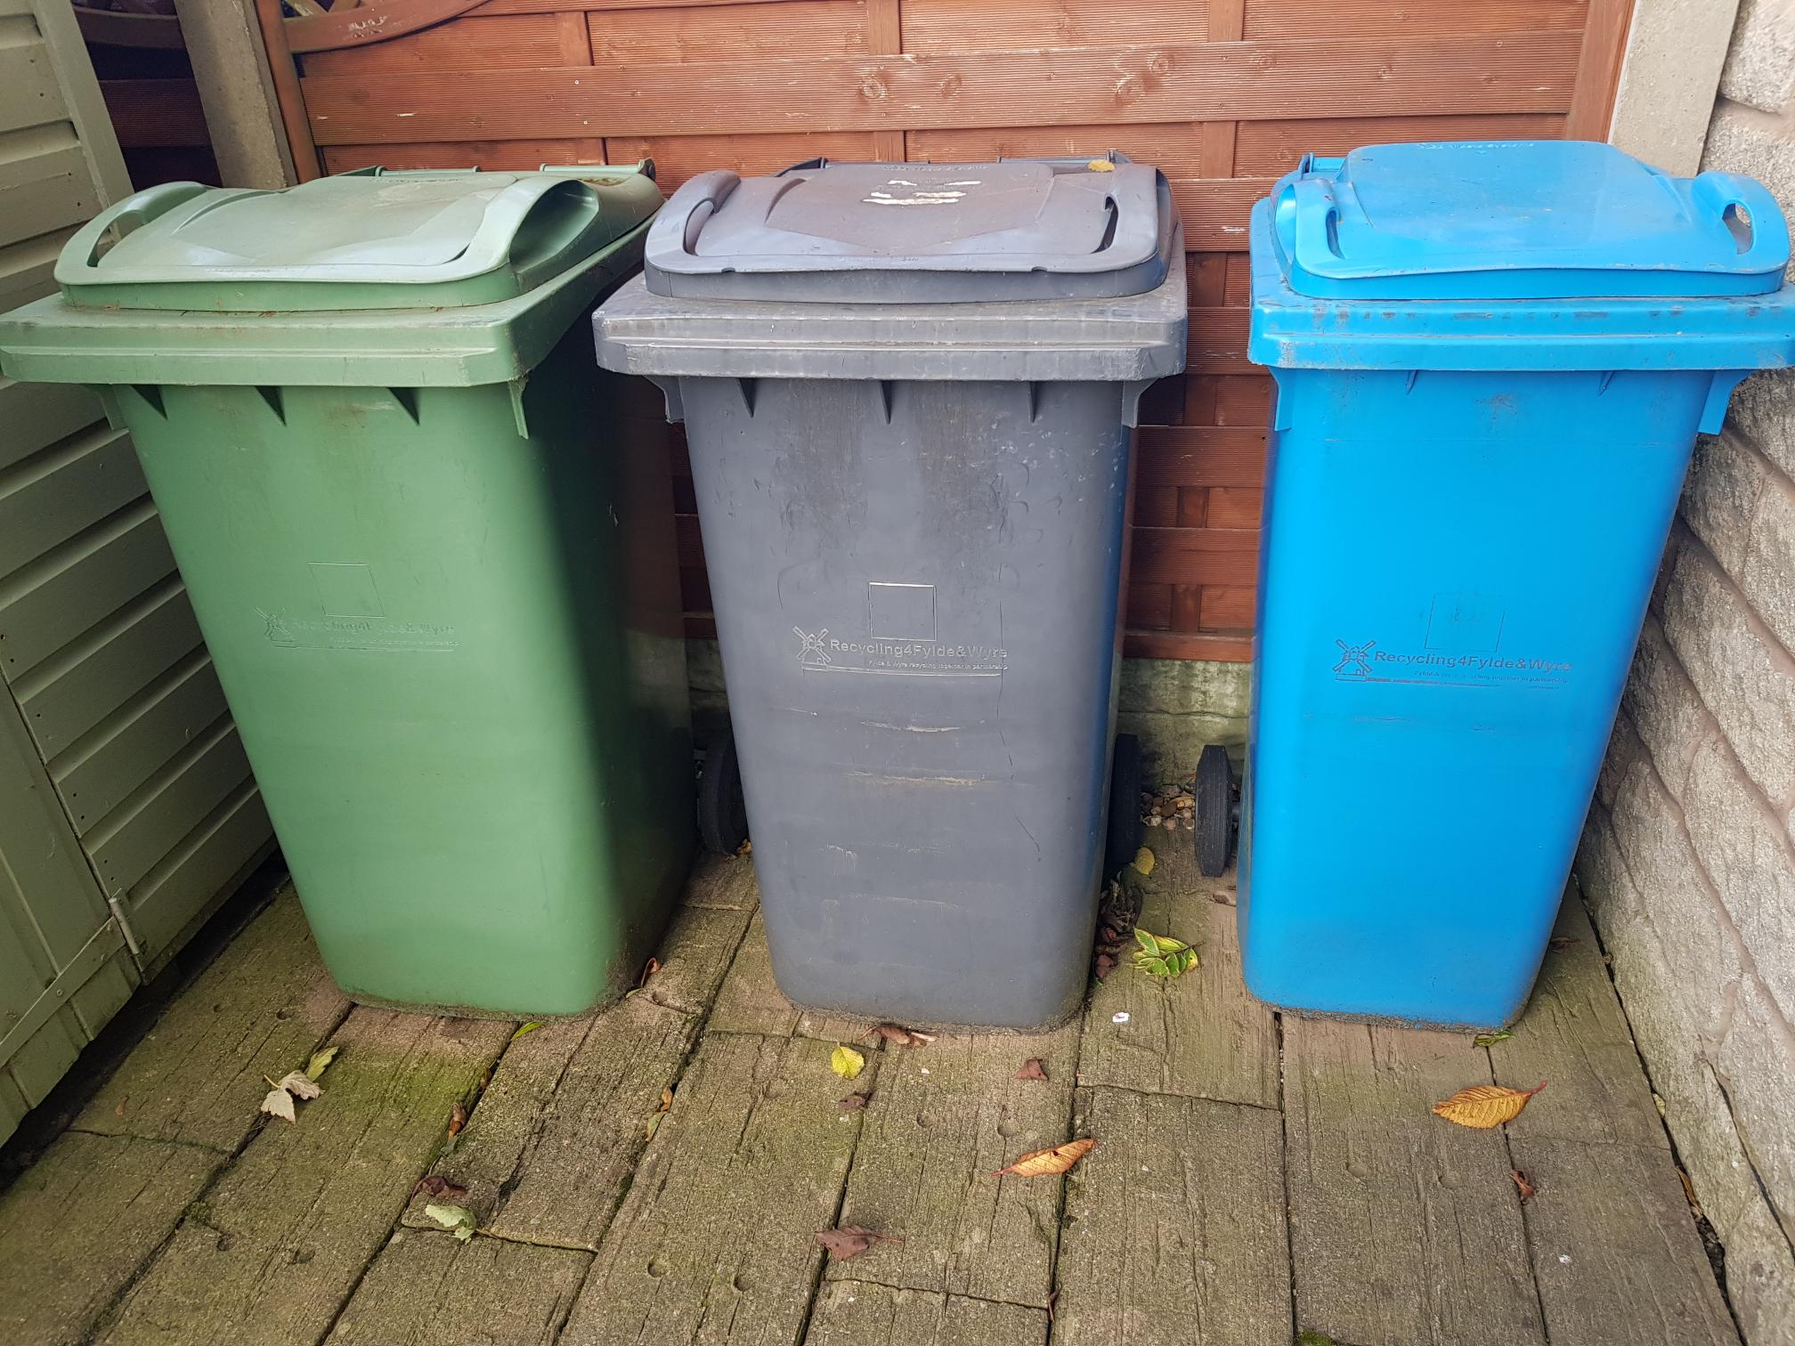

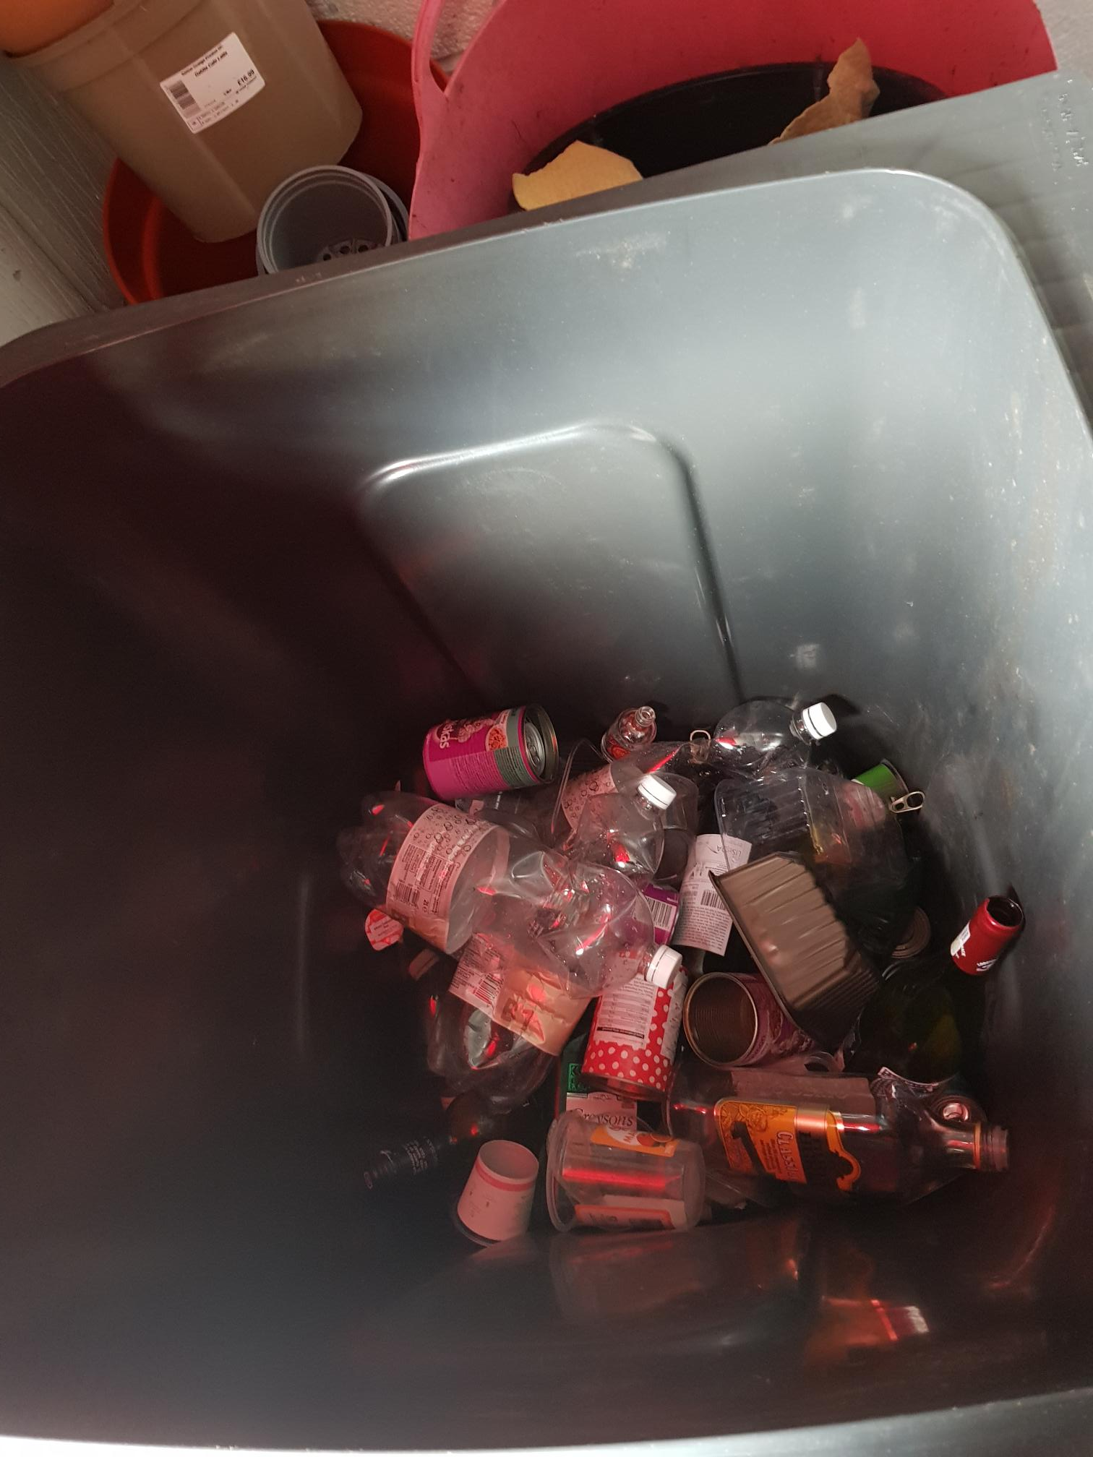
Not the best photo but it shows the inside of my other main bin, which is the hard plastic, tins and glass bin. This is collected monthly. I can also recycle small electrical items and batteries with this bin (if they’re put next to/on top of it in a plastic bag).

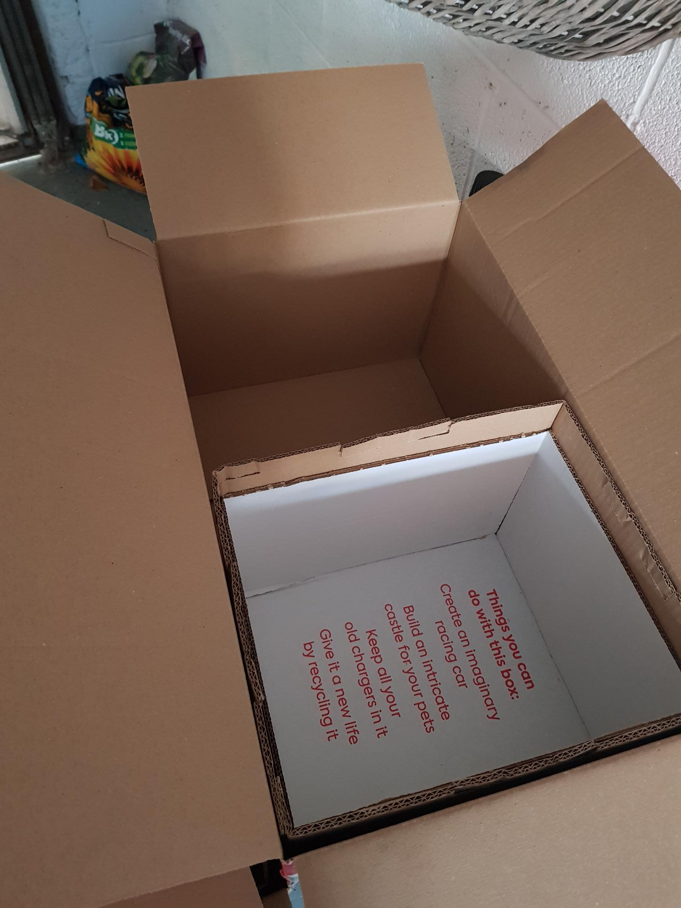
The inside of an empty Gousto box – the inner box with the red writing in it in the cool box section. This has a cardboard lid too and has the ice pack(s) and chilled items. The other side is for the ambient temperature items.

[photo removed]
I try and get the cats to eat more tinned food alongside the food that comes in the annoying and faffy sachets. The tins are fully recyclable and easy to wash out and there’s just this outer bit of plastic. So far, this has either been thrown away, gone into the Zerowaste box that I had or is collected with other soft plastics to go to the soft plastic recycling at a supermarket.

