ppipl diary

week commencing 29th november 2021

Feeling a bit under the weather this week, with what turned out to be a chest infection, which explains why the last couple of weeks, I’ve not been as enthusiastic about food and cooking as I normally am.

monday 29th November
I was on annual leave today, visiting family and had breakfast at my parents’ house. I’d taken some cinnamon and raisin bagels with me, plus some cream cheese and had a bagel with cream cheese for breakfast. There was still a couple of bagels and some cream cheese left, so the packaging wasn’t discarded or recycled at this stage.
Lunch was eaten out, at a local wine bar/deli. No plastic packaging was involved. I had homemade soup, with bread and butter (the butter was in foil). The cutlery was in a paper envelope, with a napkin.
Dinner was a Gousto dish of lemon and panko crusted cod on a lentil and carrot stew. Not the most tasty or exciting meal, to be honest. It lacked flavour and mostly just tasted bland a bit too healthy. The cod was in plastic that was recycled at home. The panko breadcrumbs and lentils were in paper; the lemon, carrot, bay leaf and onion had arrived loose in the Gousto box and had no packaging; veg stock powder was in a non-recyclable sachet.

Tuesday 30th november
I was working at home today and had bagel with cream cheese for breakfast, with coffee. Lunch was the remaining bit of the vegan ‘pastrami’ on a sandwich with cream cheese, mayonnaise and gherkins. I also had a yoghurt with lunch.
Dinner was a Gousto dish – refried beans, tacos, corn salsa with a feta and panko topping. The tortillas were in a plastic sleeve (six in the pack and I used 2 for dinner); the feta and spices were in non-recyclable plastic; the panko breadcrumbs were in paper; sweetcorn and black beans were in tins.

Wednesday 1st December
Busy day today – on annual leave this morning as I had to pick up my new car. It should have been fairly quick and then home for lunch, but the dealership had missed installing something that I’d requested when I ordered the car. They did it whilst I waited but it took a couple of hours, meaning lunch was a quickly grabbed egg mayonnaise sandwich and banana bought from the nearby Aldi. Packaging was thrown away in the bin at the dealership.
Dinner was nachos with the refried beans and corn salsa from last night, with additional salsa, sour cream and grated cheese. The additional salsa was in a glass jar, the sour cream was in a plastic tub which was washed and put into the recycling bin at home. The cheese was part of a large block, in resealable plastic and that went back into the fridge. I also made a peach cobbler for dessert. The peaches were in a recyclable plastic jar (washed and put into the recycling) and the only other ingredient in plastic was the single cream that it was served with. This went back into the fridge as it wasn’t all used tonight.

Thursday 2nd december
Breakfast today was eaten at home, as I was working from home. I had cereal with milk, plus a coffee. Lunch was egg mayonnaise sandwich that I made at home, with a yoghurt. The only plastic from lunch was the yoghurt pot which was washed and put into the recycling bin at home.
Dinner was the usual homemade pizza – bought pizza base, topped with goats cheese, chili, tomatoes, onion, oregano. The goats cheese was in a plastic pot which was washed and put into the home recycling bin. The soft plastic from the pizza was thrown away.

friday 3rd December
Bit boring and predictable with breakfast and lunch this week as I’d not had a Sainsbury’s delivery. Breakfast was cereal and milk with coffee, then lunch was another egg mayonnaise sandwich with yoghurt – all eaten at home.
Dinner was a bit more interesting as I made an Indonesian style vegan mince curry with green beans. It was a Gousto recipe and frustratingly all the various spices were in plastic sachets that are hard to recycle (coconut cream, tamarind paste, turmeric, cumin). The garlic, ginger and cardamom pods were all loose or in paper bags, so no plastic with them. The green beans were in plastic which was added to the pile in the garage for recycling at the local supermarket. The vegan mince was in a recyclable plastic tray which was washed and added to the home recycling bin.
I went out tonight with a friend for cocktails and despite having eaten dinner at home, we shared a large cheese platter. Easily the most interesting meal of the week so far.

Saturday 4th december
Still on cereal and milk with coffee for breakfast. Lunch was more interesting though as I went with one of my friends, to another friend’s house for a leisurely lunch. Lots more cheese, with bread, crackers and assorted olives, chutneys and crudités. The cheeses were very expensive ones from small dairies, ordered online through a cheese society and therefore didn’t come in plastic. The chutneys were in glass jars. Not sure about the crackers and bread, but my friend is a keen recycler, so am hoping they were all recycled.
I’d eaten so much cheese at lunch that I didn’t have a proper dinner this evening, just some toast with butter and jam.

sunday 5th December
Quick breakfast at home (cereal with milk and a cup of tea) before I met a couple of friends for a 4 mile walk. We had breakfast at a café after the walk (poached eggs on toast, with coffee). No plastic on the table – sauces were in glass bottles and cutlery was in napkins.
No lunch as I’d eaten a late and large second breakfast.
Dinner was a Gousto meal (Gousto delivery for the week arrived this morning) – Tofu in a sweet chilli sauce with rice that had carrot and peas added to it. Not as interesting as I’d hoped it to be. Wasn’t hugely keen on the veg in the rice, preferring rice on its own. The sesame seeds, cornflour and soy sauce were all in plastic sachets that weren’t recycled. The agave syrup and chilli jam were in plastic pots which I washed and put into the household recycling bin.

Plastic packaging for one of the Gousto meals. The lentils are for a different recipe. The little pots are easy to clean and recycle, but the sachets are really tricky, so often get thrown away.
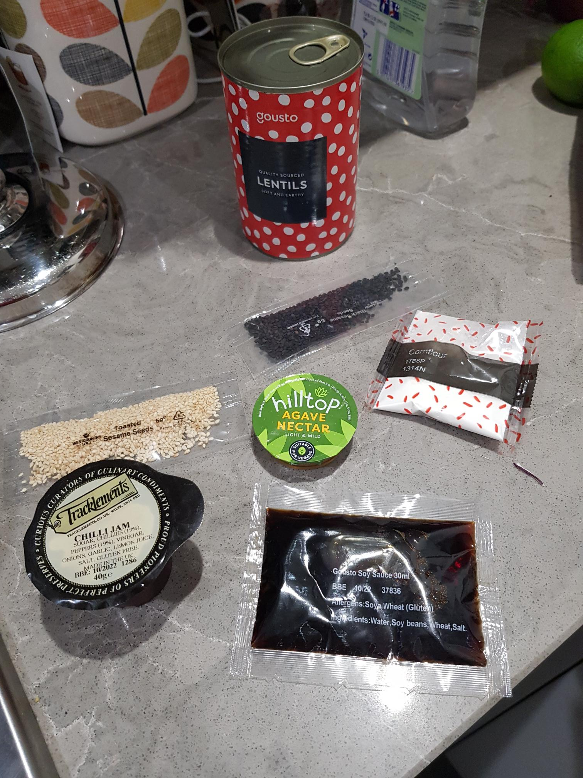

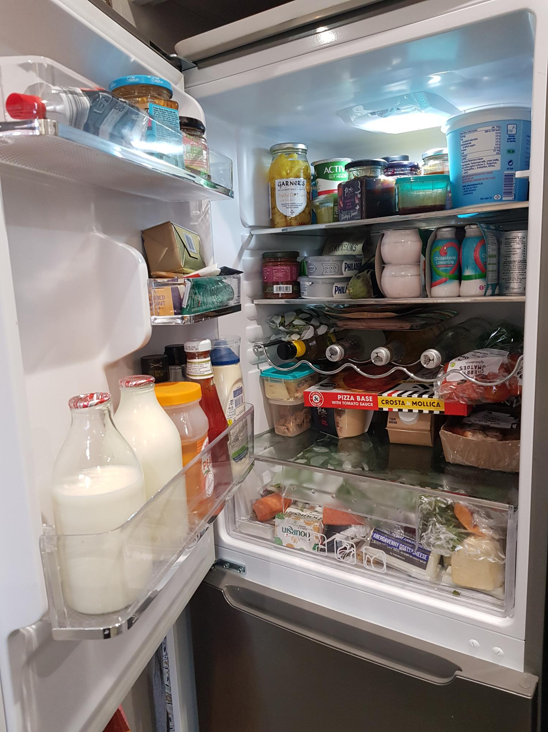
Fridge. Still quite full, despite not having ordered from Sainsbury’s this week.

