7th - 14th November
Week 1 Diary
8th November
Shopping today and noticed how many cardboard boxed products feature plastic windows on them. This wound me up a bit and I thought these to be unnecessary – I know what a mince pie looks like!
Also noticed the big round boxes of chocolates people tend to get this time of year. They used to always be metal, now a lot more are made of plastic. We have several in our cupboard from over the years which we use for storing things now and then. If I make some scones or biscuits for example, they end up kept in an old plastic celebrations box till they’re eaten usually.

10th November
Our Huel box arrived today. We got 4 bags of Huel with 665grams in each. This works out as 28 meals all together. Considering that they come in just these four plastic bags my feeling is that they must create less waste per meal than other foods. Some research indicates that the people at Huel think this packaging is necessary to ensure longevity of the food and prevent food waste. However they do seem open to looking at alternatives.

13th November
Had ‘Oats so simple’ porridge for breakfast. The outer packaging is cardboard – easily recyclable. But the pouches with the actual porridge in are paper lined with plastic and non-recyclable. I use them because they are quick and convenient but am wondering if I should give up and try to find porridge oats in a more sustainable packaging and just do the measuring out myself.
Big lunch out with visiting family. Evening had frozen pizza – cardboard box and plastic wrapping on the pizza.
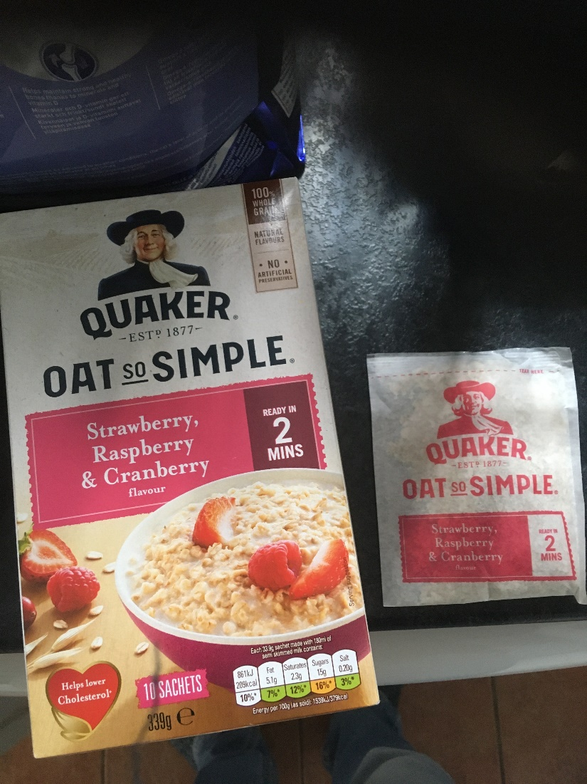

14th November
Left over pizza for breakfast.
For lunch made use of some veg that needed eating. Made vegan brunch which consisted of:
Hasselback potatoes, baked beans, toast, ‘scrambled tofu’ (tofu, kale, broccoli, red onion and spices).
Potatoes were in a plastic bag as was the Kale. The tofu comes in a cardboard box, but inside is in plastic.
Intended to take a photo when it was all cooked but forgot until I’d finished eating!

