7th - 14th November
Week 1 Diary
8th November
Shopping today and noticed how many cardboard boxed products feature plastic windows on them. This wound me up a bit and I thought these to be unnecessary – I know what a mince pie looks like!
Also noticed the big round boxes of chocolates people tend to get this time of year. They used to always be metal, now a lot more are made of plastic. We have several in our cupboard from over the years which we use for storing things now and then. If I make some scones or biscuits for example, they end up kept in an old plastic celebrations box till they’re eaten usually.

10th November
Our Huel box arrived today. We got 4 bags of Huel with 665grams in each. This works out as 28 meals all together. Considering that they come in just these four plastic bags my feeling is that they must create less waste per meal than other foods. Some research indicates that the people at Huel think this packaging is necessary to ensure longevity of the food and prevent food waste. However they do seem open to looking at alternatives.
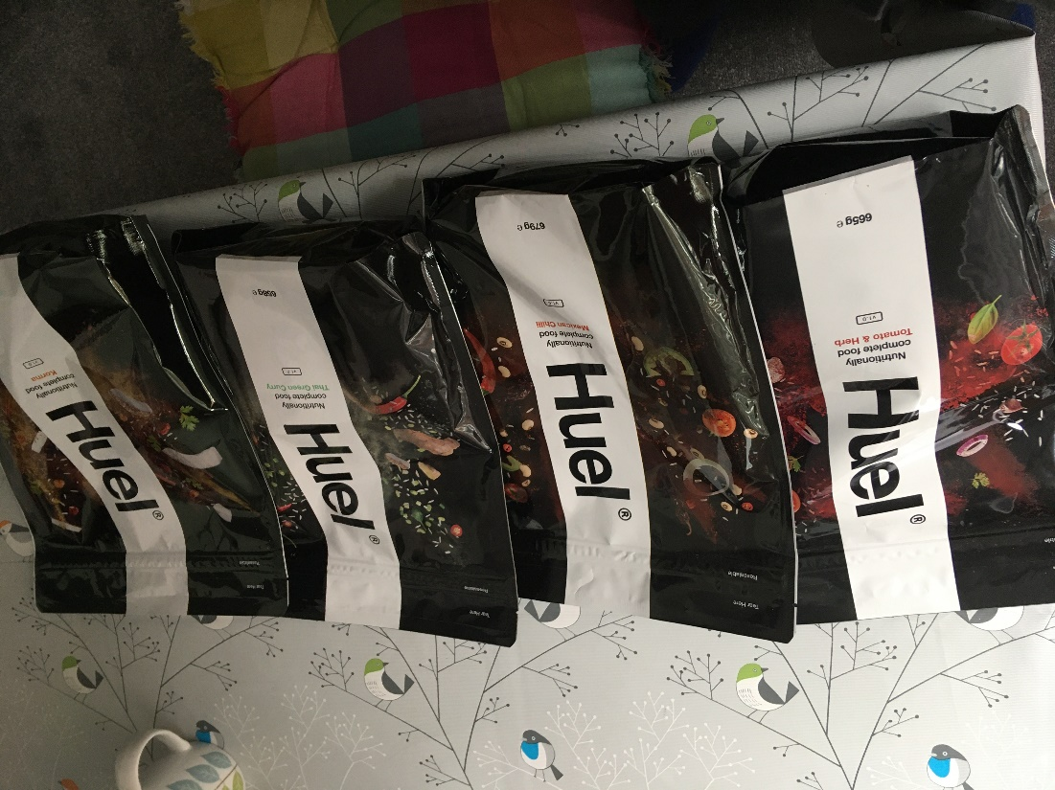

13th November
Had ‘Oats so simple’ porridge for breakfast. The outer packaging is cardboard – easily recyclable. But the pouches with the actual porridge in are paper lined with plastic and non-recyclable. I use them because they are quick and convenient but am wondering if I should give up and try to find porridge oats in a more sustainable packaging and just do the measuring out myself.
Big lunch out with visiting family. Evening had frozen pizza – cardboard box and plastic wrapping on the pizza.
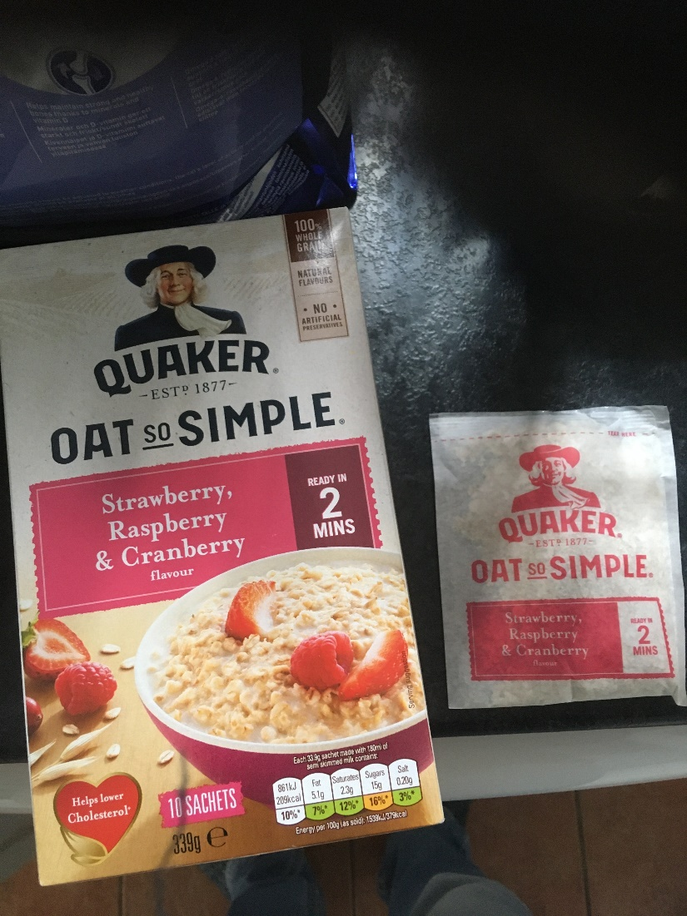

14th November
Left over pizza for breakfast.
For lunch made use of some veg that needed eating. Made vegan brunch which consisted of:
Hasselback potatoes, baked beans, toast, ‘scrambled tofu’ (tofu, kale, broccoli, red onion and spices).
Potatoes were in a plastic bag as was the Kale. The tofu comes in a cardboard box, but inside is in plastic.
Intended to take a photo when it was all cooked but forgot until I’d finished eating!

Week 2
Monday 15th November
Toast – bread from a paper wrapper, peanut butter form a glass jar so no plastic there.
Huel for lunch. For dinner I used lots veg that needed eating. Sprouts and Kale came in plastic bags which were thrown away. Carrots, parsnip, fennel were just loose with no packaging.
Here is a pic of the leftovers!
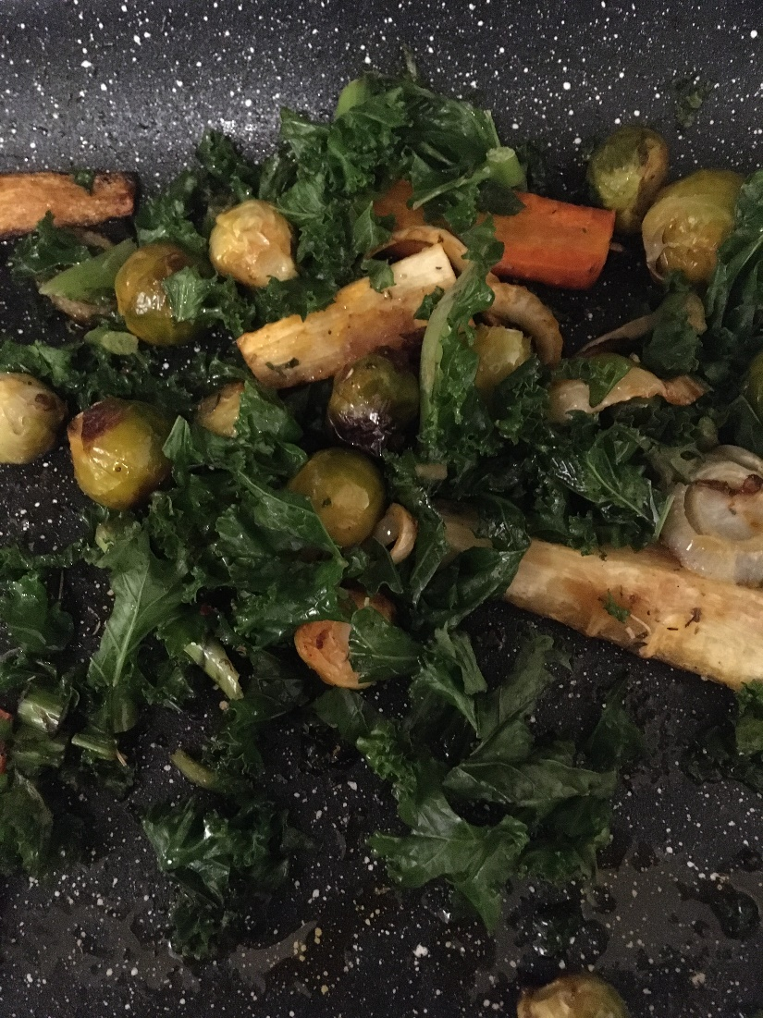

Tuesday 16th
Toast for breakfast again, yesterday's leftovers for lunch. ‘Chippy’ tea in the evening. Comes in a mix of cardboard and plastic packaging which all gets thrown in the rubbish bin due to being covered in fat and grease.

Wednesday 17th

Porridge for breakfast – plastic and paper pouch.
Pitta and Huel for lunch – pitta's came wrapped in plastic.
Tea – Pies, mash and veg. Potatoes came in a plastic bag, broccoli wrapped in plastic.

Friday 19th
Breakfast bar in plastic wrapper. Huel for lunch with tortilla chips in a plastic bag. Chinese takeaway for tea as it was [wife]s’s birthday. Mix of plastic tubs which we wash and recycle/re-use. Also plastic bag for prawn crackers.

Saturday 20th
Huel shake for breakfast. Leftover Chinese food for lunch. Pizza for tea – cardboard box and shrink wrap plastic on the pizza. I noticed that the box has a clear window cut in it – so the buyer can see the pizza. The plastic wrapping keeps it all sealed and hygienic.

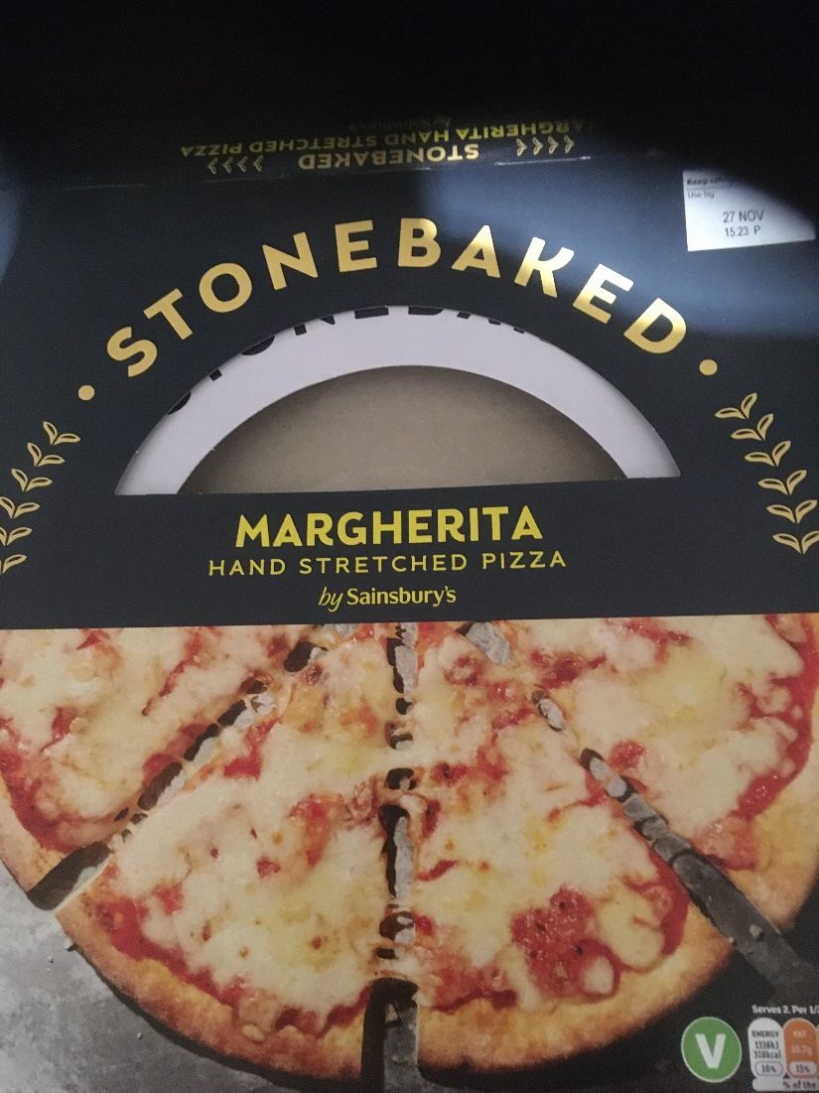

Sunday 21st
Went shopping today. Bought more than I might have in order to take advantage of a money off coupon. - Possibly a false economy.
I made a quick video of the unpacking but having trouble getting this to embed in this document!

For lunch we had a vegan brunch. Hash browns, vegan bacon, toast beans and scrambled tofu. the Vegan bacon comes in shrink wrapped plastic. the hash browns are frozen and come in a plastic bag. The tofu is also shrink wrapped in plastic.

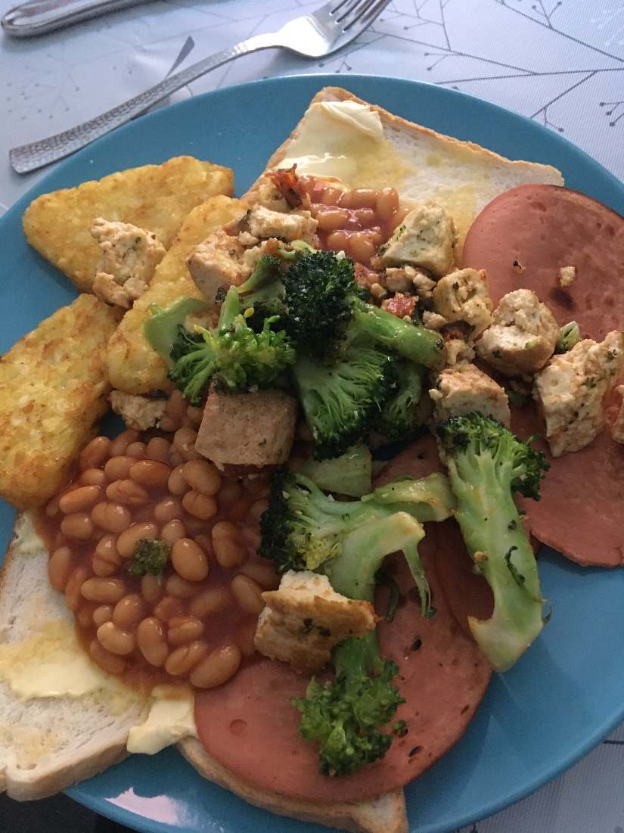

Week 3
22nd to 28th of November

I’ve had some trouble getting the previous document to open so started this new one instead.
It’s felt like quite a hectic week this week with [son] (my son) isolating from school meaning taking on some home schooling activities alongside working some long days.

Monday 22nd
So today I made a beetroot,chickpea and coconut curry for tea. I toned down the spices a bit to suit [son] and also added in carrots as he’s not a fan of beetroot.

On Tuesday we had our traditional ‘chippy tea’ - normally a reward for [son] working hard at swimming and reflecting the fact that [wife] and I are busy! [wife] will be working all day and not have time to make a meal and I will be busy with taking [son] to and from his swimming lesson. So with [son] being hungry for a quick meal and us being too busy to have cooked normally, a take away makes sense for us on a busy Tuesday night. We try not to make a habit of getting too many a week for health and financial reasons.

Wednesday was the last day of isolation for [son] and I made him a tuna sandwich - one of his favourite things - for lunch, while I ate some hot huel. I’ve seen a few bits of advertising for Huel recently. The main selling points appear to be: cost, convenience and eco-friendly. This last one is due to it being plant based. I suppose the fact that it uses plastic - while not good, is not that different from a lot of other food which comes in plastic. At least it is plant based and so better for the environment than meat.

This Thursday I had a very busy day at work and was doing visits till 5.15 before rushing off to get [son] from after school club. [wife] cooked us some food - and then we realised [son] had eaten at after school club and wasn’t hungry! We ate some vegetables and plant based burgers for tea. I like the frozen plant based range from Morrisons as it is gluten free and Vegan and comes in cardboard packaging with no plastics.

Saturday and I realised I bought some avocados last weekend and hadn’t used them yet! So it was avocado with a little salt inside a warmed pitta bread. The Avacado’s come in a net bag similar to ones you get oranges in. I had thought these were better than plastic but a quick bit of googling came up with this -
Are orange net bags recyclable?
The nets that citrus fruits are sold in are one of the most environmentally-unfriendly household waste materials. Not only are they non-recyclable, but they can cause all kinds of problems for birds and water animals.

Though this was from an old article, I couldn’t find anything more recent stating they are recyclable. I thought by buying produce in these I was doing something good - but now I have to rethink this!

For lunch we all ate together but had different meals! [son] had the last of the fishless finger, [wife] had some Huel and I ate some leftovers from the other night. A frugal lunch using up things. It feels good to make use of things and not be wasteful - both environmentally and I’ve noticed how the shopping is getting more and more expensive so if we can not waste food that’s good for our finances.
[wife] did a quick shop as we needed a few basics and weren’t sure what to have for tea.
[wife] got some filled tortellini pasta and a plastic tub of sauce for me and [son] to eat so it would be quick and easy as we’d all had a busy day delivering our leaflets for the Green party and the upcoming elections next week.
The pasta came in a non-recyclable plastic tub with plastic cover, the sauce also came in a plastic tub - which is recyclable. Convenient for us but no so convenient for the planet though!

Week 4
Monday 29th of November
I had a cold huel shake for breakfast nd some hot huel for lunch along with an avocado.
For tea I went to a bit more effort and made spicy harissa sprouts and broccoli and halloumi. Also featuring spinach. The sprouts cam in non-recyclable plastic bags unfortunately. The broccoli was unpackaged - in the supermarket they appeared to just have a huge box of broccoli all in one plastic bag rather than having them all individually wrapped.
The spinach was frozen from a plastic packet as I was mistaken in thinking we still had some in the fridge.
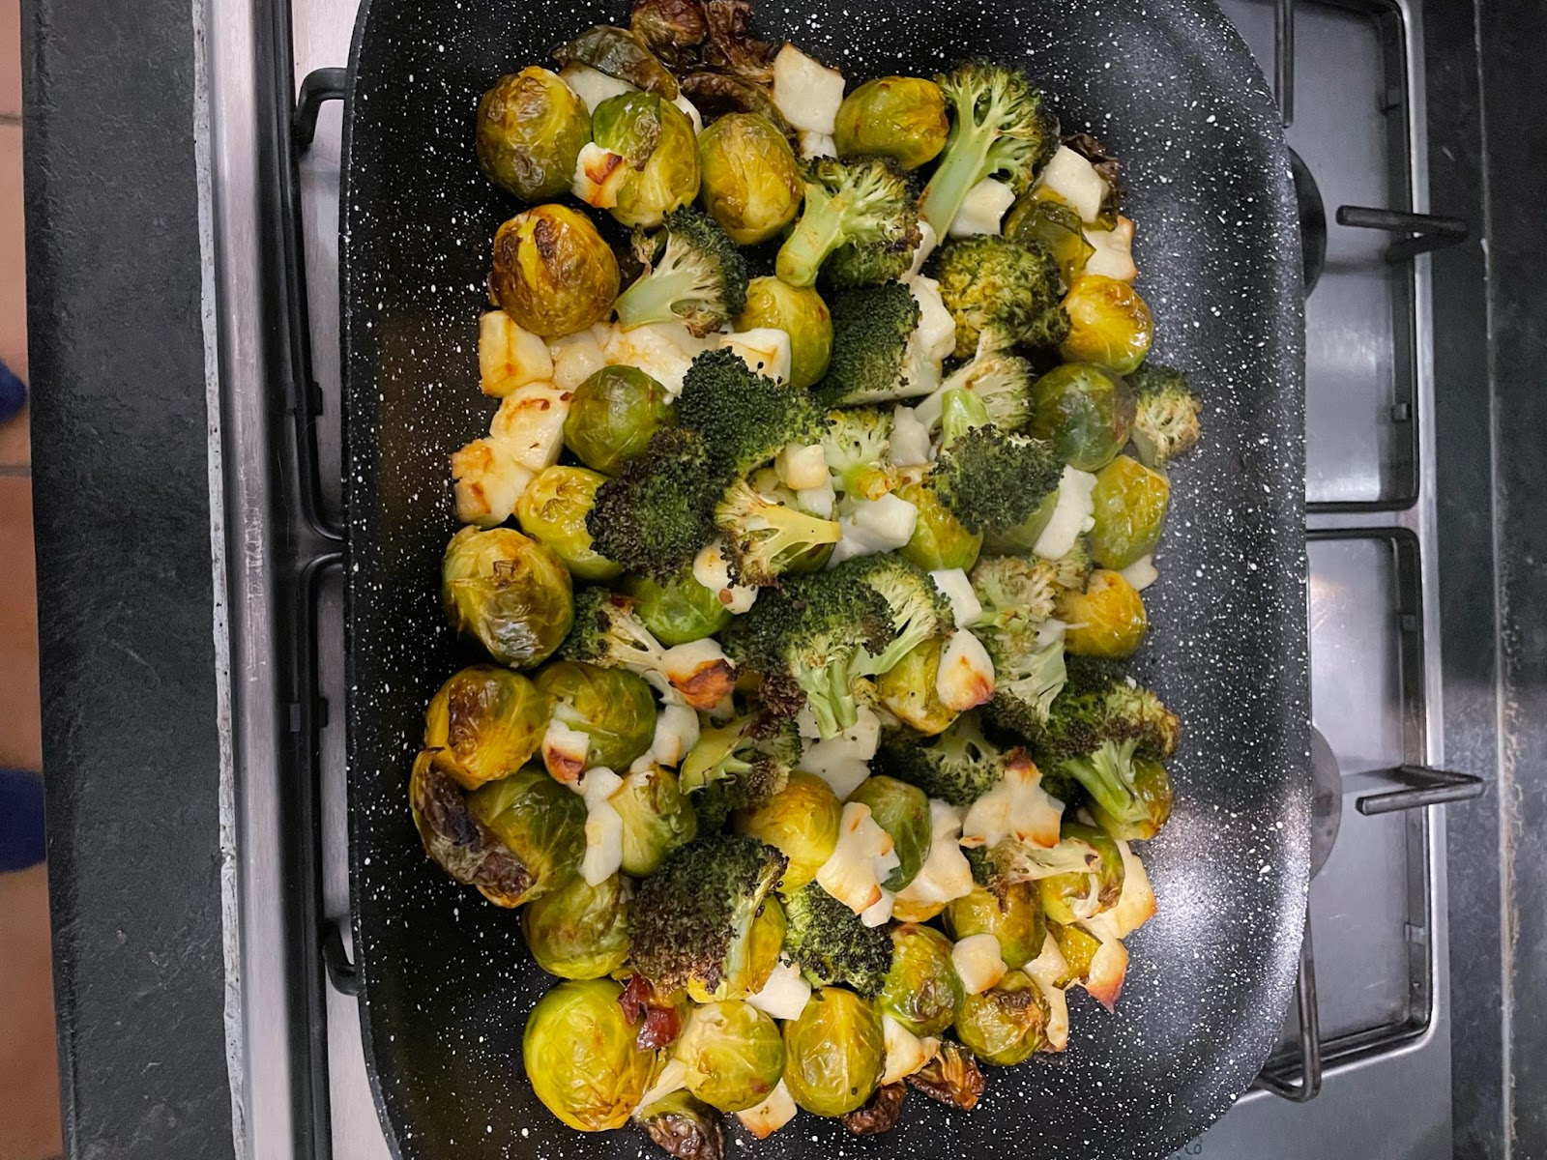

Taking part in this study has made me realise there’s so much more plastic packaging involved in food than I realised when I started. I think at the beginning I wouldn’t have easily been able to identify how much plastic packaging there is in my weekly shop or daily meals - but now it seems like there is loads! It feels like a lot. It feels like too much.

On Wednesday I got fully into the festive spirit with two Christmas outings! I had some toast for breakfast. Then for lunch it was a trip to [x] with my team, 10 of us altogether. We had afternoon tea – sandwiches, scones and mini desserts. Then for tea I was out with my old team – some of whom left for other jobs and others who have just moved across the district so I rarely see them anymore. We were at the [x], a pub just near where I live and I had the no chicken Katsu curry (the vegan option). Difficult for me to say how much plastic packaging was involved in these meals – but presumably quite a lot.
At our lunch we did a ‘secret santa’ gift exchange. I know that these sort of things are a ‘lottery’ - what you get depends on someone else’s picture of you and who you are – modified by their own taste and interests and reduced down to a £5 budget. I have had some lovely gifts over the years and some terrible ones. This year I received a ‘Jolly Holly, Festive play That Tune’ box. 4 plastic Kazoos and some cards with songs for you hum through them. Whilst I love playing games – this is not the sort of thing I can see me playing – unless its while entertaining the kids at Christmas. I’m also slightly appalled about the use of plastics for the Kazoos and can imagine thousands or even millions of these being produced which will all end up in landfill or the ocean eventually.

