PPIP Melissa’s Diary
Weds 12th Jan 2021
Taking part in this study has caused me to become quite aware of the plastic in my life. It’s everywhere! I always knew we were too reliant on plastic as a society but I am realising how ubiquitous plastic packaging is in my life.
I received a Tassimo coffee maker for Christmas from my boyfriend. I’d never invested in one myself before as I didn’t feel I needed one (I’m quite happy with instant coffee and my kettle), and I am aware the plastic coffee pods generate plastic waste. Anyway, it’s actually quite a nice little invention; I can have Costa coffee for a fraction of the price, and the different flavours available is pretty good. The machine came with some pods which I’ve almost used up so I guess I’ll have to buy some more. What’s worse, not using a coffee machine to avoid generating plastic waste, despite the coffee machine being manufactured etc.
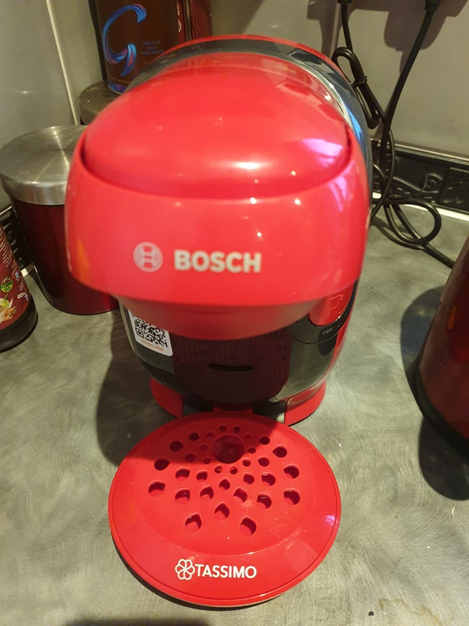
Tassimo coffee machine received as a Christmas present.
Thurs 13th Jan
I use a BRITA filter jug for my tap water as it taste bad (starchy and chlorinated). Before I invested in the BRITA jug, I would buy 2L bottles of mineral water and drink approximately 1 bottle per day. I must admit, the filter jug is pretty good but I occasionally (if the tap water is particularly chlorinated/starchy that day) then it still tastes bad. So recently I’ve been drinking bottled water when I just want water, but for anything else, juice, tea, coffee etc., I’ll use the filtered water. I feel bad generating plastic waste by buying all these water bottles (hence the investment in the filter) but I prefer the taste and believe it’s better for my health. I do put the water bottles out for recycling but I don’t know if they ever do get recycled. I’m not sure what to do with the filter cartridge itself so I through it in the general waste.
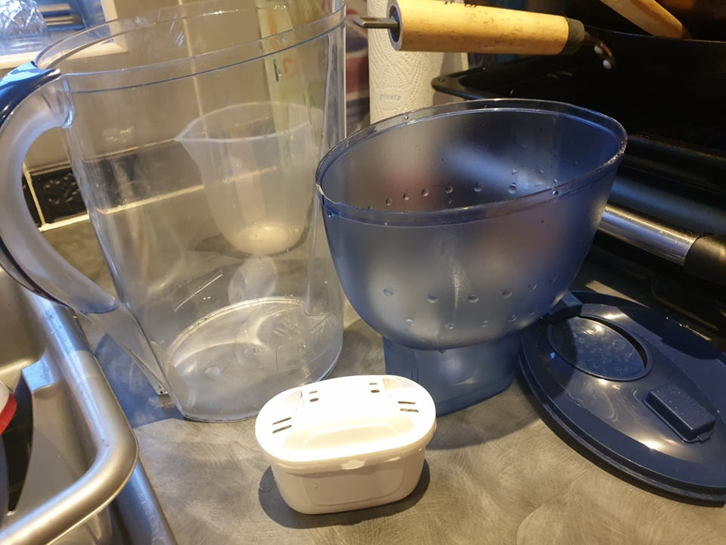
Deconstructed BRITA filter and cartridge.

Friday 14th
Had an interview with [researcher]. During which I said, I feel I’m ‘environmentally aware’, by which I meant I feel strongly about environmental issues. However, when [researcher] asked me to elaborate on things, I realised I didn’t know too much about plastic packaging, particularly what can and can’t be recycled. I understand plastic waste is a big issue, the characteristic that makes plastic useful (it is a stable yet versatile material that doesn’t react with the environment) is also the reason it is an environmental issue – it doesn’t decompose. Something I’ve been quite interested in and concerned about is microplastic accumulation in the environment and animals (including us)!
Saturday 15th
Bought a takeaway [x] in [x]. The food came in foil trays, and then in a big paper bag. For some reason, a plastic bag was used also – not sure why!
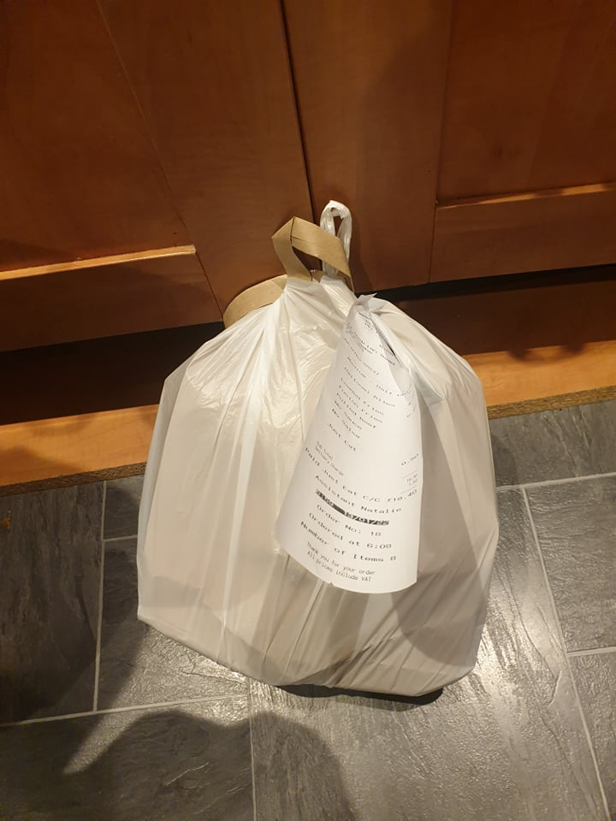
Takeaway in a pointless plastic carrier bag.

Monday 16th
I like to try and take care of my microbiota and so buy Actimel (contains live cultures of Streptococcus thermophilus and Lactobacillus bulgaricus) for myself and my boyfriend. My boyfriend suffers from irritable bowel and has quite a bad diet, so he also has Actimel to help his bowel health. Unfortunately they come in little plastic bottles, but I do put them in the recycling. I wonder why they don’t use little cardboard cartons like fruit juice?
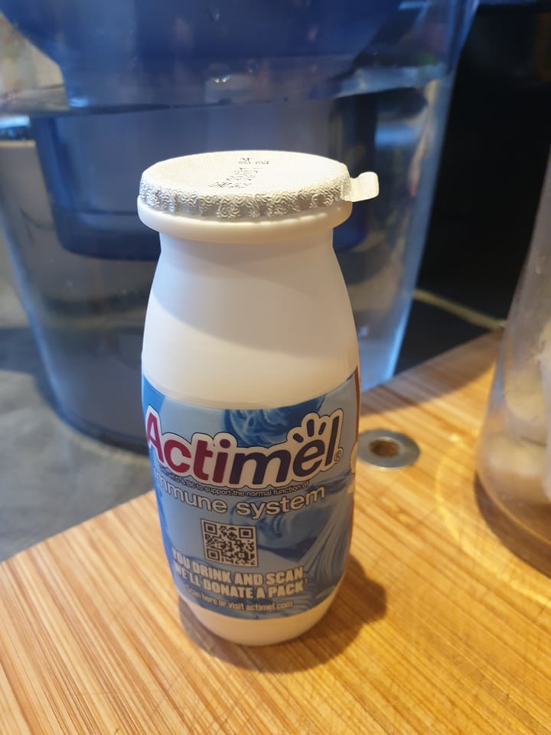
Actimel bottle.

