Katie PPiP Diary – Week 2
Weds 19th Jan
Went to the shop for cat food, water, and lunch.
For the cat I got the Gourmet mousses (left of photo below). Each portion comes in a little white plastic pot. The food I usually get her comes in tins.
The bottle of water I bought was a plastic 2L bottle.
For lunch I picked up some bananas for my smoothie, plus a pot noodle as I just fancied one. However when I got home, I realised I had no other ingredients for my smoothie so just had the pot noodle.
I put the plastic cat food pot, pot noodle, and water bottle in the recycling when I’d finished.
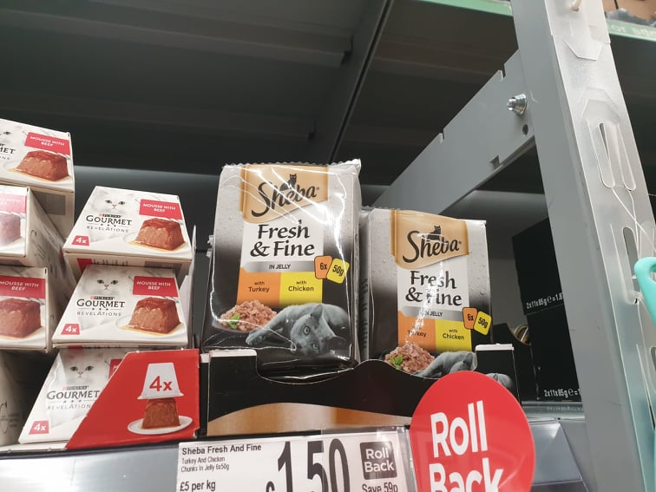
Thurs 20th Jan
Made ‘boil in the bag’ kippers for lunch, with some mixed salad (from a bag). The kippers come in a plastic bag which you put in hot water for around 12 mins. I’m not keen on heating food in plastic packaging (e.g. microwavable food usually) because of the risk of migration of the packaging chemicals into the food. I’m not keen… but I don’t avoid it completely. When life feels rushed and stressful I don’t always have the energy to be health and environment conscious, which is when I lean towards convenient foods. However when I’m feeling motivated and on top of things, I tend to eat more fresh, less processed, and healthy food, which also happen to be better for the environment (less processing, less packaging).

Fri 21st Jan
Lunch
Wasn’t sure what to do with some vegetarian sausages we’d picked up (to try). So I fried them, chopped them up, and put them with some mushrooms, onions, chopped tomatoes, and organic mixed beans, with some salad leaves. The sausages were really awful! They tasted of sour mush. I usually make this meal but sometimes add chorizo instead of the sausage, which is delicious, but I want to cut down on red meat. Anyway these vege sausages are not an acceptable alternative!
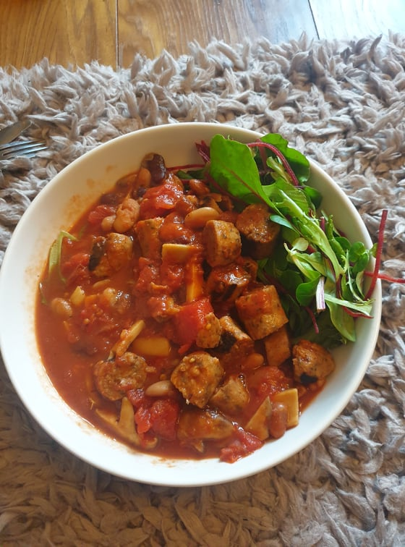
Dinner / or tea as we northerners say
We ordered from the same Fusion takeaway as last week, including half a chicken, a mushroom and halloumi wrap, some loaded fries, and extra halloumi bites (too much food for 2 people in turns out, but it was 20% off)! It came in the usual packaging of paper bag, foil trays with cardboard lids, but no plastic carrier bag this week.
Sat/Sun
We spent the weekend visiting wedding fayres (exhausting), and so we ate whilst out and about. We got McDonalds once, and Greggs one day, and managed to get some food tasters at the wedding fayres.
For tea on Saturday night, we had some cheese dips, e.g. camembert and a cheddar melt pot. We cooked up some chicken nuggets and other breaded things to dip in. To be honest we were just trying to use up what food we had in, but it felt disgustingly processed, and I didn’t feel too great for it the next day.
Mon
We did a big shop in ASDA which ended up costing me £89 for some reason. Since discovering I am pregnant, I have tried to buy organic options. Perhaps this is reflected in the price, but we also may have got carried away this week. Photo below shows fridge and cupboard (we didn’t buy all of that this week – it’s just to demonstrate the amount of plastic). Please note the sheer amount of cheese, chocolate/fudge, and alcohol is due to Christmas and we’ve not managed to get round to eating/drinking (not that I will be drinking).
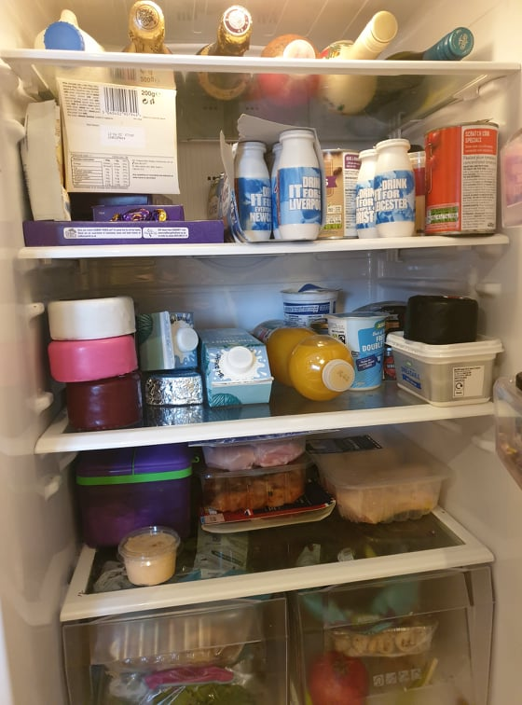
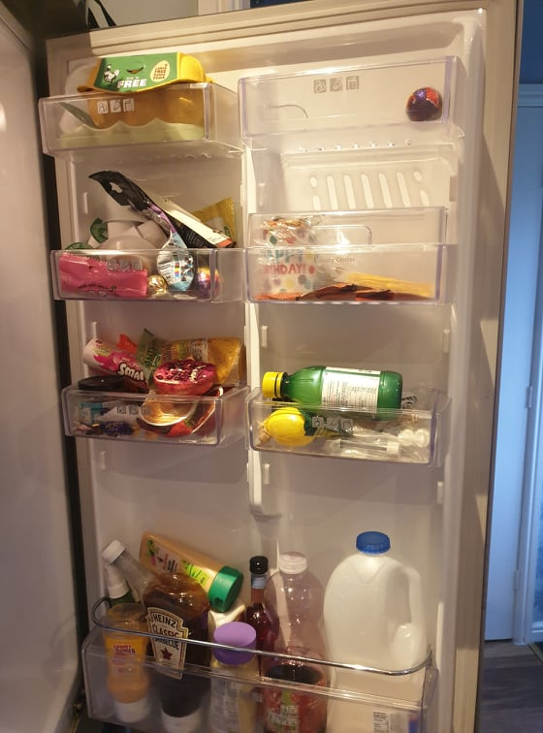
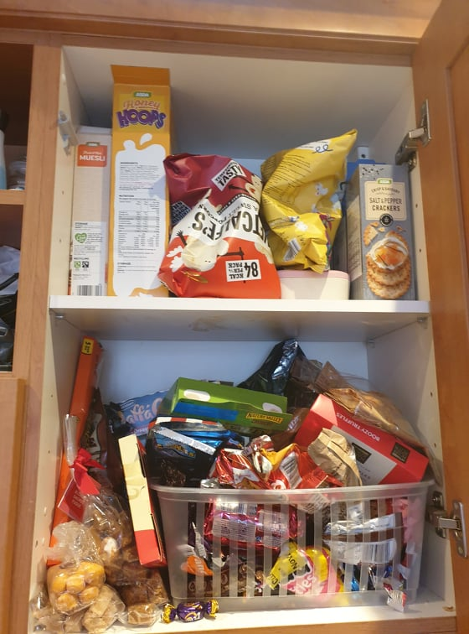

Tues 25th Jan
Discovered my water bottle is made from recycled plastic. That makes me feel a little better about buying bottled water.

