PPiPL Diary Week 3
Weds 26th Jan
Got a couple of reduced price croissants from ASDA for around 30 pence each. I took the plastic bit off and recycled the paper but not the plastic.
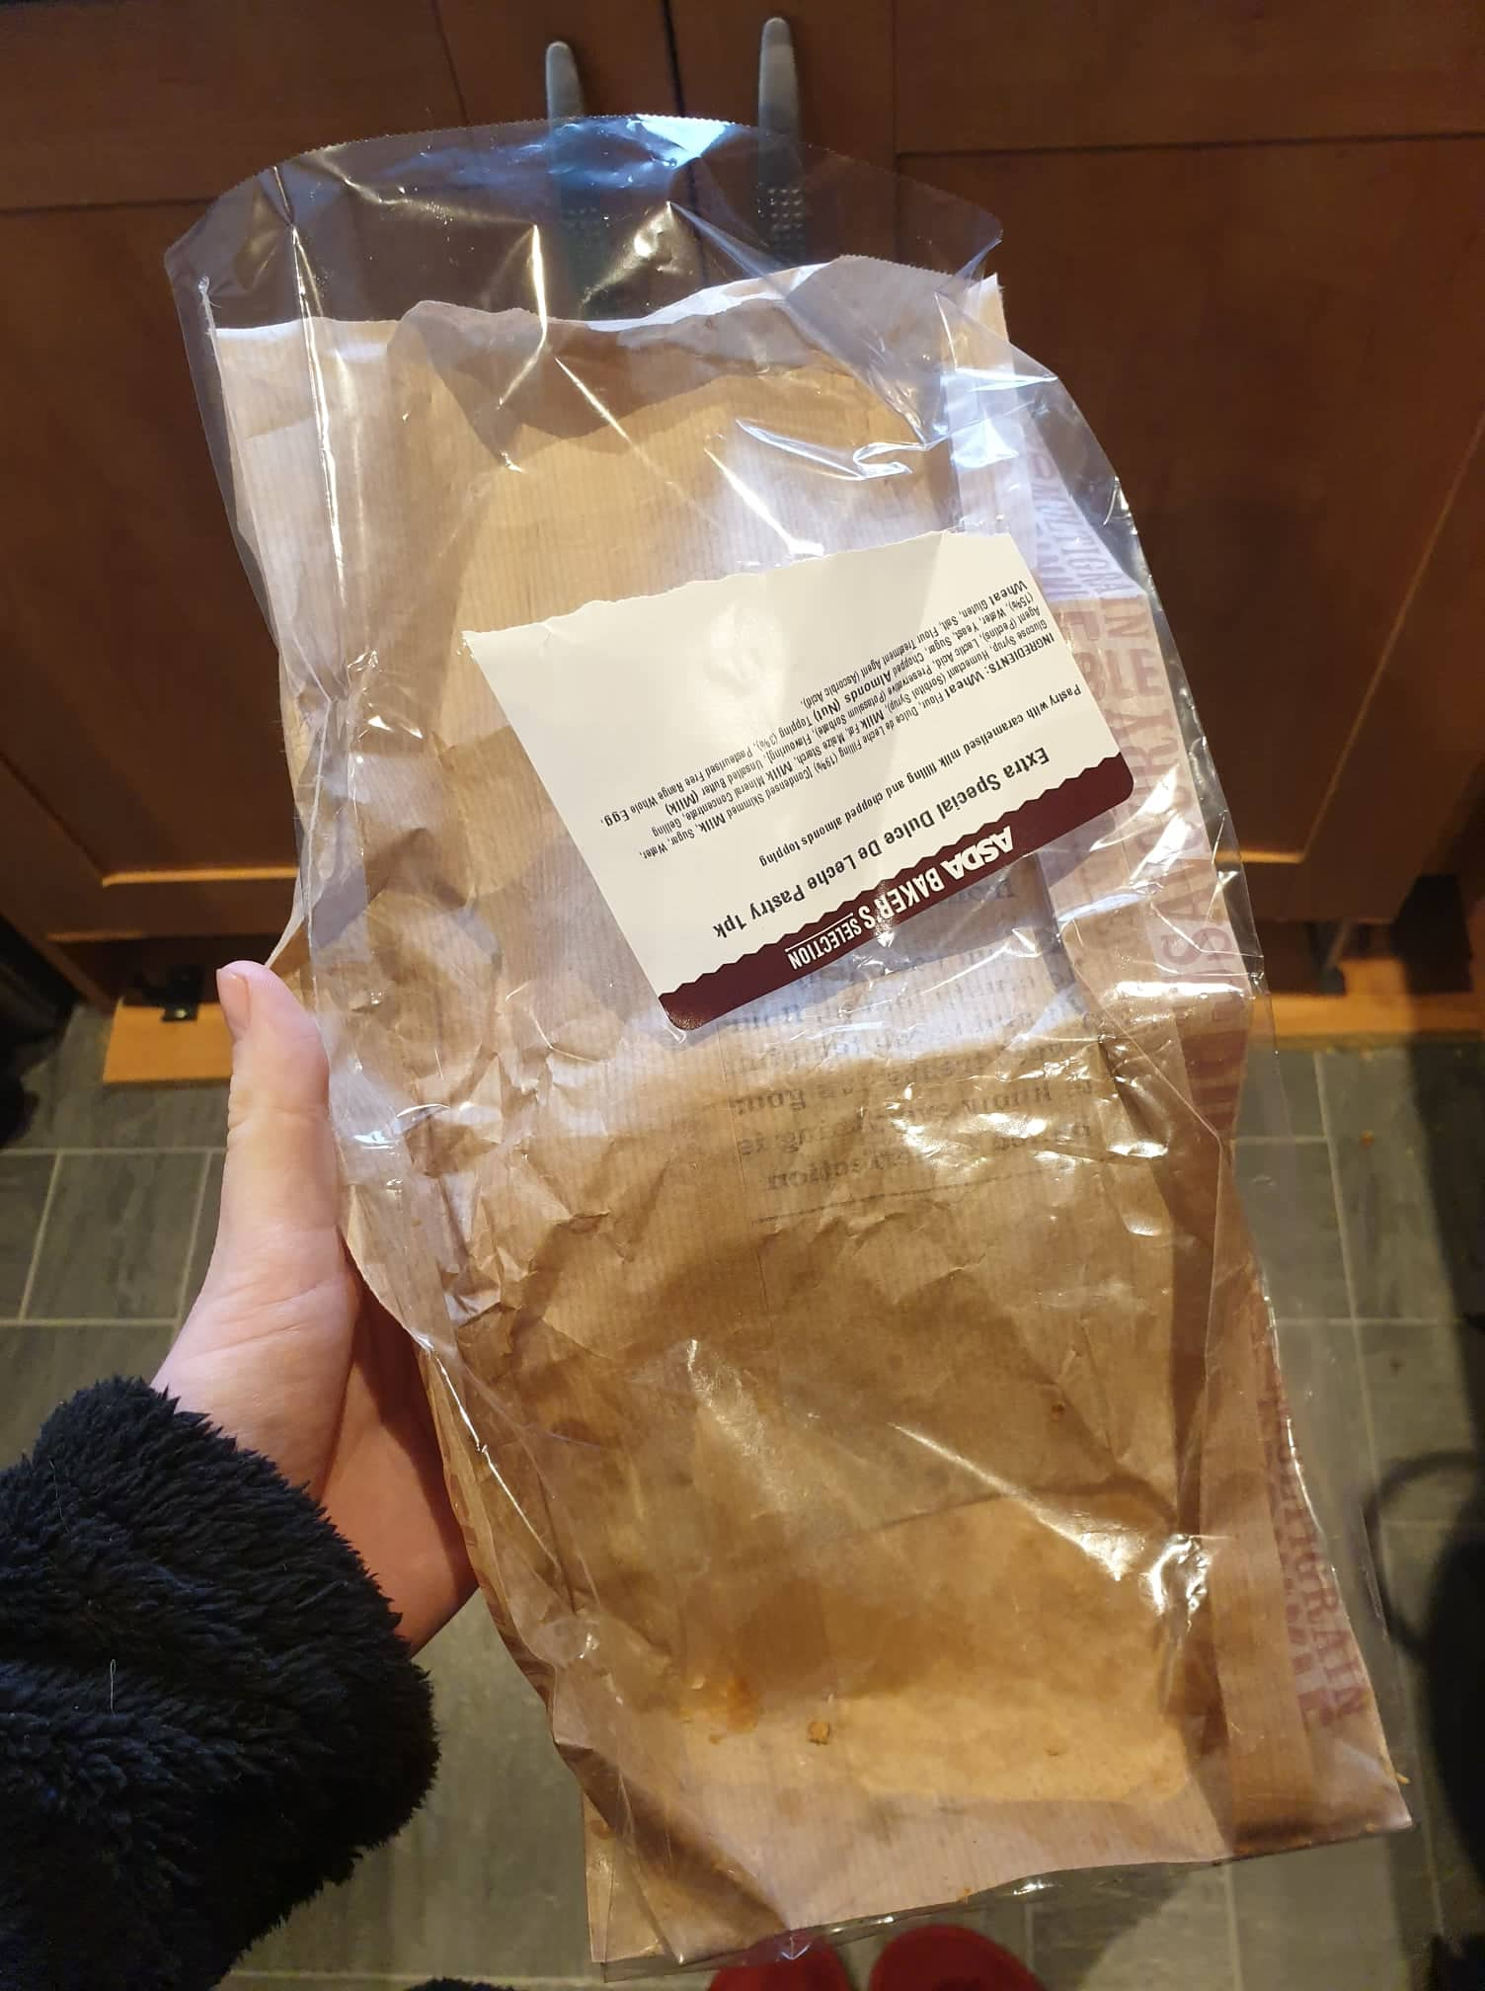

We had stir fry for tea (again) which comes in a pre-prepared pack with raw chicken, chopped peppers, spring onions, and a sauce. The sauce and overall packet were in plastic.
Thus 27^{th Jan}
Have been feeling quite sick and not keen on lots of foods, tea, or coffee. Not morning sickness, but more like all-day nausea. Not been using the Tassimo coffee machine as a result. It also means I’ve been eating quite poorly, e.g. Pot Noodle as that’s all I could stomach. So much for my organic-only diet!
We had smoked gammon (in plastic packaging) with frozen chips (Boyfriend) and frozen/boiled vegetables (me).
Saturday 29th Jan
Had a cheese toasted dusted muffin for breakfast with butter.
Sunday 30th Jan
Had my usual breakfast of a smoothie: banana, blueberries, avocado, coconut milk.
We went to view a wedding venue next to Ullswater and on the way back we visited the farm shop at Tebay services. We picked up a few nice bits I including: pick n mix biltong (in a plastic pot like fruit sometimes comes in), pick n mix truffles (in paper bag), a small choc fudge cake (paper and plastic), chocolate orange shortbread (plastic wrapping), a small cherry pie (cling film and foil), a chicken and chorizo scotch egg (cardboard and plastic mix box), a wild boar sausage roll (paper bag), and some reduced price goat sausages (polystyrene tray with cling film)! As you can tell, we tried to pick up things we don’t normally get from ASDA.
For tea we had two poussins which I picked up from Sainsbury’s the night before. I cooked them in a garlic butter and I had veg with mine, Boyfriend had chips. The poussins were delicious.
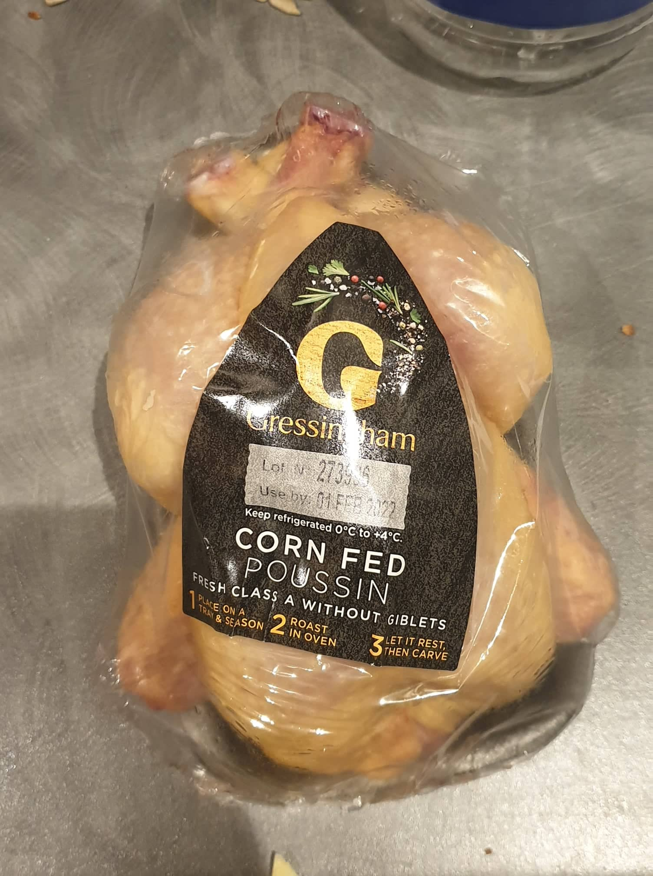

Monday 31st Jan
We had the goat sausages for tea, but Boyfriend ordered some chips from the Chip Shop to have with them, but unfortunately got the food delivered to a different address. So after about 2 hours of chasing down our food, we managed to eat. However I’d got too hungry by this stage and had already starting nibbling olives and cake from the kitchen!
Tuesday 1st Feb
I have been feeling very nauseous and all I have been able to think about eating is plain things like noodles! So went to ASDA and got a pack of super noodles, and some Naked egg noodles which said ‘50% less plastic’ but not sure what this is in comparison to. I bought some canned tuna and actually put this in the noodles – bit weird but quite nice. Also really fancied apple juice so picked up a carton of that.
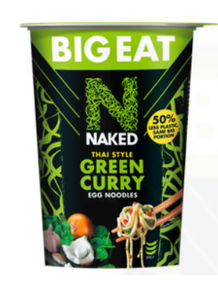
We did a food shop Tuesday evening and it was Boyfriend’s turn to pay. He wouldn’t buy the organic chicken as it was not in the ‘3 for £10’ deal. I put as much organic veg as I could in the trolley though, although the organic range is limited in ASDA.
Even though I am thinking about plastic a lot more now, I’ve not changed what I buy as a result, because it would just be too difficult to avoid. As consumers we do have a little responsibility to try and avoid unnecessary plastic, but it’s hard when there’s few alternatives. I’d love to be able to get all my veg from a local farmer’s market, fish from local fishmonger, meat from butcher etc… as I feel that uses less plastic and is better for the environment and the community for many more reasons, but supermarkets are much more convenient! Maybe if I go on maternity leave or when I retire, I can start doing that, but life is too hectic and busy at the moment.
Fridge full of plastic.

