PPiPL Week 4
Thursday 3rd Feb
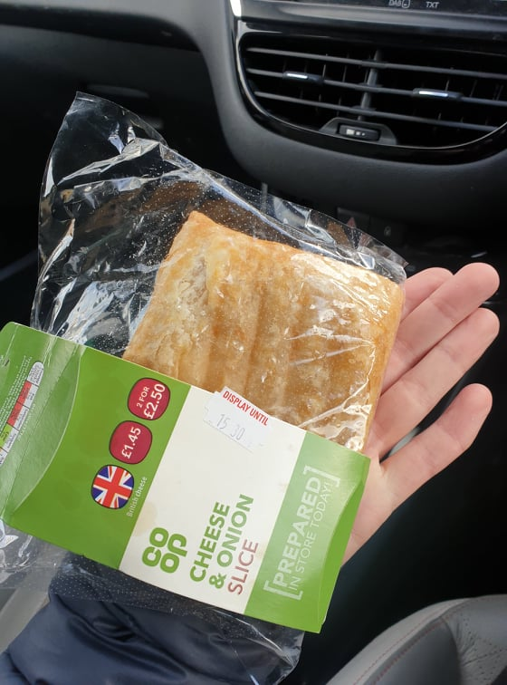
Was working out of office doing some visits and found myself very hungry all of a sudden. I popped into the Co Op in [x] and grabbed this cheese and onion slice as it looked tasty. I ate it very quickly before I noticed that it was actually quite grim. I felt horrible afterwards and wish I’d not ate it – really processed and stodgy. It came in this clear plastic packing which I chucked in the general waste bin.
Saturday 5th Feb
We went to [x] garden centre for lunch with [boyfriend]’s family (jacket potato and cake). I didn’t come across any plastic in terms of packaging whilst eating there.
Later on, we went to Bella Italia before going to a comedy show at the [x]. Again, I didn’t come across any plastic packing with my meal which was arancini to start, and mushroom pizza.
Sunday 6th Feb
My brother’s birthday at [x]. Again, I got suddenly very hungry (being pregnant, hunger seems to come on all of a sudden, when I don’t feel nauseous). I ordered a jacket potato with tuna and cheese which took 45 mins to arrive, so I ordered a pear (no packaging), packet of Seabrooks crisps, and a bottle of water (plastic) whilst I waited. The jacket potato came in a polystyrene tray with plastic cutlery. There was no need for the disposable packing as it was a café set up and they knew I was eating it there!
Monday 7th Feb
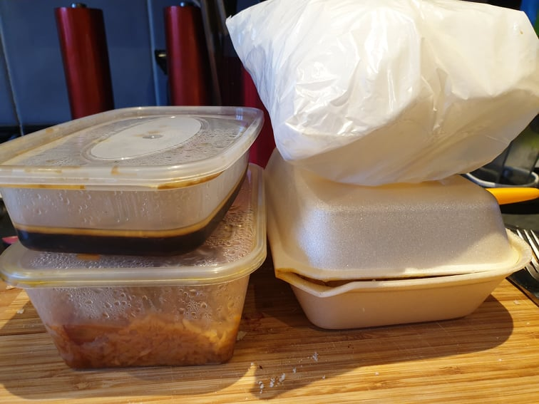
We ordered a Chinese takeaway and it came in a mixture of plastic and polystyrene packing (as above). We ordered salt and pepper chips (polystyrene), chicken and mushroom in black bean sauce, and duck/pork in BBQ with rice. The prawn crackers, white bag, were free.
Tues 8th Feb
The best before date on the bread muffins (see photo below) was 4th Feb but they looked fine up until the 7th/8th. So when I felt too queasy for a breakfast smoothie, I was having an egg on a muffin, sometimes with mushrooms too.

Note – my ‘organic’ diet has gone out of the window… Most of the time I feel nauseous, and I’ve gone off a lot of food. So I’ve mostly just been eating what my body wants on the day, but that’s not always ‘healthy’. I am still trying to eat a variety of food, and I find myself forcing veg and salad down, whereas I used to enjoy eating it! I am a big fan of apples at the moment though, although the 6 packs I buy from ASDA come in plastic. Since becoming pregnant, disappointingly I’ve been eating more rubbish, processed food, which I believe is also associated with extra plastic packing.
