PPiP Week 5 and onwards
Thurs 10th Feb
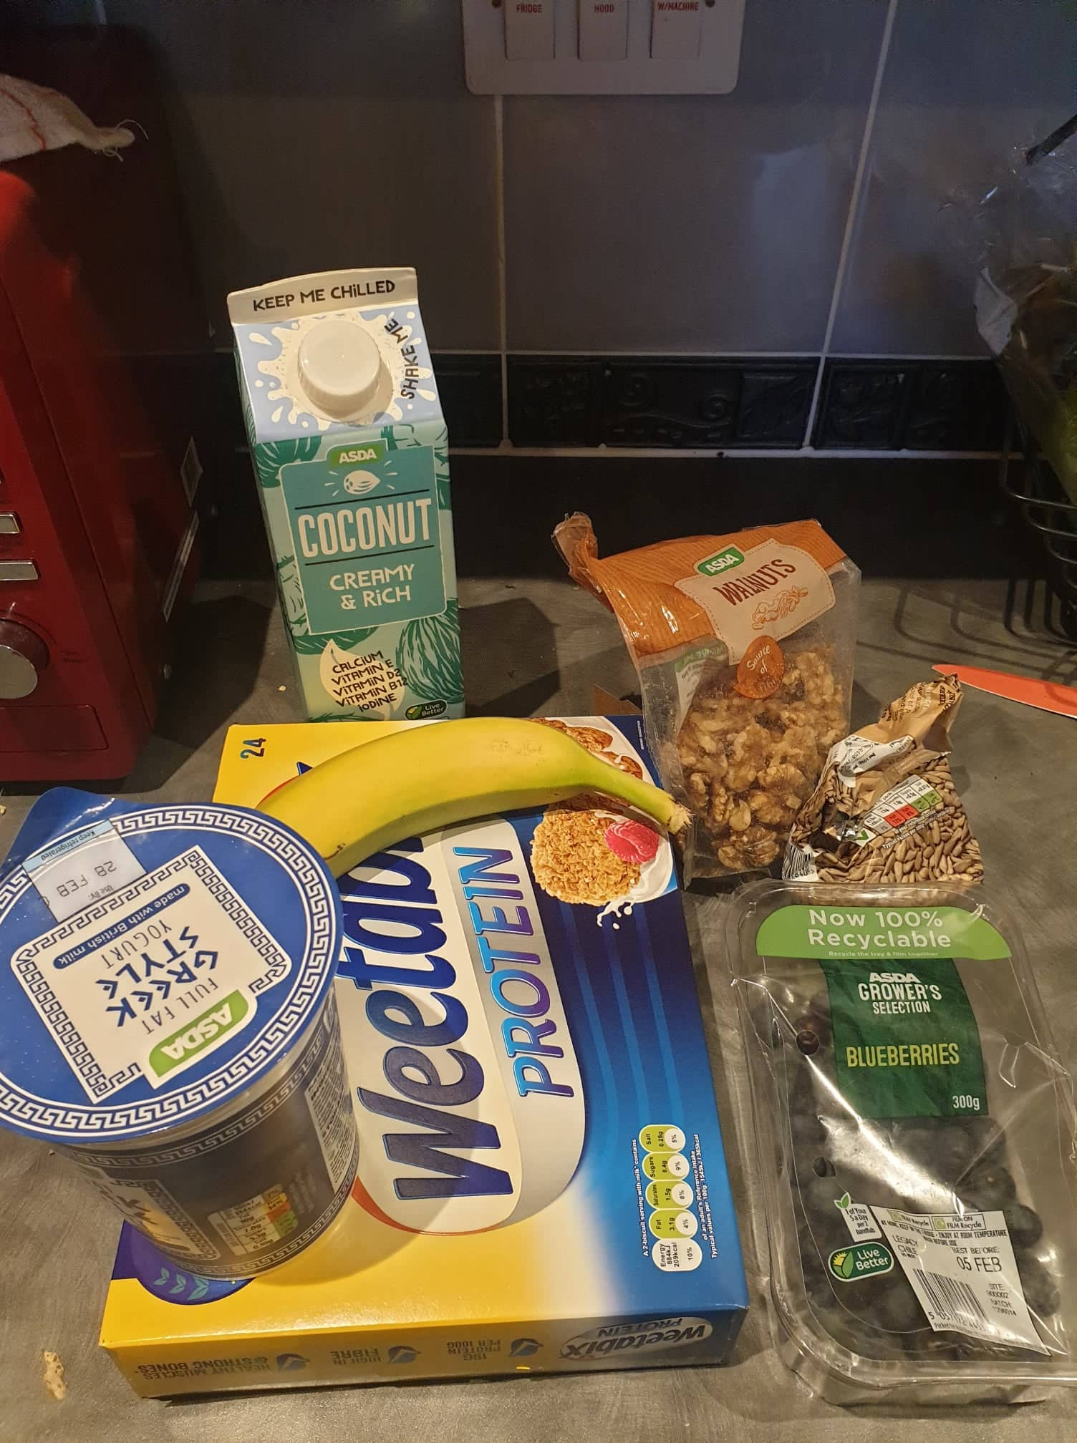
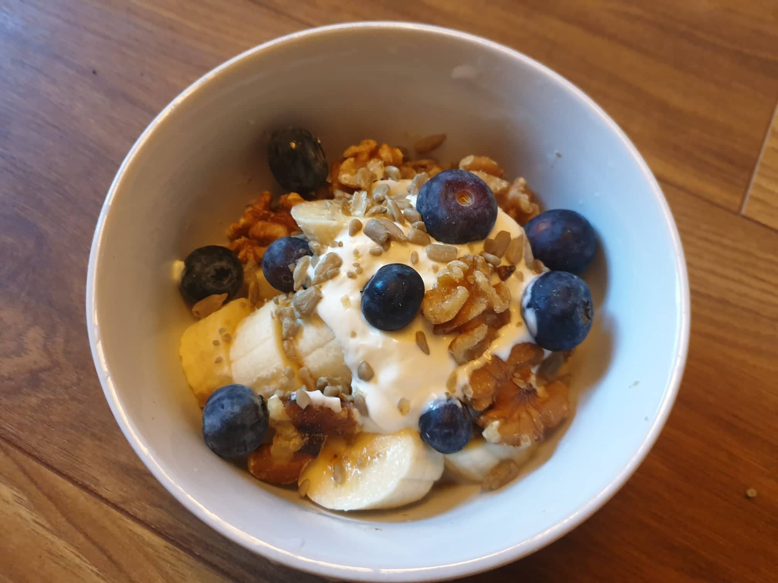
Breakfast: Weetabix as above. Photo above showing the ingredients and packaging used.
Lunch: Tinned tomato soup with seeded bread (as above)
Tea: Duck legs with chips and salad
14th Feb
Went for a Valentine’s meal at the [x] – a steak and seafood restaurant. I was feeling very nauseous and could only stomach steak and chips, weirdly enough. It was very nice though. I am wondering if eating in restaurants generates less or more waste than eating at home. [boyfriend] and myself have both worked in various restaurants (before we started our current career paths) and we were thinking about how the food would have arrived with the chef. Based on what we saw when working in restaurants, we think the potatoes for the chips come in huge sacks (maybe plastic), the veg comes in carboard boxes/trays, the prawns in plastic bags, and the steaks come in vacuum packs. However, this is a specialist seafood and steak restaurant and have local suppliers, so perhaps it is different for this restaurant.
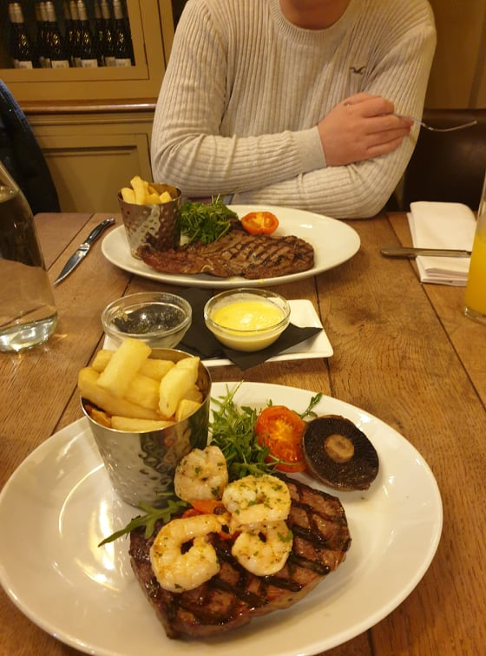
15th Feb
Fancied steak for the second time in a row. Chimichurri steaks from Booths were packed as the pork below. Dauphinoise potatoes were in cardboard but with a plastic seal lid. My salad came from a plastic back and the sun-dried tomatoes were in a plastic punnet.
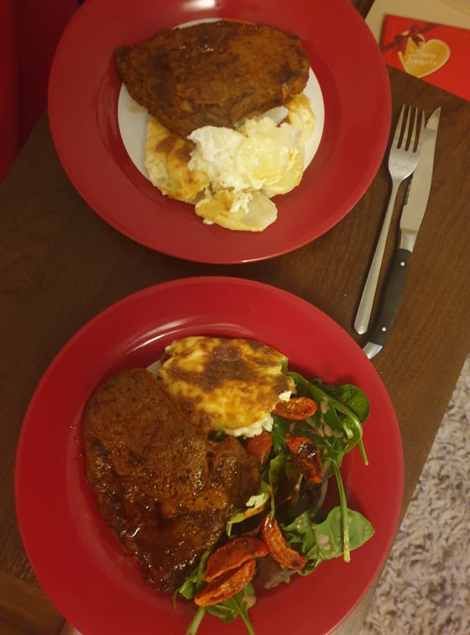
Pork and steak from Booths were packed in cardboard trays with a plastic film lid.
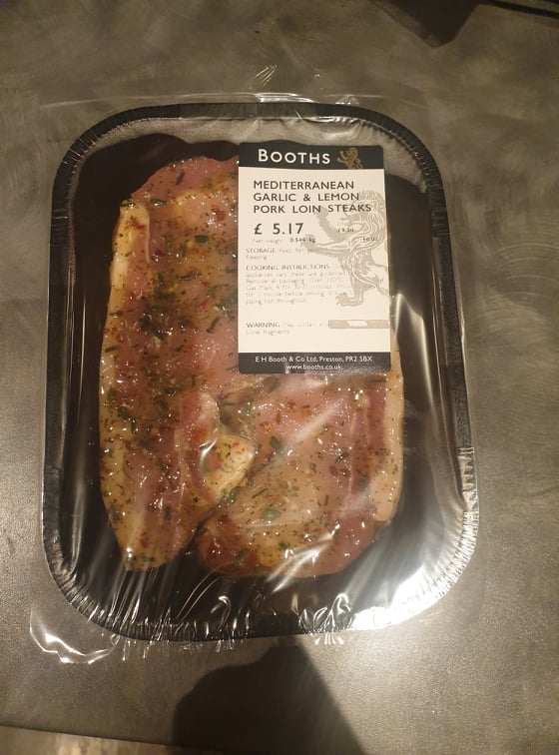
16th Feb
This week I’ve been really enjoyed seafood stick sandwiches. This is a photo of my preparing one.
The tiger loaf bread is in a mixture of paper and plastic, the crab sticks were in double plastic, and the mayo was in a jar.
You can also see the grapes in a plastic punnet in the background.
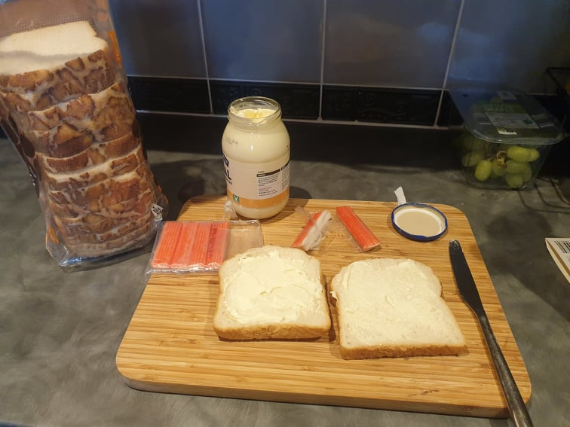

Really interesting article in New Scientist about waste. I found some of the stats mind-boggling. It talks about some positive things other countries are doing though. For example France has set a target of recycling all plastics by 2025, and phasing out single use plastic by 2040. The EU also plans to promote a circular economy. I hope the UK follows suit.

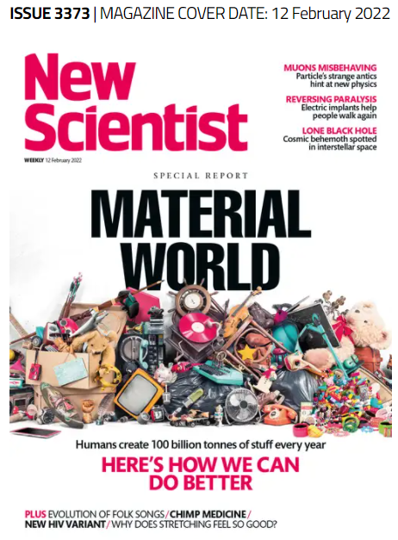
The end of waste: The grand plan to build a truly circular economy | New Scientist
There are about 4 articles on the theme in this issue and this is the first one^.

A little reflection
At the start of the study, I thought I was ‘good’ in terms of trying to reduce my plastic waste impact. I am quite interested in waste and environmental pollution which is what interested me in the study in the first place. I thought because I choose fruit/veg without plastic packaging when shopping, or pick up rubbish at the beach, never litter, use a reusable coffee cup, and do my bit of recycling, that I was environmentally friendly. During the study however, I was noting the amount of plastic in my life, and it made me realise I generate a lot, and 90% of it is from food packaging. If I continue to shop at ASDA it will be really hard to reduce the amount of plastic packaging I produce as it is ubiquitous. As an individual I could perhaps shop elsewhere, and I’ve stated before how I’d like to visit the farmers markets and but fresh produce etc., but that’s not feasible right now. I do think the responsibility is largely with the producer, but more pressure needs to be put on them from the consumer (like me – but easier said than done) but also regulators and perhaps the government. I think plastic waste though, like all other waste, and environmental pollution in general, is a symptom of our linear economy. I do feel a little helpless (in terms of trying to change anything) in the grand scheme of things, as any change I make will be a drop in the ocean, but I’ll keep doing my bit and try to improve the way I eat, shop, and deal with waste.

