2022-09-19 - Week 4 - Hannah's diary entries

Week 4

12/9

We made porridge in two very nearly empty peanut butter jars to have breakfast en route. This was partly due to a lack of other containers available but mostly due to it being a good way to use up the last of the peanut butter.

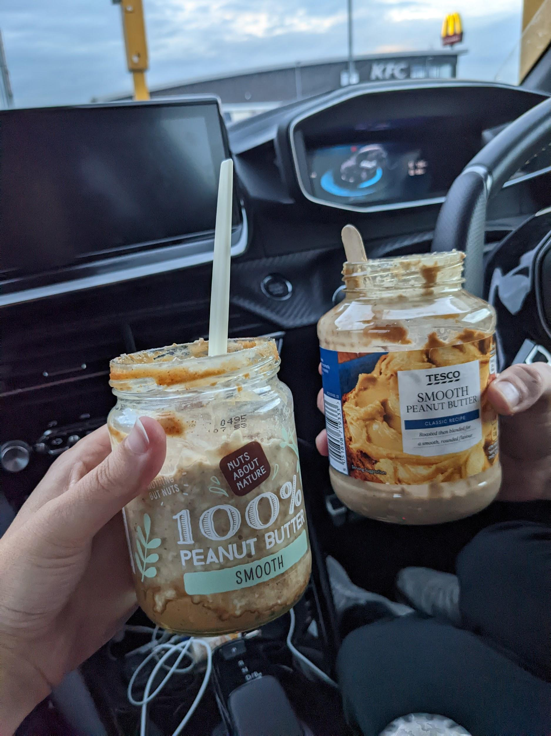

We didn't have coffee cups with us. I left mine at work on Thurs on purpose, but I'd forgotten about the drive home (back to my sister's house). It was 280 miles in an electric car...a very long journey. We left at 4:15am and arrived at 11:30am. [partner] was struggling so bought a coffee. We've still got the cup (writing this on Sunday) and I intend to take it to a nearby Costa or equivalent to go into their coffee cup recycling systems.

My sister forgot to cancel her Oddbox before going on holiday. She told me that she'd gone through it and "dealt" with anything that would need to be used soon. I think this means chopping it up and putting it in the freezer either in tupperware or a bag of some form. I was very glad that she did this because having to use lots of fruit and veg up quickly would have meant having to spend more time cooking than I felt I had time for/wanted to and would have made me stressed. I was aware that the fridge would still have quite a lot of fruit and veg in it though and so we would make meals based on what needed to be eaten first. I was glad for some food left in the fridge as it meant we didn't have to go shopping.

Most of the Oddbox was unpackaged, even a cucumber, which is rare to see. A brown paper bag was used for tomatoes. There was some form of lettuce which was in a clear plastic bag. I've washed the bag with the thought of being able to use it to put tupperware containing meals in inside my rucksack but it's got small holes in so might not be that useful and will therefore just go to the soft plastics recycling at a supermarket. My sister has a place to collect it next to the recycling bin in the kitchen. I appreciated having lettuce and cucumber when I wouldn't usually buy it because of the packaging.

We also had instructions from my sister to pick tomatoes from the garden when they went red.

We brought home quite a lot of food from my partner's parents' - 3 tupperware's of the curry he made last Monday (frozen), the remaining vegan cheese, some of the sandwiches that couldn't be sold on the van.

For lunch [partner] made one of the sandwiches into a toastie and I had salad with lettuce and cucumber from the Oddbox and tomatoes from the garden. We had one of the curry portions for dinner with chips because there were potatoes that needed using.

13/9
I'm getting the train at 5am to go to work on weds and getting a Megabus arriving back at 10:30pm on Thurs. I'm staying with family friends on wed night but it was suggested that I either bring food or suggest what to buy from Waitrose - I think this was partly down to me being vegan but also because he'd had a shoulder operation and was unable to cook as a result. Not wanting to buy anything for both money and packaging reasons I made 6 meals on Tues night. Two portions were the same as Tuesday night's dinner (curry and rice), two were something different - couscous with the remaining lettuce and tomatoes. I used jars for porridge for both breakfasts. The only stress in this preparation was that ideally I'd run to the station but this wouldn't all fit in my bag. This meant my partner needed to give me a lift at 4:45am. Once I'd come round to this idea it was easier to get the food ready because I could use tubs of whatever size. I also packed one of the packets of crisps that came from my partner's grandparents. I'd usually probably just let these sit in the house because they're not what I normally eat but moving has made me think about decluttering and these crisps really don't need to move with us. They're already past the best before and best used ASAP.

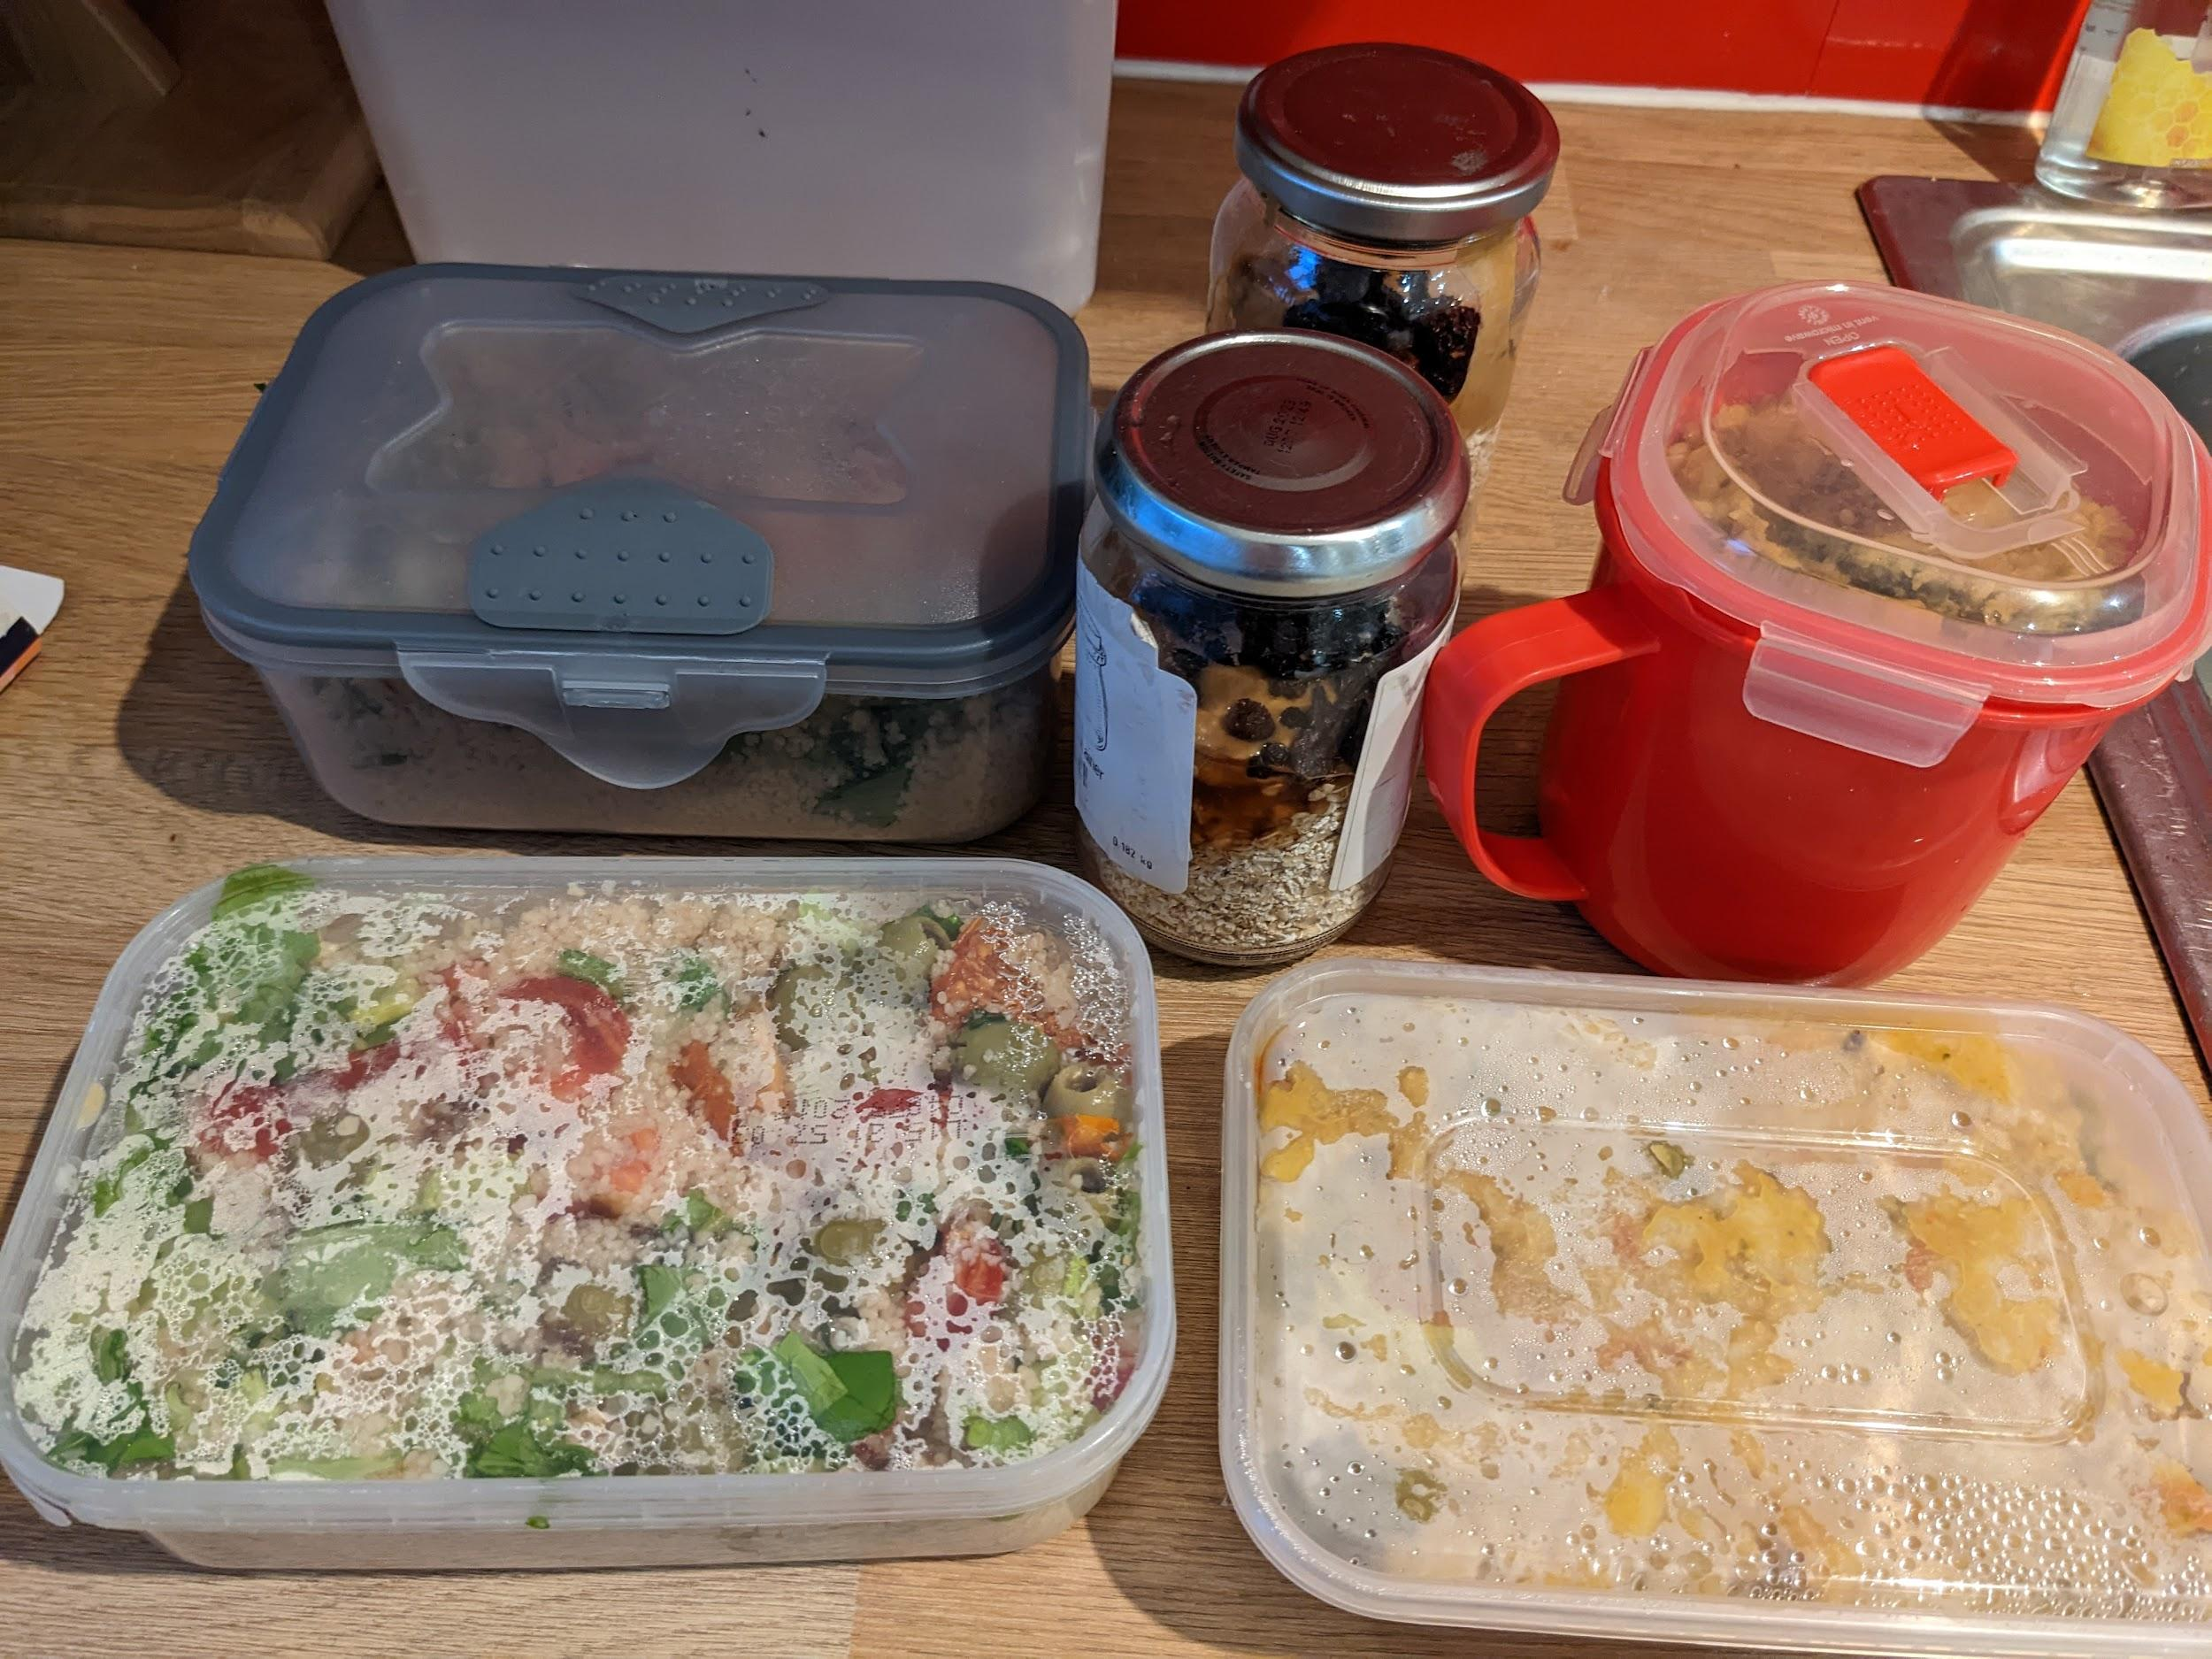

14/9
Part way through the day the family friend I was staying with said we could go out for dinner, "no need to buy anything". I didn't tell him I'd already made food - it was in the fridge at work so it would be fine for lunch on Fri and therefore nothing would be wasted. The only food/drink I had at theirs was a cup of chamomile tea - I noticed this was in a plasticy-foil looking bag inside a cardboard box. I haven't bought tea bags for ages (probably over a year) but when I do I try to buy boxes which are just tea bags in a cardboard box with no film. Making my own meals and taking them with me to work is much less stressful for me than buying on the go even though it takes a bit of time to prep. This is because I can control the packaging as well as how healthy it is. Also because it's cheaper and I'm spending a lot of money on train/bus travel.

16/9

I'm WFH today so no preparation required for meals. My partner had another of the sandwiches (still being stored in the freezer) for lunch. I had the unused meal from yesterday. For dinner we had another portion of curry from the freezer with rice. We put the bread machine on so that we could have bread before parkrun in the morning. With all the veg in the house and food in the freezer I feel like I didn't have to think about packaging much this week because we didn't need to shop.

17/9
We planned to have (fake) burgers, chips and coleslaw for tea so we needed to buy the ingredients. I also planned to go to a refill shop seeing as I had the time with no other plans for the afternoon (the same one as two weeks ago). I wanted to buy pasta, more coffee beans because there weren't many left and I didn't want my sister and her husband to come home to us having used them all, and peanuts as the shop didn't have any last time I went and they were on my sister's list. I also needed to go to a bike shop because I had a problem with my wheel. There was a greengrocer a few doors down from the bike shop so I bought 2 carrots and a red onion from there using my veg bags. It came to 45p - I actually felt a bit embarrassed about how little I was spending but it shows how only buying what you need means that shopping at places that would be perceived to be more expensive, without packaging, is really not. There was also a bakery so I looked through the window for bread rolls but couldn't see any. I saw a couple of other bakeries on my way to the refill shop but it was mostly cakey things. I also went into a Tesco express but all the bread rolls were packaged up. I was pretty sure I'd be able to get rolls from coop, or at least Lidl (near my sister's but the opposite direction from where I was shopping), so I didn't mind the failed attempts. I just thought it would be a bonus if I found them earlier. Being in a city there are so many shops in a small area..plus I was running so if necessary I could cover more distance than walking in a reasonable time. In the end I bought frozen burgers and bread rolls from coop. I used a cotton produce bag for the rolls. They were slightly more expensive than the packaged up rolls but not significantly. At the till I just told the lady behind the checkout that the bag contained four white rolls and opened it a bit to show her and she didn't have a problem with it. I also bought some chocolate in foil and cardboard - the packet told me that the inner packaging was foil which made it really easy - often it's possible to peek inside the cardboard layer to see what the inner packaging is but this a bit more awkward. I also try to remember which brands use foil instead of plastic. We buy frozen burgers because they come in just cardboard, whereas ones in the fridge come in plastic trays with plastic film.
The refill shop had pasta, but only a tiny amount of coffee beans. I took those anyway but asked when the next delivery was expected- I was told Tuesday so ready for wed when the shop is next open after the weekend. This week I'm WFH on wed so I will be able to go. I also asked about peanuts and there weren't any. Bombay mix was offered instead - not what I wanted, but it's nice and I had a spare container so I went for it anyway. I didn't mind that I couldn't get everything I wanted, nothing was urgent and I expect it from these kind of shops. I think it's part of the adaptation we all need to make, towards the practices of many years ago when we can't expect to get everything and anything at almost any time. We need to do this in order live more sustainably - that is, use less packaging and waste less food. To be honest I also just appreciate that these shops exist, especially as lots are struggling/closing down at the moment.
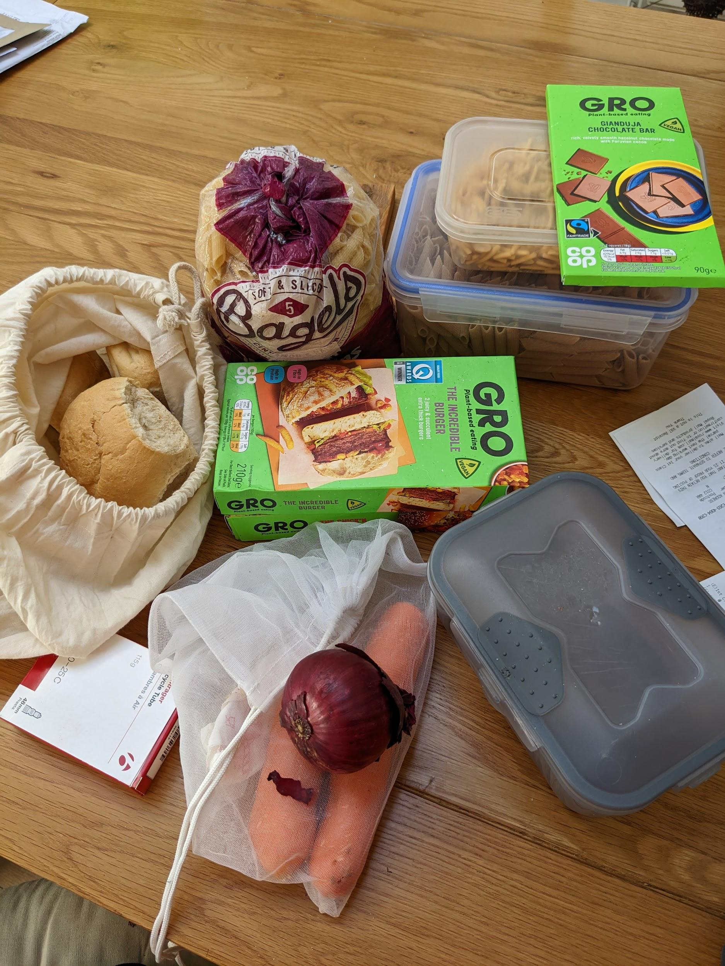

Later my partner and I walked to the nearest Coop to buy pepsi for my partner and diet coke for me and my sister and coke zero for my sister's husband for when they got back from holiday on sun (we can't agree on the best cola drink!). 1.5L bottles were cheaper per 100ml than 2L. We discussed whether we should get larger bottles because it's less plastic but in this case, money won and we went for the cheaper option of multiple smaller bottles. We took the current collection of "soft plastics" with us. I kept the outer bag which is from a bedsheet as it seemed like a useful one to collect the next load in.
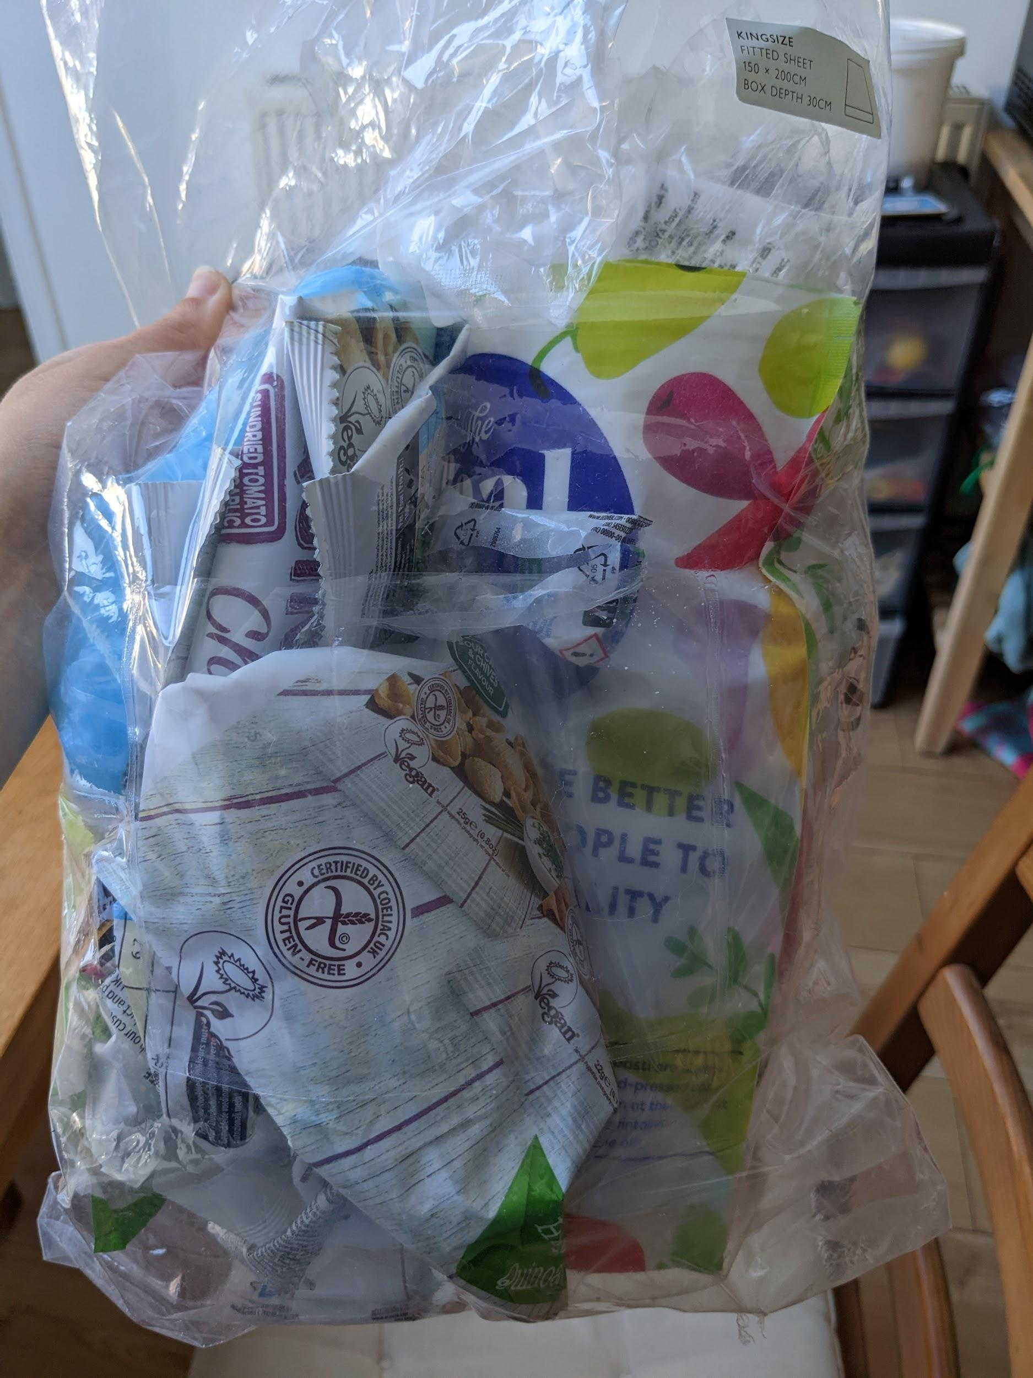

This evening we went to watch something at the arena. All drinks were served in single use plastic cups. I felt bad about using one but in this case not bad enough not to. I was prepared to take it home with me but one of the bins was clearly marked as mixed recycling so I put it in there.

18/9

My sister and her husband arrived home about mid-day. We all had dinner together, mostly cooked by my sister. She made pesto because they've managed to grow quite a lot of basil. There was also a small bag of pine nuts in the cupboard (plastic packaging). We had a discussion about where they'd come from as it's not something either of us would have bought due to the packaging and also the price of pine nuts. We're still scarred by the time we filled a jar in a refill shop and it came to almost £20. It was when we were still learning how to shop that way! We decided it must have been her husband's mum last time she stayed and offered to cook one evening, but then plans changed. Seeing as the product and packaging was already in the house it made sense to use them and be grateful. We had pesto pasta, also with some tomato.

