# Slack Integration Guide with PagerDuty

**How it Works ?**

* Users can trigger, acknowledge, resolve, escalate, add notes and run response plays within Slack, which will send events to PagerDuty, resulting in the corresponding incident actions.
* When a PagerDuty incident is triggered outside of Slack, an event is sent to the mapped Slack workspace, which generates a message with the incident's details in the designated channel. Users can then perform actions (listed above) within Slack, or within PagerDuty, and the actions will be synced bi-directionally.

# Integration Walkthrough:

## Initial Configuration

To begin the integration, you will need to map your PagerDuty account to your Slack Workspace. If this has already been performed, please skip ahead to the [Add the Slack Extension to a Service](https://support.pagerduty.com/docs/slack-integration-guide#section-add-the-slack-extension-to-a-service) section.

1. Navigate to **Apps & Add-Ons**   **Extensions**.
2. Select **Slack**.
3. On the Slack Workspace Mapping screen, click the **Install App into Workspace** button to connect your PagerDuty account to your Slack workspace. Connecting your PagerDuty account to your Slack workspace ensures that the PagerDuty bot is present and that PagerDuty slash commands can be executed from any Slack channel.
4. On the next screen, you will be asked to authorize the PagerDuty for Slack extension to perform the following actions:

* **Confirm your identity on PagerDuty**
* **Access and modify information about your channels**: In order to send prompts to Slack users to associate their Slack and PagerDuty usernames, the extension needs to obtain user IDs from the associated channel. The modify channels access is only used for the per-incident, on-demand Slack channel feature.
* **Add slash commands and add actions to messages (and view related content)**
* **Access information about your workspace**: This allows the extension to access your team’s profile information and it is used for Slack user association. The list of members from the channel endpoint only gives PagerDuty your Slack ID and this allows it to obtain necessary usernames.
* **Send messages as [Workspace Name] for Slack**: This allows the extension to post to specific channels in your Slack workspace.
* **Access your workspace’s profile information**: Similar to the above, this allows the extension to access your team’s profile information and it is used for Slack user association. The list of members from the channel endpoint only gives PagerDuty your Slack ID and this allows it to obtain necessary usernames.
* **Send messages as you**: This is used to post notifications into the selected channel when a PagerDuty incident has been triggered, updated or resolved.

Click **Allow** to authorize. Once this step is complete, you can then begin connecting PagerDuty services to a specific Slack channel. Continue to [Add the Slack Extension to a Service](https://support.pagerduty.com/docs/slack-integration-guide#section-add-the-slack-extension-to-a-service) to complete the integration.

## **Add the Slack Extension to a Service:**

1. Navigate to **Services**  **Service Directory**  click the **name** of your desired service  **Integrations** tab  **Add or Manage Extensions**  **+ New Extension**.

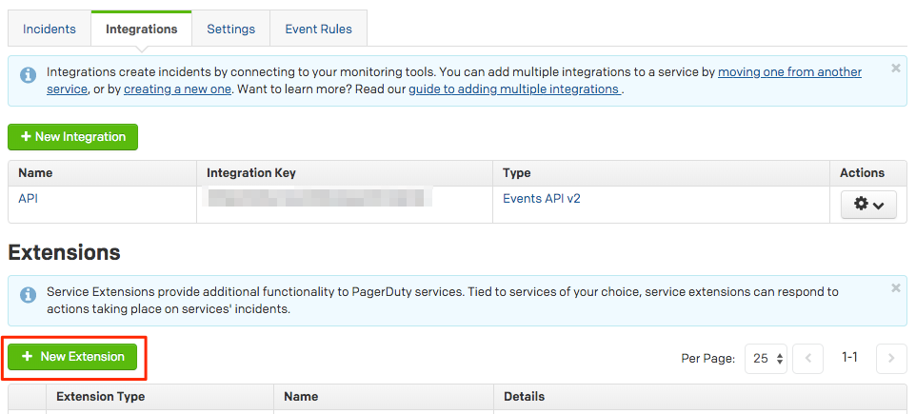

1. Select **Slack V2** from the dropdown menu and enter a friendly **Name** for the integration, such as SlackV2-Service-Name (e.g. If your service name is Shopping Cart, the extension name would be SlackV2-Shopping-Cart). Next, select the **Service** that you would like to integrate with the Slack extension. In the **Details** section, you can select which updates you want sent to Slack: **Escalate**, **Resolves**, **Acknowledgements**, **Reassign** and **Notes** actions. Click **Authorize** to continue.
2. On the authorization screen, ensure that you are in the correct Slack **workspace** by checking the dropdown in the upper right hand corner. Please note that if you plan to use Slack V1 and V2 at the same time, you will need to integrate Slack V2 into the same workspace. Next, in the **Choose a channel...** dropdown, search and select the channel where you would like PagerDuty to send messages. This authorization screen has many of the same permissions listed above in step 4, with the following differences:

Once you have reviewed these permissions, click **Authorize**. You may add the Slack extension to multiple services.

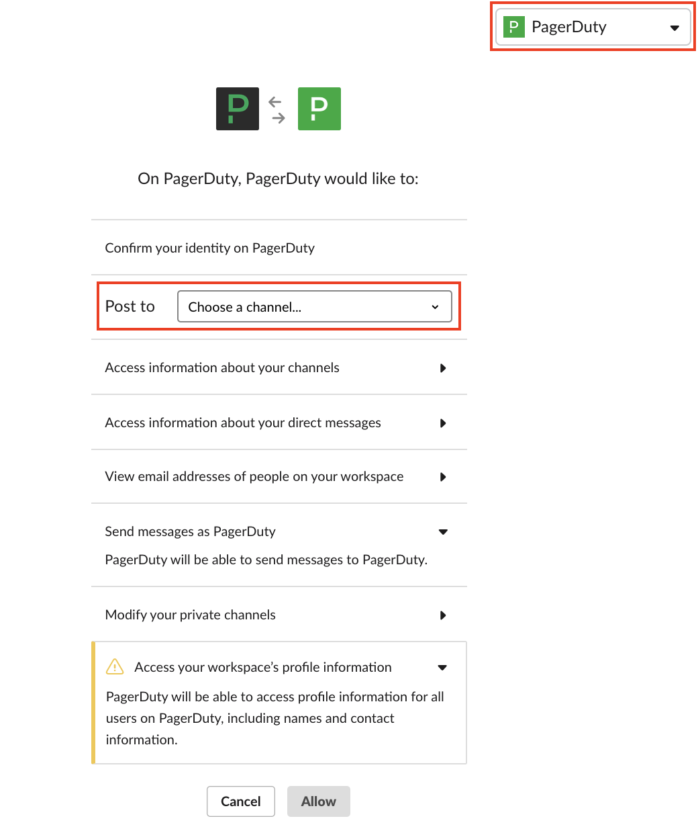

1. The Slack integration is now complete. You should see a message in your designated Slack channel that the PagerDuty integration has been added. If you set up the integration on a private channel, add **@pagerduty** to your channel.
2. When an incident is triggered, the trigger message in Slack will show **Acknowledge** and **Resolve** buttons, and under the **More actions…** menu, you will see the options **View Details**, **Add a Note**, **Escalate** or **Run a Play**.

