**Bihar**

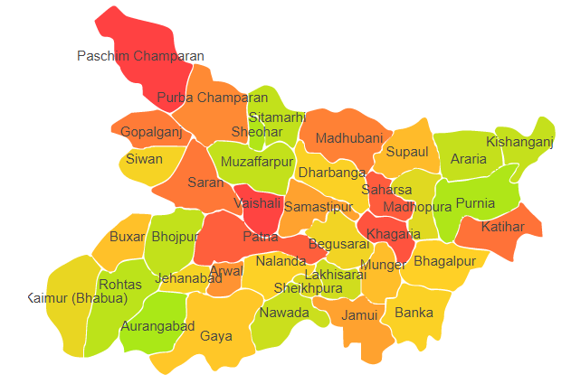

Bihar comprises of two Agro Ecological Regions (AER) namely 9 and 13.

**Agro-Eco Region 9:** AER 9 in Bihar comprises of Arwal, Aurangabad, Bhabua, Bhojpur, Buxar, Gaya, Jahanabad, Nalanda, Nawada, Patna, Rohtas and Sheikhpura districts of Northern Plain under Agro Ecological Sub Regions (AESR) 9.2.

**Agro-Eco Region 13:** AER 13 in Bihar comprises of Arariya, Banka, Begusarai, Bhagalpur, Drabhanga, Gopalganj, Jamui, Katihar, Khagaria, KishanganJ, Lakhisarai, Madhepura, Madubani, Munger, Muzaffarpur, Pachim Champaran, Purba champaran, Purnia, Saharsa, Samastipur, Saran, Sheohar, Sitamarhi, Siwan, Supaul and Vaishali districts of Eastern Plain under Agro Ecological Sub Regions (AESR) 13.1.

**Major NRM issues :**

**AESR 9.2 :** The region is hot dry subhumid ESR with deep loamy alluvium-derived soils, medium to high AWC and LGP 150-180 days in a year.

|  |  |  |  |  |
| --- | --- | --- | --- | --- |
| **Districs** | ***Land degradation*** | ***Soil health & fertility*** | ***Water related constraints*** | ***Environmental constraints*** |
| Arwal | Water Erosion | Soil deficient in Zn, Fe, Cu, Mn, B & S | - | **-** |
| Aurangabad | Water Erosion | Soil deficient in Zn | GW Contaminated with F, NO3 & Fe | Highly prone to flood & drought |
| Bhabua | Water erosion under open forest | **-** | GW Contaminated with F & NO3 | **-** |
| Bhojpur | Sodic Soils&  Water Erosion | Soil deficient in N, Zn, Fe, Cu, Mn, B & S | GW Contaminated with NO3, As & Fe | **-** |
| Buxar | Water Erosion | Soil deficient in P | GW Contaminated with As & Fe | **-** |
| Gaya | Water Erosion | **-** | GW Contaminated with F | **-** |
| Jahanabad | - | Soil deficient in B & S | GW Contaminated with F | **-** |
| Nalanda | Water Erosion | Soil deficient in Zn, Fe, Cu, Mn, B & S | GW Contaminated with F | **-** |
| Nawada | Water Erosion | Soil deficient in B | GW Contaminated with F & Fe | **-** |
| Patna | Waterlogged | Soil deficient in Zn | GW Contaminated with NO3  & As | Highly prone to flood & drought |
| Rohtas | Water erosion under open forest | **-** | GW Contaminated with F, NO3 & Fe | Highly prone to drought & cyclone |
| Sheikhpura | - | Soil deficient in Zn, B & S | GW Contaminated with F | **-** |

**AESR 13.1 :** The region is hot dry to moist subhumid transitional ESR with deep, loamy alluvium-derived soils, low to medium AWC and LGP 180-210 days in a year.

|  |  |  |  |  |
| --- | --- | --- | --- | --- |
| **Districs** | ***Land degradation*** | ***Soil health & fertility*** | ***Water related constraints*** | ***Environmental constraints*** |
| Arariya | **-** | Soil deficient in B | - | Koshi river flood |
| Banka | Water erosion & Waterlogged | Low in OC & Soil is deficient in N, Zn & S | GW Contaminated with F & NO3 | Highly prone to flood & cyclone |
| Begusarai | Water erosion & Waterlogged | Soil is deficient in N | GW Contaminated with As & Fe | Moderately prone to flood, drought & cyclone |
| Bhagalpur | Water erosion | Soil deficient in Zn, Fe, Cu, Mn, B & S | GW Contaminated with F, NO3 & As | Highly prone to flood, drought & cyclone |
| Drabhanga | Water erosion | Soil is deficient in N | GW Contaminated with NO3 & As | - |
| Gopalganj | Water erosion | Low in OC & Soil is deficient in N | Rainfed (~ 50%)GW Contaminated with Fe | Highly prone to flood, drought & cyclone |
| Jamui | Water erosion | **-** | Mostly Rainfed , GW Contaminated with F | - |
| Katihar | Water erosion | Soil is deficient in N | GW Contaminated with As & Fe | Koshi river flood |
| Khagaria | - | **-** | GW Contaminated with As & Fe | Highly prone to flood |
| Kishanganj | Water erosion | Low in OC & Soil is deficient in N | Mostly Rainfed , GW Contaminated with As & Fe | Highly prone to flood |
| Lakhisarai | - | Soil is deficient in K | GW Contaminated with F, As & Fe | - |
| Madhepura | - | Low in OC, Soil is deficient in N, P & K | GW Contaminated with As & Fe | Moderately prone to flood & drought |
| Madubani | - | Soil is deficient in N | **-** | - |
| Munger | - | **-** | GW Contaminated with F, As & Fe | Moderately prone to flood & drought |
| Muzaffarpur | Water erosion | Soil is deficient in N | GW Contaminated with As & Fe | Moderately prone to flood & drought |
| Pachim Champaran | Water erosion | Low in OC, Soil is deficient in N & K | GW Contaminated with As & Fe | - |
| Purnia | Water erosion | Soil is deficient in N | GW Contaminated with As & Fe | Highly prone to flood |
| Saharsa | - | - | GW Contaminated with As | Highly prone to flood & drought |
| Samastipur | Water erosion | Soil is deficient in N | GW Contaminated with As & Fe | Highly prone to flood & drought |
| Saran | Water erosion | Soil is deficient in N | GW Contaminated with As & Fe | Moderately prone to flood & drought |
| Sheohar | **-** | Soil is deficient in K | GW Contaminated with As | Highly prone to flood, drought & cyclone |
| Sitamarhi | **-** | Soil is deficient in K | **-** | Highly prone to flood & drought |
| Siwan | Water erosion | Soil is deficient in N | - | - |
| Supaul | **-** | Low in OC & Soil is deficient in N | GW Contaminated with NO3, As & Fe | Koshi river flood |
| Vaishali | Water erosion | Low in OC & Soil is deficient in N | GW Contaminated with Fe | Highly prone to flood & drought |

**Organization and Establishments for Technology Backstopping**

***ICAR Research Institutes:***

|  |  |
| --- | --- |
| ICAR Research Complex for Eastern Region, Patna | <https://icarrcer.icar.gov.in/> |
| Regional Station of ICAR Research Complex for Eastern Region for Makhana at Darbhanga |  |
| Mahatma Gandhi Integrated Farming Research Institute, Motihari | <https://mgifri.icar.gov.in/> |
| KVK Portal | <https://kvk.icar.gov.in/> |

***SAUs/CAUs:***

|  |  |
| --- | --- |
| Bihar Agricultural University, Sabour | <https://bausabour.ac.in/> |
| Dr. Rajendra Prasad Central Agricultural University, Pusa, Samastipur | <https://www.rpcau.ac.in/> |

***List of KVKs:*** <https://icar.org.in/content/bihar>

***List of Soil testing Laboratories****:* <https://farmer.gov.in/STLDetails.aspx?State=10>