**Chhattisgarh**

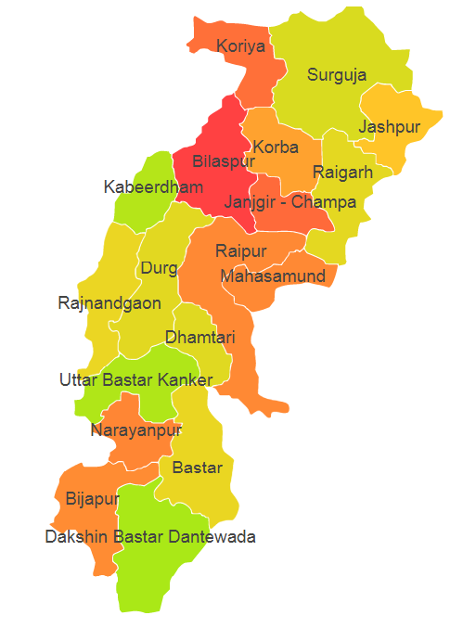

Chhattisgarh comprises of Agro Ecological Region (AER) 11.

**Agro-Eco Region 11:** AER 11 in Chhattisgarh comprises of Bastar, Bijapur, Bilaspur, Dabtewara, Dhamtari, Durg, Janjgir Champa, Jashpur, Kanker, Kawardha, Korba, Korea, Mahasamund, Narayanpur, Raigarh, Raipur, Rajnandgaon and Surguja districts of Eastern Plateau under Agro Ecological Sub Region (AESR) 11.

**Major NRM issues :**

**AESR 11 :** The region is hot moist/dry subhumid transitional ESR with deep loamy to clayey Red and Yellow soils, medium AWC and LGP 150-180 days in a year.

|  |  |  |  |  |
| --- | --- | --- | --- | --- |
| **Districts** | ***Land degradation*** | ***Soil health & fertility*** | ***Water related constraints*** | ***Environmental constraints*** |
| Bastar | Acid soils, water erosion. | Soil deficient in N, Zn & S | Mostly Rainfed, GW Contaminated with F, NO3 & Fe | **-** |
| Bijapur | Acid soils under water erosion. | **-** | GW Contaminated with F, NO3 & Fe | Highly prone to Flood & Drought |
| Bilaspur | Acid soils, water erosion. | Soil deficient in N | Saline, GW Contaminated with F, NO3 & Fe | **-** |
| Dabtewara | Acid soils under water erosion. | Soil deficient in Zn | Mostly Rainfed | **-** |
| Dhamtari | Acid soils under water erosion. | Low in OC , Soil deficient in N & S | GW Contaminated with F, NO3 & Fe | **-** |
| Durg | Exclusively water erosion & Acid soils | - | GW Contaminated with F & Fe | **-** |
| Janjgir Champa | Exclusively water erosion & Acid soils | Low in OC & Soil deficient in N | GW Contaminated with Fe | **-** |
| Jashpur | Exclusively water erosion | Low in OC, Soil deficient in N, B & P | Mostly Rainfed , GW Contaminated with F, NO3 & Fe | **-** |
| Kanker | Acid soils under water erosion. | Soil deficient in Zn | Mostly Rainfed | **-** |
| Kawardha | **-** | Low in OC, Soil deficient in N, S & P | Mostly Rainfed , GW Contaminated with NO3 & Fe | **-** |
| Korba | Exclusively water erosion | Soil deficient in N & P | Mostly Rainfed , GW Contaminated with F, NO3, Fe & heavy metals | **-** |
| Korea | Exclusively water erosion | Low in OC, Soil deficient in N | Mostly Rainfed , GW Contaminated with F & Fe | **-** |
| Mahasamund | Acid soils | Soil deficient in N | Mostly Rainfed , GW Contaminated with F, NO3, Fe | **-** |
| Narayanpur | Acid soils, water erosion. | Soil deficient in Mn | Mostly Rainfed | **-** |
| Raigarh | Exclusively water erosion | Low in OC, Soil deficient in N & P | GW Contaminated with F, NO3, Fe | **-** |
| Raipur | Exclusively water erosion, acid soils | Low in OC, Soil deficient in N | GW Contaminated with NO3, Fe | **-** |
| Rajnandgaon | Exclusively water erosion | Low in OC, Soil deficient in N & Zn | Mostly Rainfed , GW Contaminated with F, NO3, As, Fe | **-** |
| Surguja | Exclusively water erosion | Low in OC, Soil deficient in N & Zn | Mostly Rainfed , GW Contaminated with F, Fe | **-** |

**Organization and Establishments for Technology Backstopping**

***ICAR Research Institutes /SAUs/CAUs:***

|  |  |
| --- | --- |
| [Indira Gandhi Krishi Viswa Vidhyalaya, Raipur](http://igau.edu.in/) | <https://igkv.ac.in/web/igkv.aspx> |
| KVK Portal | <https://kvk.icar.gov.in/> |

***List of KVKs:*** <https://icar.org.in/content/chhattisgarh>

***List of Soil testing Laboratories****:* <https://farmer.gov.in/STLDetails.aspx?State=22>