**Delhi**

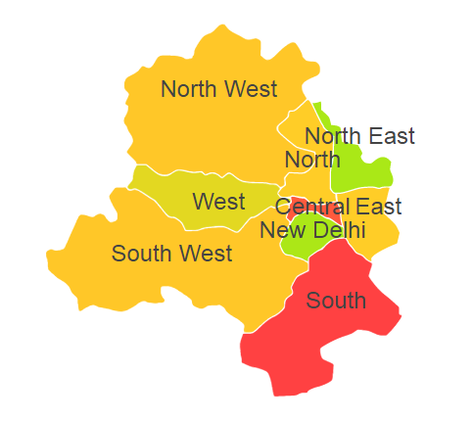

Delhi comprises of one Agro Ecological Region (AER) namely 4.

**Agro-Eco Region 4:** AER 4 in Delhi comprises of Central Delhi, East Delhi, North Delhi, North West Delhi, South Delhi, South West Delhi and West Delhi districts of Northern Plain and Central Highlands including Aravallis under Agro Ecological Sub Regions (AESR) 4.1.

**Major NRM issues :**

**AESR 4.1:** The region warm to hot semi-arid ESR with deep loamy alluvium-derived soils (occasional saline and sodic phases), medium AWC and LGP 90-120 days in a year.

|  |  |  |  |  |
| --- | --- | --- | --- | --- |
| **Districts** | ***Land degradation*** | ***Soil health & fertility*** | ***Water related constraints*** | ***Environmental constraints*** |
| Central Delhi | **-** | Soil deficient in P & K | GW Contaminated with NO3 | **-** |
| East Delhi | - | Soil deficient in N & P | GW Saline, Contaminated with F, NO3 & As | **-** |
| North Delhi | **-** | Soil deficient in P | GW Saline, Contaminated with F & NO3 | **-** |
| North West Delhi | **-** | Soil deficient in P | GW Saline, Contaminated with F & NO3 | **-** |
| South Delhi | **-** | Soil deficient in K | GW Saline, Contaminated with F, NO3 & heavy metals | **-** |
| South West Delhi | - | Soil deficient in P | GW Saline, Contaminated with F, NO3 & Fe | **-** |
| West Delhi | **-** | Soil deficient in P | GW Saline, Contaminated with F, NO3 & Fe | **-** |

**Organization and Establishments for Technology Backstopping**

***ICAR Research Institutes:***

|  |  |
| --- | --- |
| Indian Agricultural Research Institute, New Delhi | <https://www.iari.res.in> |
| Regional Station of National Bureau of Soil Survey & Land Use Planning, New Delhi | <https://nbsslup.icar.gov.in/new-delhi> |

***List of KVKs:*** <https://icar.org.in/content/delhi>

***List of Soil testing Laboratories****:* <https://farmer.gov.in/STLDetails.aspx?State=7>