**Goa**

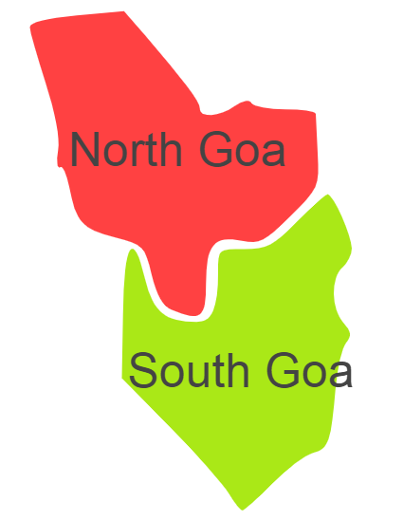

Goa comprises of one Agro Ecological Region (AER)19.

**Agro-Eco Region 19 :** AER 19 in Goa comprises of North Goa, South Goa districts of Western Ghats & Coastal Plain under Agro Ecological Sub Regions (AESR) 19.2 and 19.3.

**Major NRM issues :**

**AESR 19.2 :** The region is hot moist subhumid to humid transitional ESR with deep, loamy to clayey Red and Lateritic soils, low to medium AWC and LGP 210-270 days in a year.

|  |  |  |  |  |
| --- | --- | --- | --- | --- |
| **Districts** | ***Land degradation*** | ***Soil health & fertility*** | ***Water related constraints*** | ***Environmental constraints*** |
| North Goa | Exclusively acid soils | Soil deficient in N & P | GW Contaminated with Fe | **-** |
| South Goa | Exclusively acid soils | Soil deficient in P & S | GW Contaminated with Fe | **-** |

**AESR 19.3 :** The region hot humid to per humid transitional ESR with deep, clayey to loamy acidic coastal alluvium-derived soils, low AWC and LGP 240-270 daysin a year.

|  |  |  |  |  |
| --- | --- | --- | --- | --- |
| **Districts** | ***Land degradation*** | ***Soil health & fertility*** | ***Water related constraints*** | ***Environmental constraints*** |
| North Goa | Exclusively acid soils | Soil deficient in P | GW Contaminated with Fe | **-** |
| South Goa | Exclusively acid soils | Soil deficient in P & S | GW Contaminated with Fe | **-** |

**Organization and Establishments for Technology Backstopping**

***ICAR Research Institutes:***

|  |  |
| --- | --- |
| Central Coastal Agricultural Research Institute,Goa | <https://ccari.icar.gov.in/welcome.php> |
| KVK Portal | <https://kvk.icar.gov.in/> |

***List of KVKs:*** <https://icar.org.in/content/Goa>

***List of Soil testing Laboratories****:* <https://farmer.gov.in/STLDetails.aspx?State=30>