**Haryana**

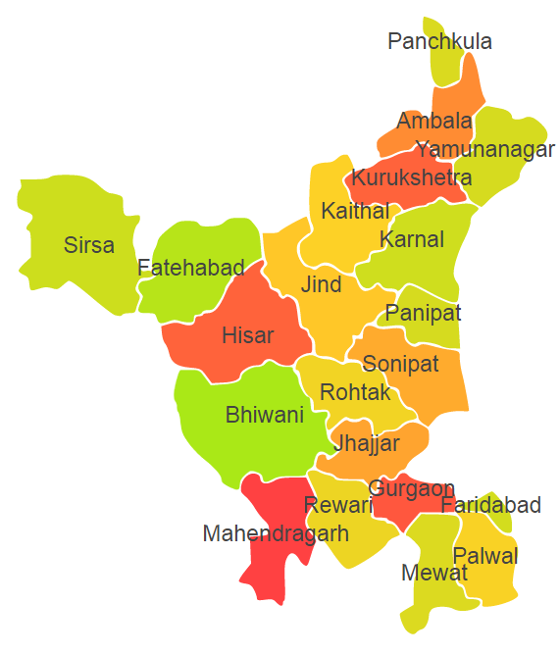

Haryana comprises of three Agro Ecological Region (AER) 2, 4 and 9.

**Agro-Eco Region 2 :** AER 2 in Haryana comprises of Bhiwani, Fatehabad, Hisar, Mahendergarh and Sirsa districts of Western Plain under Agro Ecological Sub Region (AESR) 2.3.

**Agro-Eco Region 4 :** AER 4 in Haryana comprises of districts Gurgaon, Jhajjar, Jind, Kaithal, Karnal, Kurukshetra, Panipat, Palwal, Rewari, Rohtak, Sonipat, Faridabad and Mewat of Northern Plain and Central Highlands including Aravallis under Agro Ecological Sub Region (AESR) 4.1.

**Agro-Eco Region 9:** AER 9 in Haryana comprises of Ambala, Panchkula and Yamunanagar districts of Northern Plain under Agro Ecological Sub Region (AESR) 9.1.

**Major NRM issues :**

**AESR 2.3 :** The region is hot typic- arid ESR with deep, loamy desert soils (inclusion of saline phase), low AWC and LGP 60-90 days in a year.

|  |  |  |  |  |
| --- | --- | --- | --- | --- |
| **Districs** | ***Land degradation*** | ***Soil health & fertility*** | ***Water related constraints*** | ***Environmental constraints*** |
| Bhiwani | - | Low in OC, Soil deficient in N, P, Zn & Fe | Saline, GW Contaminated with F, NO3, As, Fe & heavy metals | Extreme Drought |
| Fatehabad | - | Low in OC, Soil deficient in N, P, K, S, Fe , B & Mn | Saline, GW Contaminated with F, NO3, As, Fe & heavy metals | **-** |
| Hisar | Exclusively saline soils | Low in OC, Soil deficient in N, P, K, Fe & Mn | Saline, GW Contaminated with F, NO3, As, Fe & heavy metals | **-** |
| Mahendergarh | Exclusively water erosion | Low in OC, Soil deficient in N, P, S, Zn & Fe | Saline, GW Contaminated with F, NO3, As, Fe & heavy metals | **-** |
| Sirsa | Exclusively water erosion | Low in OC, Soil deficient in N, P, B & Fe | Saline, GW Contaminated with F, NO3, As, Fe & heavy metals | **-** |

**AESR 4.1 :** The region is hot semi-arid ESR with deep loamy alluvium-derived soils (occasional saline and sodic phases), medium AWC and LGP 90-120 days in a year.

|  |  |  |  |  |
| --- | --- | --- | --- | --- |
| **Districs** | ***Land degradation*** | ***Soil health & fertility*** | ***Water related constraints*** | ***Environmental constraints*** |
| Faridabad | Exclusively water erosion | Low in OC, Soil deficient in N, K & P | Saline, GW Contaminated with F, NO3, As, Fe & heavy metals | **-** |
| Gurgram | Exclusively water erosion | Low in OC, Soil deficient in N & P | Saline, GW Contaminated with F, NO3, Fe & heavy metals | **-** |
| Jhajjar | - | Low in OC, Soil deficient in N & P | Saline, GW Contaminated with F, NO3, As, Fe & heavy metals | **-** |
| Jind | Exclusively sodic soils | Low in OC, Soil deficient in N & P | Saline, GW Contaminated with F, NO3, As, Fe & heavy metals | **-** |
| Kaithal | Exclusively sodic soils | Low in OC, Soil deficient in N & P | Saline, GW Contaminated with F, NO3, Fe & heavy metals | **-** |
| Karnal | Exclusively sodic soils | Low in OC, Soil deficient in N & P | Saline, GW Contaminated with F, NO3, As, Fe & heavy metals | **-** |
| Kurukshetra | Exclusively sodic soils | Low in OC, Soil deficient in N & P | GW Contaminated with F, NO3 &Fe | **-** |
| Mewat | **-** | Low in OC, Soil deficient in N & P | Saline, GW Contaminated with F & NO3 | **-** |
| Palwal | **-** | Low in OC, Soil deficient in N & P | Saline, GW Contaminated with F, NO3 & As | **-** |
| Panipat | Exclusively sodic soils | Low in OC, Soil deficient in N & P | Saline, GW Contaminated with F, NO3, As, Fe & heavy metals | **-** |
| Rewari | Exclusively water erosion | Low in OC, Soil deficient in K & P | Saline, GW Contaminated with F, NO3 & heavy metals | **-** |
| Rohtak | **-** | Low in OC, Soil deficient in N & P | Saline, GW Contaminated with F, NO3, As, Fe & heavy metals | **-** |
| Sonipat | Exclusively sodic soils | Low in OC, Soil deficient in N & P | Saline, GW Contaminated with F, NO3, As, Fe & heavy metals | **-** |

**AESR 9.1:** The region is hot dry/moist subhumid transitional ESR with deep, loamy to clayey alluvium-derived (inclusion of saline and sodic phases) soils, medium AWC and LGP 120-150 days in a year.

|  |  |  |  |  |
| --- | --- | --- | --- | --- |
| **Districs** | ***Land degradation*** | ***Soil health & fertility*** | ***Water related constraints*** | ***Environmental constraints*** |
| Ambala | **-** | Low in OC, Soil deficient in N, K & P | Saline, GW Contaminated with F, NO3, As, Fe & heavy metals | **-** |
| Panchkula | Exclusively water erosion | Low in OC, Soil deficient in N & P | GW Contaminated with F, NO3, As, Fe & heavy metals | **-** |
| Yamunanagar | Exclusively water erosion | Low in OC, Soil deficient in N, K & P | GW Contaminated with F & NO3 | Highly prone to Flood |

**Organization and Establishments for Technology Backstopping**

***ICAR Research Institutes:***

|  |  |
| --- | --- |
| National Dairy Research Institute, Karnal | <http://ndri.res.in/> |
| Central Soil Salinity Research Institute, Karnal | <https://cssri.res.in/> |
| Indian Institute of Wheat and Barley Research, Karnal | <https://iiwbr.icar.gov.in/> |
| Central Soil and Water Conservation Research and Training Institute, Research Centre, Chandigarh. | <http://www.cswcrtiweb.org/index1.html?Chandigarh/Chandigarh_back.htm> |
| KVK Portal | <https://kvk.icar.gov.in/> |

***SAUs/CAUs:***

|  |  |
| --- | --- |
| Chaudhary Charan Singh Haryana Agricultural University, Hisar | <https://www.hau.ac.in/> |

***List of KVKs:*** <https://icar.org.in/content/haryana>

***List of Soil testing Laboratories****:* <https://farmer.gov.in/STLDetails.aspx?State=6>