**Jharkhand**

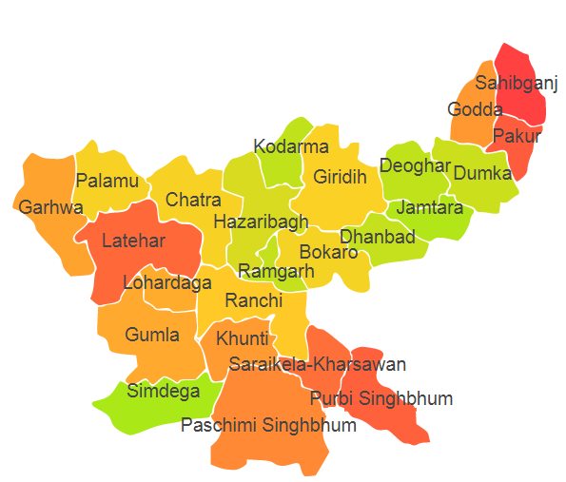

Jharkhand comprises of four Agro Ecological Regions (AER) 11,12,13 and 15.

**Agro-Eco Region 11:** AER 11 in Jharkhand comprises of Chatra, Garhwal, Gumla, Hazaribagh, Kodarma, Latehar, Lohardaga, Palamu, Simdega and Ranchi districts of Eastern Plateau under Agro Ecological Sub Region (AESR) 11.

**Agro-Eco Region 12:** AER12 in Jharkhand comprises of Bokaro, Devgarh, Dhanbad, Dumka, Giridih, Jamtara, Kunti, Pakur, Paschim Singhbhumi, Purbi Singhbhumi, Ranchi, Ramgarh, Sahebganj and Saraikela districts of Eastern Plateau and Eastern Ghats under Agro Ecological Sub Region (AESR) 12.3.

**Agro-Eco Region 13:** AER 13 in Jharkhand comprises of Gooda and Sahebganj districts of Eastern Plain under Agro Ecological Sub Region (AESR) 13.1.

**Agro-Eco Region 15:** AER15 in Jharkhand comprises of Pakur and Sahebganj districts of Bengal and Assam Plain under Agro Ecological Sub Region (AESR) 15.1.

**Major NRM issues :**

**AESR 11:** The region is hot moist/dry subhumid transitional ESR with deep loamy to clayey Red and Yellow soils, medium AWC and LGP 150-180 days in a year.

|  |  |  |  |  |
| --- | --- | --- | --- | --- |
| **Districts** | ***Land degradation*** | ***Soil health & fertility*** | ***Water related constraints*** | ***Environmental constraints*** |
| Chatra | Exclusively water erosion | Low in OC,Soil deficient in N & Zn | Mostly Rainfed , GW Contaminated with NO3 & Fe | **-** |
| Garhwal | Exclusively water erosion | Soil deficient in B | Mostly Rainfed , GW Contaminated with F & NO3, | - |
| Gumla | Exclusively water erosion & Water erosion under open forest | Low in OC,Soil deficient in P, B & S | Mostly Rainfed , GW Contaminated with F & NO3 | **-** |
| Hazaribagh | Exclusively water erosion, Water erosion under open forest & Acid soils under water erosion | Low in OC,Soil deficient in N & P | Mostly Rainfed , | **-** |
| Kodarma | Exclusively water erosion | Low in OC, Soil deficient in N, P & K | Mostly Rainfed , GW Contaminated with F | **-** |
| Latehar | - | Low in OC,Soil deficient in N, P, Zn & S | Mostly Rainfed , | **-** |
| Lohardaga | Exclusively water erosion | Low in OC,Soil deficient in N & P | Mostly Rainfed , GW Contaminated with NO3 & As | **-** |
| Palamu | Exclusively water erosion & Water erosion under open forest | Soil deficient in P, K & Mn | Mostly Rainfed , GW Contaminated with F & NO3 | **-** |
| Ranchi | Exclusively water erosion & Acid soils under water erosion | Soil deficient in N & P | Mostly Rainfed , GW Contaminated with F, NO3 & Fe | **-** |
| Simdega | - | Soil deficient in N & P | Mostly Rainfed , | **-** |

**AESR 12.3:** The region is hot, dry subhumid ESR with moderately deep to deep loamy to clayey Red and Lateritic soils, medium AWC and LGP of 150-180 days in a year.

|  |  |  |  |  |
| --- | --- | --- | --- | --- |
| **Districts** | ***Land degradation*** | ***Soil health & fertility*** | ***Water related constraints*** | ***Environmental constraints*** |
| Bokaro | Exclusively water erosion | Soil deficient in P | Mostly Rainfed , GW Contaminated with F | Moderately prone to Drought |
| Devgarh | Exclusively water erosion | Soil deficient in B | Mostly Rainfed , GW Contaminated with Fe | **-** |
| Dhanbad | Exclusively water erosion | Soil deficient in K | Mostly Rainfed , GW Contaminated with F | **-** |
| Dumka | Exclusively water erosion | Low in OC, Soil deficient in N, K , P & B | Mostly Rainfed , | **-** |
| Giridih | Exclusively water erosion | Low in OC, Soil deficient in P & S | Mostly Rainfed , GW Contaminated with F & Fe | Moderately prone to Drought |
| Jamtara | - | Low in OC, Soil deficient in P, Zn & B | Mostly Rainfed , | **-** |
| Kunti | - | Soil deficient in P, B & Zn | Mostly Rainfed , GW Contaminated with F | **-** |
| Pakur | Exclusively water erosion | Low in OC, Soil deficient in N, K & B | Mostly Rainfed , GW Contaminated with F & NO3 | **-** |
| Paschim Singhbhumi | Exclusively water erosion | Low in OC, Soil deficient in K & Fe | GW Contaminated with NO3 & Fe | **-** |
| Purbi Singhbhumi | Exclusively water erosion | Soil deficient in N, K & P | Mostly Rainfed , GW Contaminated with NO3 & Fe | **-** |
| Ramgarh | - | Soil deficient P | Mostly Rainfed , | **-** |
| Ranchi | Exclusively water erosion & Acid soils under water erosion | Soil deficient in N | Mostly Rainfed , GW Contaminated with F, NO3 & Fe | **-** |
| Sahebganj | Exclusively water erosion | Soil deficient in P | Mostly Rainfed , GW Contaminated with F, NO3  & As | **-** |
| Saraikela | - | Soil deficient in N & P | Mostly Rainfed , | **-** |

**AESR 13.1:** The region is hot dry to moist subhumid transitional ESR with deep, loamy alluvium-derived soils, low to medium AWC and LGP 180-210 days in a year.

|  |  |  |  |  |
| --- | --- | --- | --- | --- |
| **Districts** | ***Land degradation*** | ***Soil health & fertility*** | ***Water related constraints*** | ***Environmental constraints*** |
| Gooda | Exclusively water erosion | Soil deficient in N & P | Mostly Rainfed , GW Contaminated with F & NO3 | **-** |
| Sahebganj | Exclusively water erosion | Soil deficient in P | Mostly Rainfed , GW Contaminated with F, NO3  & As | **-** |

**AESR 15.1:** The region is hot moist subhumid ESR with deep loamy to clayey alluvium-derived soils, medium to high AWC and LGP 210-240 days in a year.

|  |  |  |  |  |
| --- | --- | --- | --- | --- |
| **Districts** | ***Land degradation*** | ***Soil health & fertility*** | ***Water related constraints*** | ***Environmental constraints*** |
| Pakur | Exclusively water erosion | Low in OC, Soil deficient in N, K & B | Mostly Rainfed , GW Contaminated with F & NO3 | **-** |
| Sahebganj | Exclusively water erosion | Soil deficient in P | Mostly Rainfed , GW Contaminated with F, NO3 & Fe | **-** |

**Organization and Establishments for Technology Backstopping**

***ICAR Research Institutes:***

|  |  |
| --- | --- |
| Regional Station of ICAR Research Complex for Eastern Region , Ranchi | https://icarrcer.icar.gov.in *› research-centerranchi* |
| KVK Portal | <https://kvk.icar.gov.in/> |

***SAUs/CAUs:***

|  |  |
| --- | --- |
| Birsa Agricultural University, Ranchi | <https://www.bauranchi.org/> |

***List of KVKs:*** <https://icar.org.in/content/jharkhand>

***List of Soil testing Laboratories****:* <https://farmer.gov.in/STLDetails.aspx?State=20>