**Kerala**

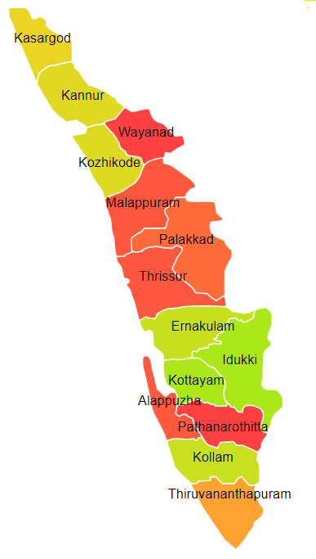

Kerala comprises of one Agro Ecological Region (AER) namely 19.

**Agro-Eco Region 19:** AER 19 in Kerala comprises of Alappuzha, Ernakulam, Idukki, Kannur, Kasargod,Kollam,Kottyam,Kozikod, Malappuram, Palakkad, Pattanamittia, Thiruvananthpuram, Trishur and Wayanad districts of Western Ghats & Coastal Plain under Agro Ecological Sub Regions (AESR) 19.2 & 19.3.

**Major NRM issues :**

**AESR 19.2:** The region is hot moist subhumid to humid transitional ESR with deep, loamy to clayey Red and Lateritic soils, low to medium AWC and LGP 210-270 days in a year.

|  |  |  |  |  |
| --- | --- | --- | --- | --- |
| **Districts** | ***Land degradation*** | ***Soil health & fertility*** | ***Water related constraints*** | ***Environmental constraints*** |
| Ernakulam | Exclusively acid soils | Soil deficient in N, K, B & S | GW Saline, Contaminated with F, Fe & heavy metals | Moderately prone to flood & drought |
| Idukki | Exclusively acid soils & Acid soils under water erosion | Soil deficient in N,& P | GW Contaminated with F, NO3 & Fe | Moderately prone to flood & drought |
| Kannur | Exclusively acid soils | So, B & S | GW Contaminated with Fe | **-** |
| Kollam | Exclusively acid soils & Acid soils under open forest | Soil deficient in N | GW Saline, Contaminated with Fe, NO3 & heavy metals | Moderately prone to flood & drought |
| Kottyam | Exclusively acid soils & Acid soils under open forest | Soil deficient in N, P & B | GW Saline, Contaminated with NO3 & Fe | **-** |
| Kozikod | Exclusively acid soils, | Soil deficient in N & Zn | GW Contaminated with NO3 & Fe | **-** |
| Malappuram | Exclusively acid soils | Soil deficient in N, B & S | GW Contaminated with NO3 & Fe | **-** |
| Palakkad | Exclusively acid soils | Soil deficient in N, S & B | GW Contaminated with F, NO3 & Fe | Moderately prone to drought |
| Pattanamittia | Exclusively acid soils | Soil deficient in N, B & S | GW Contaminated with NO3 & Fe | Highly prone to flood & drought |
| Thiruvananthpuram | Exclusively acid soils | Soil deficient in N, B & S | GW Saline, Contaminated with F, NO3 & Fe | Moderately prone to flood & drought |
| Trishur | Exclusively acid soils & Acid soils under water erosion | Soil deficient in N, B & S | GW Contaminated with NO3 & Fe | **-** |
| Wayanad | Exclusively acid soils | Soil deficient in N, B & S | GW Contaminated with NO3 & Fe | **-** |

**AESR 19.3:** The region is hot humid to per humid transitional ESR with deep, clayey to loamy acidic coastal alluvium-derived soils, low AWC and LGP 240-270 days in a year.

|  |  |  |  |  |
| --- | --- | --- | --- | --- |
| **Districts** | ***Land degradation*** | ***Soil health & fertility*** | ***Water related constraints*** | ***Environmental constraints*** |
| Alappuzha | Exclusively acid soils | Soil deficient in N , K & B | GW Contaminated with F, NO3 & Fe | **-** |
| Ernakulam | Exclusively acid soils & Acid soils under water erosion | Soil deficient in N, B & S | GW Saline, Contaminated with F, Fe & heavy metals | Moderately prone to flood & drought |
| Kannur | Exclusively acid soils | Soil deficient in N, B & S | GW Contaminated with Fe | **-** |
| Kasargod | Exclusively acid soils | Soil deficient in N , P, K, B & S | GW Contaminated with Fe | Moderately prone to flood & drought |
| Kollam | Exclusively water erosion | Soil deficient in N & B | GW Saline, Contaminated with Fe, NO3 & heavy metals | Moderately prone to flood & drought |
| Kozikod | Exclusively acid soils | Soil deficient in N & Zn | GW Contaminated with NO3 & Fe | **-** |
| Malappuram | Exclusively acid soils | Soil deficient in N, B & S | GW Contaminated with NO3 & Fe | **-** |
| Thiruvananthpuram | Exclusively acid soils | Soil deficient in N | GW Saline, Contaminated with F, Fe & NO3 | Moderately prone to flood & drought |
| Trishur | Exclusively acid soils & Acid soils under water erosion | Soil deficient in N | GW Contaminated with NO3 & Fe | **-** |

**Organization and Establishments for Technology Backstopping**

***ICAR Research Institutes:***

|  |  |
| --- | --- |
| Central Plantation Crops Research Institute. Kasragod | <https://cpcri.icar.gov.in> |
| KVK Portal | <https://kvk.icar.gov.in/> |

***SAUs/CAUs:***

|  |  |
| --- | --- |
| Kerala Agricultural University, Thrissur | <https://www.kau.in/> |

***List of KVKs:*** <https://icar.org.in/content/kerala>

***List of Soil testing Laboratories****:* <https://farmer.gov.in/STLDetails.aspx?State=32>