**Manipur**

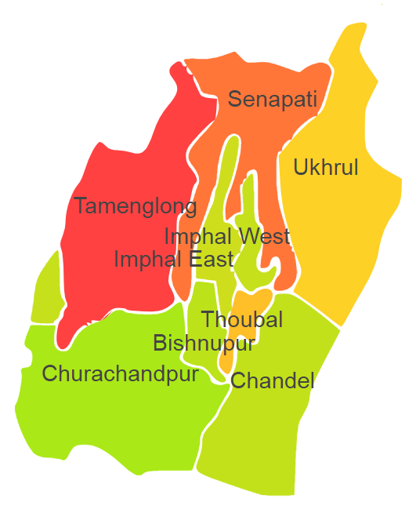

Manipur comprises of one Agro Ecological Region (AER) 17.

**Agro-Eco Region 17:** AER 17 in Manipur comprises of Bishnupur, Chandel, Churachandpur, Senapati, Tamenglong, Thoubal, Ukhrul, Imphal West and Imphal East districts North-eastern Hills (Purvachal) under Agro Ecological Sub Regions (AESR) 17.2.

**AESR 17.2:** The region is warm to hot perhumid ESR with medium to deep loamy Red and Yellow soils, low to medium AWC and LGP 300 days in a year.

**Major NRM issues :**

|  |  |  |  |  |
| --- | --- | --- | --- | --- |
| **Districts** | ***Land degradation*** | ***Soil health & fertility*** | ***Water related constraints*** | ***Environmental constraints*** |
| Bishnupur | - | Soil deficient in N, P & K | GW Contaminated with As & Fe | Highly prone to flood |
| Chandel | Acid soils under open forest | Soil deficient in N, P & K | - | **-** |
| Churachandpur | Acid soils under open forest | **-** | GW Contaminated with Fe | **-** |
| Imphal East | Acid soils under water erosion | Soil deficient in K | GW Contaminated with Fe | Moderately prone to flood & cyclone |
| Imphal West | Exclusively acid soils | **-** | - | Moderately prone to flood |
| Senapati | Acid soils under open forest | **-** | - | **-** |
| Tamenglong | Acid soils under open forest | Soil deficient in P | - | **-** |
| Thoubal | **-** | Soil deficient in N & P | GW Contaminated with As & Fe | Moderately prone to flood |
| Ukhrul | Acid soils under open forest | **-** | - | **-** |

**Organization and Establishments for Technology Backstopping**

***ICAR Research Institutes/KVKs/CAU/SAU:***

|  |  |
| --- | --- |
| ICAR Research Complex for NEH Region, , Barapani | http://www.icarneh.ernet. |
| KVK Portal | <https://kvk.icar.gov.in/> |
| Central Agricultural University, Imphal | <https://cau.ac.in/> |

***List of KVKs:*** <https://icar.org.in/content/manipur>

***List of Soil testing Laboratories****:*  [https://farmer.gov.in/STLDetails.aspx?State=14](https://farmer.gov.in/STLDetails.aspx?State=16)