**Meghalaya**

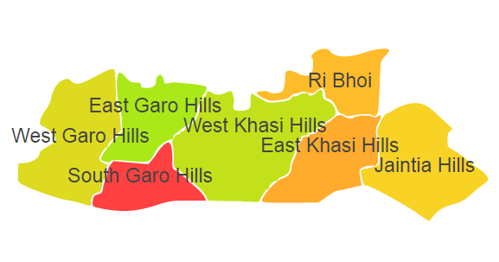

Meghalaya comprises of one Agro Ecological Region (AER) 17.

**Agro-Eco Region 17:** AER 17 in Meghalaya comprises of East Garo Hills, East Khasi Hills, Jaintia Hills, West Khasi Hills, Ri Bhoi and South Garo Hills districts of North-eastern Hills under Agro Ecological Sub Region (AESR) 17.1.

**Major NRM issues :**

**AESR 17.1 :** The region is warm to hot moist humid to perhumid ESR with medium to deep loamy to clayey Red and Lateritic soils, medium AWC and LGP 270-300+ days in a year.

|  |  |  |  |  |
| --- | --- | --- | --- | --- |
| **Districts** | ***Land degradation*** | ***Soil health & fertility*** | ***Water related constraints*** | ***Environmental constraints*** |
| East Garo Hills | Water erosion under open forest & Acid soils under open forest | Soil deficient in N, P & K | GW Contaminated with Fe, silting of water bodies | Deforestation & biodiversity loss. |
| East Khasi Hills | Acid soils under open forest | Soil deficient in N & K | GW Contaminated with Fe, silting of water bodies | Deforestation & biodiversity loss. |
| Jaintia Hills | Acid soils under open forest | Soil deficient in N, P, Zn, Fe, Cu, Mn, B & S | GW Contaminated with Fe, silting of water bodies | Deforestation & biodiversity loss. |
| Ri Bhoi | Acid soils under open forest | Soil deficient in N & P | GW Contaminated with Fe, silting of water bodies | Deforestation & biodiversity loss. |
| South Garo Hills | Acid soils under open forest | Soil deficient in N, P & K | GW Contaminated with Fe, silting of water bodies | Deforestation & biodiversity loss. |
| West Khasi Hills | Water erosion under open forest & Acid soils under open forest | Soil deficient in P & S | GW Contaminated with Fe, silting of water bodies | Deforestation & biodiversity loss. |

**Organization and Establishments for Technology Backstopping**

***ICAR Research Institutes/KVKs/CAU/SAU:***

|  |  |
| --- | --- |
| ICAR Research Complex for NEH Region, , Barapani | http://www.icarneh.ernet. |
| KVK Portal | <https://kvk.icar.gov.in/> |
| **College of Post Graduate Studies in Agricultural Sciences, Umiam** under Central Agricultural University, Imphal, Manipur, | <https://cau.ac.in/home-pg-studies-in-agricultural-sciences-umiam/> |
| College of Agriculture, Kyrdemkulai, Meghalaya | <https://cau.ac.in/home-ca-kyrdemkulai/> |

***List of KVKs:*** <https://icar.org.in/content/meghalaya>

***List of Soil testing Laboratories****:* <https://farmer.gov.in/STLDetails.aspx?State=17>