**Mizoram**

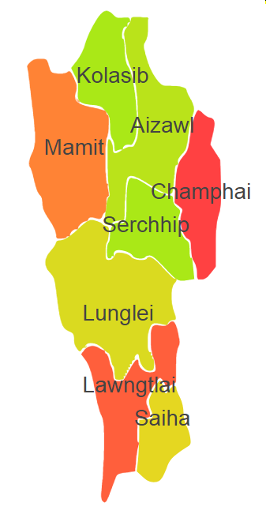

Mizoram comprises of one Agro Ecological Region (AER) 17.

**Agro-Eco Region 17:** AER 17 in Mizoram comprises of Aizawal, Champhai, Kolasib, Lawngtali, Lunglei, Mamit, Saiha and Serchhip districts of North-eastern Hills under Agro Ecological Sub Region (AESR) 17.2.

**AESR 17.2 :** The region is warm to hot perhumid ESR with medium to deep loamy Red and Yellow soils, low to medium AWC and LGP 300 days in a year.

**Major NRM issues :**

|  |  |  |  |  |
| --- | --- | --- | --- | --- |
| **Districts** | ***Land degradation*** | ***Soil health & fertility*** | ***Water related constraints*** | ***Environmental constraints*** |
| Aizawal | Exclusively acid soils & Acid soils under open forest | Soil deficient in P | - | **-** |
| Champhai | Acid soils under open forest | Low in OC, Soil deficient in P | - | **-** |
| Kolasib | **-** | Soil deficient in P, B & S | - | **-** |
| Lawngtali | Acid soils under open forest | Soil deficient in P | - | **-** |
| Lunglei | Acid soils under open forest | Soil deficient in P | - | **-** |
| Mamit | **-** | Soil deficient in P | - | **-** |
| Saiha | Acid soils under open forest | Soil deficient in P | - | **-** |
| Serchhip | Acid soils under open forest | Low in OC, Soil deficient in P | - | **-** |

**Organization and Establishments for Technology Backstopping**

***ICAR Research Institutes/KVKs/CAU/SAU:***

|  |  |
| --- | --- |
| Regional station ICAR Research Complex for NEH Region, ,Kolasib, | http://www.icarneh.ernet. |
| KVK Portal | <https://kvk.icar.gov.in/> |
| College of Horticulture, Thenzawl, Mizoram under Central Agricultural University, Imphal, Manipur, | [https://cau.ac.in/home-ch-thenzawl/](https://cau.ac.in/home-ch-thenzawl/%20) |
| College of Veterinary Sciences & Animal Husbandry, Aizawl, Mizoram under Central Agricultural University, Imphal, Manipur, | <https://www.cvsccauaizawl.edu.in/> |

***List of KVKs:*** <https://icar.org.in/content/mizoram>

***List of Soil testing Laboratories****:* <https://farmer.gov.in/STLDetails.aspx?State=15>