**Nagaland**

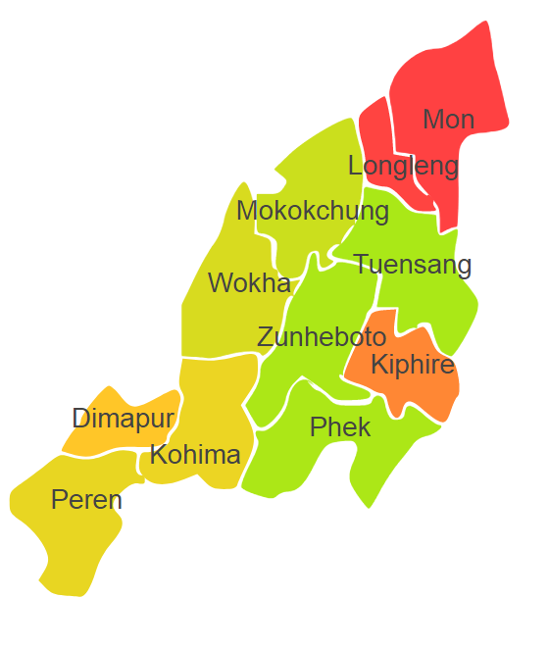

Manipur comprises of one Agro Ecological Region (AER) 17.

**Agro-Eco Region 17:** AER 17 in Nagaland comprises of Dimapur, Kiphire, Kohima, Longleng, Mokokuchung, Mon, Peren, Tuensang, Wokha and Zunheboto districts North-eastern Hills (Purvachal) under Agro Ecological Sub Regions (AESR)17.1 & 17.2.

**Major NRM issues :**

**AESR 17.1 :** The region is warm to hot moist humid to perhumid ESR with medium to deep loamy to clayey Red and Lateritic soils, medium AWC and LGP 270-300+ days.

|  |  |  |  |  |
| --- | --- | --- | --- | --- |
| **Districts** | ***Land degradation*** | ***Soil health & fertility*** | ***Water related constraints*** | ***Environmental constraints*** |
| Dimapur | Acid Soils under open forest | Soil deficient in P | GW Contaminated with F & Fe | Moderately prone to Flood |
| Kiphire | - | Soil deficient in P & Cu | - | Moderately prone to Flood |
| Kohima | Acid Soils under open forest | Soil deficient in P, Fe, Cu & S | - | **-** |
| Longleng | - | Soil deficient in P, Zn & Cu | - | - |
| Mokokchung | Acid Soils under open forest | Soil deficient in P & K | - | **-** |
| Mon | Acid Soils under open forest | Soil deficient in P | - | **-** |
| Peren | Acid Soils under open forest | Soil deficient in P, K, Zn, Cu, Mn & B | - | - |
| Tuensang | Acid Soils under open forest | Soil deficient in P & Zn | - | - |
| Wokha | Acid Soils under open forest | Soil deficient in P & Cu | - | - |
| Zunheboto | Acid Soils under open forest | Soil deficient in P & Zn | - | **-** |

**AESR 17.2 :** The region is warm to hot perhumid ESR with medium to deep loamy Red and Yellow soils, low to medium AWC and LGP 300 days in a year.

|  |  |  |  |  |
| --- | --- | --- | --- | --- |
| **Districts** | ***Land degradation*** | ***Soil health & fertility*** | ***Water related constraints*** | ***Environmental constraints*** |
| Peren | Acid Soils under open forest | Soil deficient in P, K, Zn, Cu, Mn & B | - | - |
| Phek | Acid Soils under open forest | Soil deficient in P | - | - |
| Kohima | Acid Soils under open forest | Soil deficient in P, Fe, Cu & S | - | **-** |

**Organization and Establishments for Technology Backstopping**

***ICAR Research Institutes/KVKs/CAU/SAU:***

|  |  |
| --- | --- |
| Regional station of ICAR Research Complex for NEH Region, , Jharnapani, Dimapur | http://www.icarneh.ernet. |
| KVK Portal | <https://kvk.icar.gov.in/> |
| College of Veterinary Sciences and Animal Husbandry, Jalukie, District Peren, Nagaland, | [https://cau.ac.in/home-cvah-jalukie/](%20https://cau.ac.in/home-cof/%20/) |

***List of KVKs:*** <https://icar.org.in/content/nagaland>

***List of Soil testing Laboratories****:* <https://farmer.gov.in/STLDetails.aspx?State=13>