**Odisha**

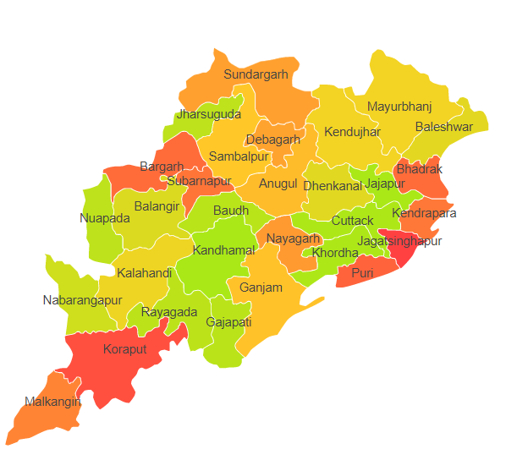

Odisha comprises of two Agro Ecological Regions (AER) 12 & 18.

**Agro-Eco Region 12:** AER 12 in Odisha comprises of Anugul, Balangir, Baleshwar, Baragarh, Bauda, Bhadrak, Cuttack, Deogarh, Dhenkanal, Gajapathi, Ganjam, Jharsuguda, Jajapur, Kalahandi, Kandhamal, Kendujhar, Khordha, Koraput, Malkangiri, Mayurbhanj, Nabarangapur, Nayagarh, Nuapadha, Rayagarha, Sambalpur, Subarnapur and Sundargarh districts of Eastern (Chhotanagpnr) Plateau and Eastern Ghats under Agro Ecological Sub Regions (AESR) 12.1,12.2 & 12.3.

**Agro-Eco Region 18:** AER 18 in Odisha comprises of Baleshwar, Ganjam, Jagatsinghapur, Kendraparha, Khordha and Puri districts of Eastern Coastal Plains under Agro Ecological Sub Regions (AESR) 18.4 & 18.5.

**Major NRM issues :**

**AESR 12.1 :** The region is hot moist subhumid ESR with deep loamy Red and Lateritic soils, low to medium AWC and LGP 180-210 days in a year.

|  |  |  |  |  |
| --- | --- | --- | --- | --- |
| **Districts** | ***Land degradation*** | ***Soil health & fertility*** | ***Water related constraints*** | ***Environmental constraints*** |
| Anugul | Exclusively water erosion | Soil deficient in Zn, B, N & P | Saline, GW Contaminated with F, NO3 & Fe | **-** |
| Balangir | Exclusively water erosion | Soil deficient in Zn, N & P | Saline, GW Contaminated with F, NO3 & Fe | **-** |
| Baleshwar | **-** | Low in OC , Soil deficient in Zn, Cu, B, N, P & K | Saline, GW Contaminated with F, NO3 & Fe | Highly prone to Flood, Drought & Cyclone |
| Baragarh | Exclusively water erosion | Low in OC , Soil deficient in B, N & P | - | **-** |
| Bauda | Exclusively water erosion | Soil deficient in N & P | - | **-** |
| Bhadrak | Exclusively saline soils | Soil deficient in N, P & K | Saline, GW Contaminated with F, NO3 & Fe | Highly prone to Flood, Drought & Cyclone |
| Cuttack | Exclusively water erosion | Soil deficient in Cu, B, N & P | GW Contaminated with F, NO3 & Fe | Moderately prone to Flood, Drought & Cyclone |
| Deogarh | Exclusively water erosion | Low in OC , Soil deficient in Zn, B, N & P | - | **-** |
| Jharsuguda | Exclusively water erosion | Low in OC , Soil deficient in B, N & P | GW Contaminated with NO3 & Fe | **-** |
| Kalahandi | Exclusively water erosion & Water erosion under open forest | Low in OC , Soil deficient in B, S, N & P | - | **-** |
| Kandhamal | **-** | Low in OC , Soil deficient in B, S, N & P | - | **-** |
| Kendujhar | Water erosion under open forest | Low in OC , Soil deficient in Zn, B, S, N, P & K | GW Contaminated with F, NO3 & Fe | **-** |
| Koraput | Exclusively water erosion & Water erosion under open forest | Low in OC, Soil deficient in Zn, N & P | Saline, GW Contaminated with F, NO3 & Fe | Moderately prone to Flood & Cyclone |
| Malkangiri | Exclusively water erosion & Water erosion under open forest | Low in OC, Soil deficient in B &N | GW Contaminated with NO3 & Fe | **-** |
| Nabarangapur | Exclusively water erosion | Low in OC, Soil deficient in N & B | GW Contaminated with Fe | **-** |
| Nuapadha | Exclusively water erosion | Low in OC , Soil deficient in Zn, Fe, Cu, Mn, B, S, N & P | GW Contaminated with F, NO3 & Fe | **-** |
| Rayagarha | Exclusively water erosion & Water erosion under open forest | Low in OC , Soil deficient in N & P | Saline, GW Contaminated with F& Fe | Moderately prone to Flood |
| Sambalpur | Exclusively water erosion | Low in OC , Soil deficient in Zn, B, S, N & P | GW Contaminated with F, NO3 & Fe | **-** |
| Subarnapur | **-** |  | - | **-** |
| Sundargarh | Exclusively water erosion & Water erosion under open forest | Soil deficient in Zn, Fe, Cu, Mn, B, S & N | GW Contaminated with F, NO3 & Fe | Moderately prone to Drought & Cyclone |

**AESR 12.2 :** The region is hot moist subhumid ESR with medium to deep loamy Red and Lateritic soils, medium AWC and LGP 180-210 days in a year.

|  |  |  |  |  |
| --- | --- | --- | --- | --- |
| **Districts** | ***Land degradation*** | ***Soil health & fertility*** | ***Water related constraints*** | ***Environmental constraints*** |
| Bhadrak | Exclusively saline soil | Soil deficient in Cu, B, N, P & K | Saline GW contaminated with F, NO3 & Fe | Highly prone to Flood, Drought & Cyclone |
| Cuttack | Exclusively water erosion | Soil deficient in B, S, N & P | GW contaminated with F, NO3 & Fe | Moderately prone to Flood, Drought & Cyclone |
| Dhenkanal | Exclusively water erosion | Low in OC, Soil deficient in Cu, S, N & P | Contaminated with F, NO3 & Fe | **-** |
| Gajapathi | Exclusively water erosion & Water erosion under open forest | Soil deficient in Zn, B & N | Saline GW contaminated with F, NO3 & Fe | Highly prone to Flood, Drought & Cyclone |
| Ganjam | Exclusively water erosion & Water erosion under open forest | Soil deficient in Zn, B, N & P | GW Contaminated with F, NO3 & Fe | Highly prone to Flood, Drought & Cyclone |
| Jajapur | - | Low in OC, Soil deficient in N, P & K | Saline GW contaminated with F, NO3 , Fe & heavy metals | **-** |
| Khordha | **-** | Soil deficient in N & P | GW contaminated with F, NO3 & Fe | Highly prone to Flood, Drought & Cyclone |
| Nayagarh | Exclusively water erosion | Low in OC, Soil deficient in B & P | GW contaminated with F, NO3 & Fe | Highly prone to Flood, Drought & Cyclone |
| Rayagarha | Exclusively water erosion & Water erosion under open forest | Low in OC, Soil deficient in N & P | Saline GW contaminated with F& Fe | Moderately prone to Flood |

**AESR 12.3 :** The region is hot moist subhumid ESR with medium to deep loamy Red and Lateritic soils, medium AWC and LGP 180-210 days in a year.

|  |  |  |  |  |
| --- | --- | --- | --- | --- |
| **Districts** | ***Land degradation*** | ***Soil health & fertility*** | ***Water related constraints*** | ***Environmental constraints*** |
| Kendujhar | Water erosion under open forest | Low in OC, Soil deficient in Zn, B, S, N, P & K | GW contaminated with F, NO3 & Fe | **-** |

**AESR 18.4 :** The region is hot dry subhumid ESR with deep, loamy to clayey Coastal and deltaic alluvium derived soils, medium AWC and LGP 180-210 days in a year.

|  |  |  |  |  |
| --- | --- | --- | --- | --- |
| **Districts** | ***Land degradation*** | ***Soil health & fertility*** | ***Water related constraints*** | ***Environmental constraints*** |
| Ganjam | Exclusively water erosion & Water erosion under open forest | Soil deficient in N, P, Zn & B | Saline, GW Contaminated with F, NO3 & Fe | Highly prone to Flood, Drought & Cyclone |
| Jagatsinghapur | - | Low in OC, Soil deficient in N, P, B & S | Saline, GW Contaminated with F, NO3 & Fe | Highly prone to Flood & Drought |
| Khordha | **-** | Soil deficient in N & P | GW contaminated with F, NO3 & Fe | Highly prone to Flood, Drought & Cyclone |
| Puri | - | Low in OC, Soil deficient in N, P, K, B & Zn | Saline, GW Contaminated with F, NO3 & Fe | Highly prone to Flood, Drought & Cyclone |

**AESR 18.5 :** The region is hot moist subhumid to humid ESR with deep, loamy to clayey Coastal and deltaic alluvium-derived soils, medium AWC and LGP 240-270 days in a year.

|  |  |  |  |  |
| --- | --- | --- | --- | --- |
| **Districts** | ***Land degradation*** | ***Soil health & fertility*** | ***Water related constraints*** | ***Environmental constraints*** |
| Baleshwar | **-** | Low in OC, Soil deficient in Zn, Cu, B, N, P & K | - | Highly prone to Flood, Drought & Cyclone |
| Jagatsinghapur | - | Low in OC, Soil deficient in N, P, B & S | Saline, GW Contaminated with F, NO3 & Fe | Highly prone to Flood & Drought |
| Kendraparha | - | Low in OC, Soil deficient in N, P, Fe & B | Saline, GW Contaminated with NO3 & Fe | Highly prone to Flood & Cyclone |

**Organization and Establishments for Technology Backstopping**

***ICAR Research Institutes/KVKs:***

|  |  |
| --- | --- |
| Indian Institute of Water Management, Bhubaneswar | <http://www.iiwm.res.in/> |
| Regional Station of Indian Institute of Soil & Water Conservation, Koraput. | <https://iiswc.icar.gov.in/centres/koraput> |
| KVK Portal | <https://kvk.icar.gov.in/> |

***SAUs/CAUs:***

|  |  |
| --- | --- |
| [Orissa University of Agricultural & Technology, Bhubaneswar](http://www.ouat.nic.in/) | <https://www.ouat.nic.in/> |

***List of KVKs:*** <https://icar.org.in/content/odisha>

***List of Soil testing Laboratories****:* <https://farmer.gov.in/STLDetails.aspx?State=21>