**Punjab**

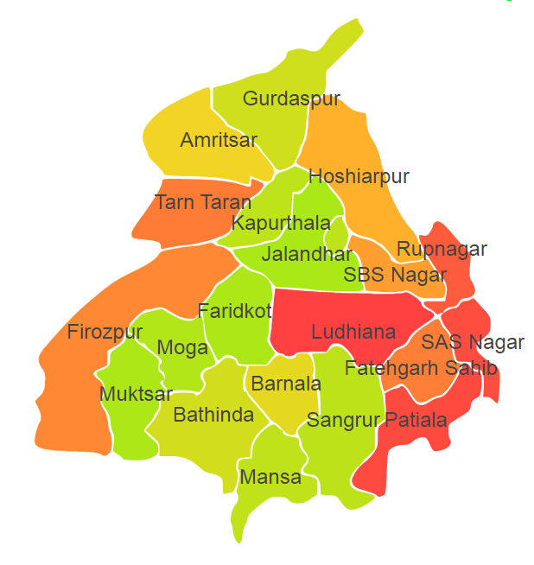

Punjab comprises of four Agro Ecological Regions (AER) 2,4, 9 & 14 .

**Agro-Eco Region 2:** AER 2 in Punjab comprises of Bathinda, Faridkot, Mansa and Muktsar districts of Western Plain under Agro Ecological Sub Region (AESR) 2.3.

**Agro-Eco Region 4:** AER 4 in Punjab comprises of Amritsar, Barnala, Faridkot, Firozpur, Jalandhar, Ludhiana, Moga, Patiala, Sangrur and Tarn Taran districts of Northern Plain and Central Highlands including Aravallis under Agro Ecological Sub Region (AESR) 4.1.

**Agro-Eco Region 9:** AER 9 in Punjab comprises of Amritsar, Fatehgarh Sahib, Gurdaspur, Hoshiarpur, Jalandhar, Kapurthala, Ludhiana, Nawashahr, Patiala, Rupnagar, SAS Nagar and SBS Nagar districts of Northern Plain under Agro Ecological Sub Region (AESR) 9.1.

**Agro-Eco Region 14:** AER 14 in Punjab comprises of Gurdaspur, Hoshiarpur and Rupnagar districts of Western Himalayas under Agro Ecological Sub Region (AESR) 14.2.

**Major NRM issues :**

**AESR 2.3 :** The region is hot typic- arid ESR with deep, loamy desert soils (inclusion of saline phase), low AWC and LGP 60-90 days in a year.

|  |  |  |  |  |
| --- | --- | --- | --- | --- |
| **Districts** | ***Land degradation*** | ***Soil health & fertility*** | ***Water related constraints*** | ***Environmental constraints*** |
| Bathinda | **-** | Low in OC, Soil deficient in N & P | Saline GW Contaminated with F, NO3, Fe & heavy metals | **-** |
| Faridkot | - | Low in OC & Soil deficient in P | Saline GW Contaminated with F, NO3, As & Fe | **-** |
| Mansa | **-** | Low in OC, Soil deficient in P & Fe | Saline GW Contaminated with F, NO3, As, Fe & heavy metals | **-** |
| Muktsar | - | Low in OC, Soil deficient in N, P & Mn | Saline GW Contaminated with F, NO3, As, Fe & heavy metals | **-** |

**AESR 4.1:** The region is hot semi-arid ESR with deep loamy alluvium-derived soils (occasional saline and sodic phases), medium AWC and LGP 90-120 days in a year.

|  |  |  |  |  |
| --- | --- | --- | --- | --- |
| **Districts** | ***Land degradation*** | ***Soil health & fertility*** | ***Water related constraints*** | ***Environmental constraints*** |
| Amritsar | - | Low in OC, Soil deficient in N, P, Mn & B | GW contaminated with F, NO3, As & heavy metals | **-** |
| Barnala | **-** | Low in OC, Soil deficient in N, P & B | Contaminated with F, NO3 & heavy metals | **-** |
| Faridkot | - | Low in OC & Soil deficient in P | Saline GW contaminated with F, NO3, As & Fe | **-** |
| Firozpur | - | Low in OC, Soil deficient in N & P | Saline GW contaminated with F, NO3, Fe & heavy metals | **-** |
| Jalandhar | **-** | Low in OC & Soil deficient in N, Zn, Mn, B & S | GW contaminated with F, NO3 & heavy metals | **-** |
| Ludhiana | **-** | Low in OC , Soil deficient in N, P & Mn | Saline GW contaminated with F, NO3 & heavy metals | **-** |
| Moga | **-** | Low in OC, Soil deficient in P & Mn | Saline GW contaminated with F & NO3 | **-** |
| Patiala | **-** | Low in OC, Soil deficient in N & P | Saline GW contaminated with F, NO3  & heavy metals | **-** |
| Sangrur | Exclusively sodic soil | Low in OC, Soil deficient in N, P & B | Saline GW contaminated with F, NO3, Fe, As & heavy metals | **-** |
| Tarn Taran | **-** | Low in OC, Soil deficient in N & P | GW contaminated with F, NO3, As & heavy metals | **-** |

**AESR 9.1:** The region hot dry/moist subhumid transitional ESR with deep, loamy to clayey alluvium-derived (inclusion of saline and sodic phases) soils, medium AWC and LGP 120-150 days in a year.

|  |  |  |  |  |
| --- | --- | --- | --- | --- |
| **Districts** | ***Land degradation*** | ***Soil health & fertility*** | ***Water related constraints*** | ***Environmental constraints*** |
| Amritsar | - | Low in OC, Soil deficient in N, P, Mn & B | GW contaminated with F, NO3, As & heavy metals | **-** |
| Fatehgarh Sahib | **-** | Low in OC, Soil deficient in N, P & B | GW contaminated with F, NO3, Fe & heavy metals | **-** |
| Gurdaspur | Exclusively water erosion | Low in OC, Soil deficient in N & P | Saline GW contaminated with F, NO3, As, Fe & heavy metals | **-** |
| Hoshiarpur | Exclusively water erosion | Low in OC, Soil deficient in N, P, K, Zn & S | GW contaminated with NO3, As & Fe | **-** |
| Jalandhar | **-** | Low in OC, Soil deficient in N, Zn, Mn, B & S | GW contaminated with F & NO3 | **-** |
| Kapurthala | - | Low in OC, Soil deficient in Mn & B | - | **-** |
| Ludhiana | **-** | Low in OC, Soil deficient in N & B | Saline GW contaminated with F & NO3 | **-** |
| Nawashahr | Water erosion under open forest | Low in OC, Soil deficient in N & P | GW contaminated with As & heavy metals | **-** |
| Patiala | **-** | Low in OC & Soil deficient in N | Saline GW Contaminated with F & NO3 | **-** |
| Rupnagar | Exclusively Water erosion | Low in OC, Soil deficient in N, P, Mn & S | GW contaminated with NO3 & Fe | **-** |
| SAS Nagar | **-** | Low in OC & Soil deficient in B | GW contaminated with F, NO3 & heavy metals | **-** |
| SBS Nagar | **-** | Low in OC | - | **-** |

**AESR 14.2 :** The region is warm moist to dry subhumid transitional ESR with medium to deep loamy to clayey Brown Forest and Podzolic soils, medium AWC and LGP 150-210 days in a year.

|  |  |  |  |  |
| --- | --- | --- | --- | --- |
| **Districts** | ***Land degradation*** | ***Soil health & fertility*** | ***Water related constraints*** | ***Environmental constraints*** |
| Gurdaspur | - | Low in OC, Soil deficient in N & P | Saline GW Contaminated with F, NO3, As, Fe & heavy metals | **-** |
| Hoshiarpur | Exclusively Water erosion | Low in OC, Soil deficient in N , P, K, Zn & S | GW contaminated with As & Fe | **-** |
| Rupnagar | Exclusively Water erosion | Low in OC, Soil deficient in N, Mn & S | GW contaminated with NO3 & Fe | **-** |

**Organization and Establishments for Technology Backstopping**

***SAUs/CAUs/KVKs:***

|  |  |
| --- | --- |
| Punjab Agricultural University, Ludhiana | <https://www.pau.edu/> |
| KVK Portal | <https://kvk.icar.gov.in> |

***List of KVKs:*** <https://icar.org.in/content/punjab>

***List of Soil testing Laboratories****:* <https://farmer.gov.in/STLDetails.aspx?State=3>