**Sikkim**

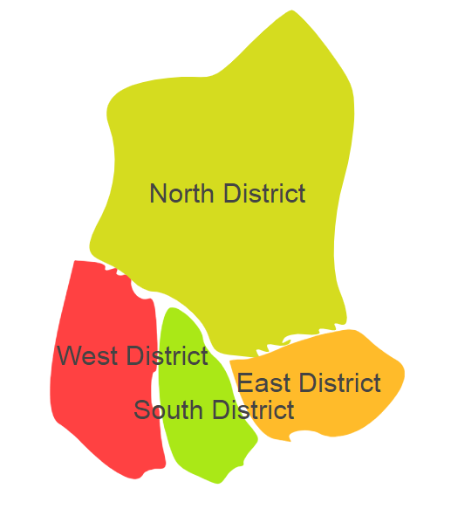

Sikkim comprises of one Agro Ecological Regions (AER)16.

**Agro-Eco Region16:** AER16 in Sikkim comprises of East,North,South and Westdistricts of Eastern Himalayas under Agro-Ecological Sub Regions (AESR)16.2.

**Major NRM issues:**

**AESR 16.2:** The region is warm perhumid ESR with shallow to medium deep loamy Brown and Red Hill soils, low to medium AWC and LGP 300 daysin a year.

|  |  |  |  |  |
| --- | --- | --- | --- | --- |
| **Districts** | ***Land degradation*** | ***Soil health & fertility*** | ***Water related constraints*** | ***Environmental constraints*** |
| EAST | **-** | Soil deficient in N& Zn | - | **-** |
| NORTH | **-** | Soil deficient in N, Fe, Mn, B & S | - | Moderately prone to Flood |
| SOUTH | **-** | Soil deficient in N& B | - | Moderately prone to Flood |
| WEST | **-** | Soil deficient in N, Zn,Fe,Mn, B & S | - | **-** |

**Organization and Establishments for Technology Backstopping**

***ICAR Research Institutes/KVKs/CAU/SAU:***

|  |  |
| --- | --- |
| Regional center ICAR Research Complex for NEH Region, , Sikkim | <http://www.icarneh.ernet.in/sikkim_center.html> |
| KVK Portal | <https://kvk.icar.gov.in/> |
| College of Horticulture, Bermiok, Sikkim | <https://cau.ac.in/about-ch-bermiyok/> |

***List of KVKs:*** <https://icar.org.in/content/sikkim>

***List of Soil testing Laboratories****:* <https://farmer.gov.in/STLDetails.aspx?State=11>