**Tripura**

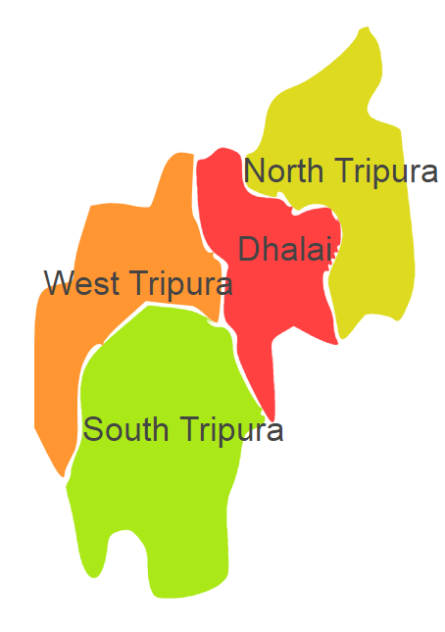

Tripura comprises of one Agro Ecological Region (AER) 17.

**Agro-Eco Region 17:** AER 17 in Tripura comprises of Dhalai, North Tripura, South Tripura and West Tripura districts of North-eastern Hills (Purvachal) under Agro Ecological Sub Region (AESR) 17.2.

**Major NRM issues :**

**AESR 17.2:** The region is warm to hot perhumid ESR with medium to deep loamy Red and Yellow soils, low to medium AWC and LGP 300 days in a year.

|  |  |  |  |  |
| --- | --- | --- | --- | --- |
| **Districts** | ***Land degradation*** | ***Soil health & fertility*** | ***Water related constraints*** | ***Environmental constraints*** |
| Dhalai | Acid soils under open forest | Soil deficient in N | GW Contaminated with Fe | Deforestation & biodiversity loss. |
| North Tripura | Acid soils under open forest | Soil Deficient in N & K | GW Contaminated with Fe | Deforestation & biodiversity loss. |
| South Tripura | Acid soils under open forest | Soil Deficient in N & K | GW Contaminated with Fe | Deforestation & biodiversity loss. |
| West Tripura | Acid soils under open forest | Soil Deficient in N, K & Zn | GW Contaminated with Fe | Deforestation & biodiversity loss, Highly prone to Flood |

**Organization and Establishments for Technology Backstopping**

***ICAR Research Institutes/KVKs/CAU/SAU:***

|  |  |
| --- | --- |
| Regional station of ICAR Research Complex for NEH Region, Lembucherra | http://www.icarneh.ernet. |
| KVK Portal | <https://kvk.icar.gov.in/> |

***List of KVKs:*** <https://icar.org.in/content/tripura>

***List of Soil testing Laboratories****:* <https://farmer.gov.in/STLDetails.aspx?State=16>