**Uttarakhand**

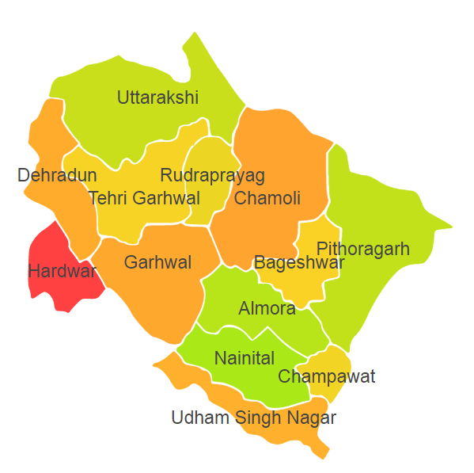

Uttarakhand comprises of two Agro Ecological Regions (AER) 9 & 14.

**Agro-Eco Region 9:** AER 9 in Uttarakhand comprises of Haridwar and Udham Singh Nagar districts of Eastern Ghats under Agro Ecological Sub Regions (AESR) 9.1 & 9.2.

**Agro-Eco Region 14:**AER 14 in Uttarakhand comprises of Almora, Bageshwar, Chamoli, Champawat, Dehradun, Nanital, Pithoragarh, Purbi Garhwal, Rudraprayag, Tehri Garwal and Uttarkashi districts of Western Himalayas under Agro Ecological Sub Regions (AESR) 14.2,14.4 & 14.5.

**Major NRM issues :**

**AESR 9.1:** The region is hot semi-arid ESR with deep loamy alluvium-derived soils (occasional saline and sodic phases), medium AWC and LGP 90-120 days in a year.

|  |  |  |  |  |
| --- | --- | --- | --- | --- |
| **Districts** | ***Land degradation*** | ***Soil health & fertility*** | ***Water related constraints*** | ***Environmental constraints*** |
| Haridwar | Exclusively water erosion | Soil deficient in N & B | GW Contaminated with NO3 & Fe | Deforestation & biodiversity loss |

**AESR 9.2:** The region hot dry subhumid ESR with deep loamy alluvium-derived soils, medium to high AWC and LGP 150-180 days in a year.

|  |  |  |  |  |
| --- | --- | --- | --- | --- |
| **Districts** | ***Land degradation*** | ***Soil health & fertility*** | ***Water related constraints*** | ***Environmental constraints*** |
| Udham Singh Nagar | Exclusively water erosion | Low in OC , Soil deficient in N & B | GW Contaminated with NO3 & Fe | Deforestation & biodiversity loss |

**AESR 14.2:** The region is warm moist to dry subhumid transitional ESR with medium to deep loamy to clayey Brown Forest and Podzolic soils, medium AWC and LGP 150-210 days in a year.

|  |  |  |  |  |
| --- | --- | --- | --- | --- |
| **Districts** | ***Land degradation*** | ***Soil health & fertility*** | ***Water related constraints*** | ***Environmental constraints*** |
| Almora | **-** | Soil deficient in N & P | GW Contaminated with NO3 | Deforestation & biodiversity loss |
| Bageshwar | **-** | **-** | - | Deforestation & biodiversity loss |
| Chamoli | Exclusively water erosion | Soil deficient in N & B | - | Deforestation & biodiversity loss |
| Champawat | **-** | Soil deficient in N & S | - | Deforestation & biodiversity loss |
| Dehradun | Exclusively water erosion | Soil deficient in B | GW Contaminated with NO3 & Fe | Deforestation & biodiversity loss |
| Pithoragarh | **-** | Soil deficient in N & B | - | Deforestation & biodiversity loss |
| Rudraprayag | **-** | Soil deficient in N & Mn | - | Deforestation & biodiversity loss |
| Tehri Garwal | Exclusively water erosion & Soil Acidity | Soil deficient in N , B & S | - | Deforestation & biodiversity loss |
| Uttarkashi | Exclusively water erosion & Soil Acidity | Soil deficient in N & S | - | Deforestation & biodiversity loss |

**AESR 14.4:** The region is humid to perhumid transitional ESR with shallow to medium deep loamy Red and Yellow soils, low AWC and LGP 270-300+ days in a year.

|  |  |  |  |  |
| --- | --- | --- | --- | --- |
| **Districts** | ***Land degradation*** | ***Soil health & fertility*** | ***Water related constraints*** | ***Environmental constraints*** |
| Dehradun | Exclusively water erosion | **-** | GW Contaminated with NO3 & Fe | Deforestation & biodiversity loss |
| Uttarkashi | Exclusively water erosion & Soil Acidity | Soil deficient in N | GW Contaminated with Fe | Deforestation & biodiversity loss |

**AESR 14.5:** The region is warm moist subhumid ESR with medium to deep, loamy arai soils, medium AWC and LGP 270-300 days in a year.

|  |  |  |  |  |
| --- | --- | --- | --- | --- |
| **Districts** | ***Land degradation*** | ***Soil health & fertility*** | ***Water related constraints*** | ***Environmental constraints*** |
| Almora | **-** | Soil deficient in N & P | - | Deforestation & biodiversity loss |
| Nanital | Exclusively water erosion | Soil deficient in N & P | - | Deforestation & biodiversity loss |
| Purbi Garhwal | Exclusively water erosion | Soil deficient in N | - | Deforestation & biodiversity loss |

**Organization and Establishments for Technology Backstopping**

***ICAR Research Institutes/KVKs:***

|  |  |
| --- | --- |
| [Indian Institute of Soil and Water Conservation, Dehradun](http://www.cswcrtiweb.org/) | <https://iiswc.icar.gov.in> |
| [Vivekananda Parvatiya Krishi Anusandhan Sansthan, Almora](https://vpkas.icar.gov.in/) | <https://vpkas.icar.gov.in> |
| KVK Portal | <https://kvk.icar.gov.in/> |

***SAUs/CAUs:***

|  |  |
| --- | --- |
| [G.B. Pant University of Agriculture & Technology, Pantnagar](http://www.gbpuat.ac.in/) | [https://www.gbpuat.ac.in/ /](https://www.gbpuat.ac.in/%20/) |
| [VCSG Uttarakhand University of Horticulture & Forestry, Bharsar](http://www.uuhf.ac.in/) | https://www.uuhf.ac.in/ |

***List of KVKs:*** <https://icar.org.in/content/uttrakhand>

***List of Soil testing Laboratories****:* <https://farmer.gov.in/STLDetails.aspx?State=5>