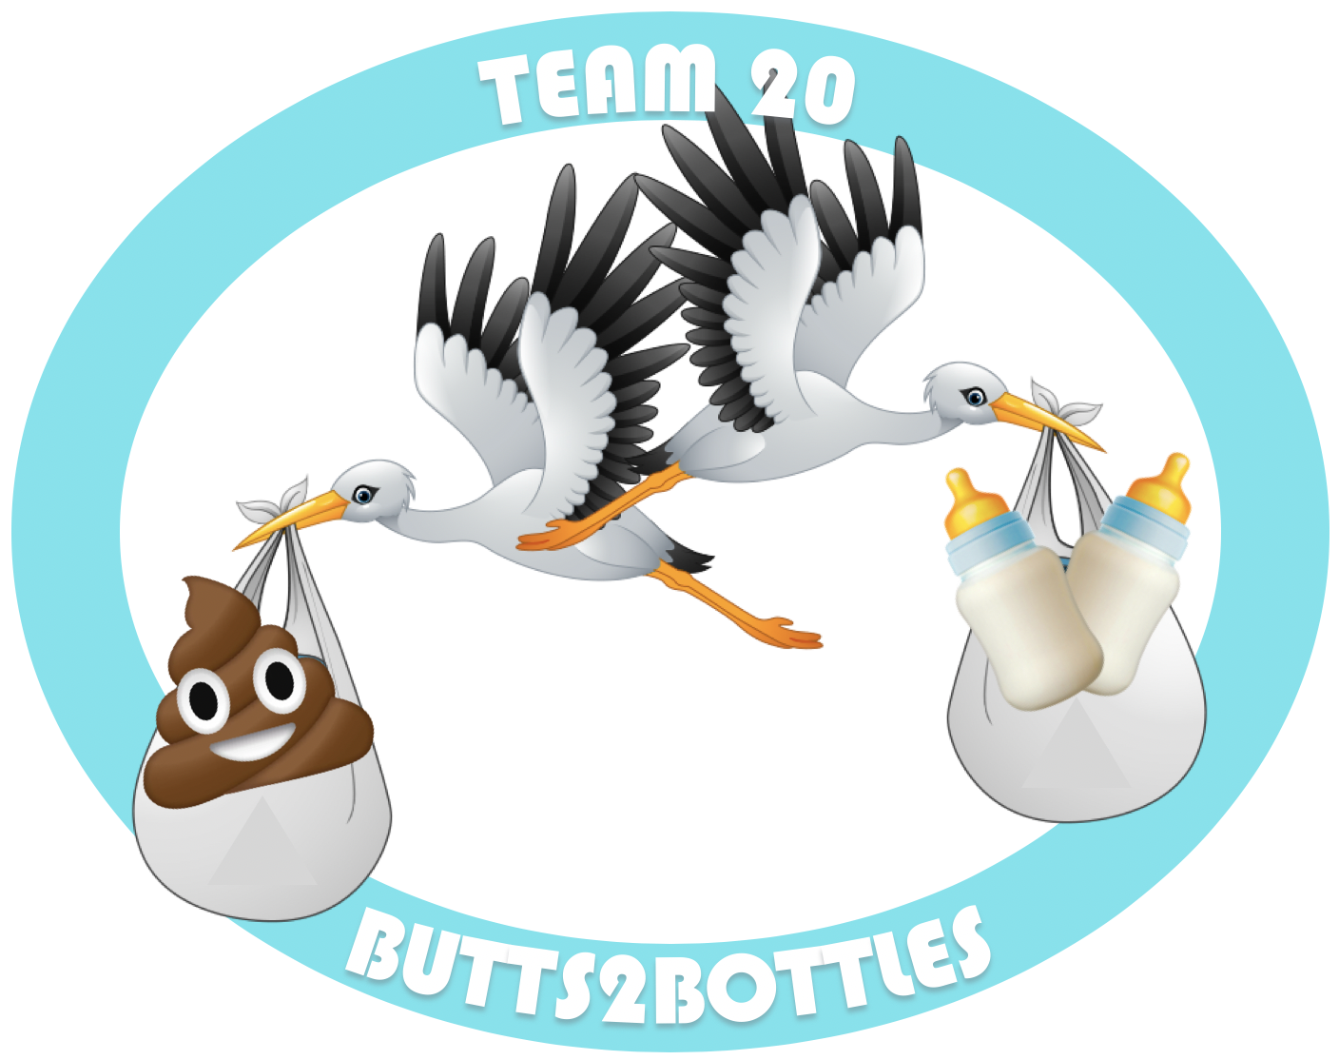

**BUTTS2BOTTLES**

***Delivering solutions to balance your baby’s belly***

**DC3**

**EM.412 IAP 2020**

**Team 20**

ByeongJo Kong

Alli Johnson

Masato Kawano

Mark Mayefske

Mollie LeBlanc



# SimpliFed - Butts2Bottles

|  |  |
| --- | --- |
| **1.0 PROJECT IDENTIFICATION** | |
| **Name** | BUTTS2BOTTLES |
| **Sponsor** | SimpliFed |
| **Project Manager** | Andrea Ippolito |
| **Project Team** | ByeongJo Kong, Alli Johnson, Masato Kawano, Mark Mayefske, Mollie LeBlanc |

|  |
| --- |
| **2.0 DESCRIPTION** |
| At Butts2Bottles, our mission is to significantly advance the field of infant nutrition and health by developing a non-invasive, mobile health tool that offers real time and evidence-based information for caregivers to identify issues surrounding their infant’s health using a personalized nutrition platform and health analysis service. Butts2Bottles aims to simplify the product delivery experience, build an online community for caregivers and healthcare professionals to connect, and to grow the start-up business into a sustainable market presence. |

|  |
| --- |
| **3.0 BUSINESS IMPACT AND STRATEGY** |
| Cultivate public awareness in risk of nutritional deficiencies developed from lack of access to breast milk during early stages of infant development.  *Short-term (0-3 years)*   * Successfully complete clinical trials in conjunction with DIAPER (Daily Information About Poop Enhancing Resolution) cohort * Launch marketing campaign in United States markets * Establish online community * Explore traditional US Healthcare options for consumers (ie. insurance coverage for analysis and product line) * Develop the supplement vs. formula tradespace   *Medium-term (3-10 years)*   * First product sales * Explore non-US markets * Develop partnerships with medical professionals (pediatricians) to expand beyond direct-to-consumer market * Identify geographically-based analysis of deficiencies to educate local population |

|  |  |
| --- | --- |
| **4.0 PROJECT SCOPE** | |
| **Business Need** | Gap in nutritional value between breastmilk and formula currently available, impacting infant development in early stages of life |
| **Project Goals** | Develop a total infant nutrition platform personalized for each customer |
| **In Scope/Out of Scope** | **In scope**:   * Evaluation of sampling and analysis methods to identify dietary deficiencies * Safe, efficient transportation of sample from customer to lab * Simple, easy to understand report with clear recommendations * Development of supplement and/or formula based on identified nutritional deficiency * Online profile for each patient including access to online community * Multiple package levels for analysis, support, and subscription options * Strategy for shipping and logistics (supplier vs. owner)   **Out of scope**:   * Genetic testing * Analysis of children nutrition beyond age 3 or after dietary transition to solid foods |
| **Project Assumptions** | * R&D effort is underway examining the patterns across infant stools including biochemical data, infant stool images and other environmental elements |

|  |  |
| --- | --- |
| **5.0 KEY PROJECT STAKEHOLDERS** | |
| **Key Stakeholders** | **Stakeholder Needs** |
| Infants | Satisfy dietary needs, Safe for consumption, Tastes good |
| Caregivers | Easy to administer infant dietary supplement, Affordable cost, Ease procurement of dietary supplement, Community support |
| Regulators | Compliance, Safety, Protecting the public’s health |
| Researchers | Funding, Clear business case, Partnership/network, Proven results/metrics/feedback loop |
| Investors | Clear business case, Profits, Return on Investment |
| Doctors | Clear business case, Decision-making authority, R&D partnership, Compliance |

|  |  |  |
| --- | --- | --- |
| **6.0 PROJECT TARGETS** | | |
| **Constraints** | **Targets** | **Tolerances** |
| Schedule | Completion of clinical trials within 18 months from initiation of testing | +/- 6 months |
| Interactive portal deployed and in production within 2 years | +/- 6 months |
| Obtain relevant approval of compliance for product sales | - |
| Scope | Diagnosis technology selected | TRL > 6 |
| Establish preferred supplier | - |
| Establish preferred shipping and logistics partner | - |
| Cost | Price of product and subscription options such that  Customer Acquisition Cost (CAC) < Lifetime Value (LTV)  LTV = 3 * CAC | +/- 20% |
| CAC recovery plan within 12-month subscription cycle | +/- 1.5 months |

|  |
| --- |
| **7.0 KEY RISKS** |
| **Regulatory Compliance:** If product selection is formula, Federal Drug Administration (FDA) approval is required by Code of Federal Regulations (CFR) Title 21. If the product is a supplement to formula, FDA certification is not required; however, FDA acknowledgement is required. Federal Trade Commission (FTC) requirements apply to either product selection. |
| **Adverse reactions to product:** Comprehensive analysis of infant sample required to eliminate potential for adverse side effects, including distaste of the product. |
| **Transfer and Management of Hazardous Material:** Clear procedures and definition of liability for shipping and logistics to be outlined in contracts with shipping organization. Any contamination of the sample may lead to inaccurate diagnosis. |
| **Data breach:** Potential risk of hacking to virtual database containing personal data. |
| **Affordability of product:** Price point for analysis and products need to be such that Customer Acquisition Cost (CAC) yields profit, but also meets affordability expectations of customers. |
| **Contamination of Samples Leading to Inaccurate Diagnosis:**  Caretakers do not follow sample procurement procedure, improper handling of samples within lab. |
| **Inventory Management:** Shelf life of product will require additional attention in order sizing and management of material. |

.