D279: Project Proposal with Strategies

Student ID: 011456279

Date: 11/08/2023

1. Explain the necessary website functionality and micro interactions needed to meet audience and stakeholder needs.

The Paradigm Pet Professionals website must meet the needs of multiple users. All visitors arriving at the landing page may do so via desktop or mobile device. The website must meet the functionality of different view ports, meaning the UI must match for the appropriate device. Depending on the user, interactions may vary. Some users will visit Paradigm Pet Professionals for information, while others may seek consultation by filling out a contact form. The user should be easily directed to their destination by having succinct UI – a navigation, link highlighting, and necessary micro interactions.

1. Describe the type of content that will be used for **one** new page based on **one** of the new user personas, including how the elements of the content align directly to the chosen user persona.

I have chosen to add a page for bird owners. The bird owner persona’s interest focus on the well-being of their bird(s). This means the page’s content must focus on the relational needs, and thus, the elements must clearly convey this information. It isn’t a page to admire birds, but rather to convey the necessary information of a bird’s well-being.

1. Identify existing content from the website that will be removed or redeveloped and explain how that content fails to meet the proposed audience and stakeholder needs.

The current Paradigm Pet Professionals website is in a state of incompleteness and novice design. The following lists contain areas of needed improvement:

Landing Page:

* Content alignment – currently, everything is left-aligned
* No company description nor mission statement – what is Paradigm Pet Professionals?
* No information regarding contact.

Navigation:

* Erroneous highlighting – when the user lands on the ‘Dogs’ page, the ‘Cats’ link is highlighted. When clicking ‘Cats’, there is no highlight. When visiting the ‘FAQs’ page, the ‘Home’ link is highlighted.
* Search vocabulary – while ‘fetch’ is a great programming term, the average user does not think of a search algorithm as ‘fetching.’ Thus, the button text should be changed to ‘Search.’ However, in the instance of my redesign, the search box will be removed due to very limited website content and the need for straight-forwardness.

Header:

* The header is stacked – the logo sits on top of the text. The alignment needs much improvement. I will realign the header to be present and functional in **each** page. That is, ‘Paradigm Pet Professionals’ and slogan will always be present.
* Simply having the animal name, i.e., ‘Cats’ or ‘Dogs’ does not suffice is an appropriate header.

Individual Animal Page:

* What is the information being displayed here? The page must be redesigned to include elements and headers that direct the user to what they are about to read; i.e., “Raising Your Cat:”
* There are no images or icons. I will add a universal animal image for each individual animal page.
* Content must be provided with elements of color contrast and highlighting, as to engage the user and to make it clear to the user which information is important.

As it currently stands, the Paradigm Pet Professionals website fails to meet the audience needs with erroneous elements and poor site UI. It fails the audience by not being direct – the user knows what they need, thus the site should easily direct them.

The site fails both the stakeholder and audience needs by not pushing the user in a business direction. What is the business objective of Paradigm Pet Professionals? This is not stated. What makes the user want to contact Paradigm Pet Professionals? And greater, how can the user contact the business?

Site Map

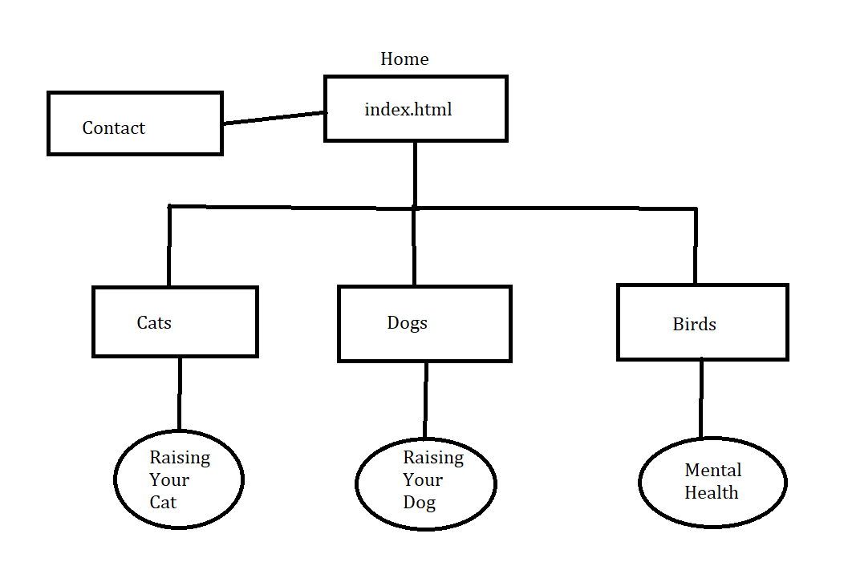

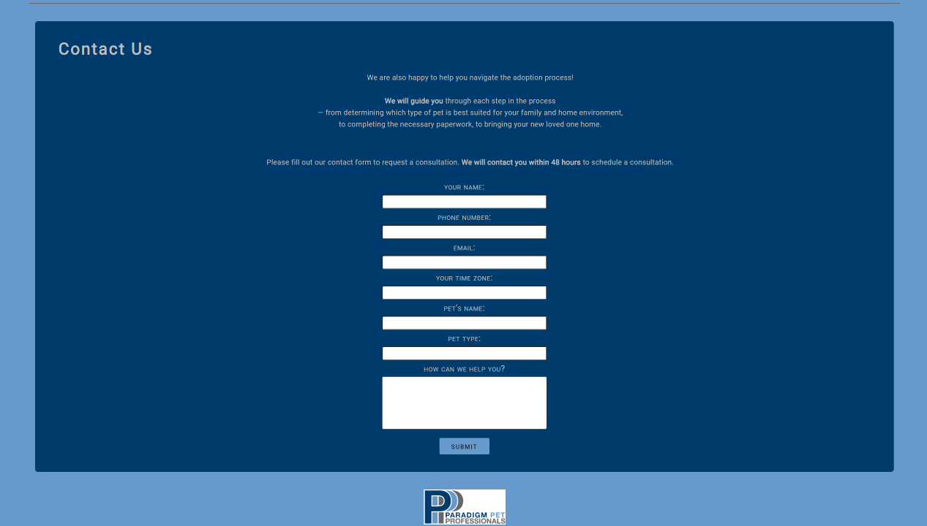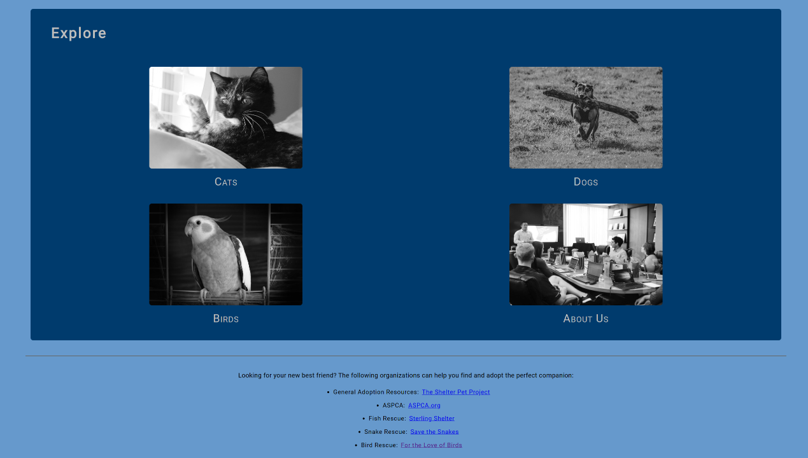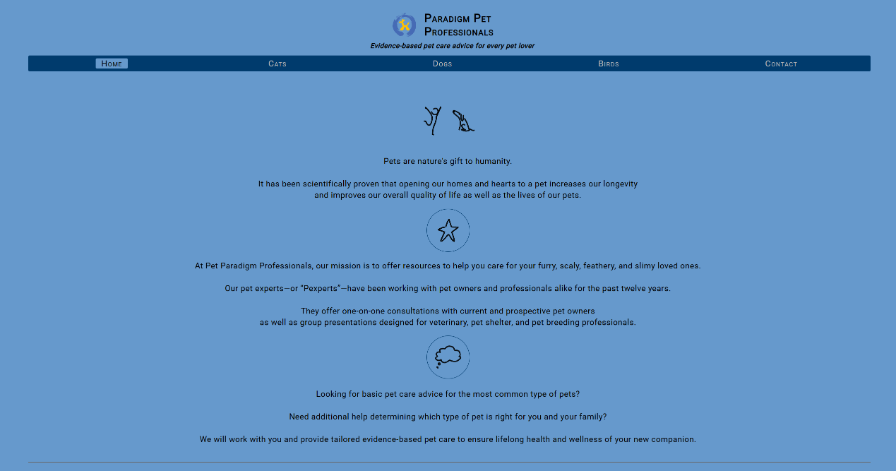Home Page Desktop Layout

The primary navigational element is the nav bar that is present on each of the pages. This navigation bar contains links to each of the site’s pages. When the user is located on a given page, the page is highlighted by sky-blue (primary business color). Clicking the *footer* logo will redirect the user to Paradigm Pet Professional’s landing page (the home page).

The secondary navigational elements of the site are numerous among the site – for example, the home page’s ‘Explore’ midnight blue section have an animal for display, when hovered, fills the opacity (displays color), and when clicked, redirects the user to the appropriate page (which are the pages of the primary navigation).

Using these navigational elements fulfills the audience needs by being clear and succinct. Further, these navigational elements fulfill the stakeholder needs by directing the user to contact Paradigm Pet Professionals for consultation. The content of the site should funnel the user to consultation.