# Capgemini Big Data and Azure Engineering Batch

1. What is the difference between Network and Hierarchical database?
2. What is the difference between DBMS and RDBMS?
3. What are importance of ACID property in DBMS?
4. What is the difference between Primary Key and Foreign Key?
5. What are the schema objects?

## Assignments - SQL Server BI & Database Internals

Query all columns (attributes) for every row in the CITY table.

The CITY table is described as follows:

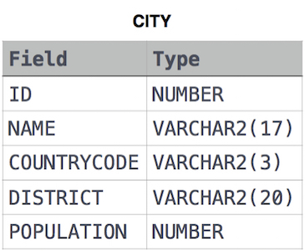

Query all columns for a city in CITY with the ID 1661.

The CITY table is described as follows:



3. Query the Name of any student in STUDENTS who scored higher than Marks 75. Order your output by the last three characters of each name. If two or more students both have names ending in the same last three characters (i.e.: Bobby, Robby, etc.), secondary sort them by ascending ID.

Input Format

The STUDENTS table is described as follows: 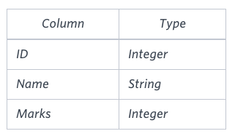

The Name column only contains uppercase (A-Z) and lowercase (a-z) letters.

Sample Input

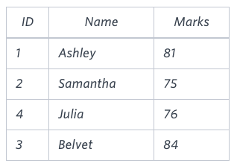

Sample Output

Ashley

Julia

Belvet

4. Write a query that prints a list of employee names (i.e.: the name attribute) for employees in Employee having a salary greater than per month who have been employees for less than months. Sort your result by ascending employee_id.

Input Format

The Employee table containing employee data for a company is described as follows:

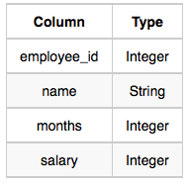

where employee_id is an employee's ID number, name is their name, months is the total number of months they've been working for the company, and salary is the their monthly salary.

Sample Input

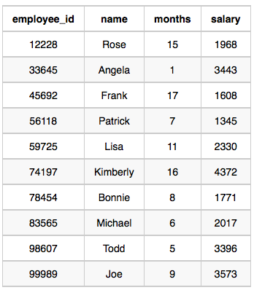

Sample Output

Angela

Michael

Todd

Joe

5. Query all attributes of every Japanese city in the CITY table. The COUNTRYCODE for Japan is JPN.

The CITY table is described as follows:



6. Query the total population of all cities in CITY where District is California.

Input Format

The CITY table is described as follows: 

7. We define an employee's total earnings to be their monthly worked, and the maximum total earnings to be the maximum total earnings for any employee in the Employee table. Write a query to find the maximum total earnings for all employees as well as the total number of employees who have maximum total earnings. Then print these values as space-separated integers.

Input Format

The Employee table containing employee data for a company is described as follows:



where employee_id is an employee's ID number, name is their name, months is the total number of months they've been working for the company, and salary is the their monthly salary.

Sample Input



Sample Output

69952 1

8. Given the CITY and COUNTRY tables, query the names of all cities where the CONTINENT is 'Africa'.

Note: CITY.CountryCode and COUNTRY.Code are matching key columns.

Input Format

The CITY and COUNTRY tables are described as follows: 

