This website is basically for a logistic company which ships product from china to America

The front page of the website will be like <https://transferwise.com/> The form on the right side should be removed, instead there should be two buttons on the top background:

This website will have 3 type of permisions the company the user the this Companies will create an account on the webpage and input their prices.

Fex. Air express DHL: 0-20Kg=$10/Kg, 21-50Kg=$8/Kg ————Air Freight Turkish Airlines________Sea Freight Cosco: 2-5CBM =$400/cbm, 5-10cbm=$380/CBM etc.

**User permissions:**

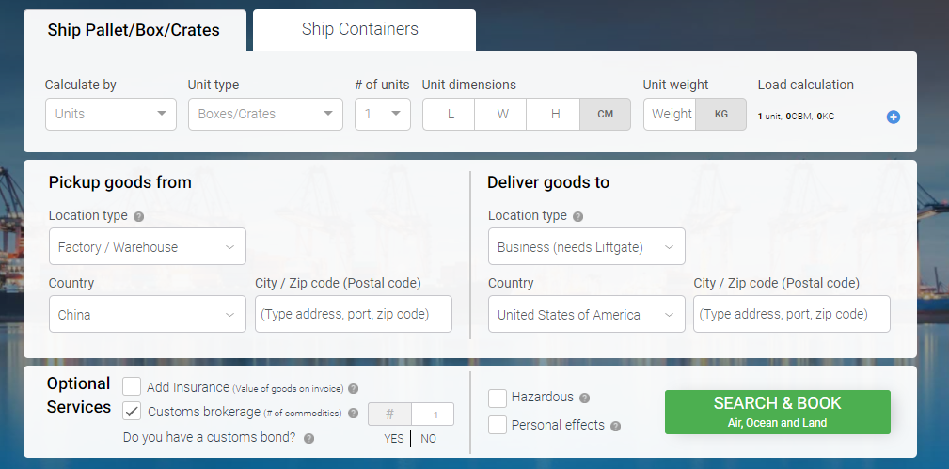

The user will have this form on when they input the info based on the user information the details of all the companies will show after the user login to there account based on this information the companies details page will be like this

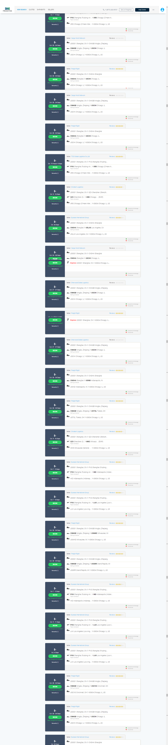

So this is it and if in the design you can add some video in the background or animations it will be great