**IMDAD ULLAH**

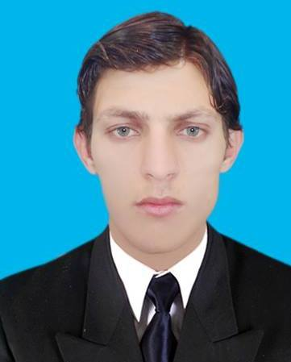

[Uimdad19@gmail.com](mailto:Uimdad19@gmail.com)

+923159036207

**PERSONAL STATEMENT:**

I’m an experienced Website Developer looking to continue my career within agency side development.

I have excellent design & coding skills, as well as an ability convert client requirements into exciting online applications.

**TECHNICAL SKILLS:**

**Programming/web:**Html5/css3,less,composer,bootstrap3,javscript,jquery,php,mysql,oop

concepts,wordpress,codegniter basics,git basics

**Software’s :** brackets, photoshop, ms. office,illustrator,eclipse

**Database:** mysql,sql

**Operating Systems**:Windows 7/8/10

**CAREER DEVELOPMENT:**

Various clients 2016

Currently working on fiverr as a webdeveloper with level badge and soon level two during my career on fiverr I have managed so many websites and make more then 50 happy clients with 5 star review on my profile

* Developed several web applications with both frontend and backend with secure database systems
* Converted several psds to html and bootstrap or made several websites responsive as in modern era most of the websites are responsive
* Fixed several bugs in the bootstrap html css php mysql during my career on fiverr

**EDUCATION:**

Currently I am a student of Bsse (bachelor of science and software engineering )8th semester know all the basic of software development life cycle and want to join a best organization to learn the modern technologies to polish my skills by working with professional developer