# Appendix E: Remanence Data Analysis

## **E.1 Hard Drive: USB-HD-01**

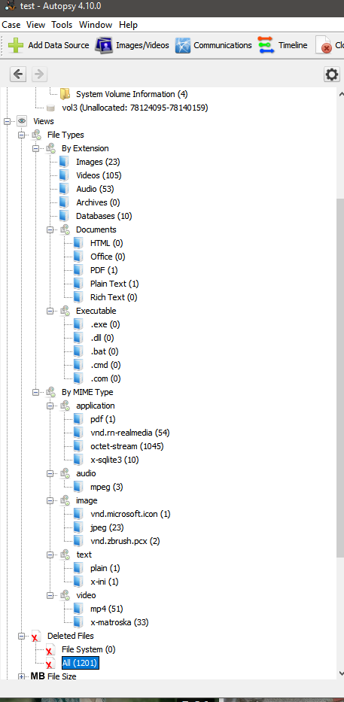

**Figure E.1: Data analysed from USB-HD-01**

**Table E.1: File type collected from USB-HD-01**

|  |  |  |
| --- | --- | --- |
| **Data Categories** | **File type** | **Quantity** |
| **Text** | PDF | 1 |
| **Video** | MKV | 33 |
| MP4 | 54 |
| **Audio** | MPEG | 1 |
| **Image** | JPEG | 23 |
| ICON | 1 |
| **Data Base** | SQLITE | 10 |

## **E.2 Hard Drive: USB-HD-02**

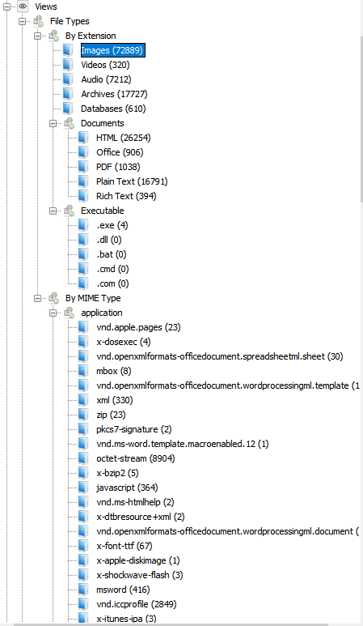

**Figure E.2: Data analysed from USB-HD-02**

**Table E.2: Data collected from USB-HD-02**

|  |  |  |
| --- | --- | --- |
| **Data Categories** | **File Types** | **Quantity** |
| **Application** | ZIP | 23 |
| EXE | 4 |
| XML | 330 |
| BZ2 | 5 |
| JS | 364 |
| CHM | 2 |
| RES | 2 |
| TTF | 67 |
| DMG | 1 |
| SWF | 3 |
| ICC | 2849 |
| JSON | 2 |
| XMP | 7 |
| SQLITE | 583 |
| TAR | 15 |
| RTF | 396 |
| DB | 27 |
| PLIST | 40068 |
| PY | 152 |
| RB | 70 |
| SH | 30 |
| GZ | 17480 |
| HTML | 13006 |
| JAVA | 6190 |
| CSS | 518 |
| H | 1155 |
| CSV | 2 |
| VCF | 17 |
| INI | 156 |
| **Audio** | M4P | 3142 |
| AIF | 693 |
| MP3 | 3132 |
| WAV | 195 |
| WMA | 4 |
| **Image** | TIF | 17033 |
| BMP | 10 |
| ICNS | 39 |
| GIF | 9818 |
| PNG | 21084 |
| PSD | 36 |
| PCT | 101 |
| JPG and JPEG | 34726 |
| **Message** | MBOX | 69 |
| **Text** | ICS | 1576 |
| DOC and DOCX | 416 |
| XLS and XLSX | 122 |
| PDF | 1114 |
| PPTX | 6 |
| **Video** | MP4 | 45 |
| MPEG | 67 |
| MOV | 186 |
| 3GP | 3 |
| AVI | 2 |
| WMV | 18 |

## **E.3 Hard Drive: USB-HD-03**

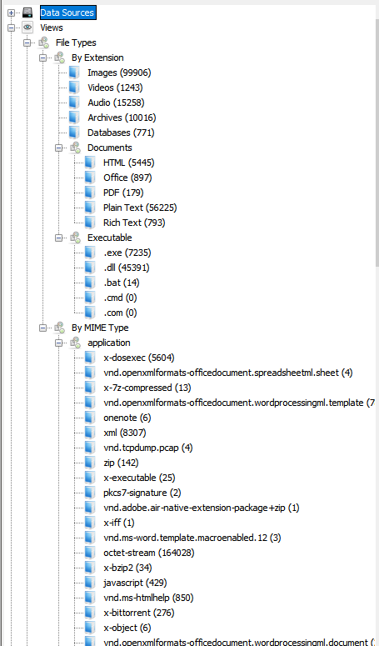

**Figure E.3: Data analysed from USB-HD-03**

**Table E.3: Data collected from USB-HD-03**

|  |  |  |
| --- | --- | --- |
| **Data Categories** | **File Types** | **Quantity** |
| **Application** | EXE | 5604 |
| ZIP | 144 |
| 7Z | 13 |
| ONE | 6 |
| XML | 8307 |
| DMP | 4 |
| ELF | 25 |
| BZ2 | 34 |
| JS | 429 |
| CHM | 850 |
| TORRENT | 276 |
| DLL | 47046 |
| CAB | 1003 |
| SWC | 1929 |
| ICC | 299 |
| RAR | 7 |
| HTML | 901 |
| JSON | 20 |
| XMP | 45 |
| SQLITE | 758 |
| RTF | 794 |
| VSD | 3 |
| JAR | 23 |
| JSP | 198 |
| H | 2508 |
| BAT | 14 |
| CSS | 72 |
| XUL | 13 |
| PLIST | 455 |
| INI | 231 |
| C | 131 |
| GZ | 8751 |
| **Audio** | MP4 | 200 |
| MIDI | 5 |
| SPX | 20 |
| FLAC | 45 |
| MP3 | 13589 |
| WAV | 1055 |
| WMA | 24 |
| OGG | 29 |
| **Image** | ICO | 178 |
| TIF | 12 |
| BMP | 5428 |
| GIF | 3378 |
| PNG | 21310 |
| WMF | 233 |
| JPG and JPEG | 73199 |
| **Text** | JAVA | 9670 |
| CSV | 121 |
| TXT | 56225 |
| DOC and DOCX | 494 |
| XLS and XLSX | 40 |
| PDF | 1114 |
| PPTX | 29 |
| XML | 92761 |
| **Video** | MP4 | 257 |
| OGM | 2 |
| FLV | 7 |
| MOV | 815 |
| 3GP | 30 |
| MKV | 13 |
| AVI | 36 |
| WEBM | 13 |
| WMV | 76 |

## **E.4 Hard Drive: USB-HD-04**

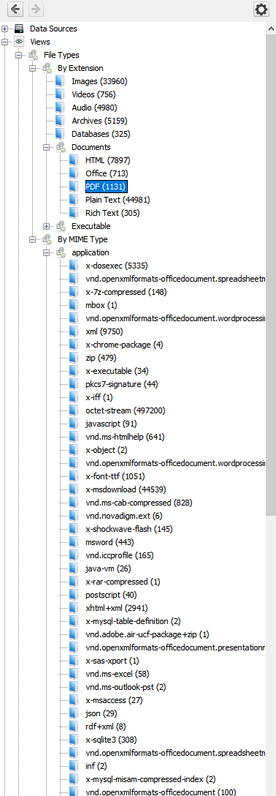

**Figure E.4: Data analysed from USB-HD-04**

**Table E.4: Data collected from USB-HD-04**

|  |  |  |
| --- | --- | --- |
| **Data Categories** | **File Types** | **Quantity** |
| **Application** | EXE | 5335 |
| 7z | 148 |
| ZIP | 479 |
| ELF | 34 |
| SLG | 44 |
| MFT | 467200 |
| JS | 91 |
| CHM | 641 |
| TTF | 1051 |
| DLL | 44539 |
| CAB | 828 |
| EXT | 6 |
| SWC | 145 |
| ICC | 165 |
| CLASS | 26 |
| PS | 40 |
| HTML | 9284 |
| PST | 2 |
| MDB | 27 |
| JSON | 29 |
| XMP | 8 |
| SQLITE | 308 |
| RTF | 306 |
| DEB | 13 |
| ZIP | 23 |
| DTD | 93 |
| PY | 4 |
| PHP | 51 |
| DB | 17 |
| BAT | 91 |
| PLST | 444 |
| GZ | 3675 |
| APPLE | 40 |
| H | 1232 |
| F | 52 |
| C | 63 |
| INI | 137 |
| **Audio** | MP4 | 750 |
| MIDI | 20 |
| MP3 | 3352 |
| WAV | 466 |
| WMA | 130 |
| M3U | 1 |
| OGG | 47 |
| **Image** | ICO | 131 |
| TIF | 13 |
| BMP | 2073 |
| GIF | 5948 |
| PNG | 17688 |
| WMF | 840 |
| JPG and JPEG | 73199 |
| EMF | 22 |
| **Message** | MBOX | 48 |
| **Text** | JAVA | 35211 |
| CSS | 17 |
| ICS | 7 |
| JSP | 371 |
| CSV | 64 |
| TXT | 87 |
| DOC and DOCX | 647 |
| XLS and XLSX | 73 |
| PDF | 1140 |
| PPTP and PPTX | 6 |
| XML | 62029 |
| **Video** | MP4 | 207 |
| FLV | 5 |
| M4V | 7 |
| MOV | 283 |
| 3GP | 8 |
| ASF | 4 |
| MPG | 39 |
| AVI | 102 |
| MKV | 72 |
| WEBM | 1 |
| WMV | 92 |
| JNG | 35 |

## **E.5 Hard Drive: USB-HD-05**

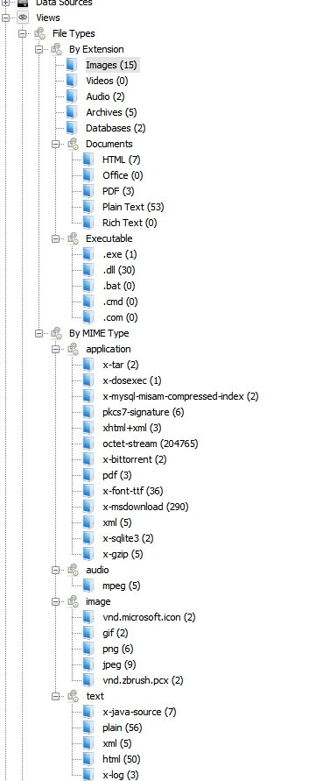

**Figure E.5: Data analysed from USB-HD-05**

**Table E.5: Data collected from USB-HD-05**

|  |  |  |
| --- | --- | --- |
| **Data Categories** | **File Types** | **Quantity** |
| **Application** | MFT | 204765 |
| EXE | 1 |
| MYI | 2 |
| STL | 6 |
| TORRENT | 2 |
| TTF | 36 |
| MUI | 290 |
| XML | 10 |
| SQLITE | 2 |
| GZ | 5 |
| HTML | 50 |
| **Audio** | MPEG | 5 |
| **Image** | ICON | 2 |
| GF | 2 |
| PNG | 6 |
| JPEG | 9 |
| PCX | 2 |
| **Text** | JAVA | 7 |
| TXT | 56 |
| LOG | 3 |

## **E.6 Hard Drive: USB-HD-06**

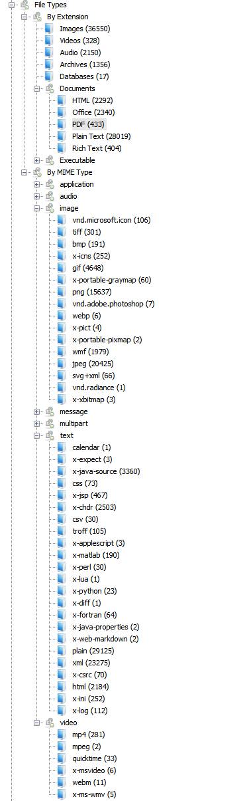

**Figure E.6: Data analysed from USB-HD-06**

**Table E.6: Data collected from USB-HD-06**

|  |  |  |
| --- | --- | --- |
| **Data Categories** | **File Types** | **Quantity** |
| **Application** | EXE | 1672 |
| 7Z | 83 |
| OTC | 2 |
| PUB | 1 |
| XML | 9320 |
| ZIP | 119 |
| ELF | 6 |
| Codesignature | 76 |
| Localized | 11423 |
| JS | 144 |
| CHM | 373 |
| TTF | 421 |
| DLL | 17850 |
| CAB | 638 |
| DMG | 7 |
| SWC | 8 |
| LCC | 148 |
| CLASS | 63 |
| RAR | 1 |
| PS | 487 |
| PKG | 17 |
| HTML | 23275 |
| MSI | 1 |
| MDB | 18 |
| JSON | 172 |
| XMP | 3 |
| SQLITE | 16 |
| INI | 254 |
| TAR | 1 |
| RTF | 404 |
| ZIP | 3 |
| DTD | 14 |
| VSD | 15 |
| BAT | 11 |
| ZIB | 97 |
| PY | 93 |
| A | 6 |
| STRINGS | 31193 |
| GZ | 536 |
| JAVA | 3360 |
| CSS | 73 |
| JSP | 467 |
| H | 2503 |
| CSV | 30 |
| PY | 23 |
| F | 64 |
| C | 70 |
| **Audio** | M4A | 148 |
| MID | 44 |
| AFF | 80 |
| MP3 | 36 |
| WAV | 154 |
| WMA | 981 |
| OGG | 431 |
| **Image** | RSRC | 106 |
| TIFF | 301 |
| BMP | 191 |
| ICONS | 252 |
| GIF | 4648 |
| PGM | 60 |
| PNG | 15637 |
| PSD | 7 |
| WMF | 1979 |
| JPG | 20425 |
| SVG | 66 |
| **Message** | MBOX | 4 |
| **Text** | DOC and DOCX | 2202 |
| XLS and XLSX | 126 |
| PDF | 438 |
| PPTP and PPTX | 118 |
| TXT | 208 |
| ICS | 1 |
| EXP | 3 |
| LOG | 112 |
| **Video** | MP4 | 281 |
| MPG | 2 |
| MOV | 33 |
| AVI | 6 |
| WEBM | 11 |
| WMV | 5 |

## **E.7 Hard Drive: USB-HD-07**

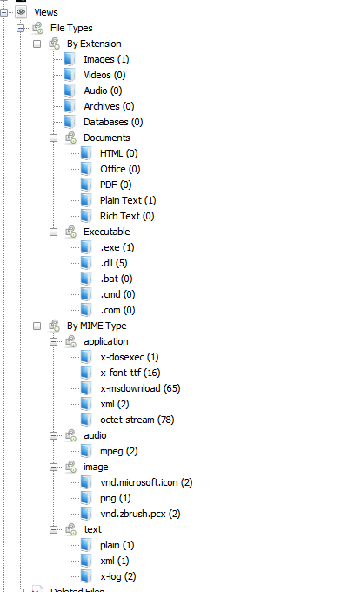

**Figure E.7: Data analysed from USB-HD-07**

**Table E.7: Data collected from USB-HD-07**

|  |  |  |
| --- | --- | --- |
| **Data Categories** | **File Types** | **Quantity** |
| **Application** | EXE | 1 |
| TTF | 16 |
| MUI | 65 |
| XML | 3 |
| MFT | 78 |
| **Audio** | MPEG | 2 |
| **Image** | ICON | 2 |
| PNG | 1 |
| PCX | 2 |
| **Text** | TXT | 1 |
| LOG | 2 |

## **E.8 Hard Drive: USB-HD-08**

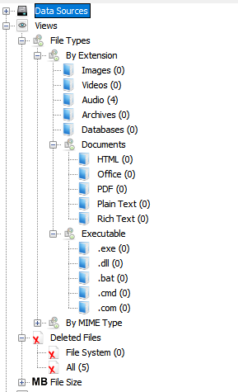

**Figure E.8: Data analysed from USB-HD-08**

**Table E.8: Data collected from USB-HD-08**

|  |  |  |
| --- | --- | --- |
| **Data Categories** | **File Types** | **Quantity** |
| **Application** | DAT | 19 |
| **Audio** | MP3 | 4 |
| **Image** | ICON | 1 |
| PCX | 2 |

## **E.9 Hard Drive: USB-HD-09**

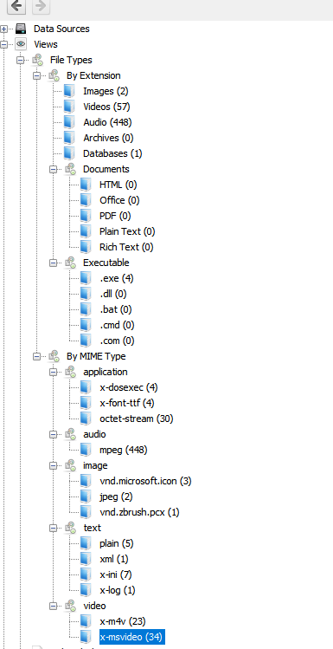

**Figure E.9: Data analysed from USB-HD-09**

**Table E.9: Data collected from USB-HD-09**

|  |  |  |
| --- | --- | --- |
| **Data Categories** | **File Types** | **Quantity** |
| **Application** | EXE | 4 |
| LOG | 5 |
| DAT | 30 |
| XML | 1 |
| INI | 7 |
| INF | 5 |
| **Audio** | MP3 | 448 |
| **Image** | ICON | 3 |
| JPG | 2 |
| PCX | 2 |
| **Video** | MOV | 23 |
| AVI | 34 |

## 

## **E.10 Hard Drive: USB-HD-10**

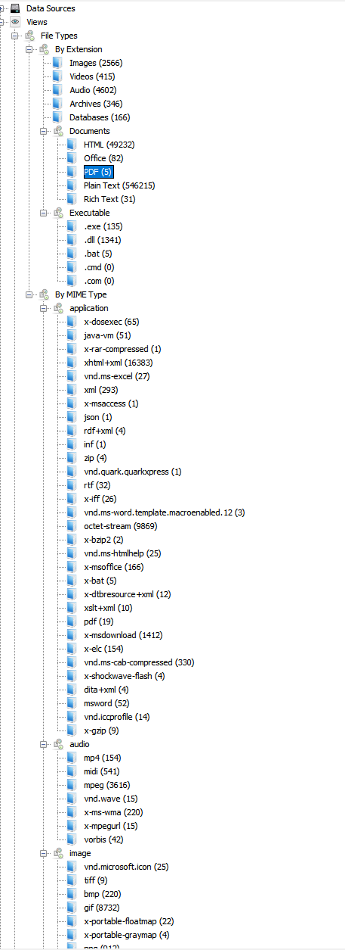

**Figure E.10: Data analysed from USB-HD-10**

**Table E.10: Data collected from USB-HD-10**

|  |  |  |
| --- | --- | --- |
| **Data Categories** | **File Types** | **Quantity** |
| **Application** | EXE | 65 |
| CLASS | 51 |
| RAR | 1 |
| XML | 16383 |
| JSON | 1 |
| XMP | 4 |
| INI | 1 |
| ZIP | 4 |
| QXD | 1 |
| RTF | 32 |
| FAT | 9869 |
| BZ2 | 2 |
| CHM | 25 |
| DB | 166 |
| BAT | 5 |
| RES | 12 |
| DLL | 1412 |
| CAB | 330 |
| SWC | 4 |
| ICC | 14 |
| JAVA | 133818 |
| JSP | 12036 |
| H | 14003 |
| CSV | 867 |
| **Audio** | MID | 541 |
| M4P | 154 |
| MP3 | 3616 |
| WAV | 15 |
| WMA | 220 |
| M3U | 15 |
| OGG | 42 |
| **Image** | ICON | 25 |
| TIF | 9 |
| BMP | 220 |
| GIF | 8732 |
| PNG | 912 |
| JPG | 1427 |
| PCX | 13 |
| **Text** | DOC and DOCX | 52 |
| XLS and XLSX | 10 |
| PDF | 5 |
| PPTP and PPTX | 2 |
| TXT | 542163 |
| **Video** | MPG | 407 |
| AVI | 7 |
| WMV | 1 |

## **E.11 Hard Drive: USB-HD-11**

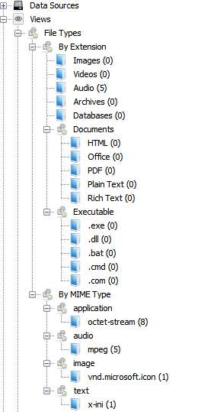

**Figure E.11: Data analysed from USB-HD-11**

**Table E.11: Data collected from USB-HD-11**

|  |  |  |
| --- | --- | --- |
| **Data Categories** | **File Types** | **Quantity** |
| **Application** | DAT | 8 |
| INI | 1 |
| **Audio** | MP3 | 5 |
| **Image** | ICON | 1 |

## **E.12 Hard Drive: USB-HD-12**

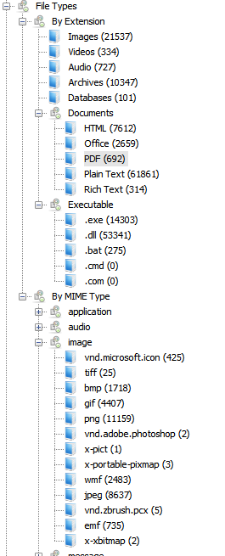

**Figure E.12: Data analysed from USB-HD-12**

**Table E.12: Data collected from USB-HD-12**

|  |  |  |
| --- | --- | --- |
| **Data Categories** | **File Types** | **Quantity** |
| **Application** | EXE | 11311 |
| 7Z | 3 |
| ISO | 3 |
| XML | 6039 |
| HLP | 34 |
| ZIP | 1821 |
| ELF | 74 |
| RSA | 2 |
| MFT | 483208 |
| JS | 143 |
| CHM | 577 |
| ELF | 133 |
| TTF | 2821 |
| DLL | 56345 |
| CAB | 8249 |
| EXT | 122 |
| SWC | 37 |
| ICC | 240 |
| PRC | 3 |
| CLASS | 307 |
| HTML | 9120 |
| SXW | 5 |
| XPT | 10 |
| ACCDB | 129 |
| SQLITE | 92 |
| INI | 1225 |
| TAR | 7 |
| RTF | 314 |
| ZIP | 61 |
| DTD | 21 |
| VSD | 4 |
| BAT | 275 |
| SH | 46 |
| GZ | 205 |
| JAVA | 10790 |
| CSS | 13 |
| JSP | 244 |
| H | 1438 |
| CSV | 142 |
| PM | 37 |
| PHP | 80 |
| F | 108 |
| C | 40 |
| **Audio** | MP3 | 76 |
| MID | 62 |
| WAV | 566 |
| WMA | 26 |
| **Image** | ICO | 425 |
| TIFF | 25 |
| BMP | 1718 |
| GIF | 4407 |
| PNG | 11159 |
| PSD | 2 |
| WMF | 2483 |
| JPG | 8637 |
| PCX | 5 |
| EMF | 735 |
| **Message** | PST | 19 |
| MSG | 7 |
| **Text** | DOC and DOCX | 1472 |
| XLS and XLSX | 1154 |
| PDF | 694 |
| PPTP and PPTX | 47 |
| PUB | 1 |
| ONE | 6 |
| TXT | 27 |
| XML | 38803 |
| LOG | 49 |
| **Video** | MP4 | 3 |
| ASF | 2 |
| MPG | 1 |
| MOV | 1 |
| AVI | 51 |
| WMV | 283 |

## **E.13 Hard Drive: USB-HD-13**

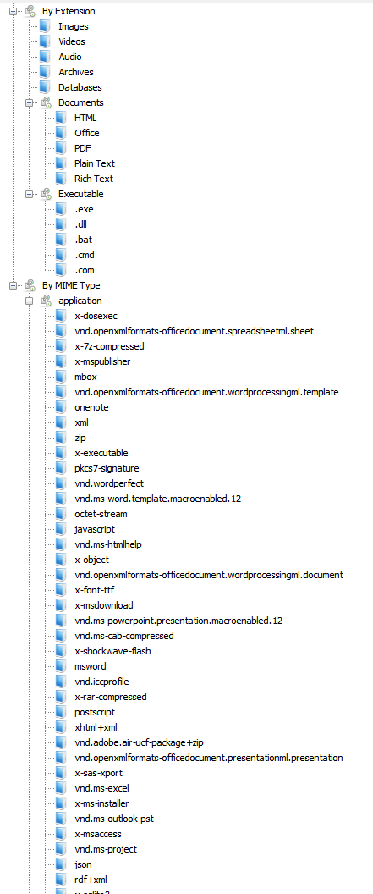

**Figure E.13: Data analysed from USB-HD-13**

**Table E.13: Data collected from USB-HD-13**

|  |  |  |
| --- | --- | --- |
| **Data Categories** | **File Types** | **Quantity** |
| **Application** | EXE | 1274 |
| 7Z | 3 |
| XML | 1987 |
| HLP | 34 |
| ZIP | 68 |
| ELF | 3 |
| WPD | 36 |
| MFT | 1417452 |
| JS | 22 |
| CHM | 169 |
| ELF | 12 |
| TTF | 527 |
| DLL | 13208 |
| CAB | 136 |
| SWF | 11 |
| ICC | 18 |
| HTML | 88 |
| XPT | 1 |
| MST | 58 |
| MDB | 4 |
| JSON | 4 |
| XMP | 5 |
| SQLITE | 46 |
| RTF | 238 |
| BIN | 22 |
| DB | 365 |
| BAT | 2 |
| GZ | 1170 |
| APPLE | 4 |
| ICS | 40 |
| JAVA | 1991 |
| CSS | 4 |
| JSP | 216 |
| H | 856 |
| CSV | 8 |
| VCF | 21 |
| F | 29 |
| C | 13 |
| HTM | 5047 |
| INI | 110 |
| **Audio** | M4P | 1805 |
| MID | 1 |
| MP3 | 1274 |
| WAV | 41 |
| WMA | 5090 |
| M3U | 4 |
| **Image** | ICO | 26 |
| WMF | 7428 |
| TIFF | 2465 |
| BMP | 302 |
| GIF | 2143 |
| PNG | 43338 |
| JPG | 34257 |
| EMF | 2152 |
| **Message** | PST | 11 |
| MBOX | 1403 |
| MSG | 3011 |
| **Text** | DOC and DOCX | 22861 |
| XLS and XLSX | 5093 |
| PDF | 6846 |
| PPTP and PPTX | 190 |
| TXT | 21640 |
| **Video** | MP4 | 32 |
| MPG | 2 |
| 3GP | 2 |
| MOV | 7 |
| AVI | 186 |
| WMV | 8 |

## **E.14 Hard Drive: USB-HD-14**

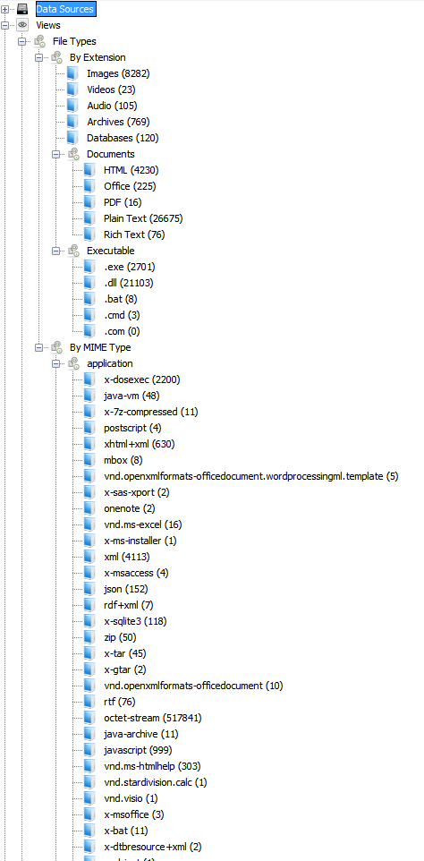

**Figure E.14: Data analysed from USB-HD-14**

**Table E.14: Data collected from USB-HD-14**

|  |  |  |
| --- | --- | --- |
| **Data Categories** | **File Types** | **Quantity** |
| **Application** | EXE | 2200 |
| CLASS | 48 |
| 7Z | 11 |
| JAVA | 4 |
| HTML | 5082 |
| XPT | 2 |
| XML | 32874 |
| ACCDB | 4 |
| JSON | 152 |
| XMP | 7 |
| SQLITE | 118 |
| ZIP | 50 |
| TAR | 47 |
| RTF | 76 |
| MFT | 517841 |
| ZIP | 11 |
| JS | 999 |
| CHM | 303 |
| SDC | 1 |
| VSD | 1 |
| BAT | 11 |
| RES | 2 |
| ELF | 1 |
| TTF | 676 |
| DLL | 21603 |
| CAB | 454 |
| SWC | 12 |
| A | 30 |
| SH | 17 |
| ICC | 7 |
| GZ | 197 |
| JAVA | 5340 |
| CSS | 7 |
| JSP | 191 |
| YAML | 131 |
| H | 1614 |
| CSV | 27 |
| PL | 5 |
| PY | 11 |
| DIFF | 9 |
| F | 76 |
| XAML | 26485 |
| C | 90 |
| RB | 4 |
| INI | 308 |
| **Audio** | MID | 6 |
| MP3 | 65 |
| WAV | 11 |
| WMA | 24 |
| **Image** | ICO | 46 |
| TIFF | 1 |
| BMP | 1178 |
| GIF | 572 |
| PNG | 5685 |
| WMF | 246 |
| JPG | 1417 |
| PCX | 51 |
| DWG | 14 |
| EMF | 19 |
| **Message** | MBOX | 950 |
| **Text** | DOC and DOCX | 192 |
| XLS and XLSX | 27 |
| PDF | 16 |
| PPTP and PPTX | 8 |
| ONE | 2 |
| TXT | 40 |
| **Video** | MP4 | 1 |
| AVI | 13 |
| WMV | 11 |

## **E.15 Hard Drive: USB-HD-15**

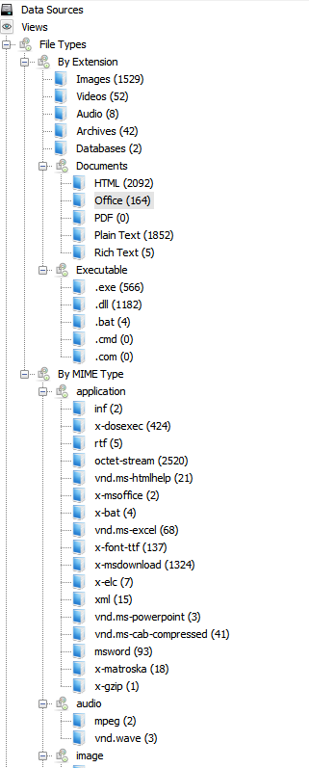

**Figure E.15: Data analysed from USB-HD-15**

**Table E.15: Data collected from USB-HD-15**

|  |  |  |
| --- | --- | --- |
| **Data Categories** | **File Types** | **Quantity** |
| **Application** | INI | 23 |
| EXE | 424 |
| RTF | 5 |
| MFT | 2520 |
| CHM | 21 |
| DB | 2 |
| BAT | 4 |
| TTF | 137 |
| DLL | 1324 |
| XML | 43 |
| CAB | 41 |
| GZ | 1 |
| JAVA | 911 |
| F | 1 |
| H | 9 |
| CSV | 4 |
| C | 1 |
| HTML | 2102 |
| **Audio** | MP3 | 2 |
| WAV | 3 |
| **Image** | ICO | 2 |
| BMP | 105 |
| GIF | 9 |
| PNG | 2 |
| JPG | 1422 |
| PCX | 1 |
| DWG | 1 |
| **Text** | DOC and DOCX | 93 |
| XLS and XLSX | 68 |
| PPTP and PPTX | 3 |
| TXT | 1871 |
| **Video** | MP4 | 5 |
| AVI | 18 |
| WMV | 23 |

## **E.16 Hard Drive: USB-HD-16**

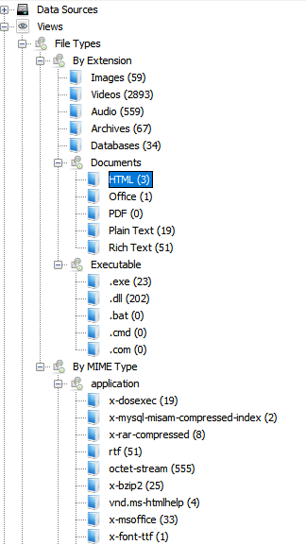

**Figure E.16: Data analysed from USB-HD-16**

**Table E.16: Data collected from USB-HD-16**

|  |  |  |
| --- | --- | --- |
| **Data Categories** | **File Types** | **Quantity** |
| **Application** | EXE | 19 |
| MYI | 2 |
| RAR | 8 |
| RTF | 51 |
| FAT | 555 |
| BZ2 | 25 |
| CHM | 4 |
| DB | 33 |
| TTF | 1 |
| RM | 1631 |
| DLL | 206 |
| CAB | 34 |
| SQLITE | 1 |
| ICC | 1 |
| APPLE | 31 |
| JAVA | 8 |
| XML | 4 |
| HTML | 2 |
| INI | 3 |
| **Audio** | MP3 | 401 |
| WAV | 4 |
| **Image** | ICO | 5 |
| BMP | 7 |
| PSD | 1 |
| PNG | 1 |
| JPG | 50 |
| PCX | 1 |
| **Text** | DOC and DOCX | 1 |
| TXT | 19 |
| **Video** | MP4 | 155 |
| MPG | 1029 |
| MKV | 43 |
| AVI | 50 |
| WMV | 28 |

## **E.17 Hard Drive: USB-HD-17**

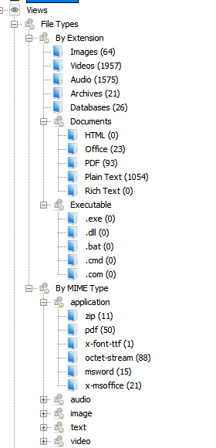

**Figure E.17: Data analysed from USB-HD-17**

**Table E.17: Data collected from USB-HD-17**

|  |  |  |
| --- | --- | --- |
| **Data Categories** | **File Types** | **Quantity** |
| **Application** | ZIP | 11 |
| TIF | 1 |
| DB | 21 |
| **Audio** | MP3 | 280 |
| **Image** | ICO | 1 |
| PNG | 61 |
| JPG | 3 |
| PCX | 1 |
| **Text** | DOC and DOCX | 15 |
| PDF | 138 |
| TXT | 1102 |
| **Video** | MP4 | 1250 |
| FLV | 606 |
| MKV | 844 |
| AVI | 36 |
| WMV | 47 |