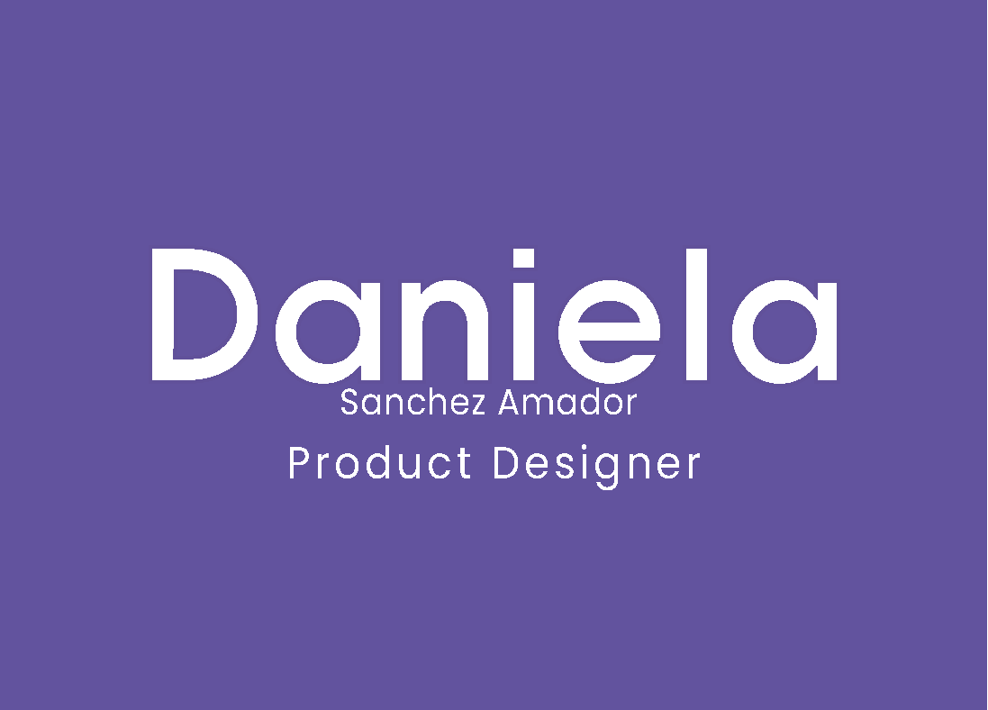



Multimedia Engineer and Interactive Media Specialist with **experience in product design and knowledge of code**. I have worked in EdTech, e-commerce, and mobile products and have **experience in UI and UX Design, Mobile UI UX, Design Systems, Research, Testing, and Prototyping**. I can bring value to any team and help create impactful and successful digital products.

I have a passion for learning new things and tools every day, and if I don't know something, I am always eager to learn it.



**SPANISH**

Native

**ENGLISH**

Professional working proficiency

**FRENCH**

Conversational



**MULTIMEDIA ENGINEERING**

UNIVERSIDAD MILITAR NUEVA GRANADA

Bogotá, Colombia

2011-2015

**INTERACTIVE MEDIA SPECIALIST**

FANSHAWE COLLEGE

London, Ontario, Canada

2017-2018





 [**linkedin.com/in/daniellasamdesign**](http://linkedin.com/in/daniellasamdesign)

 [hello@daniellasam.com](mailto:hello@daniellasam.com)

[**www.daniellasam.com**](http://www.daniellasam.com)

**UX/UI DESIGNER**

OPEN LMS PART OF LTG PLC 2020-ACTUAL REMOTE

• Worked alongside developers and design teams in the Product department to **design and implement UI and UX features** that enhanced the functionality and usability of the product.

• Established and managed direct **communication channels with customers**, collecting feedback and insight. Developed and implemented mockup designs for customer platforms.

• **Created a comprehensive design system** for the web and mobile product, ensuring a consistent and seamless user experience across all platforms.

**USER EXPERIENCE DESIGN SPECIALIST**

CONFFLUX 2020 REMOTE

• Collaborated in a multi-disciplinary team to design, envision, and conceptualize a **digital tool that made a positive impact during the pandemic**.

• Conducted **user research** to understand customer needs and preferences, resulting in **improved product design and enhanced user experience**.

**UI PRODUCT DESIGNER**

TAGSFORHOPE INC 2018-2019 ONTARIO, CANADA

• Collaborated closely with engineering, to **design and implement high-quality UI and UX features**, resulting in a seamless user experience.

• Improved sales by designing a new UI for the product and received **recognition for the design of the marketing page**, resulting in increased brand awareness and customer engagement.

**UI AND INSTRUCTIONAL DESIGNER**

E-GROUP SAS 2017 BOGOTA, COLOMBIA

• **Designed interfaces** and developed storytelling techniques for personalized courses, resulting in improved engagement and learning outcomes.

• Designed and developed **elements for use in e-learning** courses, resulting in enhanced learning experiences.

**UI AND INSTRUCTIONAL DESIGNER**

ENGAGEMENT SAS 2015-2016 BOGOTA, COLOMBIA

• **Designed interfaces** and developed storytelling techniques for personalized courses, resulting in improved engagement and learning outcomes.

• Designed and **developed elements for use in e-learning** courses, resulting in enhanced learning experiences.

**UX/UI DESIGNER**

FREELANCE 2015-ACTUAL REMOTE

• Stayed up-to-date with industry trends and best practices to continuously **improve design solutions**.

• Reviewed existing products and provided design solutions to improve user experience and business outcomes.