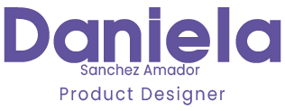Dear Recruiter,

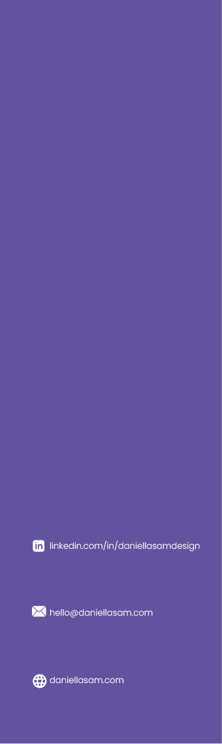I am thrilled to express my deep interest in the **UX Position** that has recently become available. As a **Multimedia Engineer and Interactive Media Specialist,** I am confident that I have the necessary skills and experience to make valuable contributions to your team.

My passion for technology and design has been a driving force throughout my career, and I am excited to bring my expertise to your company. **With a strong background in both graphics and technology, including experience with HTML, CSS, JavaScript, and various graphical software,** I am well-equipped to communicate effectively with both developers and designers. This has allowed me to create better design products and contribute to projects more efficiently.

I am particularly impressed with your company's focus on user experience and design, which aligns perfectly with my own interests and professional goals. Through my experience as an **Instructional Designer**, I have gained the skills necessary to understand **user interfaces for eLearning products**, **create wireframes and prototypes**, and **learn UI patterns**. In addition, my experience designing digital products and experiences for an **eCommerce** site has given me the opportunity to implement **user research, information architecture, interaction design, testing prototypes, and visual design.** Most recently, I have been working for an **EdTech company with a SaaS product**, where I have gained further insight into **mobile and web user experience**, and have developed strong relationships with users and clients. In all of my roles, I have collaborated closely with product managers and developers to define product requirements and ensure that my designs meet the needs of both the company and the user.

Through these experiences, I have gained solid research, analytical, and problem-solving skills, and understand the importance of teamwork in achieving success. I am excited to leverage my skills and knowledge to create unique assets and seamless user experiences with your team. It would be an honor to work with a company with such an impressive track record of producing engaging, user-friendly solutions.

Please find my resume attached, and feel free to visit my portfolio at [**www.daniellasam.com**](http://www.daniellasam.com) (password for some projects: admin). If you have any questions, please do not hesitate to contact me at [**hello@daniellasam.com**](mailto:hello@daniellasam.com). I am enthusiastic about the opportunity to interview for the UX Position and look forward to hearing from you soon.

Thank you for your time and consideration.

Sincerely,