**Ex 6 REPOSITORY IN GITHUB**

**Date: 25.08.20**

**Aim:**

To study and implement the git and git repository.

**Description:**

**The Linux Kernel :**

**GitHub** is a Git repository hosting service, but it adds many of its own features. While Git is a command line tool, **GitHub** provides a Web-based graphical interface. It also provides access control and several collaboration features, such as a wikis and basic task management tools for every project.

**GitHub** is a website for developers and programmers to collaboratively work on code. The primary benefit of **GitHub** is its version control system, which allows for seamless collaboration without compromising the integrity of the original project.

**COMMANDS**:

|  |  |  |
| --- | --- | --- |
| Sl. No. | COMMAND | DESCRIPTION |
| 1. | git init | Initialize git repository |
| 2. | git add filename | To add individual files |
| 3. | git add * | To add all files |
| 4. | git status | To see the added files status |
| 5. | git commit -m “text” | Added text note with added file |
| 6. | git remote add origin path | To link the files to the github repository |
| 7. | git push -u origin master | To push files into the repository |

**Exercise**

**Create repository and uploading files in github**

**Step 1 :**

Installing git

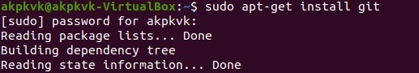

**Step 2 :**

Check version



**Step 3 :**

Initializing git



**Step 4 :**

Adding files and checking status

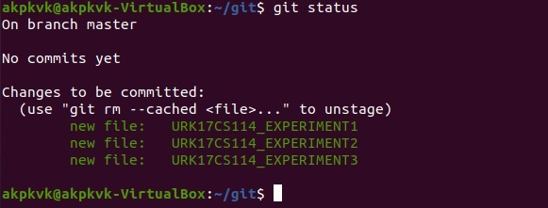

**Step 5 : checking Repository**

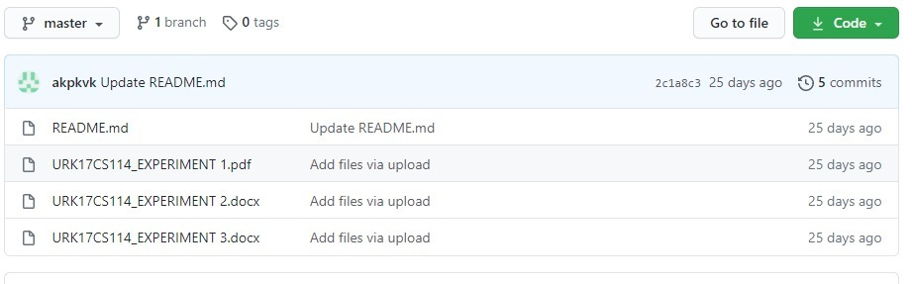

**Github link :**

https://github.com/akpkvk/ostlab

**Results:**

The study and implementation of the git and git repository is studied and executed.

**Video link :**

**https://youtu.be/HYHfsga3NB8**