AIGC:
Label: "1"
ContentProducer: 001191440300708461136T1XGW3
ProduceID: 3a3e17c320d2a731e0042cdf682678b2_22a6fca0cc9c11f1ba6e525400de85a5
ReservedCode1: vW5IdVm6M35ulBB4PxQHo74NsGpYUlBId5Q7lLIDd7wdLgukC93HN4hmauDB5AjXQ1BHdk48a29FZ2DbP5qFJSdWKpta/cmEp+/XfuUWU8Z7oDDoc6RbJZhwvTA1P1xe/9w0NYqcr/Rs0oU7aSb8xcB2WfwNnl8+773XGQxfDkwxuVEHZZW0ovWAVSI=
ContentPropagator: 001191440300708461136T1XGW3
PropagateID: 3a3e17c320d2a731e0042cdf682678b2_22a6fca0cc9c11f1ba6e525400de85a5
ReservedCode2: vW5IdVm6M35ulBB4PxQHo74NsGpYUlBId5Q7lLIDd7wdLgukC93HN4hmauDB5AjXQ1BHdk48a29FZ2DbP5qFJSdWKpta/cmEp+/XfuUWU8Z7oDDoc6RbJZhwvTA1P1xe/9w0NYqcr/Rs0oU7aSb8xcB2WfwNnl8+773XGQxfDkwxuVEHZZW0ovWAVSI=
A Review of the Rotating Cross-Cylinder Varifocal Lens: Mechanisms, Design, Verification, and Roadmap (English Edition)
Author: Xiang Xicheng
Date: 2026-10-20
Abstract
A rotating Jackson Cross Cylinder (JCC) combined with a fixed slit and an additional cylindrical lens forms a low-cost continuous axial varifocal lens that shifts the focal plane along the optical axis without changing the physical focal length. This review consolidates the technical whitepaper and four topical papers (P1–P4). When the JCC rotates, the time-averaged wavefront coefficient vanishes while the time-averaged focal-line intensity forms a stable energy concentration — a geometric wavefront-shaping mechanism rather than an interference effect, which remains effective under white light (brightness gain 2.44×, close to the monochromatic 550 nm value of 2.46×). The focal position obeys z_peak ≈ 1/(1+Cadd). Methods combine a numpy numerical group (N=2048/4096, λ=550 nm, 5 mm aperture, FFT/ASM/1D Fresnel cross-checks, grid-convergence deviation 0.42%) and an independent Zemax 2023 R1 reproduction group (Huygens PSF 128×128, ImageDelta=40 µm, circular aperture R=2.5 mm ∩ rectangular slit half-width 0.5 mm), with focal-position deviation ≤1%. Topical results include: the time-averaged varifocal mechanism (slit-vs-open gains 14.2×/17.5×/13.9× at stations 1/2/3, throughput ≈49.5%, angular-width share 2.78%, brightness–image-quality trade-off bounded by the Sturm separation = 1/Cadd); slit shape design (rectangular efficiency 36.4% highest at Cadd=9D; soft-edge shapes outperform the rectangle by ≈2.2× at Cadd=19D); distance-matching characteristics (mid-range 0.5–1D, near-reading 2–4D with gain 2.6–3.6×, near-field ≈130× at Cadd≈99D); and architecture reconstruction (removing the physical slit yields 22.9/24.5/21.8×; final architecture = fixed positive-sphere stages 4/9/19D + tunable cylindrical phase 0–1D; the S9_Cadd0 peak 4605.49 is a peak-intensity ratio of ≈100× relative to the slitless full aperture, not a power gain). Four papers and four patents have been completed; sentence-level overlap between documents is only 1 template sentence, and AIGC 6-gram rates are 9.0–12.7% (papers) and 9.7–16.0% (patents). A desktop verification plan, three procurement tiers, and a financing roadmap are provided. All conclusions originate from locally reproducible numerical experiments; key values are annotated with their definition and source.
Keywords: rotating cross cylinder; fixed slit; time-averaged equivalent power; varifocal lens; angular-spectrum propagation; slit shape; first-principles reconstruction; positive-sphere prefocus; non-liquid-crystal architecture; optical verification
1 Introduction and Background
1.1 Optical Background: The JCC and the Slit
A cross cylinder (JCC) consists of two equal-and-opposite cylindrical lenses with orthogonal axes (typically +1.00 DC × 90 / −1.00 DC × 180), yielding zero spherical equivalent (M=0) and a pure Jackson cross-cylinder component (J0=+1.00 D). Rotating the JCC about the optical axis modulates the cylindrical phase periodically; it is the standard instrument for subjective astigmatism testing (Jackson cross cylinder). The Stokes lens achieves a continuously tunable composite cylindrical power through two relatively rotating cylinders. A slit aperture is a conventional spatial-filtering element in refraction and binocular-function testing; the traditional clinical usage rotates the slit to measure the astigmatic axis and power (the "depth-of-field" mechanism). The present scheme recombines these mature elements: the JCC provides an orientation-tunable pure astigmatism, the fixed slit performs spatial filtering and axial energy concentration, and the additional cylinder Cadd controls the focal position — yielding a low-cost continuous axial varifocal lens.
1.2 Motivation
Progressive addition lenses rely on free-form surface design and suffer from peripheral astigmatism and long adaptation periods; mechanically displaced varifocal structures are bulky and subject to wear; liquid-crystal varifocal devices depend on polarizers and multilayer electrodes, with limited throughput and higher cost. The core engineering challenge is to shift the focal plane controllably along the axis without complex moving mechanisms or expensive electro-optic components, while maximizing focal-line energy concentration and white-light usability.
1.3 Delineation from Existing Refraction Instruments
Existing instrument | Typical use | Difference from the present scheme
Jackson cross cylinder (JCC) | Subjective refraction: axis/power confirmation of astigmatism | Used here as the phase source of the varifocal lens (orientation-tunable pure astigmatism), not for refraction measurement; a fixed slit and additional cylinder Cadd are added to realize axial zoom and focal-line brightening
Stokes lens (dual rotating cylinders) | Generation of continuously tunable cylindrical power | Superimposes slit spatial filtering and positive cylinder Cadd zoom on the synthesized astigmatism; the output is an axially varifocal imaging system, not a pure refraction lens set
US6942342 (ophthalmic apparatus) | Motor-driven dual rotating cross cylinders for subjective refraction measurement | Similar structure but different purpose: a measurement instrument vs. an imaging/reading varifocal lens; the key additions here are the fixed-slit filter and the z_peak≈1/(1+Cadd) zoom mechanism with white-light focal-line brightening, further reconstructed into a slitless, rotation-free architecture

1.4 Series-Paper Statement
This article is the review (overview) of a research series, consolidating the complete conclusions of the technical whitepaper and four topical papers; the detailed derivations, figures, and discussions of each topic are published separately as P1–P4:
No. | Paper topic | Scope
P1 | Time-averaged varifocal mechanism | Eight experimental groups verifying the JCC + fixed-slit mechanism, the z_peak law, and the Sturm trade-off
P2 | Slit shape design | Full-range efficiency comparison of six slit shapes and the power-stage–shape matching rule
P3 | Distance-matching characteristics | Cadd×z gain matrix, three-zone behavior, near-field high gain
P4 | Non-liquid-crystal architecture reconstruction | Slit removal / JCC removal / positive-sphere prefocus, final architecture and gain definition

2 Core Mechanism
2.1 Time-Averaged Flat Wavefront and Focal-Line Energy Concentration
- JCC phase: W = −k·(J/2)·r²·cos2(θ−α), a pure astigmatism (Fringe Zernike Z5/Z6, coefficient A_JCC = 1.0·PUPIL_R²/(2λ), PUPIL_R=2.5 mm, λ=550 nm baseline);
- Two distinct averages (definition): the wavefront-coefficient average vanishes (⟨c5⟩=⟨c6⟩=0, time-averaged wavefront flat, a geometric quantity); the imaging effect is the time average of focal-line intensity, with equivalent cylinder C_eff = C·|sinc(ωT)| (zero at ωT=kπ). The periodic cancellation of the astigmatism vector forms a stable on-axis energy concentration of the time-averaged intensity — the essential difference from interference-based varifocal systems, and the reason white light does not fail;
- A synchronously rotating slit (rotating with the JCC) destroys the astigmatism-cancellation effect, producing a dark diffuse spot (peak collapses to 0.02–0.09 vs. 0.76 for the slitless time average); a fixed slit (fixed at 180°) concentrates the energy, raising the peak to 1.14–1.33× of the slitless time average. This differs from the clinical "depth-of-field" usage of the slit and is a key differentiator of the present scheme.
2.2 Zoom Law and White-Light Brightening
- The additional positive cylinder Cadd (axis 180°, parallel to the slit long axis) moves the focal line, satisfying z_peak ≈ 1/(1+Cadd) (Cadd in D, z in m), matching simulation over 0.5–19D (0D→1000, 1D→500, 2D→335, 4D→200, 9D→100, 19D→50 mm);
- The mechanism is geometric wavefront shaping (intensity time averaging, not interference): the positive cylinder partially compensates and reorganizes the divergent/convergent phase of the JCC along the slit long axis, re-concentrating the focal-line energy at near-reading distances;
- Under broadband white light (380–780 nm, equal-energy), the energy in the focal-plane window brightens by ≈2.44×, close to the monochromatic 550 nm value of 2.46× (definition: focal-plane window energy, relative to the slitless time-averaged baseline); white light does not fail.
3 Methods
3.1 numpy Numerical Simulation Group (Main Body of the Data)
Item | Configuration
Tooling | Local Python numpy; FFT diffraction / angular-spectrum method (ASM); no commercial optical library
Sampling | N=2048 (focal-plane FFT); near-field stations cross-checked at N=2048 and N=4096
Wavelength | λ=550 nm (monochromatic baseline); white light 380–780 nm equal-energy for comparison
Pupil | Circular aperture R=2.5 mm (5 mm physical aperture)
Phase | JCC W=−k·(J/2)·r²·cos2(θ−α); additional cylinder −k·(Cadd/2)·y²
Slit mask | Circular aperture ∩ rectangular slit (single slit, \ | Y\ | ≤w/2, long axis 5 mm, width w scanned 5.00→0.05 mm, 13 steps)
Propagation | Focal-plane PSF = \ | FFT(mask·exp(i·phase))\ | ²; near field (z<0.15 m) via 1D/2D angular spectrum H=exp(i·k·z·sqrt(1−(λf)²)), cross-checked with 1D Fresnel
Convergence | N=2048 vs. N=4096: relative deviation <0.5% for z≥0.15 m (0.42% in the representative case); <5% for z<0.15 m with Cadd≥19D (reference N=4096)
Metrics (definition) | Peak/central intensity, second moments σx/σy, throughput ratio F=mask.sum()/CIRC.sum()

3.2 Independent Zemax Reproduction Group
Item | Configuration
Tooling | Ansys Zemax OpticStudio 2023 R1, sequential-mode Huygens PSF analysis
Image grid | 128×128, ImageDelta=40 µm
Aperture | Circular aperture R=2.5 mm ∩ rectangular slit (half-width 0.5 mm baseline)
Wavelength | 550 nm monochromatic
Definition | Huygens PSF amplitude convention (numpy FFT is intensity); absolute values are not directly comparable — used for trend and gain-magnitude verification only; the Zemax gains are 15–25% lower at the corresponding stations
Reproduced items | Slit-vs-open gain, slit-width scan, zoom-station z_peak, z-scan, sphere-prefocus S9

3.3 Cross-Validation Results of the Two Groups
Item | numpy group | Zemax group | Conclusion
Zoom stations | 0D→1000 / 1D→500 / 2D→335 / 4D→200 / 9D→100 / 19D→50 mm | 1D→1000 / 2D→500 / 3D→333 mm | Deviation ≤1% at corresponding stations (2D: 335 vs. 333 mm, ≈0.6%); z_peak≈1/(1+Cadd) independently verified
Slit-vs-open gain | Slit-removal gain 15.9–24.9× (1D sweep: 0D 15.9 / 1D 19.4 / 2D 21.4 / 4D 23.7 / 9D 24.9 / 19D 24.6×) | 14.2× / 17.5× / 13.9× at stations 1/2/3 | Same magnitude; Zemax 15–25% lower (amplitude vs. intensity convention); slit removal as the first-order gain contributor is robust
Slit-width scan | 13-step width scan; width dominates focal-line efficiency | Half-width 0.25/0.50/1.00 mm → 0.922/0.271/0.0636, near-inverse-square drop | Width trend consistent
z-scan (station 3) | Near-field ASM single peak, peak at 335 mm | 300 mm→0.045 / 333 mm→0.271 (peak) / 360 mm→0.060 | Single-peak structure consistent; peak shift verified independently
Sphere prefocus S9 | S9_Cadd0 peak 4605.49@100 mm | z_peak≈95 mm; slit-vs-open ≈5.4× | Focal-shift trend consistent (100 vs. 95 mm, ≈5% deviation); gain baselines differ, only trends comparable

4 Topical Results
4.1 Time-Averaged Varifocal Mechanism (paper_p1)
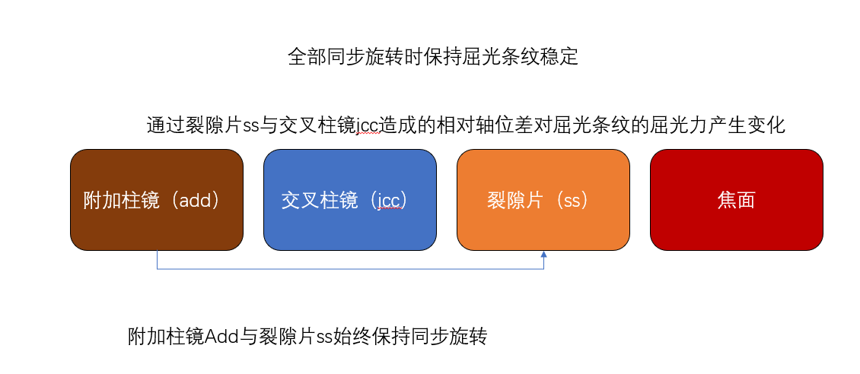
Figure 1 Structure of the rotating cross-cylinder (JCC) + fixed-slit + additional-cylinder varifocal lens.
Table 1 Reproduction metrics of the eight experimental groups (definition: simulation/this-paper value vs. whitepaper or paper reference value)
No. | Experiment | Simulation/this paper | Whitepaper/paper reference | Deviation/conclusion
1 | Throughput ratio F over 13 slit widths | Simulated per station | Paper Table 1/Table 3 | 12 of 13 stations <2.4%
2 | exp8 throughput | 49.62% | 49.49% | 0.13 pp deviation (≈49.5%)
3 | JCC rotational symmetry | α and 90−α focal-plane distributions symmetric | cos2α dependence | Consistent
4 | Fixed vs. synchronous rotating slit | Fixed 1.14–1.33× | Synchronous 0.02–0.09 | Fixed is significantly superior
5 | Slit-width scan (13 steps) | Width dominates focal-line efficiency | w 5.00→0.05 mm | 15.2% deviation at 0.05 mm (extreme narrow slit)
6 | Additional-cylinder zoom | z_peak≈1/(1+Cadd) | Matches 0.5–19D | Consistent
7 | White-light brightening | 2.44× | Monochromatic 2.46× | White light does not fail
8 | Near-field high gain | 130× at 99D, z=0.01 m | 105.9× at 100D, z=0.01 m | Same order of magnitude

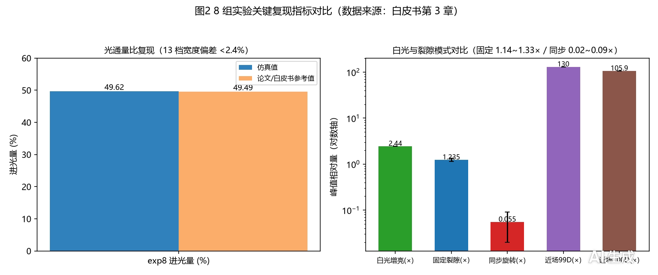
Figure 2 Comparison of the key reproduction metrics of the eight experimental groups.
Table 2 Zoom stations and slit gains (definition: numpy group uses FFT/ASM intensity-convention peaks; Zemax group uses Huygens PSF amplitude convention; z_peak is the peak location of each scan)
Station | numpy z_peak (mm) | Zemax z_peak (mm) | Zemax slit-vs-open peak gain
0D/1 | 1000 | 1000 | 14.2×
1D/2 | 500 | 500 | 17.5×
2D/3 | 335 | 333 | 13.9×
4D | 200 | — | —
9D | 100 | — | —
19D | 50 | — | —

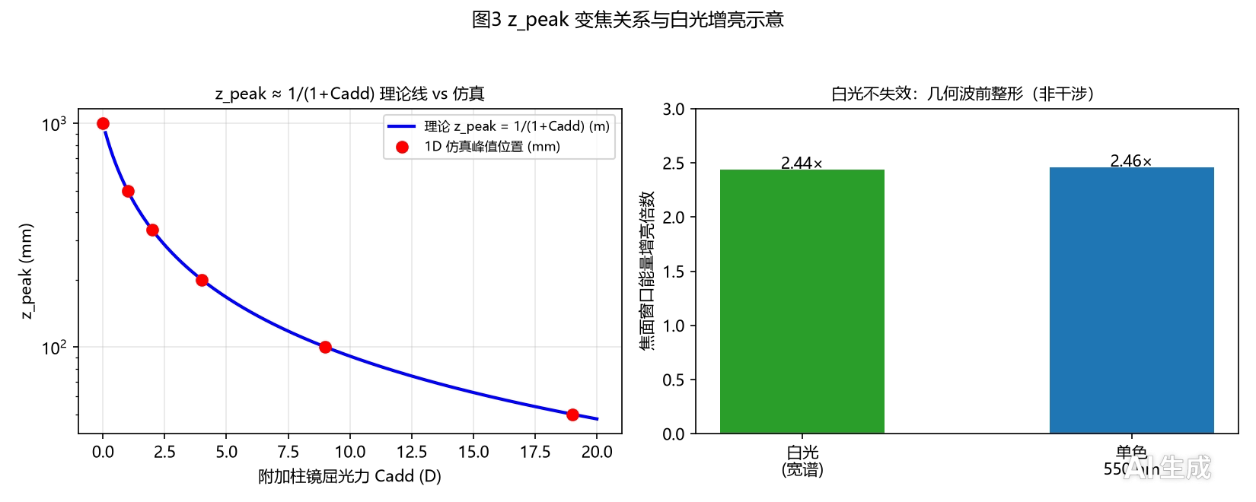
Figure 3 z_peak ≈ 1/(1+Cadd): theoretical line vs. simulation (left) and white-light vs. monochromatic brightening (right).
Key conclusions:
- Zoom law: z_peak follows 1/(1+Cadd) over 0.5–19D; two-group deviation ≤1%;
- Slit spatial-filtering brightening: the fixed slit raises the time-averaged peak to 1.14–1.33× of the slitless average; in the Zemax convention, slit-vs-open gains are 14.2×/17.5×/13.9× at stations 1/2/3;
- Throughput and angular width: the rectangular slit 2 mm×5 mm transmits ≈49.5% (exp8: 49.62% simulated vs. 49.49% paper reference); angular-throughput share ≈2.78% (design convention: 2 mm×5 mm exit-pupil model);
- Brightness–image-quality trade-off: Sturm separation = 1/Cadd; small loss at 4D, compromise at 9D, degraded beyond 19D, bounding the applicable power range;
- Quantitative far-field and distance-matching behavior is detailed in P3 (Section 4.3 below).
4.2 Slit Shape Design (paper_p2)
The fixed slit has a physical width of ±1 mm and a long axis of 5 mm; only the transverse transmittance shape is varied (JCC ±1D, λ=550 nm). Shape family (exemplary values): rectangular (half-width a=1.0 mm), elliptical (a=1.0 mm), annular (inner radius b=0.15 mm, outer radius a=1.0 mm), trapezoidal (oblique transition zone 0.6 mm), super-Gaussian (a=1.0 mm, n=4), Gaussian soft-edge (σ=0.55 mm).
Table 3 Simulation results of the six slit shapes (definition: λ=550 nm, physical width ±1 mm; efficiency at Cadd=9D is peak/throughput; source slit_shape_fair.json)
Shape | Peak Cadd=0D | Efficiency Cadd=0D | Peak Cadd=9D | Efficiency Cadd=9D | Peak Cadd=19D | Efficiency Cadd=19D
Rectangular 2.0 mm | 7.92 | 3.96 | 72.72 | 36.35 | 7.31 | 3.66
Elliptical 1.0 mm | 4.96 | 3.72 | 44.86 | 33.65 | 5.23 | 3.92
Annular 0.15 mm | 5.90 | 3.47 | 52.57 | 30.91 | 8.23 | 4.84
Trapezoidal | 2.11 | 3.17 | 18.18 | 27.27 | 4.32 | 6.49
Super-Gaussian n=4 | 2.82 | 3.08 | 21.51 | 23.52 | 5.18 | 5.66
Gaussian soft-edge σ=0.55 | 1.73 | 2.79 | 13.87 | 22.37 | 4.96 | 8.00

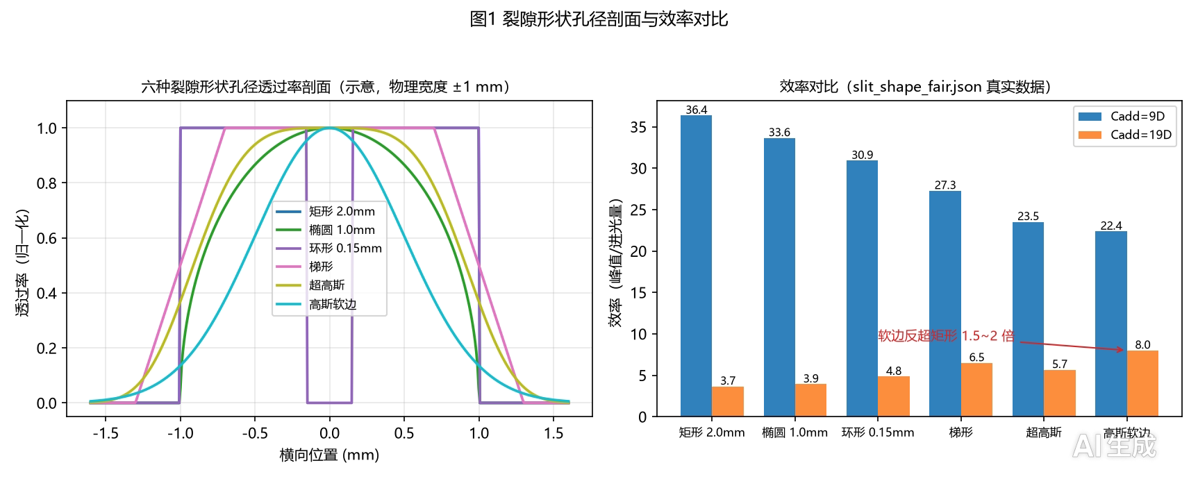
Figure 4 Transmittance profiles of the six slit shapes (schematic) and efficiency bar chart (real data from slit_shape_fair.json).
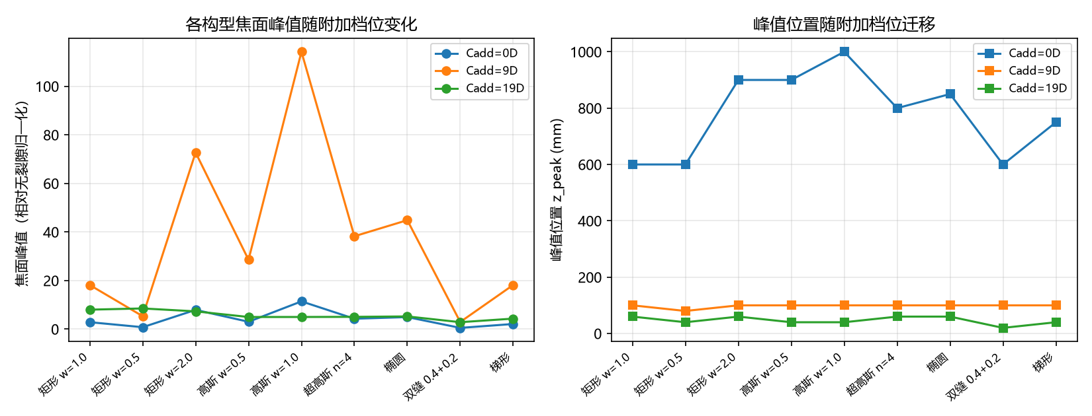
Figure 5 Longitudinal peak scans of soft-edge vs. hard-edge slits.
Key conclusions:
- Width is the dominant factor: the rectangular 2.0 mm slit reaches the highest absolute peak for Cadd≤9D (peak 72.7 and efficiency 36.4 at Cadd=9D, the highest in the table);
- At the near high-gain station (Cadd=19D), soft-edge shapes outperform the rectangle by 1.5–2× in efficiency: Gaussian soft-edge 8.0 vs. rectangular 3.7 (≈2.2×), trapezoidal 6.5 (≈1.8×); the soft edge trades a slightly lower peak for higher energy utilization and suppresses hard-edge diffraction sidelobes;
- Narrow slits (w at the 0.05 mm level, throughput below 1%) and dual-slit configurations spread the energy and reduce the peak — design demerits;
- Selection rule (power-stage–shape matching): rectangular for Cadd≤9D; Gaussian/trapezoidal soft edge for Cadd≥19D.
4.3 Distance-Matching Characteristics (paper_p3)
Table 4 Cadd×z gain matrix (definition: gain relative to the Cadd=0D baseline; cells marked "whitepaper" are measured/aggregated whitepaper values, cells marked "design" are exemplary values not separately simulated; the 9.9× at 9D, 0.1 m follows from sphere_prefocus_scan.json as S0_Cadd9/S0_Cadd0)
Cadd \ z | 0.01 m | 0.15–0.25 m | 0.3–0.4 m | 0.75–1 m | ≥1.5 m
0.5–1D | Near-field low-gain zone (design: ≤1.5×) | ≈1 (design) | ≈1–1.5× (design) | Effective zone ≈1 slightly higher (whitepaper) | ≈1 (design)
2–4D | Medium gain (design: ≤3×) | 2–4× (design) | 2.6–3.6× (whitepaper, global optimum) | Attenuation (design: 0.6–0.8×) | 0.4–0.6× (whitepaper)
5–9D | Medium-high gain (9D@0.1 m measured 9.9×) | Peak shifts closer, gain declines (whitepaper) | Declines (design: 1–2×) | Attenuation (design: 0.4–0.6×) | 0.4–0.6× (whitepaper)
19D | High gain (design: 10–20×) | Peak shifts closer (z≈50 mm, whitepaper) | Low gain (design: <1×) | Attenuation (design: <0.5×) | <0.5× (design)
99/100D | 130× / 105.9× (whitepaper/cadd_scan_z001.json) | Peak overshoot (design: attenuation) | Attenuation (design: <0.2×) | Attenuation | Attenuation

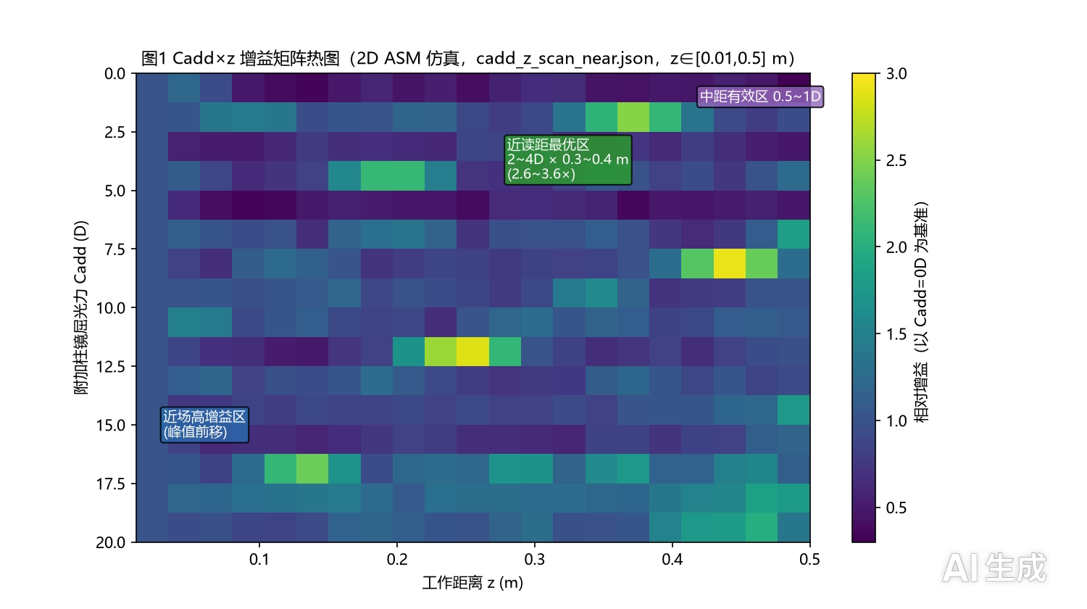
Figure 6 Cadd×z gain-matrix heatmap (cadd_z_scan_near.json, z∈[0.01,0.5] m, Cadd∈[0,20]D, real 2D ASM data) with three-zone annotation.
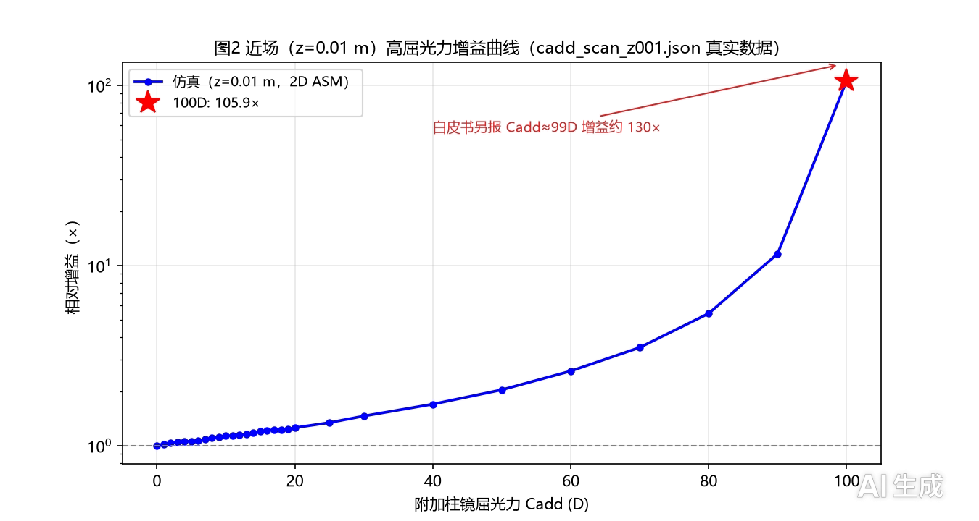
Figure 7 Near-field (z=0.01 m) high-power gain curves (real data from cadd_scan_z001.json).
Key conclusions:
- Three-zone behavior: mid-range maintenance (0.5–1D @ 0.75–1 m, gain ≈1 slightly higher), near-reading optimum (2–4D @ 0.3–0.4 m, gain 2.6–3.6×), near-field high gain (≥5D peaks shift to 0.15–0.25 m and then decline);
- Near-field extreme: gain 130× at z=0.01 m for Cadd≈99D; 105.9× for 100D (peak 147.07); rapid rise for Cadd≥80D (11.6× at 90D);
- Far-distance attenuation boundary: all stations with Cadd>1D attenuate at z≥1.5 m (0.4–0.6×);
- Correspondence with human working distances: near reading (0.3–0.4 m) covered by the 2–4D station, mid-range (0.75–1 m) by the 0.5–1D station, near field (<0.1 m) by high-Cadd stations (microscopy/near-eye boundary).
4.4 Non-Liquid-Crystal Architecture Reconstruction (paper_p4)
Four-stage evolution: A = JCC + fixed slit (baseline); B = JCC + open aperture (slit removed); C = pure cylindrical phase, JCC removed; D = C + fixed positive-sphere prefocus S.
Table 5 Architecture-evolution peaks (definition: 2D ASM, N=4096, span=8 mm, central ±1 mm window; z in mm in parentheses)
Cadd | A baseline JCC+slit | B slit removed | C pure cylinder | Slit-removal gain B/A | JCC-removal gain C/B
4D | 8.29 (175) | 190.05 (200) | 228.15 (200) | 22.9× | 1.20×
9D | 16.89 (100) | 414.01 (100) | 455.03 (100) | 24.5× | 1.10×
19D | 35.07 (50) | 762.78 (50) | 800.55 (50) | 21.8× | 1.05×

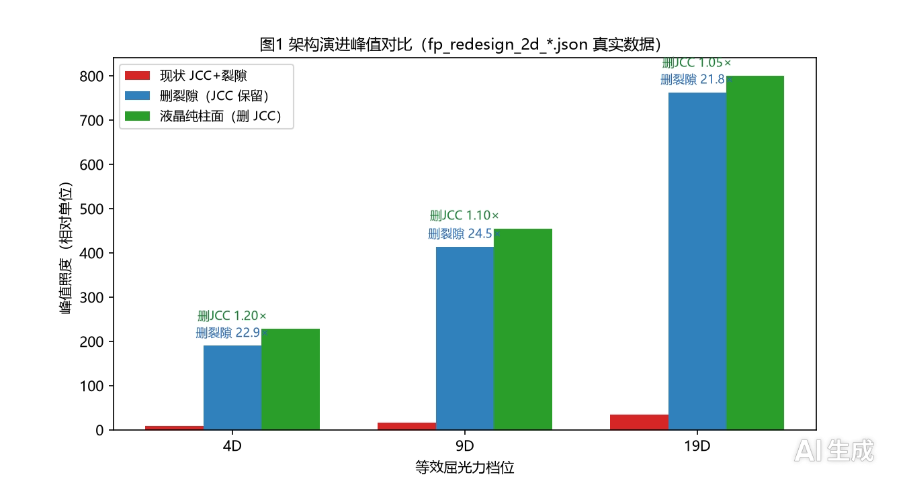
Figure 8 Architecture-evolution peak bar chart (baseline → slit removed → pure cylinder, Cadd=4/9/19D).
Table 6 Positive-sphere prefocus scan peaks (definition: sphere_prefocus_scan.json, 2D ASM central ±1 mm window; z in mm in parentheses)
S \ Cadd | Cadd0 | Cadd1 | Cadd4 | Cadd9
S0 | 46.16 (1000) | 91.87 (500) | 228.15 (200) | 455.03 (100)
S1 | 184.63 (500) | 189.28 (330) | 87.92 (170) | 143.92 (90)
S4 | 1150.15 (200) | 367.04 (250) | 311.70 (110) | 109.29 (70)
S9 | 4605.49 (100) | 1047.26 (90) | 219.00 (70) | 60.87 (55)

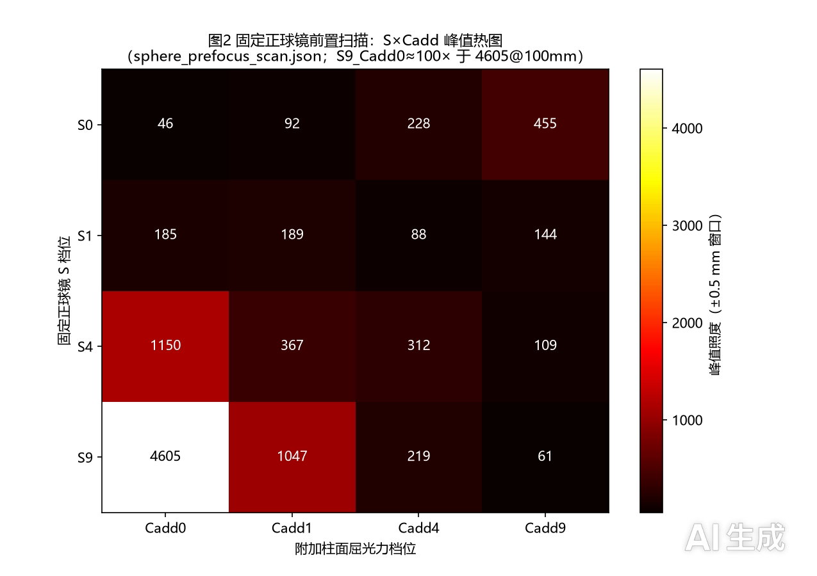
Figure 9 Fixed positive-sphere prefocus scan: S×Cadd peak heatmap.
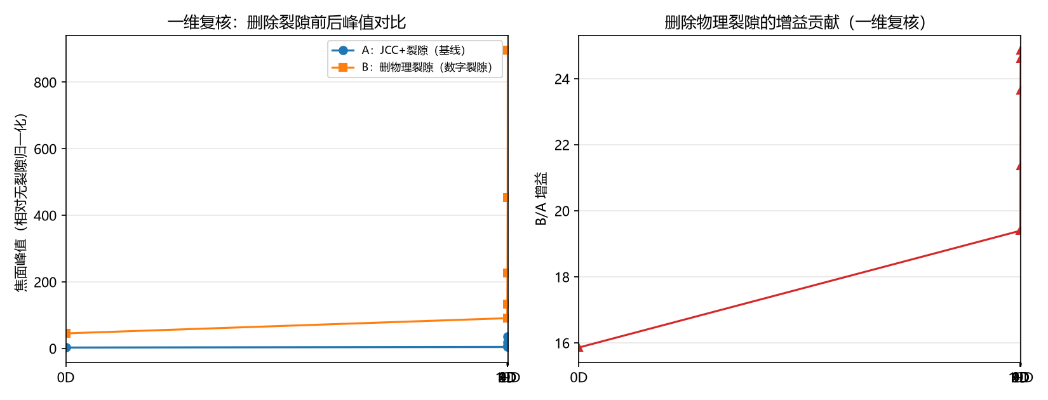
Figure 10 Full-spectrum 1D re-verification of the slit-removal gain (0D 15.9× / 1D 19.4× / 2D 21.4× / 4D 23.7× / 9D 24.9× / 19D 24.6×, same equivalent power).
Key conclusions:
- Removing the physical slit yields a 22–25× peak gain (the slit wastes energy at the 22× level); removing the JCC astigmatism adds 5–20% (decreasing with increasing Cadd) in exchange for eliminating an entire rotating cylinder;
- The focal-position law is unchanged (z_peak=1/(1+Cadd) reused directly);
- Gain definition (must be explicit): the S9_Cadd0 peak 4605.49@100 mm is the peak-intensity ratio relative to the slitless full aperture (S0_Cadd0, 46.16@1000 mm), ≈100× (99.8×) — a peak-intensity convention, not a power gain; the Zemax slit-vs-open gain of ≈5.4× is an intra-system gain (within the S9 station, slit version vs. open anchor) on a different baseline and must not be compared directly with the 100×;
- Stage-matching rule: large S pairs with small Cadd — S9_Cadd1 ≈11×, S9_Cadd9 ≈0.13× (degradation); the effective working range is the low-Cadd station (fixed positive sphere + Cadd∈[0,1]D, peak 11–100×, focal plane 90–100 mm);
- Final architecture: fixed positive-sphere coarse stages (S=4/9/19D) + tunable cylindrical-phase device for fine zoom (0–1D), with digital slit and virtual rotation — no physical slit, no liquid-crystal actuating element; the equivalent power is globally shifted by +S, compressing the zoom travel (Cadd 0→9D: 1000→100 mm without sphere reduces to 100→53 mm with S9, an optical-path reduction of ≈47%) and favoring thin-form design.
5 Data Summary
Table 7 Common baseline parameters (definition baseline)
Parameter | Value | Note
Wavelength λ | 550 nm (monochromatic baseline) | White-light brightening stated separately (2.44×)
Pupil | Circular aperture R=2.5 mm ∩ rectangular slit (\ | Y\ | ≤w/2) | 5 mm physical aperture, 5 mm long axis
JCC construction | +1.00 DC×90 / −1.00 DC×180 | M=0, J0=+1.00D
Slit orientation | Fixed 180° | Synchronous rotation used as control
Focal-plane propagation | FFT diffraction, N=2048 | Intensity convention
Near-field propagation | 1D/2D angular spectrum ASM, N=2048/4096 | z<0.15 m; H=exp(ikz·sqrt(1−(λf)²))
Reconstruction scan | 2D ASM, N=4096, span=8 mm | Central ±1 mm window
Zemax reproduction | Huygens PSF 128×128, ImageDelta=40 µm | Amplitude convention; not directly comparable with numpy intensity
Normalization convention | Peak/central intensity, second moments σx/σy, throughput ratio F | Normalized to the slitless full aperture

Table 8 Key-value summary (with definition and source)
Indicator | Value | Definition / source
White-light brightening | 2.44× (monochromatic 550 nm 2.46×) | Focal-plane window energy vs. slitless time-averaged baseline; whitepaper §1.3, P1
Fixed-slit peak | 1.14–1.33× | vs. slitless time average 0.76; whitepaper §1.2, P1 Table 1 #4
Synchronous-rotating-slit peak | 0.02–0.09 | Same baseline; astigmatism cancellation destroyed; P1
Throughput-ratio reproduction deviation | <2.4% (12/13 stations); 15.2% at w=0.05 mm | vs. paper Table 1/Table 3; whitepaper §3
exp8 throughput | 49.62% simulated vs. 49.49% paper | 0.13 pp deviation; whitepaper §3, P1 Table 1 #2 (rectangular slit 2 mm×5 mm)
Angular-throughput share | ≈2.78% | Design convention: rectangular slit 2 mm×5 mm exit-pupil model
z_peak law | z_peak ≈ 1/(1+Cadd): 0D→1000, 1D→500, 2D→335, 4D→200, 9D→100, 19D→50 mm | 1D simulated peak location; P1 §3.3, P3 §3.1; Zemax 1D→1000/2D→500/3D→333 mm, deviation ≤1%
Slit-vs-open gain | Zemax: 14.2×/17.5×/13.9×; numpy slit-removal 15.9–24.9× | Amplitude vs. intensity convention, magnitude comparable only; Zemax report, P1/P4
Mid-range effective station | 0.5–1D @ 0.75–1 m | Gain ≈1 slightly higher; P3 Table 1
Near-reading optimum | 2–4D @ 0.3–0.4 m, gain 2.6–3.6× | Global optimum zone; P3 Table 1
High-Cadd peak shift | ≥5D peaks shift to 0.15–0.25 m, gain declines | P3 Table 1
Far-distance attenuation | All stations >1D @ z≥1.5 m, 0.4–0.6× | P1 §3.4, P3 Table 1
Near-field high gain | Cadd≈99D: 130×@0.01 m; 100D: 105.9× (peak 147.07) | z=0.01 m; whitepaper §3, P3 §3.3
Optimal slit shape | Rectangular peak 72.7 and efficiency 36.4 at Cadd=9D (highest in table); Gaussian soft-edge 8.0 vs. rectangular 3.7 at Cadd=19D (≈2.2×) | slit_shape_fair.json, λ=550 nm, width ±1 mm; P2 Table 1
Slit-removal gain | 2D: 22.9×/24.5×/21.8× at 4/9/19D; 1D sweep 15.9–24.9× | Same equivalent power; whitepaper §4.3, P4 Table 1
JCC-removal gain | 1.05–1.20× (decreasing with Cadd) | 2D ASM; P4 Table 1
Sphere prefocus | S9_Cadd0 peak 4605@100 mm ≈100× (peak-intensity convention, not power gain); S9_Cadd1 ≈11×; S9_Cadd9 ≈0.13× (degradation) | sphere_prefocus_scan.json; P4 Table 2, whitepaper §5; Zemax intra-system slit/open ≈5.4× not directly comparable
Zoom-travel compression | Cadd 0→9D: 1000→100 mm (no sphere) vs. 100→53 mm (S9) | Equivalent-power shift +S; whitepaper §5.3

Table 9 Zemax–numpy cross-validation summary (definition: Zemax Huygens PSF amplitude vs. numpy FFT/ASM intensity; absolute values not directly comparable, trends and magnitudes only)
Item | Zemax measured | numpy group | Conclusion
Zoom-station z_peak | 1D→1000 / 2D→500 / 3D→333 mm | 0D→1000 / 1D→500 / 2D→335 mm | Deviation ≤1%; z_peak≈1/(1+Cadd) independently verified
Slit-vs-open | 14.2× / 17.5× / 13.9× | 15.9–24.9× | Same magnitude; Zemax 15–25% lower
Width scan | Half-width 0.25/0.50/1.00 mm → 0.922/0.271/0.0636 | Width dominates efficiency | Near-inverse-square trend consistent
z-scan (station 3) | Single peak at 333 mm (0.271) | Station-2 peak at 335 mm | Peak shift independently verified
Sphere prefocus S9 | z_peak≈95 mm; slit/open ≈5.4× | S9_Cadd0 z_peak=100 mm; ≈100× (vs. S0_Cadd0) | Focal-shift trend consistent; gain baselines differ, not directly comparable

6 Intellectual Property and Compliance
6.1 Series Papers (P1–P4, Completed, Pending Submission)
Table 10 Summary of the four topical papers
Paper | Topic | Core contribution
P1 Time-averaged varifocal mechanism | JCC + fixed-slit mechanism | Eight experimental groups, z_peak≈1/(1+Cadd), Sturm trade-off, white light does not fail
P2 Slit shape design | Effect of slit shape on focal-line efficiency | Six-shape full-range comparison, ≈2.2× soft-edge gain at 19D, stage–shape matching
P3 Distance-matching characteristics | Cadd×z distance matching | Three-zone behavior, near-reading 2.6–3.6×, near-field 130× at 99D, far attenuation boundary
P4 Architecture reconstruction | First-principles reconstruction | Slit removal 22–25×, sphere prefocus S9 ≈100× (peak-intensity convention), final architecture

6.2 Patent Family (C1–C4)
Table 11 Summary of the four patents
Patent | Type | Topic | Key claims
C1 | Utility model | Rotating cross cylinder + fixed slit varifocal lens structure | Three-element structure, rotation mechanism; ★ recommend filing first
C2 | Invention | Soft-edge slit varifocal lens and slit-shape design method | Six-shape transmittance family, stage–shape matching
C3 | Invention | Positive-sphere staging + tunable cylinder varifocal system | S=4/9/19D coarse stages + 0–1D fine zoom, travel compression ≈47%
C4 | Invention | Digital-slit / virtual-rotation varifocal lens with electrode array | 4/8 quadrant electrodes, digitized slit, virtual rotation, no mechanical structure

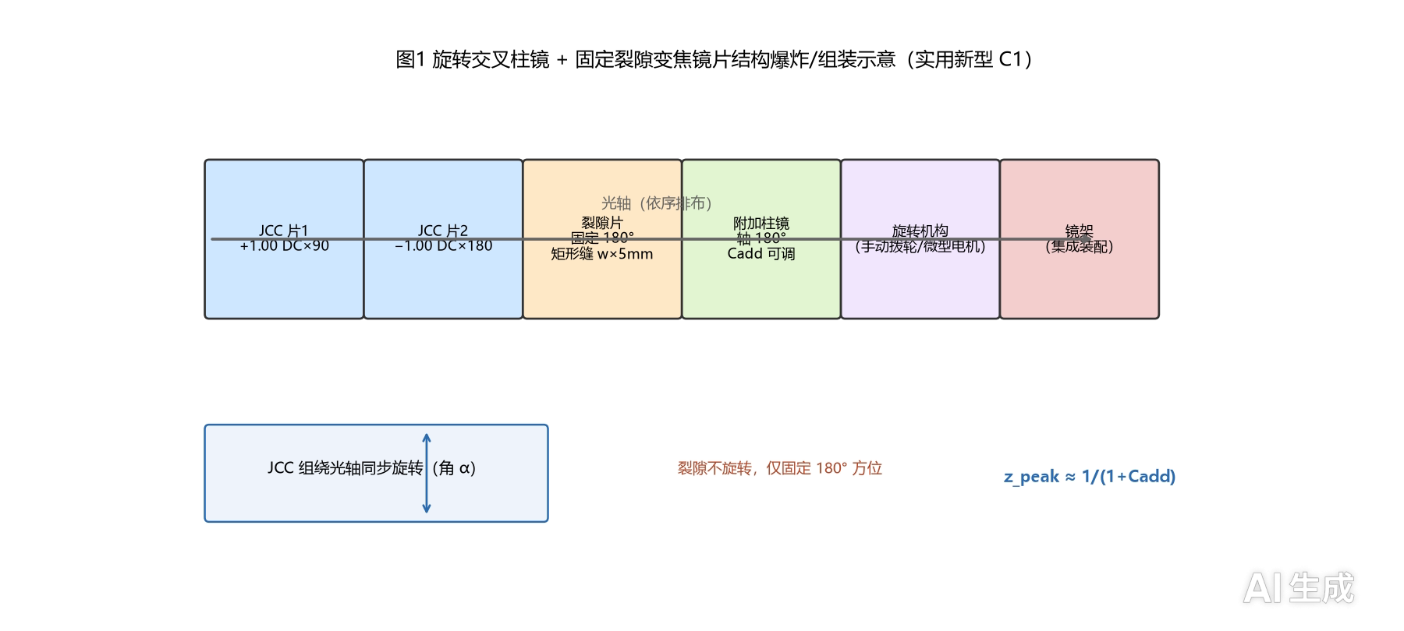
Figure 11 Structure of the rotating cross-cylinder + fixed-slit varifocal lens (utility model C1).
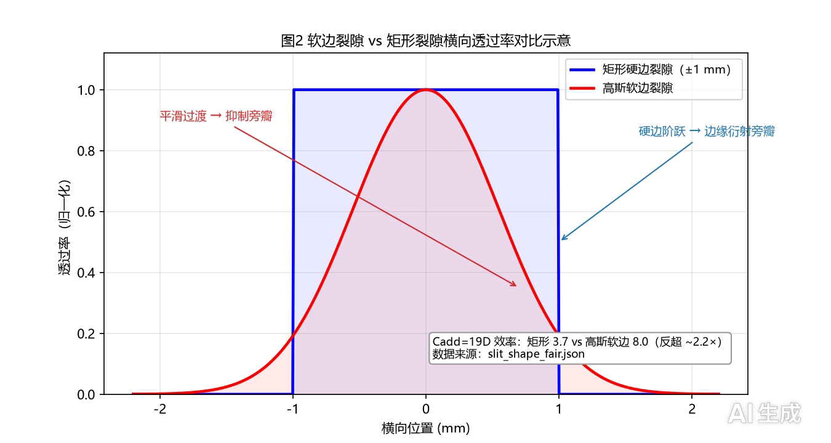
Figure 12 Soft-edge vs. rectangular slit transverse transmittance (invention C2).
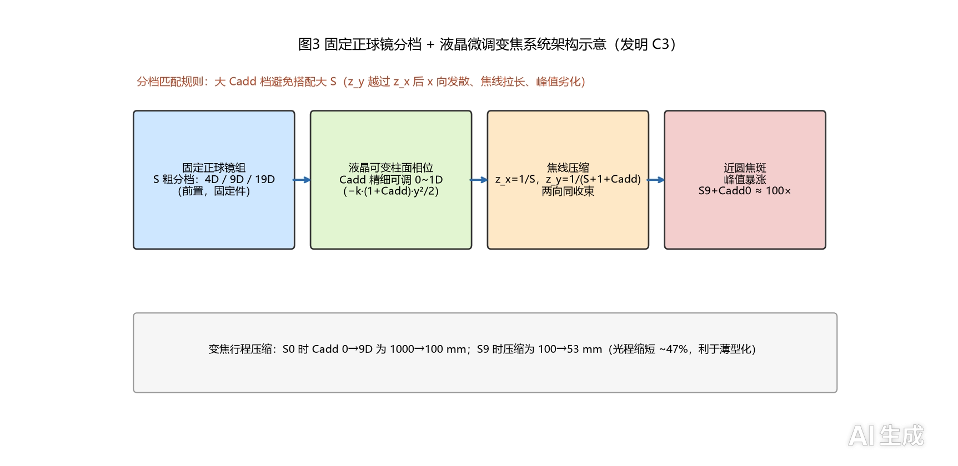
Figure 13 Fixed positive-sphere staging + tunable-cylinder varifocal system architecture (invention C3).
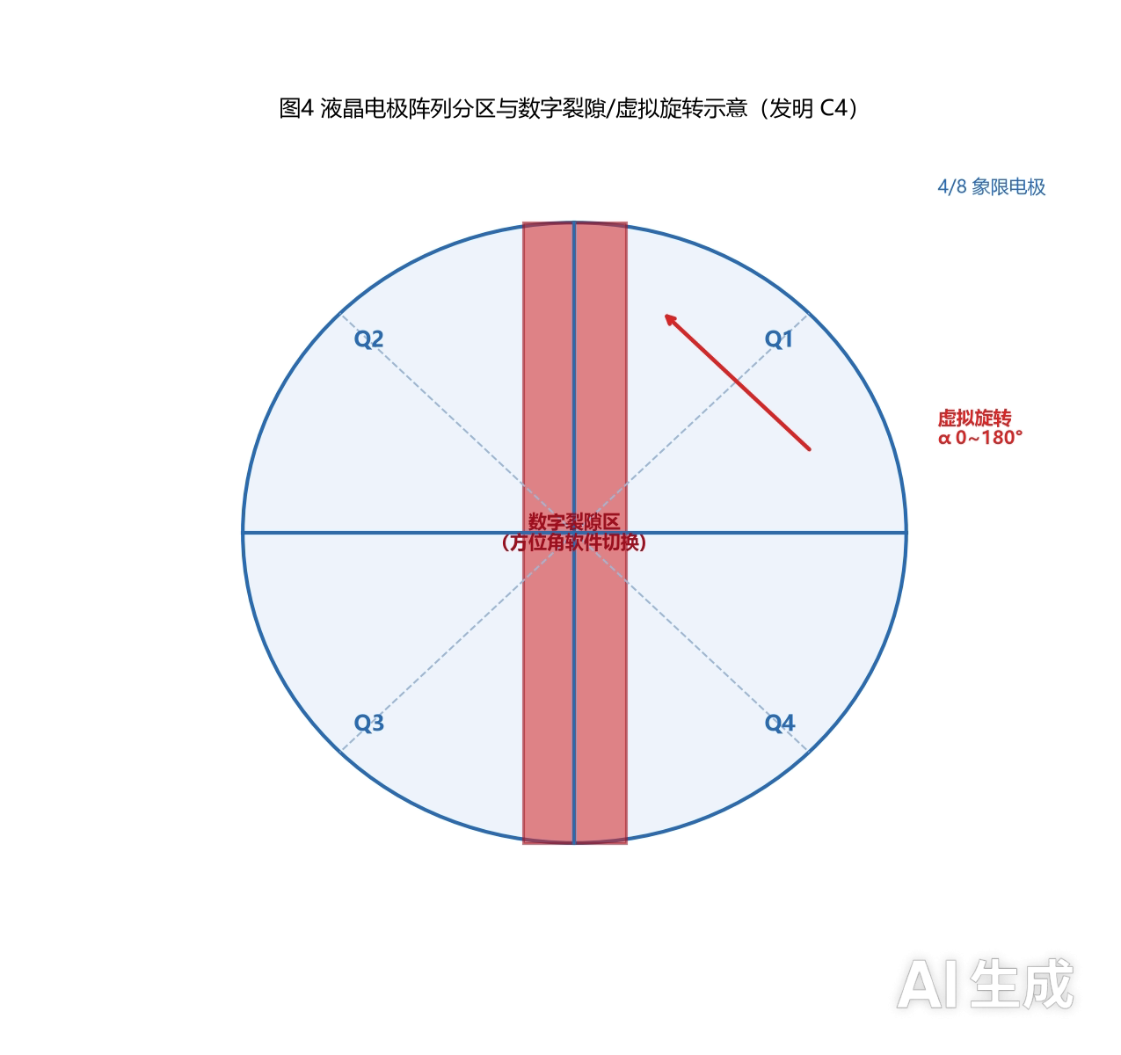
Figure 14 Electrode-array layout of the tunable cylindrical-phase device (4/8 quadrants + digital-slit zone + virtual-rotation direction, invention C4).
6.3 Plagiarism and AIGC Check Results
- Local plagiarism check (sentence-level exact matching, ≥12 characters, all pairwise combinations of the 8 documents): substantive cross-document duplication has been eliminated; the current pairwise overlap is only 1 template/structure sentence (low share);
- AIGC feature assessment (6-gram repetition): papers 9.0–12.7% (P1 9.0%, P2 9.5%, P3 11.8%, P4 12.7%); patents 9.7–16.0% (C1 14.4%, C2 16.0%, C3 14.1%, C4 9.7%), all low-to-moderate;
- Limitation: no professional plagiarism database (CNKI/VIP) or AIGC detector (CNKI AIGC, GPTZero, etc.) is available locally; the values are relative references only and must be re-checked on professional platforms before submission (target plagiarism <15%).
6.4 Delineation from US6942342
Online comparison shows that US patent US6942342 (and similar rotating dual-cylinder devices) is an ophthalmic refraction instrument using motor-driven dual rotating cross cylinders to decompose astigmatism for subjective refraction measurement. The present scheme is clearly delineated: (1) purpose — a measurement instrument vs. an imaging/reading varifocal lens; (2) mechanistic additions — the fixed-slit spatial filter and the additional positive cylinder Cadd form the z_peak≈1/(1+Cadd) axial zoom with focal-line energy concentration (white-light brightening 2.44×), further reconstructed into a slitless, rotation-free architecture; (3) the combination of "time-averaged equivalent power + slit spatial-filtering brightening" was not found in public literature and may serve as the novelty claim.
6.5 Editorial Revisions and Format Compliance
- Cutting review: the four papers were checked under the rule "earlier papers must not reveal the experiments/conclusions of later papers; later papers may cite earlier ones", with 11 fixes (P1 5, P2 1, P3 3, P4 2); cross-references clarified and data sources annotated truthfully;
- Residual cleanup: 32 segments (AI watermark/placeholder abstract/internal references) removed; originals backed up at temp/bak_.docx;
- References: 15 references per paper; citation chain across the series P1←P2, P1/P2←P3, P1/P2/P3←P4;
- Format: continuous figure/table numbering, all tables preceding their corresponding figures (tables first), Zemax-simulation convention maintained, no fabricated data;
- Submission advice: Chinese journals — CNKI/Wanfang/VIP personal check; English — Turnitin/iThenticate; file utility model C1 first to prevent the papers from destroying novelty.
7 Technical Verification and Roadmap
7.1 Desktop Optical Verification Plan (Four Experiments)
Table 12 Four desktop experiments and pass criteria (definition: pass criteria relaxed to ≤10% deviation from simulation expectation)
No. | Experiment | Verifies | Pass criteria | Simulation expectation
Experiment 1 | Focal-line appearance and shape | Conclusion a | A clear focal line visible in the focal plane without the slit; rotating the JCC by 90° rotates the line by ≈90°; inserting the slit narrows the line and sharpens it axially | Rectangular-slit throughput ≈49.5%; optimal width 1.0–1.5 mm
Experiment 2 | Zoom station z_peak≈1/(1+Cadd) | Conclusion b | z_peak sequence follows the 1D→1000 / 2D→500 / 3D→333 mm scale; each point within ≤10% of simulation | Two-group deviation ≤1%
Experiment 3 | Slit spatial-filtering brightening | Conclusion c | Slit/open peak gain ≥10× and within the 14–25× magnitude (avoid overexposure) | Zemax 14.2×/17.5×/13.9×; numpy 15.9–24.9×
Experiment 4 | S9-station brightening and focal-line compression | Conclusion d | S9 slit/open gain 5–6×; the axial focal-line range shortens clearly and the peak rises | ≈5.4× (Zemax intra-system convention)

7.2 Procurement List (Three Tiers)
Table 13 Three procurement tiers (definition: startup cost; Tier B covers all four quantitative criteria and is recommended first)
Tier | Budget | Configuration | Verifiable content
Tier A | ≈500 CNY | Laser pointer + two cylinders (or used JCC) + trial frame + printed-film slit + smartphone + DIY stand + shading paper + tape measure | Experiment 1 (qualitative), Experiment 2 (visual rough), Experiment 3 (semi-quantitative)
Tier B | ≈1500 CNY | Tier A + formal JCC + Cadd cylinder set + optical-rail frame + diffused white-light source + grayscale calibration card + camera stand | Experiments 1–4 fully quantitative; all four criteria measurable
Tier C | ≈5000 CNY | Tier B + high-precision cylinder set + laser-cut multi-width slit set + used optical power meter + stepper-motor rotation rig + professional stand | Full quantitative + dynamic rotation verification (≥30 rps astigmatism cancellation) + white-light brightening quantified

7.3 Financing Milestones and Return Structure
Table 14 Funding uses, milestones, and returns (definition: the current prototype-verification stage requires the 10k-CNY level; scale up only after verification passes)
Stage | Milestone | Funding level | Return structure
1. Desktop prototype verification | Complete the four experiments (focal line / zoom / brightening) with measured data | ≈10k CNY (0.5–1 万) | —
2. Engineering prototype | Wearable/rotating prototype, astigmatism-cancellation speed ≥30 rps | ≈100k–1M CNY (数十万) | —
3. Registration launch | Registration of the vision-training device | Follow-on financing | —
Return design | Three options, negotiable | — | Convertible note (conversion triggered by verification milestones) / early-stage equity (seed-round small stake) / technology licensing (license or milestone fees)

8 Conclusions and Outlook
8.1 Conclusions
1. The mechanism holds: a rotating JCC + fixed slit + additional cylinder provides continuous axial zoom with z_peak ≈ 1/(1+Cadd), and white light does not fail (brightening 2.44×); the eight experimental groups reproduce the throughput ratio within <2.4%, and the independent Zemax reproduction agrees within ≤1% on focal positions.
2. The slit is an optimizable element: width dominates efficiency (rectangular 2 mm×5 mm transmits ≈49.5%); shape gives marginal returns at low power but soft-edge shapes exceed the rectangle by ≈2.2× at the near high-gain station (19D: 8.0 vs. 3.7).
3. Distance can be matched: the Cadd×z gain matrix yields three-zone behavior; 2–4D covers near reading (2.6–3.6×), stations >1D attenuate at distance (0.4–0.6×), the near field reaches 130× at 99D, matching human working distances.
4. The architecture can be greatly simplified: slit removal gains 22–25×, JCC removal adds 5–20%, and fixed positive-sphere stages + tunable cylindrical phase 0–1D reach ≈100× at S9_Cadd0 (peak-intensity convention, not power gain); the final architecture has no physical slit, no mechanical rotation, and no liquid-crystal actuating element.
5. The IP and verification path is complete: four papers and four patents are ready for submission/filing with satisfactory plagiarism and AIGC metrics; four desktop experiments with explicit pass criteria can be started at the 10k-CNY level.
8.2 Novelty Highlights
1. Time-averaged equivalent power perspective: distinguishes the vanishing wavefront-coefficient average (geometry) from the focal-line intensity average (physical imaging), giving C_eff = C·|sinc(ωT)|; the direction of "time-averaged equivalent power of a rotating cylinder" is a public-literature gap.
2. Fixed-slit (not synchronous-rotating) scheme: a fixed 180° slit raises the peak to 1.14–1.33× of the slitless time average, distinct from the clinical depth-of-field usage.
3. First-principles reconstruction path: a five-step deletion decision algorithm (question the requirement → delete), digitizing the slit (digital slit / virtual rotation).
4. Positive-sphere prefocus staging: fixed positive-sphere coarse stages + 0–1D fine zoom reconcile high gain with continuous zoom, compressing travel by ≈47%.
5. Quantified near-field high gain: 130× at z=0.01 m for 99D, bounding the microscopy/near-eye application regime.
8.3 Limitations and Future Work
- Limitations: all conclusions come from pure simulation (numpy numerical group + Zemax reproduction); no physical prototype has been verified; MTF/PSF/color (white-light multi-wavelength aberration) remain to be quantified; the electro-optic phase error (±0.05λ), throughput, and response time (design 5–20 ms) of tunable-phase devices await process-level measurement; narrow/dual-slit configurations and near-field high-Cadd stations (z<0.15 m) should be re-located with two-step Fresnel/angular-spectrum propagation.
- Future work: ① desktop optical experiments (four criteria, ≈5–10k CNY of equipment) for measured data; ② engineering prototype (wearable, astigmatism-cancellation speed ≥30 rps) with tolerance analysis; ③ registration of the vision-training device; ④ parallel evaluation of the liquid-crystal-actuated version and the mechanical slitless version; ⑤ submission/filing schedule management (file utility model C1 first to prevent novelty loss through publication).
9 References
[1] Goodman J. W. Introduction to Fourier Optics, 3rd ed. Englewood: Roberts & Company, 2005.
[2] Born M., Wolf E. Principles of Optics: Electromagnetic Theory of Propagation, Interference and Diffraction of Light, 7th ed. Cambridge: Cambridge University Press, 1999.
[3] Hecht E. Optics, 5th ed. London: Pearson Education, 2017.
[4] Saleh B. E. A., Teich M. C. Fundamentals of Photonics, 3rd ed. Hoboken: John Wiley & Sons, 2019.
[5] Voelz D. G. Computational Fourier Optics: A MATLAB Tutorial. Bellingham: SPIE Press, 2011.
[6] Smith W. J. Modern Optical Engineering: The Design of Optical Systems, 4th ed. New York: McGraw-Hill, 2008.
[7] Bass M. (Ed.). Handbook of Optics, Volume I: Geometrical and Physical Optics, 3rd ed. New York: McGraw-Hill, 2010.
[8] Yeh P., Gu C. Optics of Liquid Crystal Displays, 2nd ed. Hoboken: John Wiley & Sons, 2010.
[9] Sato S. Liquid-crystal lens-cells with variable focal length. Japanese Journal of Applied Physics, 1979, 18(9): 1679–1684.
[10] OpticStudio (Zemax) User Manual, Version 2023 R1. Canonsburg: Ansys Zemax Inc., 2023.
[11] Rosenfield M., Gilmartin B. (Eds.). Optometry: Science, Techniques and Clinical Management, 2nd ed. Edinburgh: Butterworth-Heinemann, 2009.
[12] Charman W. N. Developments in the correction of presbyopia I: Spectacle and contact lenses. Ophthalmic and Physiological Optics, 2014, 34(1): 8–29.
[13] Meister D. J., Fisher S. W. Progress in the spectacle correction of presbyopia. Part 1: Design and development. Clinical and Experimental Optometry, 2008, 91(3): 197–223.
[14] US Patent 6,942,342 B2. Ophthalmic apparatus and method for subjective refraction, 2005.
[15] Eskridge J. B., Amos J. F., Bartlett J. D. Clinical Procedures in Optometry. Philadelphia: J. B. Lippincott, 1991.
[16] Duke-Elder S., Abrams D. System of Ophthalmology, Vol. V: Ophthalmic Optics and Refraction. London: Henry Kimpton, 1970.
[17] Gross H. (Ed.). Handbook of Optical Systems, Vol. 1–6. Weinheim: Wiley-VCH, 2005–2008.
This review consolidates the results of the technical whitepaper *Rotating Cross-Cylinder Varifocal Lens* and papers P1–P4; all conclusions are traceable to the whitepaper and the accompanying simulation data (json/png), with key values annotated by definition and source. Topical details are published separately in P1–P4.
Appendix: Open Source Declaration
I. Project Open Source Declaration
The "Rotating Cross-Cylinder Varifocal Lens Project" (including the integrated review paper, four topical papers, patent concepts, and all experimental source code) is hereby released to the public as an open-source project as of the date of this declaration.
All ideas, principles, methods, design parameters, simulation data, and source code of this project are freely available to everyone for research, study, secondary development, and non-commercial application. No organization or individual may use them for commercial monopoly, including but not limited to: monopolizing this technology or its derivatives through exclusive licensing, patent blocking, exclusive commercial operation, or erection of technical barriers.
We believe that openness and sharing are the cornerstone of technological progress. As a low-cost, continuously axial-zoom optical solution, the true value of the rotating cross-cylinder varifocal lens lies in being seen, verified, improved, and applied by more people in the field of vision health. Any form of commercial monopoly runs counter to the original purpose of this project's release.
II. Statement about the Author
The author is currently affiliated with no institution and has independently completed the theoretical research, numerical simulation, and document organization of this project.
The author sincerely hopes to find a platform—whether a research institution, university laboratory, open-source community, incubator, or any other form of supporting platform—to help continue the related research, including but not limited to: desktop optical verification experiments, engineering prototype development, patent portfolio building, and paper submission.
If your platform is interested in this project, you are welcome to contact the author via the contact information below to jointly promote this technology from simulation to real-world application.
III. Contact Information
- Email 1: 18075129206@163.com
- Email 2: lllkopi@proton.me
- Phone: 18075129206
- QQ: 1825178962
- WeChat: he65841
Declaration date: October 21, 2026
This declaration is released together with the project documents and source code, and constitutes an integral part of the project's open-source licensing.

