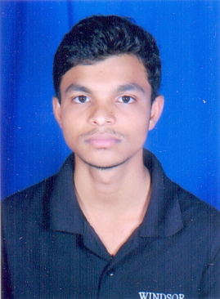**DEEPCHAND DEWANGAN**

Email id. .[imdeepchanddewangan@gmail.com](mailto:imdeepchanddewangan@gmail.com)

Mobile No. +91 7047535011

Address: Shankar Nagar, Durg 492001, Chhattisgarh

**ACADEMIC QULIFICATION** Master of Computer Application 2019-2021

Bhilai Institute of Technology, Durg

Bachelor of Computer Application 2016-2019

Shri Shankaracharya Mahavidhyalaya Junvani, Bhilai

Senior Secondary (XII), Science 2016

J.R.D. Multipurpose Govt. School, Durg

Secondary (X) 2014

Sarswati Vidhyapeeth H. S. School Shankar Nagar, Durg

**TRAININGS** Hardware & Networking 2019

GYANAMTECH(A unit of IT innovation)

I work with team GYANAM with 6 months.

**TECHNICAL SKILLS** Language : C, C++, JavaScript, PHP.

Front End: HTML&CSS.

Data Base: MYSQL.

Framework: LARAVEL

**FAMILIER WITH SOME** Node.js, React.js, Java

**TECHNOLOGY**

**PROJECT** Title: Electronic ticket booking system

Technology: ASP.net

Language: C#

Database: SQL

Title: Online Recruitment System

Language: PHP

Database: MYSQL

Frontend: HTML&CSS